Cross Lane CLP (Re-issued 24-10-2022)
1 INTRODUCTION

Development name: | Cross Lane
Landowner: | Guinness Development London Ltd
Site address: | 7 Cross Lane, Hornsey
Site postcode: | N8 7SA
Existing site use: | Motor repair work shops
Summary of works: | The demolition of the existing buildings and erection of 2 x buildings of 5 stories (Block A) and 6 storeys (Block B) to provide 50 residential apartments (16 x 1 bed, 23 x 2 bed and 11 x 3 bed units) totalling 36,608ft2 and a ground floor flexible commercial unit (Class E) extending to approximately 2,013ft

Construction Logistics Manager: | Keith Fisher
Phone number: | 07581 020072
Email: | Keith.fisher@arjconstruction.co.uk
Logistics provider contact name: | N/A
Phone number:
Email:

CLP Produced by:
Name | Signature | Date
Keith Fisher | K C Fisher | 17/10/2022
 | CLP Accreditation date:
CLP reviewed by:
Name | Signature | Date
 | CLP Accreditation date:

1.1 CLP OBJECTIVES
This project specific logistics plan has been prepared following a detailed review of the available documentation and liaison with our specialist supply chain.
The information contained herein has been developed to enable the successful development of the Cross Lane project whilst minimising health and safety risks, and the impact of construction on neighbours and the surrounding area.
This document will be regularly reviewed in conjunction with the construction Phase Health and Safety Plan and will be issued to all supply chain members to facilitate the development.
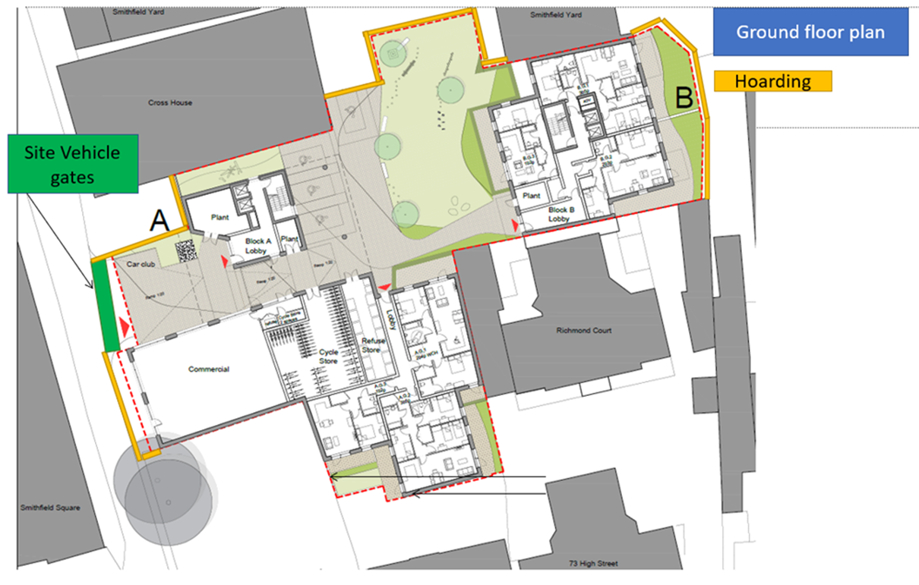
The site is located on the eastern side of Cross Lane and approximately 70 metres to the north of its junction with the A504 High Street. The site is a vacant plot and previously operated as a vehicle repair centre (circa 1,140 sqm) with vehicular access provided from Cross Lane.
To the west, the site is bounded by Hamlet Court Smithfield complex which also uses access by Cross Lane. This is a mainly residential and with minimal residence parking available.
To the south of the site is High St (A504), which again has a heavy stream of traffic. One main entrance into Cross Lane off High St. At this junction, there is a public house (The Great Northern Railway Tavern).
In a wider context, the site is in a high-density residential development. Locally, St Ann’s Hospital lies approximately 1.7 miles to the southeast of the site (along St Ann’s Road)
There are many local outlets and units in the immediate vicinity, predominantly classes A1-A5 and residences class C3/C4.
To the southeast corner of the site there are further residential units (Richmond Holiday Apartments).
In a wider context, the site is in a high-density residential development. Locally, St Ann’s Hospital lies approximately 1.7 miles to the southeast of the site (along St Ann’s Road)
There are many local outlets and units in the immediate vicinity, predominantly classes A1-A5 and residences class C3/C4.
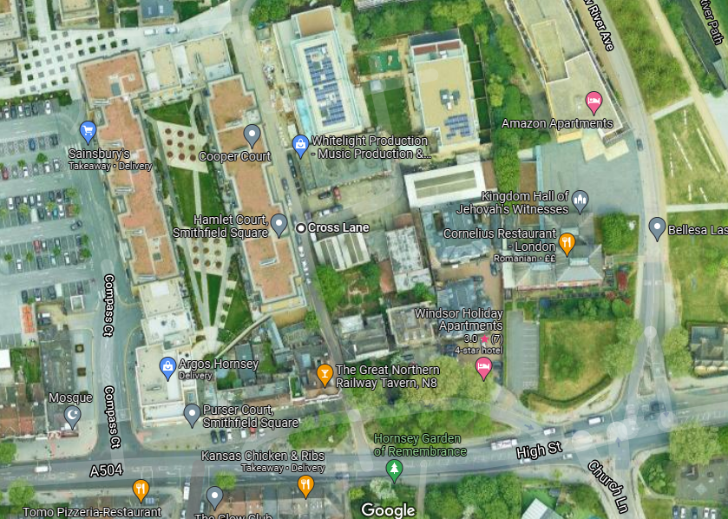

1.2 SITE CONTEXT
Existing footways in the local area would generally remain open throughout the
construction process however, for safety reasons it is proposed that the footway on
the eastern side of Cross Lane, across the site’s frontage, would be closed with
pedestrians diverted to the wide and good quality footway on the western side of
Cross Lane. As illustrated in Figure 4.1, Traffic marshals would be located at the front
of the site entrance at times when deliveries are expected to direct pedestrians during
scheduled deliveries

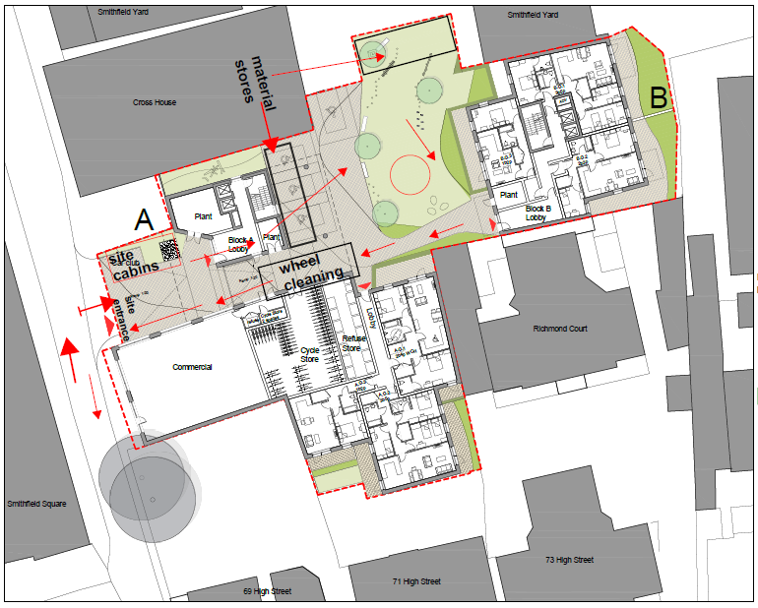

1.3 DEVELOPMENT PROPOSAL
The demolition of the existing buildings and erection of 2 x buildings of 5 stories (Block A) and 6 storeys (Block B) to provide 50 residential apartments (16 x 1 bed, 23 x 2 bed and 11 x 3 bed units) totalling 36,608ft2 and a ground floor flexible commercial unit (Class E) extending to approximately 2,013f
2 CONTEXT, CONSIDERATIONS AND CHALLENGES
2.1 POLICY CONTEXT
This section describes the local context and issues identified that need to be considered and addressed during construction.
  - POLICY CONTEXT
This section of the CLP references policies we have considered in the preparation of the document.
    - NATIONAL POLICY

The Traffic Management Act (2004)

The act makes ‘provision in relation to the management of road networks; to make new provision for regulating the carrying out of works and other activities in the street’s highways may be occupied due to construction activities and identifies appropriate changes levied for any extended occupation.
    - REGIONAL POLICY

The London Plan (2019)

The London Plan 2019 has a variety of policies designed to improve construction logistics, most notably Policy T7. This is outlined below:

E, Construction Logistics Plans and Delivery and Servicing Plans will be required and should be developed in accordance with Transport for London guidance and in a way which reflects the scale and complexities of developments.

H, At large developments, facilities to enable micro-consolidation should be provided, with management arrangements set out in Delivery and Servicing Plans.

I, Development proposals must consider the use of rail/water for the transportation of material and adopt appropriate construction site design standards to that enable the use of safer, lower trucks with increased levels of direct vision on waste and landfill sites, tip sites, transfer stations and construction sites.

IA The construction phase of development should prioritise and maintain inclusive, safe access for people walking or cycling at all times

    - When planning freight movements, development proposals should demonstrate through Construction Logistics Plans and Delivery and Servicing Plans that all reasonable endeavors have been taken towards the use of non-road vehicle modes. Where rail and water freight facilities are available, Transport for London’s freight tools should be used when developing the site’s freight strategy.

    - Delivery and Servicing Plans should demonstrate how the requirements of the site are met, including addressing missed deliveries. Appropriate measures include large letter or parcel boxes and concierges accepting deliveries. Car-free developments should consider facilitation of home deliveries in a way that does not compromise the benefits of creating low- car or car-free environments.

Transport for London’s guidance on Construction Logistics and Delivery and Servicing Plans should be adhered to when preparing planning applications. Plans should be developed in line with this guidance and adopt the latest standards around safety environmental performance of vehicl
The plans should be monitored and managed throughout the construction and operational phases of the development. TfL’s freight tools including CLOCS (Construction Logistics and Community Safety), FORS (Fleet Operator Recognition Scheme) or equivalent should be utilised to plan for and monitor site conditions to enable the use of vehicles with improved levels of direct vision.

This should be demonstrated through a Site Assessment within a Construction Logistics Plan. Development proposals should demonstrate ‘good’ on-site ground conditions ratings or the mechanisms to reach this level enabling the use of vehicles with improved levels of driver direct vision. To support the procurement of these vehicles and to minimise road danger, the Mayor has introduced his Direct Vision Standard, which rates Heavy Goods Vehicles on a star rating from 0 (lowest) to 5 (highest), based on how much the driver can see directly through the cab windows.

The Mayor’s Transport Strategy(2018)

Freight and servicing is frequently mentioned throughout this document which contains a strategy considering all methods of freight delivery including road, rail, pipeline, water, bicycles and air. The document especially highlights the importance of DSPs, CLPs and FORS to encourage improved efficiency and provide a framework for incentivisation and regulation.

In particular policies 3,6,9 and 16 and have impacts on construction activity and should be reviewed when undertaking a CLP.

TfL Freight and Servicing Action Plan (2019)

The Mayors key document for improving freight and servicing in the capital sets out a safer and cleaner vision for all freight trips. The vision for construction is set out in Actions one, two and nine which puts safety at the heart of this policy. These policy’s must be considered when undertaking a CLP

Fleet Operator Recognition Scheme (FORS)
FORS is a unique, industry-led, membership (bronze, silver, gold) scheme to help van and lorry operators become safer, more efficient and more environmentally friendly. It’s relevance to the CLP is via its mention in the Mayor’s Transport Strategy and requirements will be relayed to all operators engaged during the development.

  - CONTEXT MAPS

The following maps show the area around the development site. Figure 1 shows a regional plan with the location of the site in the context of the greater London and the road network.
Fig 2 shows the location of the site in relation to the surrounding local area.
Fig 3 Show the site boundary showing the extent of the footpaths and other buildings.
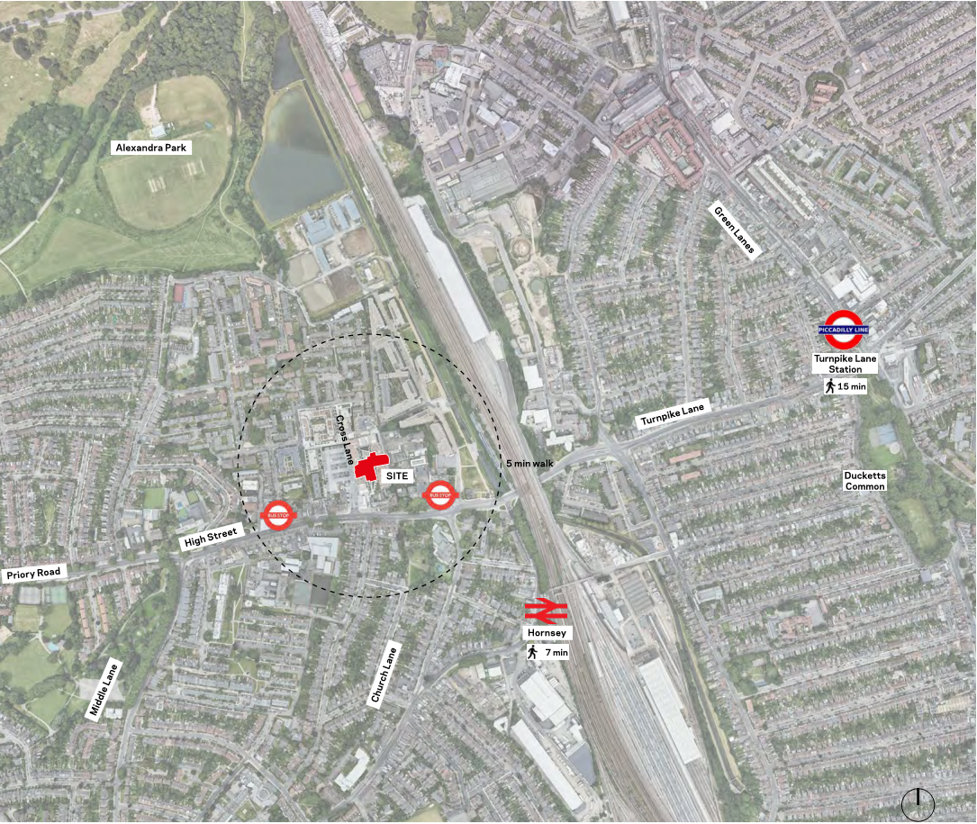
Fig 1
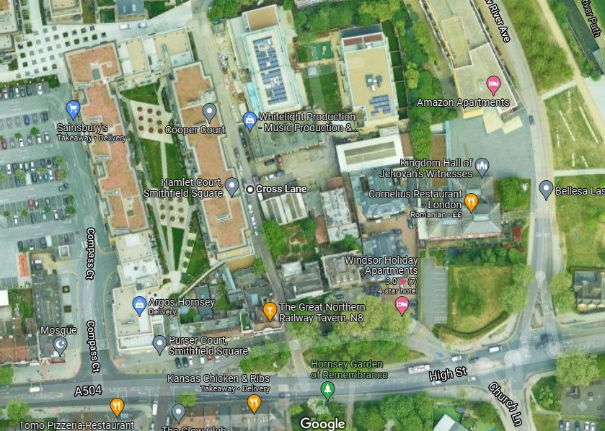
Site
Fig 2
Fig 3

Community Considerations
2.3 LOCAL ACCESS INCLUDING HIGHWAY, PUBLIC TRANSPORT.
Pedestrian Access
Existing footways in the local area would generally remain open throughout the
construction process however, for safety reasons it is proposed that the footway on
the eastern side of Cross Lane, across the site’s frontage, would be closed with
pedestrians diverted to the wide and good quality footway on the western side of
Cross Lane. Traffic marshals would be located at the front
of the site entrance at times when deliveries are expected to direct pedestrians during
scheduled deliveries.
Monitoring of the above elements will be undertaken by a Construction Manager,
appointed by the Main Contractor, throughout the programme of works to ensure the
safety of all those staff associated with the works and users of the public highway, at
all times. The above elements will be amended, with additional mitigation processes
put in place, as required, as the construction programme evolves

Cyclist Facilities

In terms of cycle infrastructure, as identified within the Haringey Cycle Plan, Cross Lane is considered a preferred, cycle friendly route. This route facilitates access north
towards Wood Green and Alexandra Palace via The Greenways. In addition, the local
highway network in the vicinity of the site is considered conducive to on-road cycling
for skilled and experienced cyclists.

The nearest bus stops to the site are located on High Street approximately 240 metres
to the east of the site. These bus stops serve bus routes 41, 144, N41 and N91 which
provides a frequent service (every 3-4 minutes at peak times) to a number of
destinations such as Lower Edmonton, Tottenham Hale, Wood Green and Muswell Hill,
Cockfosters and Trafalgar Square, for example

London Underground/Overground
Hornsey rail station is located approximately 500 metres from the site (circa 6 minutes
walk), providing direct services to a wide range of destinations, including Moorgate,
Welwyn Garden City and Hertford North,

Turnpike Lane London Underground Station is also located within 1 kilometre of the
application site and is directly accessible on-foot. Turnpike Lane is served by the
Piccadilly Line which operates to several destinations such as Cockfosters, Kings
Cross St Pancras, Leicester Square, Green Park, Hammersmith and Heathrow Airport.
Typically, there are services every 2-3 minutes in each direction at peak times.

The site has a prescribed PTAL of 3 (moderate), however it is noteworthy that the site
lies within 25 metres of a PTAL 5, representing a site with ‘very good’ public transport
accessibility. This is less than a 1-minute extra walk from the site and in reality, would
not affect how future residents would view travel by public transport.

Parking Restrictions
There will be no subcontractor parking allowed on site, due to the space complexities.
Site operatives and visitors will be encouraged to travel to/from the site via public
transport. There are frequent bus and rail services available from within close proximity
of the site, which could be conveniently utilised.

Should any site operatives or visitors arrive at the site by private vehicle, they would be
obliged to park at the nearest pay and display or on-street parking bays available,
since there would be no dedicated parking bays available on-site. In addition, car
sharing would be encouraged amongst construction staff as a suitable alternative.

The potential to provide lockers / storage areas on-site for tools and materials of
construction staff would also be explored by the appointed contractor to make
sustainable travel more convenient for staff. This could be provided by way of a
designated / secure storage area within the construction compound

2.3.2. RAILWAY/UNDERGROUND
Hornsey over ground station is located north of the site with in a 7 minute walk with regular services in to Moorgate.
2.3.3. BUS ROUTES
A range of TfL services allow high accessibility without using private cars, including step free access to buses / underground and free /subsidised travel.
Every London bus route is wheelchair accessible, with automatic ramps and designated wheelchair spaces as well as iBus audio-visual system to help those with impaired vision or hearing. There excellent PTAL rating means 5 out of the 11 local bus routes are accessible within a distance of 250m.
Concessionary travel for disabled people includes a Freedom Pass which allows free travel on London Underground, Overground, DLR and all bus services 24 hours a day. The Dial-a-Ride scheme offers free door to door service for people who have difficulty accessing public transport, whilst the Taxi card
Capital Call scheme provides subsidised taxi and minicab travel. All of London’s Black Cabs are wheelchair accessible.
Additionally, Community transport offers minibus services to community groups and door-to-door journeys for individuals unable to use public transport.
2.3.4. CYCLING
There is no designated cycle route in Cross Lane. Cyclist do you Cross Lane to access New River Village.
2.3.5 WATERWAYS
There are no waterways that will be affected by the construction works.
2.4 COMMUNITY CONSIDERATIONS
This project specific logistics plan has been prepared following a detailed review of the available documentation and liaison with our specialist supply chain.
The information contained herein has been developed to enable the successful development of the Cross Lane project whilst minimising health and safety risks, and the impact of construction on neighbours and the surrounding area.
This document will be regularly reviewed in conjunction with the construction Phase Health and Safety Plan and will be issued to all supply chain members to facilitate the development.
This project specific logistics plan has been prepared following a detailed review of the available documentation and liaison with our specialist supply chain.
The information contained herein has been developed to enable the successful development of the Cross Lane project whilst minimising health and safety risks, and the impact of construction on neighbours and the surrounding area.
This document will be regularly reviewed in conjunction with the construction Phase Health and Safety Plan and will be issued to all supply chain members to facilitate the development.

2.4.1. LOCAL POLICY
Normal working hours:
8am - 6.00pm Monday to Friday 8am - 1.00pm Saturday
No works on Sundays or Bank Holidays.

Prior to any works commencing it is proposed that a site hoarding is installed along the
curtilage of the site works to prevent unauthorised access to the site and to warn of
the potential dangers of construction zones. A site hoarding would ensure that safe
access is maintained into the site for legitimate staff and deliveries only and ensures
that safe passage is maintained for pedestrians.

Appropriate signage will also be erected around the curtilage of the site and will give
clear instruction for safe routes of passage by both cars and pedestrians which will be
continually adapted to suit any varied stages of construction.

The site manager will liaise with the local community and issue Monthly look ahead bulletins to inform residents of the upcoming works which shall include noisy works and the time it will be carried out.

Principally pedestrians will be directed to use the footway on the western side of Cross
Lane, with the footway immediately in front of the site, on the eastern side of Cross
Lane, being closed for the duration of the works. Temporary lighting would also be provided across the site, as necessary.

The site would be designed appropriately to ensure that there is no requirement for
skips or vehicles to be located on the public highway and no transfer of materials
occurs off site, as far as reasonably possible.

The extent of hoarding and any proposed temporary traffic management measures
would be agreed with the Highway Authority (LBH) in accordance with its licencing
procedures. All necessary licences would be applied for by the Main Contractor in
advance.

3 CONSTRUCTION PROGRAMME AND METHODOLOGY
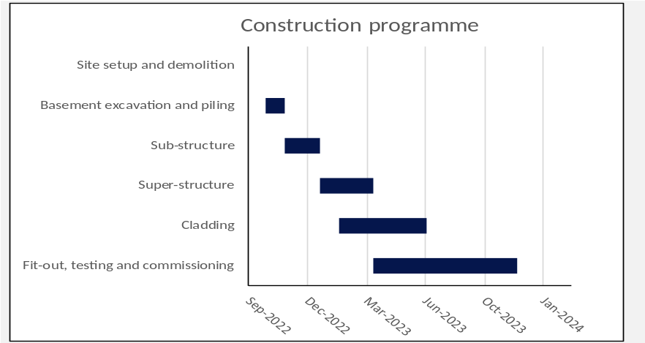

Construction phase | Start | End
Site setup and demolition | Oct-2022 | Oct-2022
Basement excavation and piling | Oct-2022 | Nov-2022
Sub-structure | Nov-2022 | Jan-2023
Super-structure | Jan-2023 | Apr-2023
Cladding | Feb-2023 | Jul-2023
Fit-out, testing and commissioning | Apr-2023 | Dec-2023

CONSTRUCTION PROGRAMME PHASES
3.1.1. SITE SETUP SUBSTRUCTURE
Full survey will be carried out to locate any below ground services. A CFA piling rig and concrete vehicles will be used to install the piles. Excavators will be used to dig out for the pile caps and ring beams, drainage, etc. As dug materials will be loaded into tipped vehicles via the excavators ready for removal and disposal.
A wheel-wash facility will be on site, to wash wheels to reduce dust and mud traversing onto local highways.
3.1.2. PILED FOUNDATIONS
Installation of CFA piles ranging from 300 – 350mm in diameter foundations
Operatives to attend site induction and sign onto Method Statement briefing sheet. Installation of CFA piles ranging from 300 – 350mm in diameter. Foundations operatives to attend Site Induction and sign onto Method Statement briefing sheet.
Complete permit to dg, identifying all known remaining services on-site and ensure operatives sign onto documentation.
Using a CAT & Genny operatives to scan the area of work ensuring all utilities are marked up on the ground using line marker.
All setting out to be carried out and marked on site using metal road pins with protective mushroom caps
Complete Permit to Dig, identifying all known remaining services on-site and ensure operatives sign onto documentation.
Using a CAT & Genny operatives to scan the area of work ensuring all utilities are marked up on the ground using line marker.
All setting out to be carried out and marked on site using metal road pins with protective mushroom caps.
Pile arisings will be removed of site via 8 wheel tipper trucks.
3.1.3. SUB-STRUCTURE
Traditional RC ground beams and pile caps will be formed with integral suspended ground floor concrete slabs, complete with drainage and service ducts.
Materials required will be concrete, delivered ready mixed via pump. The vehicle will be positioned on site so no temporary road closures will be required. Reinforcement materials will be delivered predominantly on rigid lorries and unloaded within the compound supervised by banksman.
Various other materials will be required including PVC drainage pipework, pre-cast concrete manhole rings, duct, chambers, kerbs, and gullies. These materials will be delivered from various suppliers by a variety of different vehicles. Most will be offloaded in and transported to the storage area on site for use as and when required.
An additional component of traffic to the site will be the daily arrival of deliveries of small packages which will take place with vans and other light goods vehicles.

3.1.4. SUPER-STRUCTURE
A mobile crane with luffing jib will be used for the majority of the build when loading out the Sub Frame.

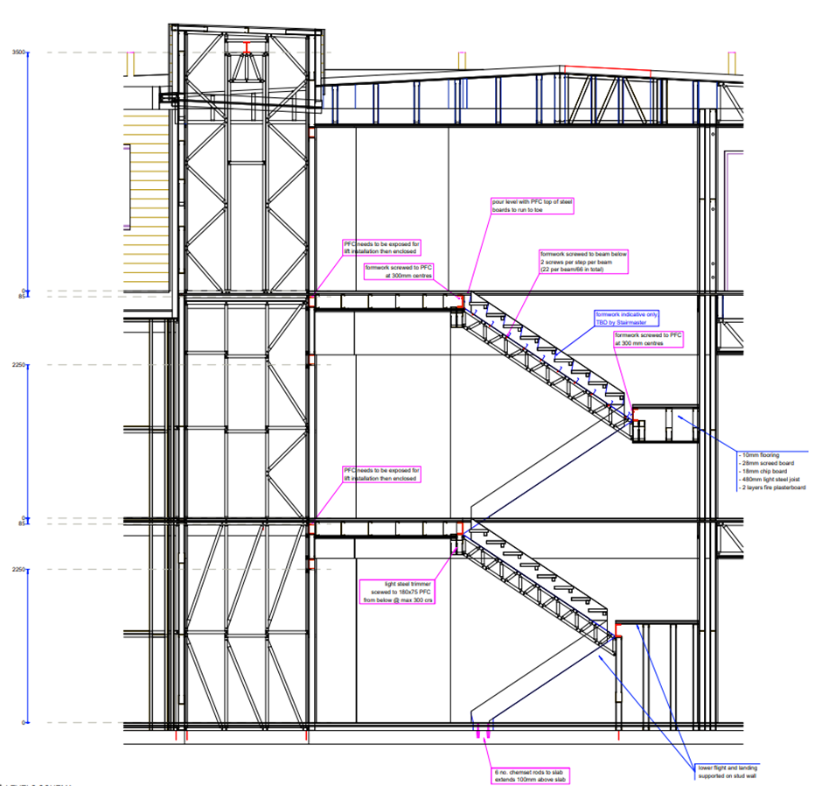
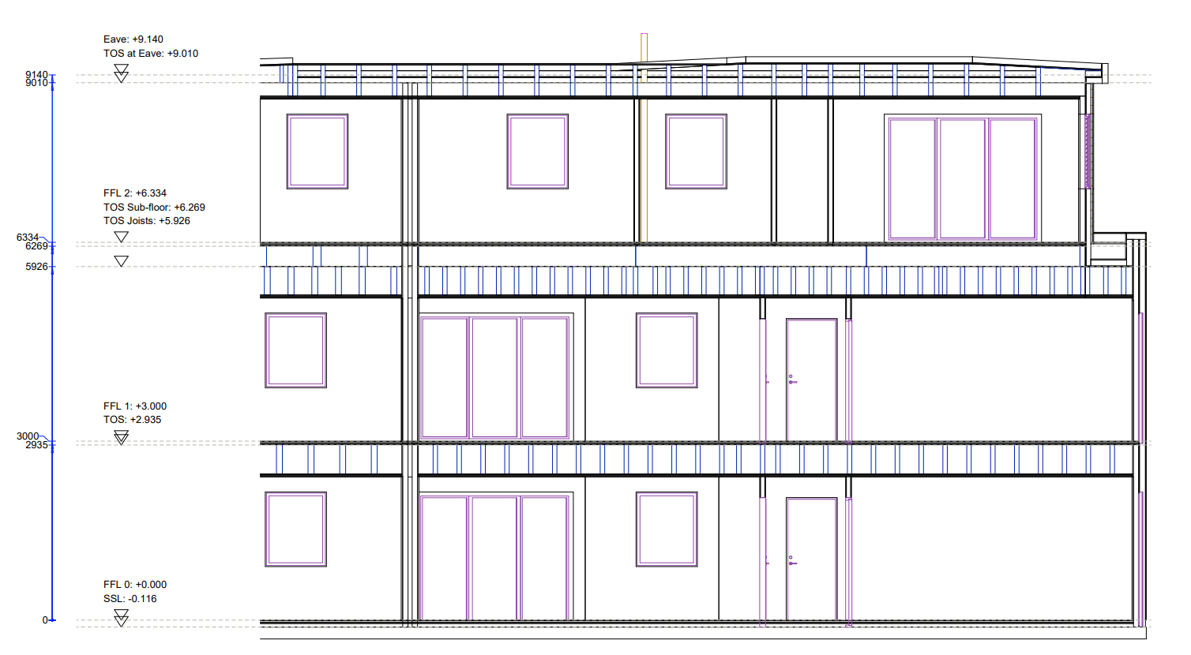
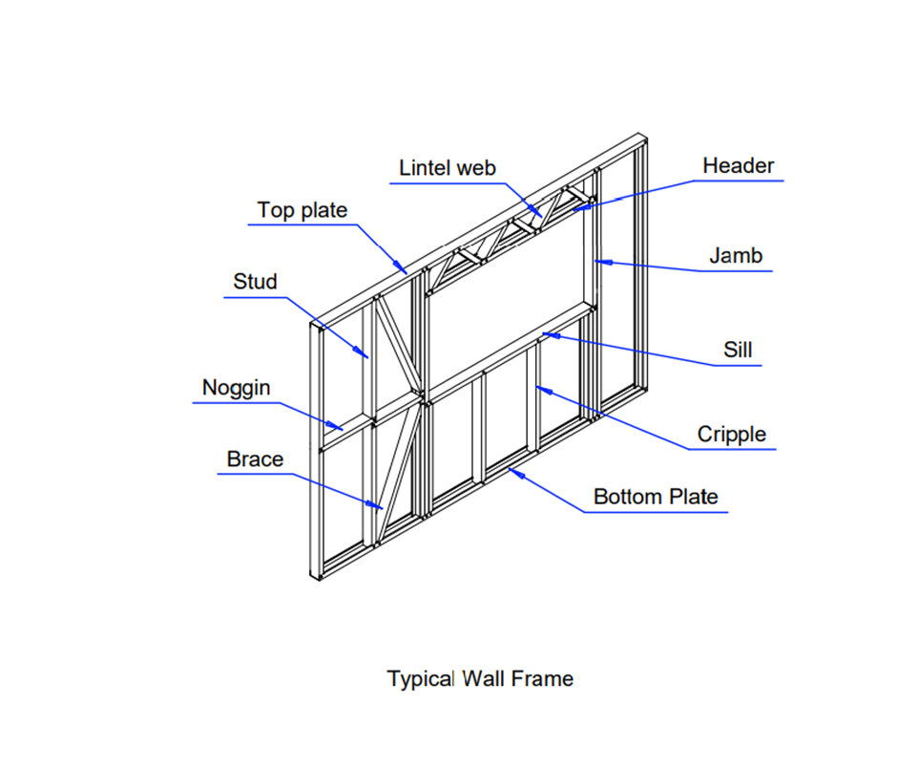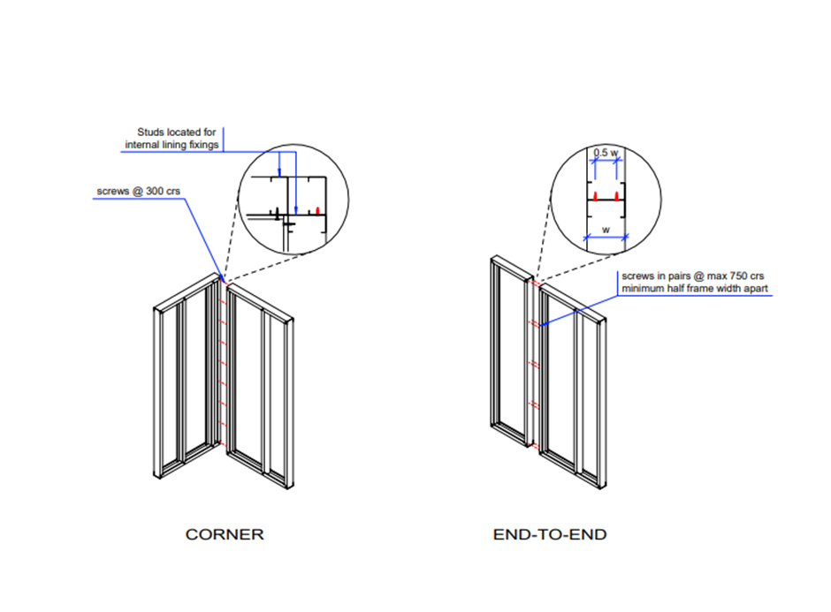
Please note that whilst the crane radius will be locked whilst in operation, it is standard safety practice to remove the restrictions at the end of each working day, to avoid compromising the stability of the crane in overnight high winds etc. However, the jib will be left in an elevated position, to ensure that any rotation is within the confines of the site.
For the construction of the façade, brickwork, windows and or roofing materials, an additional mobile crane could be used if required. The crane will then lift the materials where they can be installed. The façade materials will be delivered in large quantities to reduce the number of deliveries to site, craned into place using the tower crane and fixed into place.
Internally, materials hoists shall be used for vertical distribution of materials once the frame has been constructed. We will leave apertures in the podium slab, down to ground floor level, to allow materials to be moved. From here we will distribute materials to the appropriate levels. The apertures will be in-filled prior to the first sectional handover.
3.1.5. CLADDING
Once to LGSF is complete the building will be cladded in a single skin of brickwork complete with brick ties, DPC’s and insulation. Windows will be installed prior to the cladding commencing.
A telehandler forklift will be used with in the boundary on the site to off load ridged lorries delivering bricks, insulation and sundries. And distribute materials to the material hoist located between block A and B.
Mortar will be prepared via a mortar silo which will be refilled once a mouth.
3.1.6. FIT-OUT, TESTING AND COMMISSIONING
Typical procurement routes will be adopted for of the off the shelf fitout materials i.e. door sets, kitchens and sanitaryware will be manufactured off site and brought to site in smaller vehicles to suit our just in time delivery programme. Drylining materials will be scheduled to use smaller vehicles than usual due to restricted site storage.

- VEHICLE ROUTING AND SITE ACCESS
The majority of deliveries will be using the M25 as a route to site and travel down to the A10 to the A406 (North Circular). Traveling west on the A406 to the Colney Hatch junction, turning left heading south onto Muswell Hill and continuing on to Priory Road following on to High Street Hornsey left in to High Street (slip Road) to be met by ARJ traffic marshals.
Exit site via Cross Lane up to the junction of High Street turning left on to the Main High Street heading straight on to Turnpike Lane then turning left on to the A105 heading north to join the A406 (North Circular).

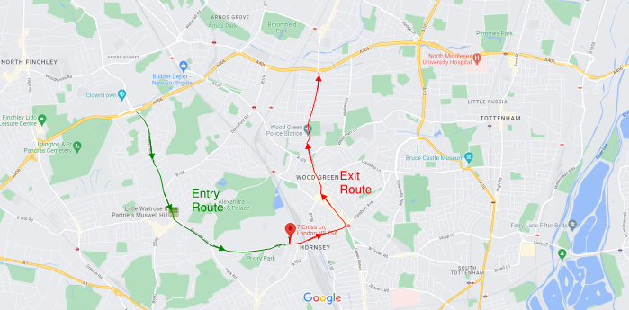
4.1 Site access from Cross Lane 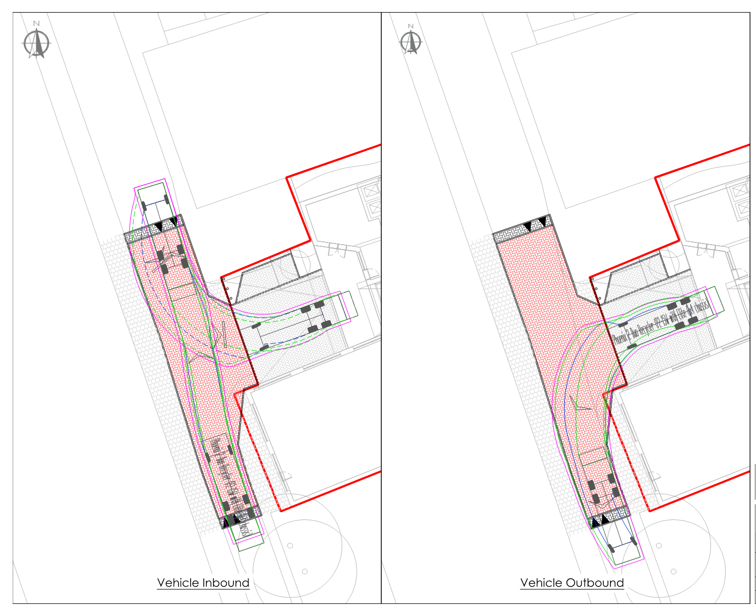
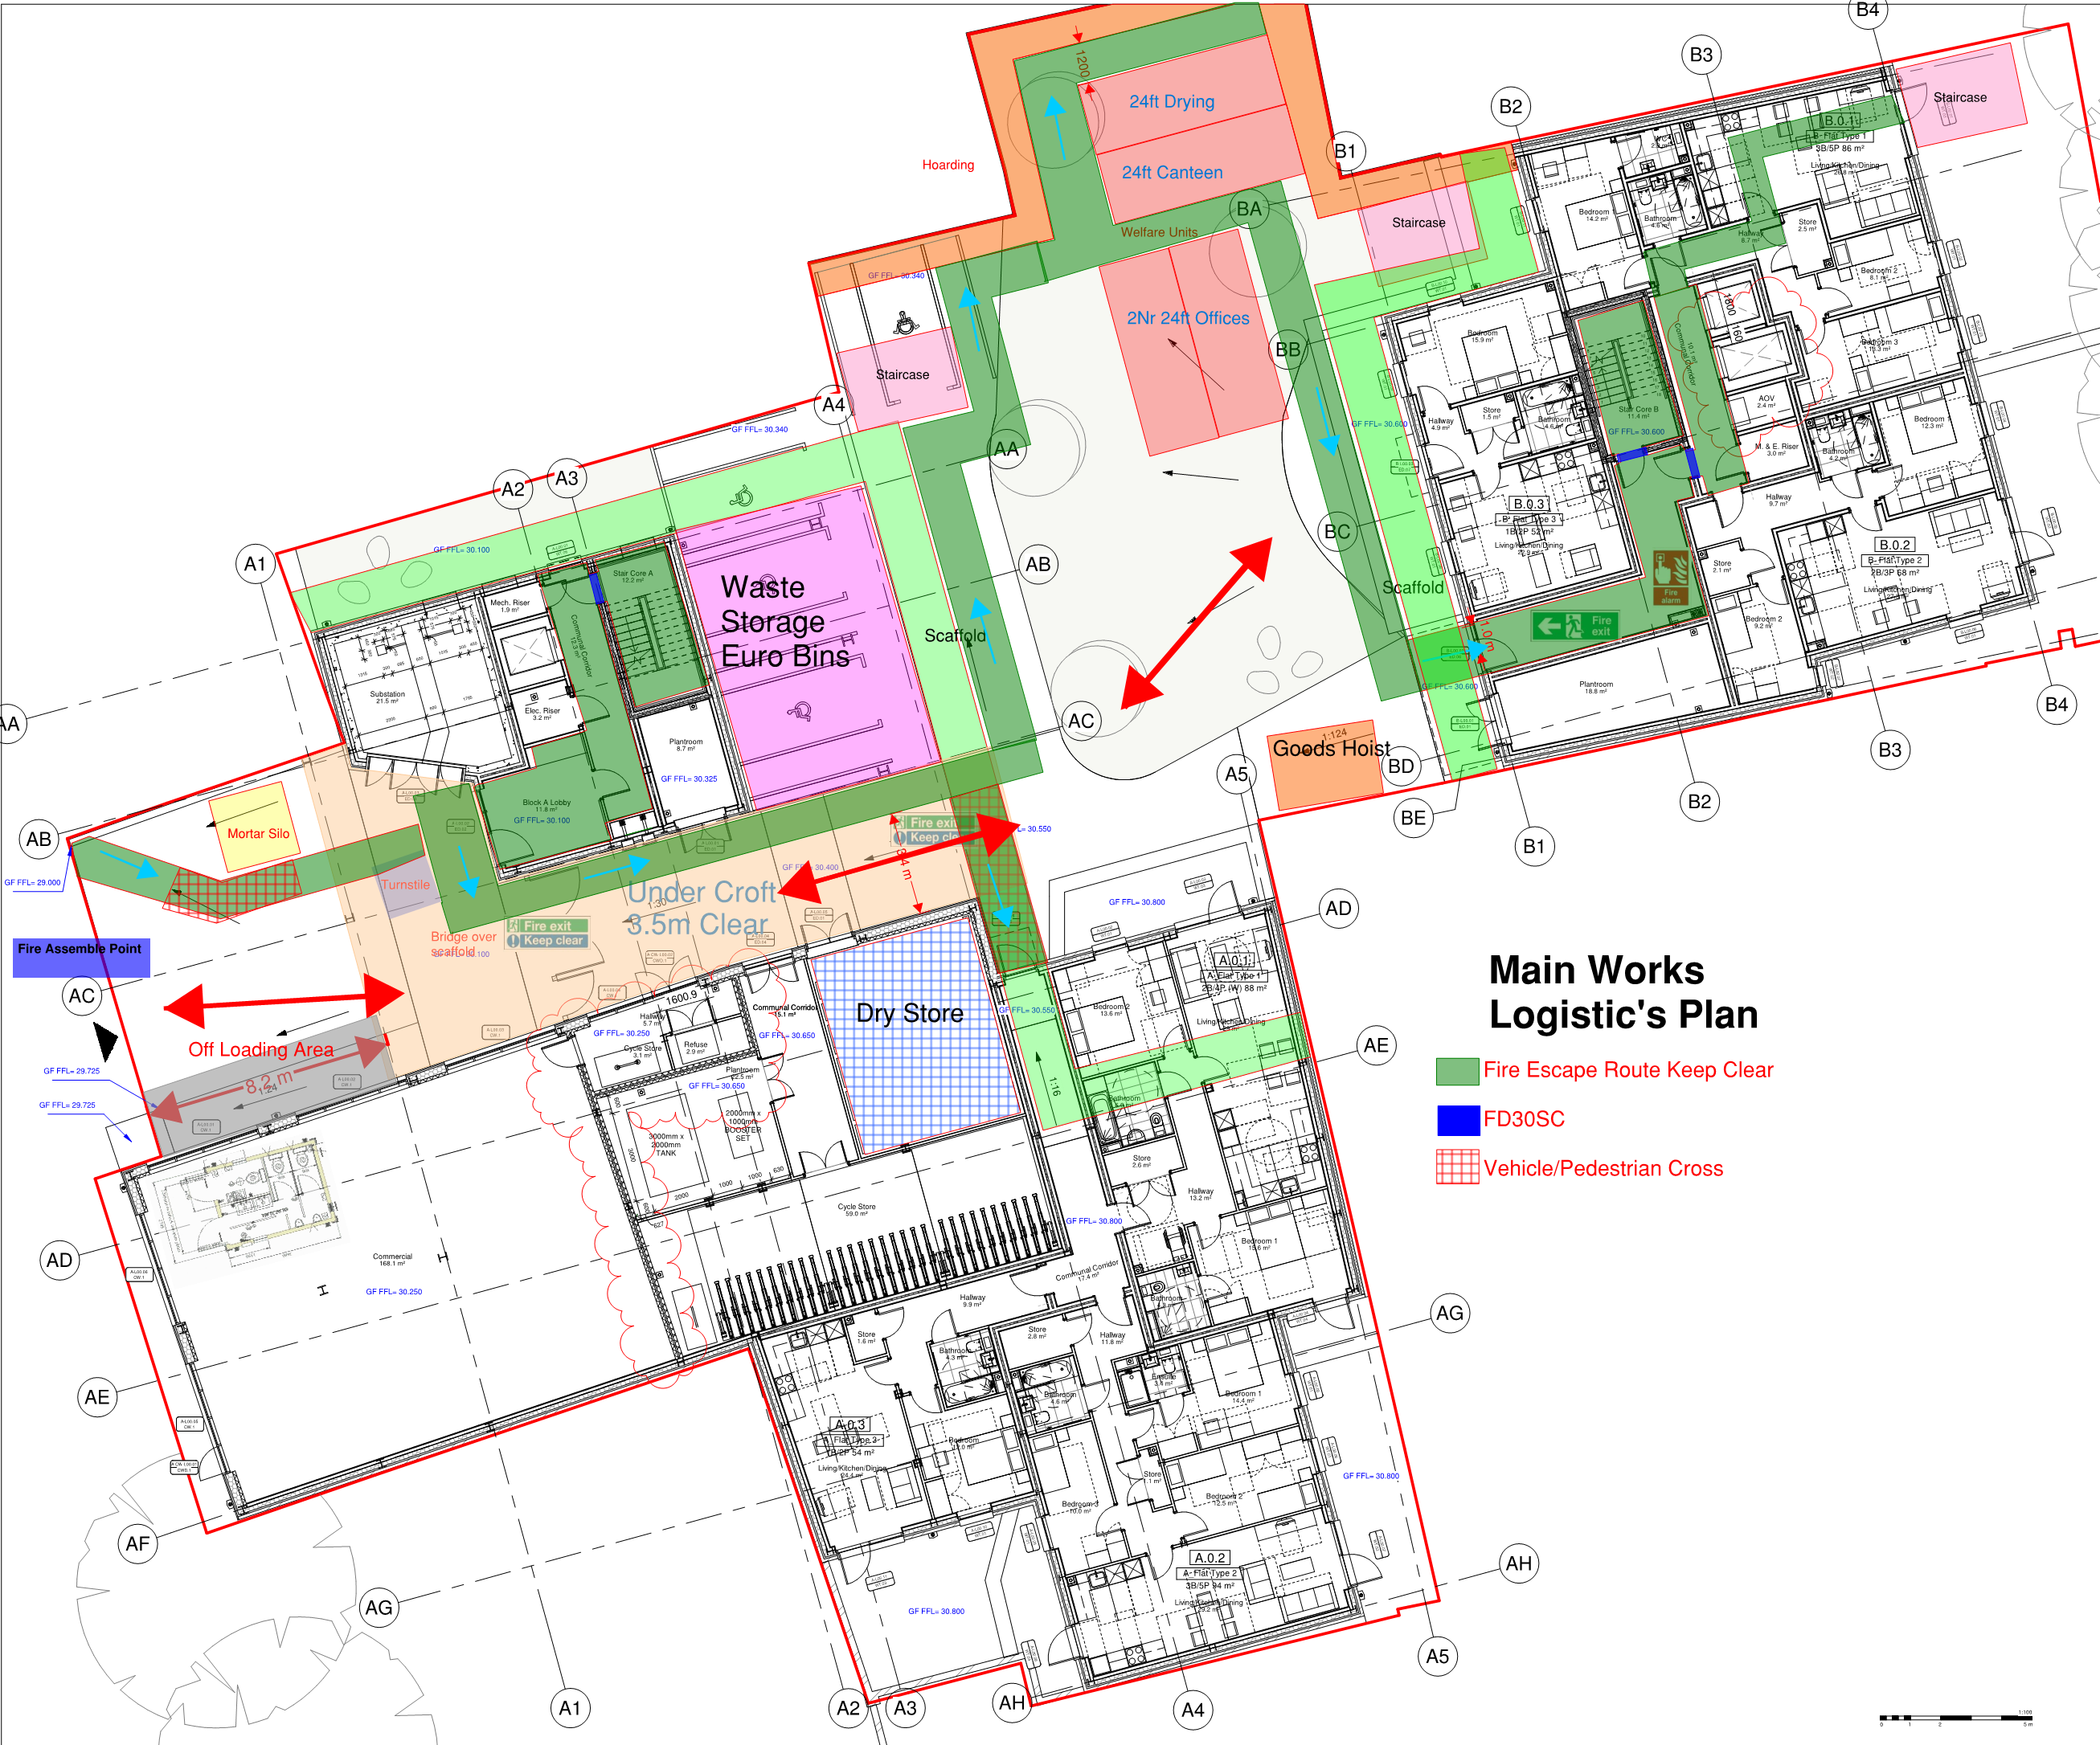

Articulated lorry deliveries will not be allowed due to the restricted access into Cross Lane.
All vehicles will be banked from the High Street and on to site via a CPCS trained traffic marshal.
All delivery vehicles will notify the traffic marshal when approaching Hornsey High Street.
Site access gates to be kept shut during working hours and lock outside working hours.
All delivery will be planned

5 STRATEGIES TO REDUCE IMPACTS
Medium Impact Site Planned Measures Checklist | Committed | Proposed | Considered
Measures influencing construction vehicles and deliveries
Safety and environmental standards and programmes | X
Adherence to designated routes | X
Delivery scheduling | X
Re-timing for out of peak deliveries |  | X
Re-timing for out of hours deliveries |  | X
Use of holding areas and vehicle call off areas
Use of logistics and consolidation centres
Vehicle choice |  | X
Measures to encourage sustainable freight
Freight by water*
Freight by rail* | X
Material procurement measures
DfMA and offsite manufacture |  | X
Re-use of material on site |  | X
Smart procurement
Other measures
Collaboration with other sites in the area | X
Implement a staff travel plan | X

5.1.1. Measures influencing construction vehicles and deliveries
It is anticipated that large delivery vehicles will generally not used due to the narrow access into Cross Lane from the Hornsey High Street. This will mean an increase in vehicle movement during various phases of construction which will be managed appropriately to avoid excessive impact on the local highway network.
It is proposed that all construction deliveries will take place in or directly inside the hoarding and thus avoiding crossing any public means of access/thoroughfare.
Two CPCS A73 traffic marshals will be used to bank vehicles from the High Street onto the High Street slip road adjacent to The Great Northern PH where the delivery vehicle will be reversed down Cross Lane into the Site.
The footpath will be closed in front of the site. This is being applied for directly to highways department. There’s a S278 agreement for complete replacement of footpath in front of site on completion of the works. Inspection record of highways and adjacent footpaths prior to construction & demolition commencing. Any damage caused by the works will be immediately made safe and rectified asap to agreement with the highways officer.
Prior to any construction activity taking place, the area of hardstanding and on-site access road will be improved to provide a clean area for loading away for any public interface.
It is anticipated that construction vehicles will only enter the site in the demolition stage and for this they will use the existing ramp to the south side. As the basement is complete all vehicles will pull parallel to the site (suspended parking bays) and be off loaded by crane and hoist directly into the site.
As part of our sub-contacting process all contractors are required to be silver members of the FORS (Fleet Operator Recognition Scheme) and thus the minimum standard required to meet the vehicle and driver standards of Construction Logistics and Community Safety (CLOCS). All ARJ Sites are required to meet the standards set down in these in the above-mentioned schemes.
All construction deliveries will be booked in and undertaken in a timely fashion to ensure only one delivery vehicle arrives at the site at any given time, which will be managed accordingly by the appointed Construction Manager. A just in time delivery system will help to minimise vehicle queuing / waiting / idling, and is a more sustainable form of delivery/collection than placing on an ad-hoc basis.
All vehicle movements and loading/unloading activity will take place under the supervision of traffic marshals.
Please see Appendix H Swept Path analysis for large vehicles entering and exiting the site.
5.1.2. MEASURES TO ENCOURAGE SUSTAINABLE FREIGHT
The scheme is committed to freight by rail as per your use of the Cranford Industrial Estate site.
Ready mix concrete will be batched from London Concrete, Cranford industrial Estate
River freight is not available in the area.

5.1.3. MATERIAL PROCUREMENT MEASURES
Segregated skips will be located within the waste/skip compound (in the main compound and the site workface. Waste will not be left to build up in the working areas. Waste shall be removed by a licensed contractor with the consignment and transfer notes held on site for inspection.
Waste will be segregated on site and will have separate waste skips for the different waste streams. We are committed to reducing waste through elimination, reductions, reuse and recycling and will produce a Site Waste Management Plan (SWMP), complete will full details of disposal methods and routes.
Waste from the piling and groundworks will be segregated as will be loaded directly into waste removal vehicles.
ARJ will only use licensed waste removal specialists with waste transfer notes issued and consignment notes particularly for the tarmac.
The generation of construction waste will, as the priority, be avoided. Any packaging used for transporting construction materials will be send back with the delivery vehicle wherever practicable. If waste is generated on site, it will be sent for reuse and recovery in preference to disposal.
Contractors will also be required to ensure that:
- Waste material is safely packed when being transferred
- Waste is transferred to the right person
- The transfer note is completed
- Records are maintained
- Waste generated will be disposed of via a registered waste carrier to a registered site.

In cases of controlled waste, there is an obligation under the Environmental Protection Act 1990 to segregate, protect and store it properly and to write a proper description of the waste. The contractor will be required to provide such details and to ensure such waste is transferred to the right person by undertaking the required checks and maintaining appropriate records. Waste will be disposed of via a registered carrier to a licensed disposal site.
Waste for final disposal will be transported via a licensed waste carrier to local sites which operate in accordance with the appropriate Waste Management licences issued by the EA. Under the Duty of Care Regulations, the receiving site must be authorised to accept the type and quantity of waste generated. Transport of wastes will be minimised by the selection of local licensed sites where available (or applicable in the case of contaminated soils or hazardous wastes). No disposal of waste by open burning will be permitted on site.
All relevant contractors will be required to investigate opportunities to minimise and reduce waste generation, such as:
Agreements with material suppliers to reduce the amount of packaging or to participate in a packaging take back scheme
- Implementation of a “just in time” material delivery system to avoid materials being stockpiled, which increases the risk of their damage and disposal as waste. All deliveries will be coordinated by our logistics manager who will book suitable delivery times using our online booking system - refer to 5.4 for more information.
- Attention to material quantity requirements to avoid over ordering and generation of waste materials.
- Segregation of waste at source where practical
- Re-use of materials on site where feasible.
- Re-use and recycling of materials off site where reuse on site is not practical.
- All hazardous materials including chemicals, cleaning agents, solvents and solvent containing products will be properly sealed in containers at the end of each day, prior to storage in an appropriately protected and bunded storage areas; and
- If not already, waste will be sorted into different waste types such as timber, copper, metal, paints, plasterboard, etc, and either disposed of into larger skips, or if suitable, placed into a compactor to reduce the volume of waste before it is taken off site.

6 ESTIMATED VEHICLE MOVEMENTS
The charts in this section are to be made using the construction logistics planning tool contained in the CLP Guidance. The following are example outputs from the spreadsheet of a construction programme. If your CLP is about an infrastructure programme, your outputs will have different stages.
ESTIMATED CONSTRUCTION VEHICLES – MONTHLY AND DAILY
 | NO. OF VEHICLES IN PEAK PHASE (EX. OTHER PHASES)
 | Construction phase |  |  |  |  |  |  |  |  |  |  |  |  |  | Period of stage |  |  |  |  |  |  |  | No. of  trips (monthly) |  |  |  |  |  | Peak no. of trips (daily)
 | Site setup and demolition |  |  |  |  |  |  |  |  |  |  |  |  |  | Q4 2022 - Q4 2022 |  |  |  |  |  |  |  | 10 |  |  |  |  |  | 0
 | Basement excavation and piling |  |  |  |  |  |  |  |  |  |  |  |  |  | Q4 2022 - Q4 2022 |  |  |  |  |  |  |  | 44 |  |  |  |  |  | 2
 | Sub-structure |  |  |  |  |  |  |  |  |  |  |  |  |  | Q4 2022 - Q1 2023 |  |  |  |  |  |  |  | 44 |  |  |  |  |  | 2
 | Super-structure |  |  |  |  |  |  |  |  |  |  |  |  |  | Q1 2023 - Q2 2023 |  |  |  |  |  |  |  | 66 |  |  |  |  |  | 3
 | Cladding |  |  |  |  |  |  |  |  |  |  |  |  |  | Q1 2023 - Q3 2023 |  |  |  |  |  |  |  | 55 |  |  |  |  |  | 3
 | Fit-out, testing and commissioning |  |  |  |  |  |  |  |  |  |  |  |  |  | Q2 2023 - Q4 2023 |  |  |  |  |  |  |  | 66 |  |  |  |  |  | 3
 | Peak period of construction |  |  |  |  |  |  |  |  |  |  |  |  |  | Q2 2023 - Q2 2023 |  |  |  |  |  |  |  | 165 |  |  |  |  |  | 8

ESTIMATED CONSTRUCTION VEHICLES – MONTHLY AND DAILY

NUMBER AND VEHICLE TYPE BY PHASE OF CONSTRUCTION

HOURLY ARRIVAL PROFILE OF VEHICLES DURING PEAK

7 IMPLEMENTING, MONITORING AND UPDATING
This outline CPL cannot include a detailed and defined description of how the CLP will be implemented, monitored and updated. However, the following strategy can be confirmed at this stage.
CLP to be reviewed every to month with Haringey Highways Department. ARJ are committed to participate in the Wood Green CLP forum.
An appointed construction site manager will be appointed to over see and implement the detailed CLP on behalf of the contractor.
Number of vehicle movements to site; collected through a delivery booking-in system
    - Total
    - By vehicle type/size/age
    - Time spent on site
    - Consolidation centre utilisation
    - Delivery/collection accuracy compared to schedule
Safety
    - Logistics-related accidents
    - Record of associated fatalities and serious injuries
    - Ways staff are travelling to site
    - Vehicles and operations not meeting safety requirements
    - Description of the contractor’s handbook
    - Description of the driver’s handbook
    - The data collected will be reported back to Sander and Sons with full transparency to local government.
The data collected will be reported back to ARJ Construction Ltd with full transparency to local government.

