Supporting Statement

The 7th August 2019 was the 150th anniversary of the opening of Finsbury Park, which was originally designed and laid out by Alexander McKenzie and opened in 1869. Finsbury Park has since undergone many changes. Since the creation of the park in the 1800’s records show that the park’s nursery was used to grow plants for the use in the park. Earliest records show a £100 pounds budget was provided for the plants in the park. In 1871 a propagation house was built for plant production, as laid out in this plan below. In 1872 water was laid on for the hot-houses and a potting shed was erected. By 1874 up to 30,000 plants were being propagated annually in the Greenhouses within the park. 25,000 of these were used in Finsbury Park and 5,000 were sent to other parts of the borough.

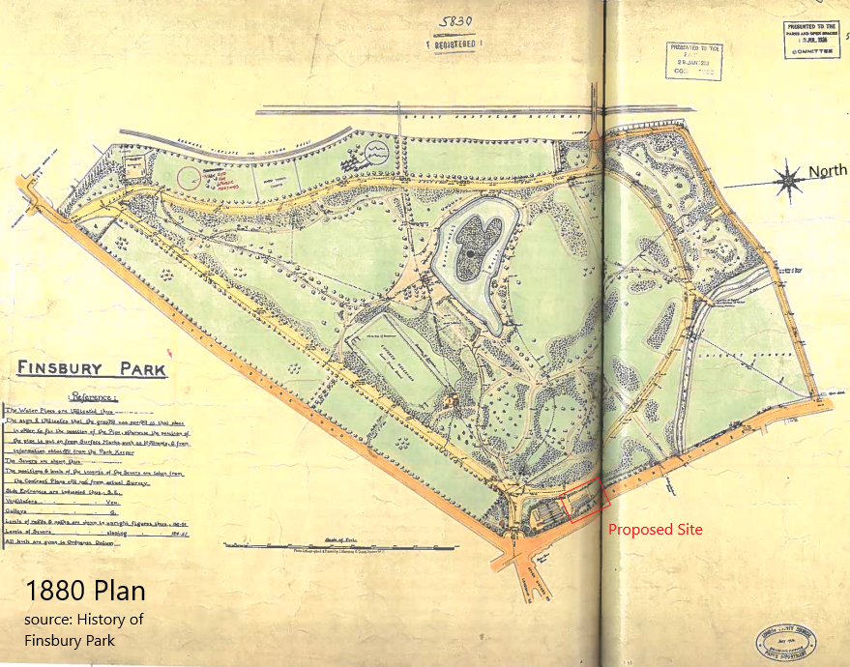

In delivering this project and installing a new polytunnel into the nursery site it will enable Haringey’s parks and greenspaces to become more self-sustainable and grow plants throughout the year, increasing in-house production to provide more plants for Finsbury Park and the other parks and greenspaces in borough, recommitting to the original designs.

This project ties into emerging Parks and Greenspaces Strategy, strategic aim ‘Climate change and sustainability’. The aim is to produce a sustainable supply of clime-friendly plants for our park’s & housing’s schemes across Haringey sites. By growing plants locally, we are also
reducing the risks of importing plants and invasive species.
The parks service aims ‘to work towards making the management of Haringey’s parks net zero carbon by 2041, by reducing or eliminating carbon generation from buildings, plant, vehicles and machinery and the overall delivery of the Parks Service’ in addition ‘to use funding for parks to maintain assets to a good standard’.

The Site forms part of the wider plant nursery in Finsbury Park, Haringey. It comprises a large area of recently cleared bare ground. The Site is in constant use; plants are cultivated for planting within Finsbury Park as well as for other sites in Haringey. Development proposals: The creation of one new polytunnel to be erected in the footprint of a previously cleared polytunnel, along with associated minor landscaping works.

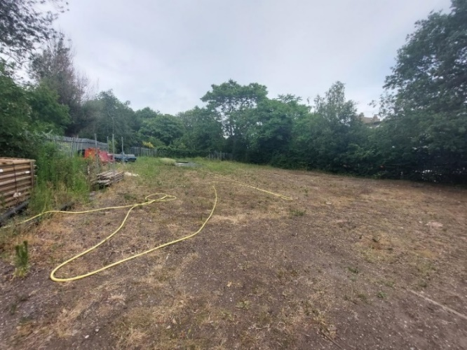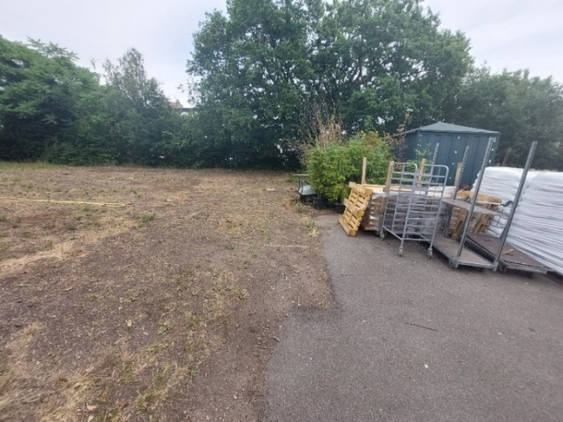
Proposed site for the Polytunnels, and current surface

The nursery sits within Finsbury Park, with a fence and tree perimeter. Access to the nursery is for landscape/ garden teams only, which comprises of two employees. The site is not open to the public and the existing access/ traffic arrangement will remain the same.

Through the years the use of the land has changed slightly between established greenhouses and the current surface, shown below on google map there was at some time a polytunnel in this area. Reinstalling a permanent polytunnel to the Northern end of the nursery site will be returning the site to it’s original plans and whilst improving the sustainability of the landscaping parks team.

