17a Topsfield Parade N8 8PP
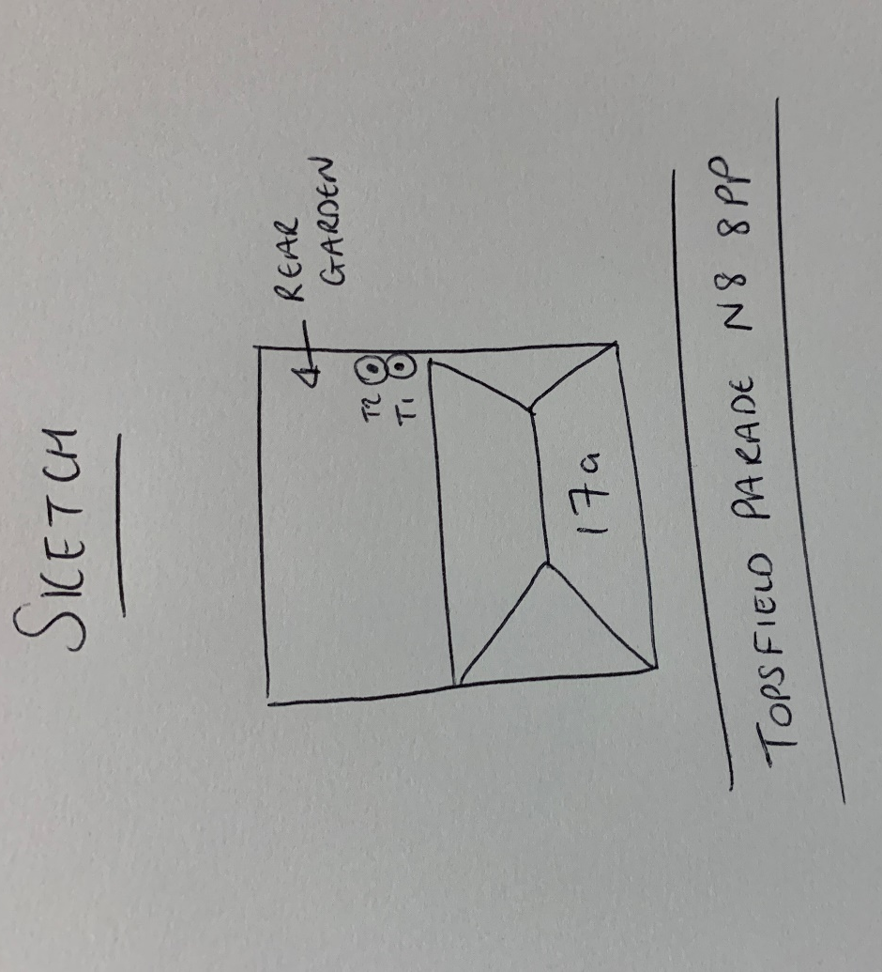
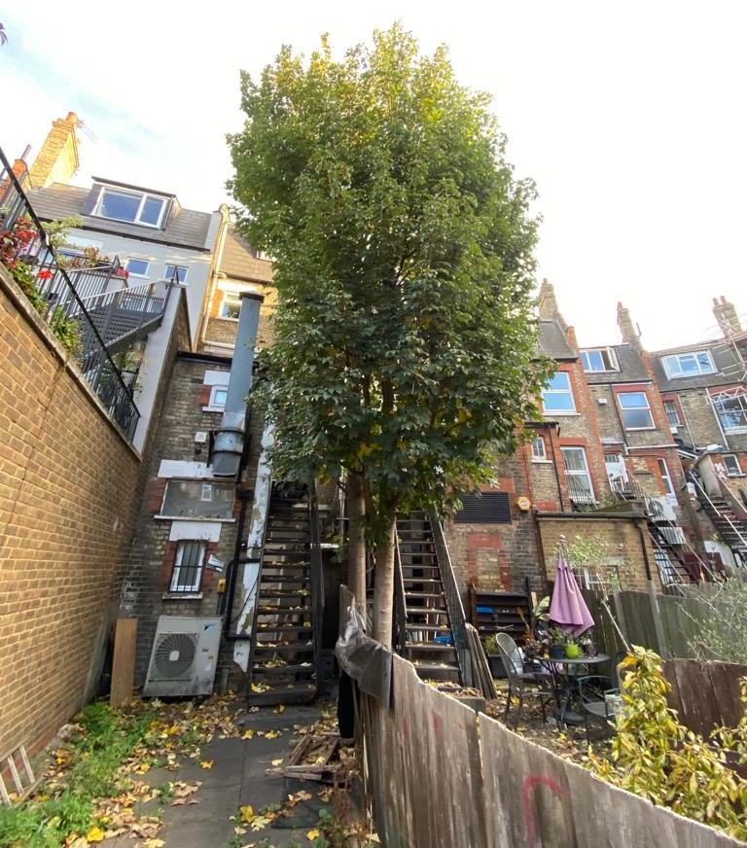
T1: Sycamore (14m): Re-pollard to previous points removing 2-3m of re-growth and shape to keep tree at a size suitable for its location and as part of regular maintenance
T2: Sycamore (14m): Re-pollard to previous points removing 2-3m of re-growth and shape to keep tree at a size suitable for its location and as part of regular maintenance

