2 St Regis Close N10 2DE
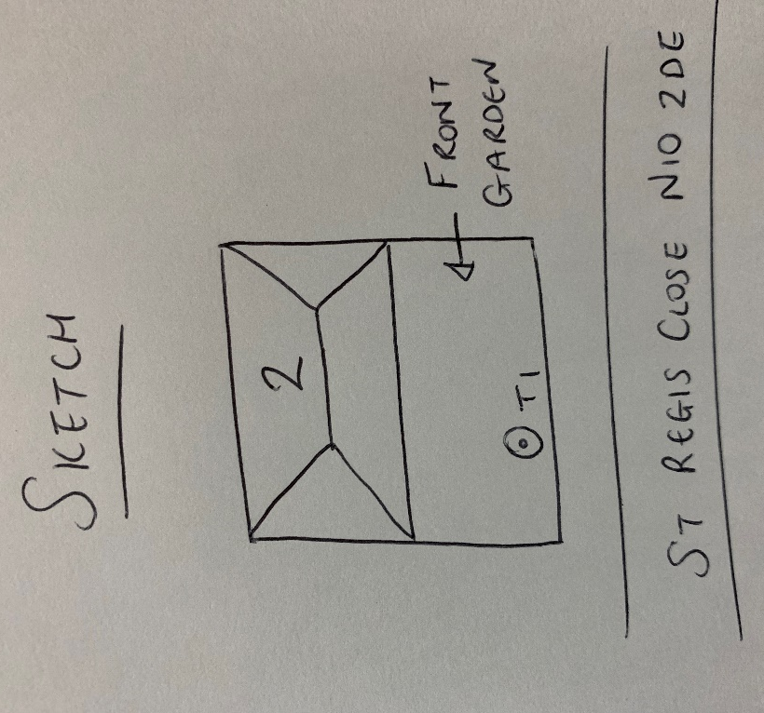
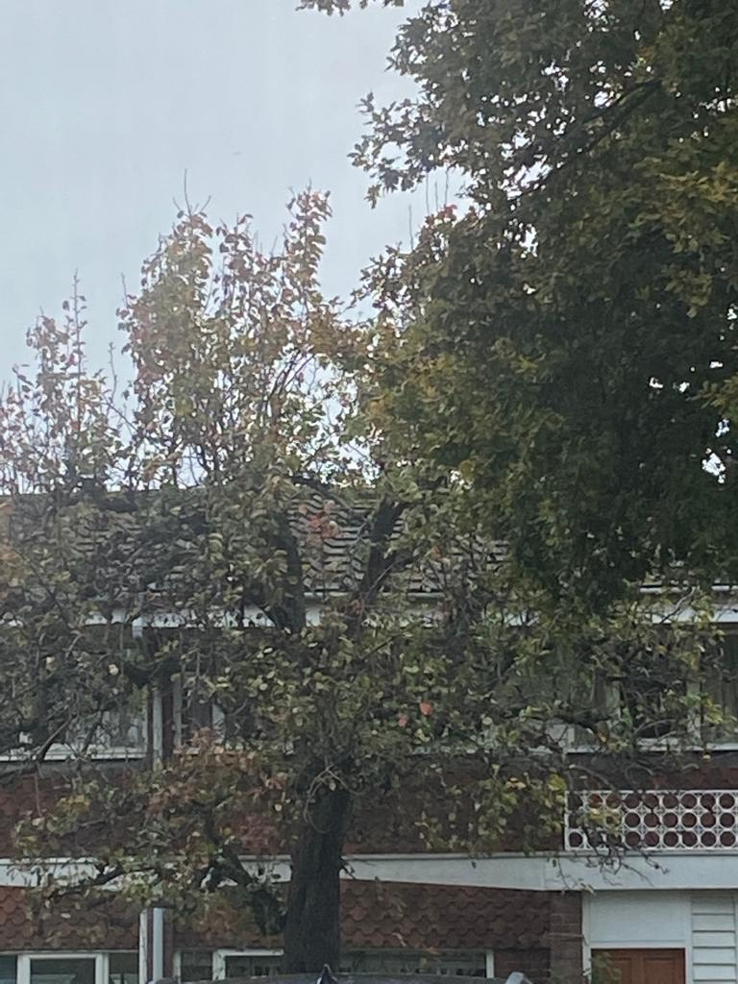
T1: Pear (6m): Crown reduce by 1m to previous points to keep tee at size suitable for its location

