20 Cromwell Avenue N6 5HL
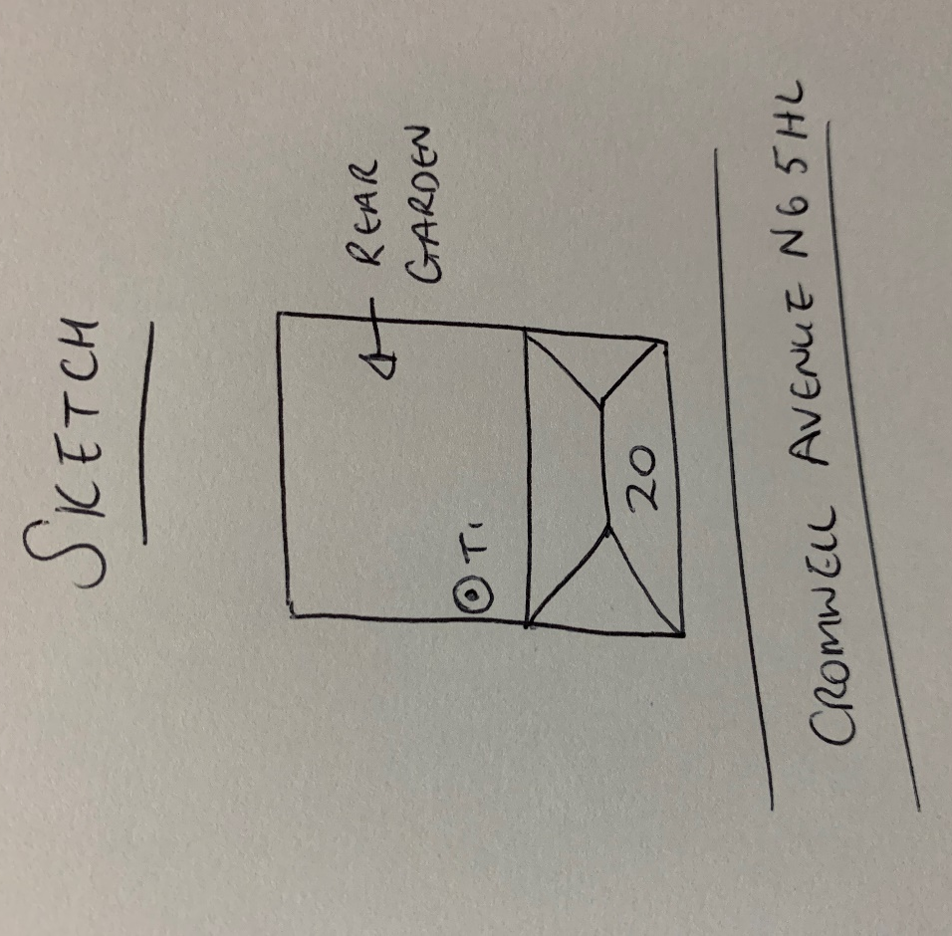
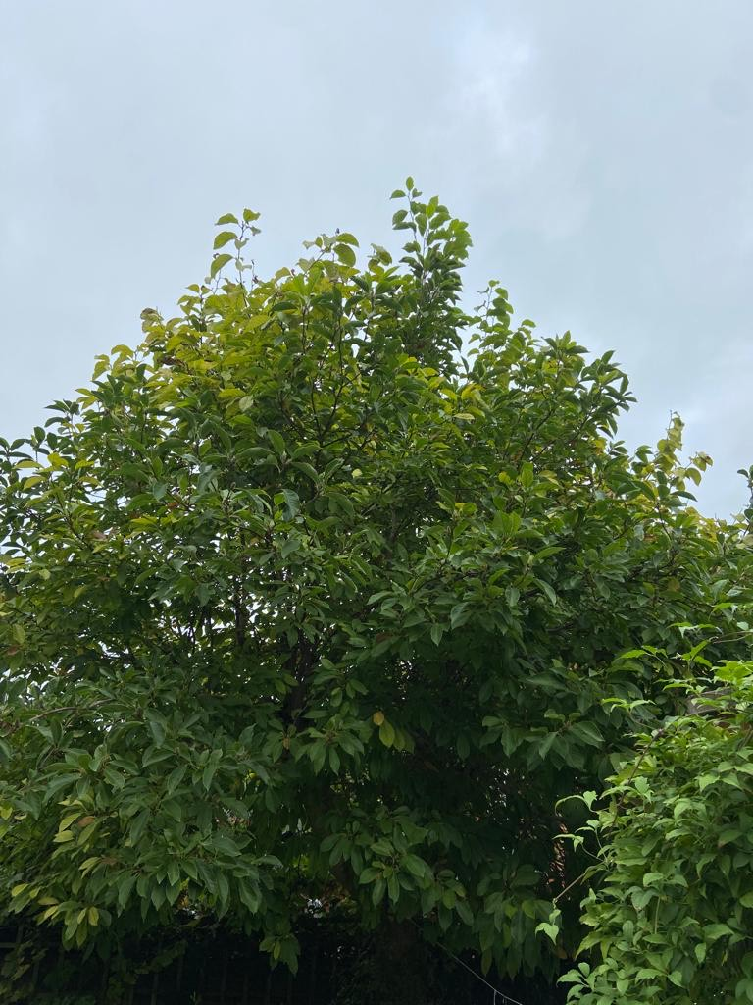
T1: Magnolia (6m): Reduce height by 2.5m and shape to keep tree at a size suitable for its location and as part of regular maintenance

