Main Drive, Cascade Avenue N10 3PS
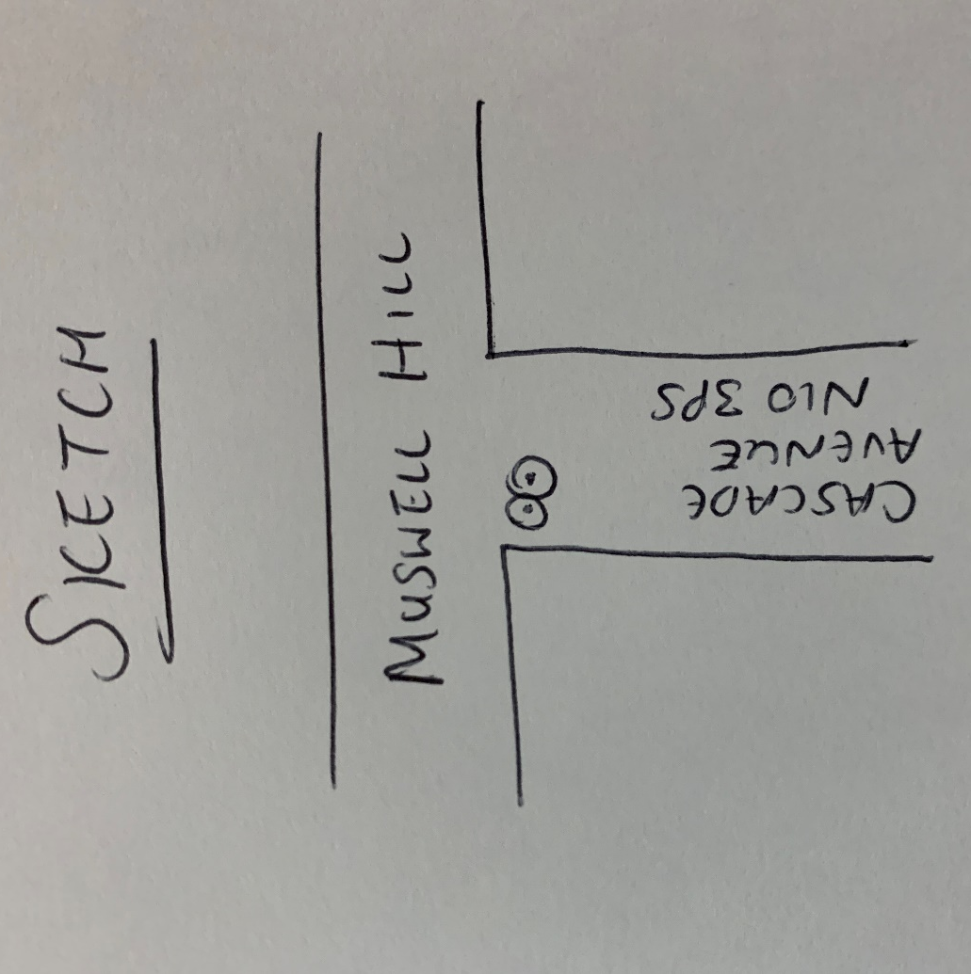
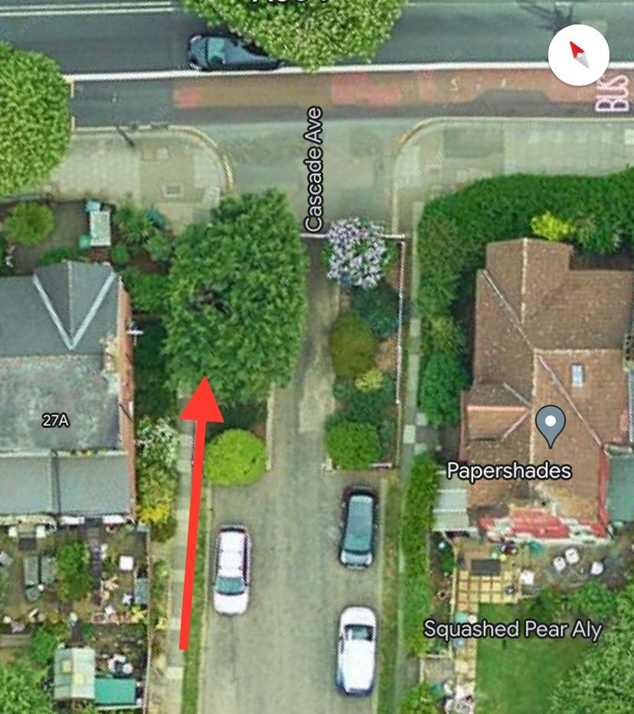
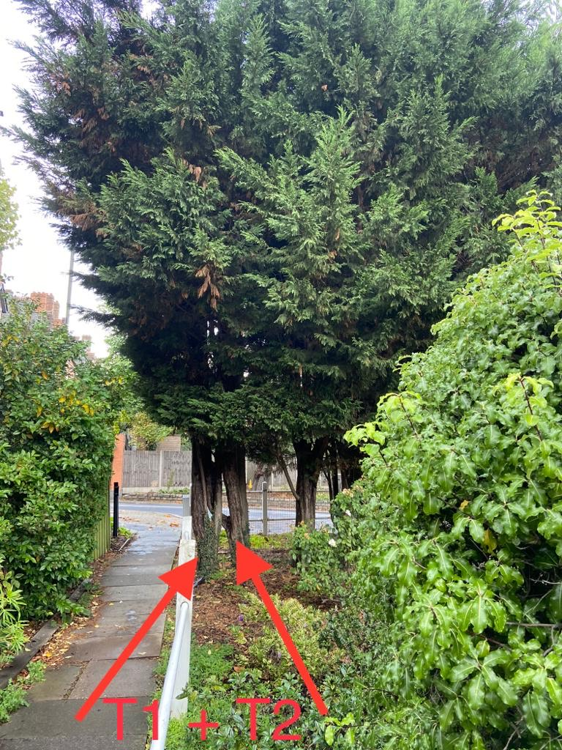
T1: Leylandii (6m): Fell to prevent encroachment onto footpath and to let more light into the area
T2: Leylandii (6m): Fell to prevent encroachment onto footpath and to let more light into the area

