123 Roseberry Road N10 2LD
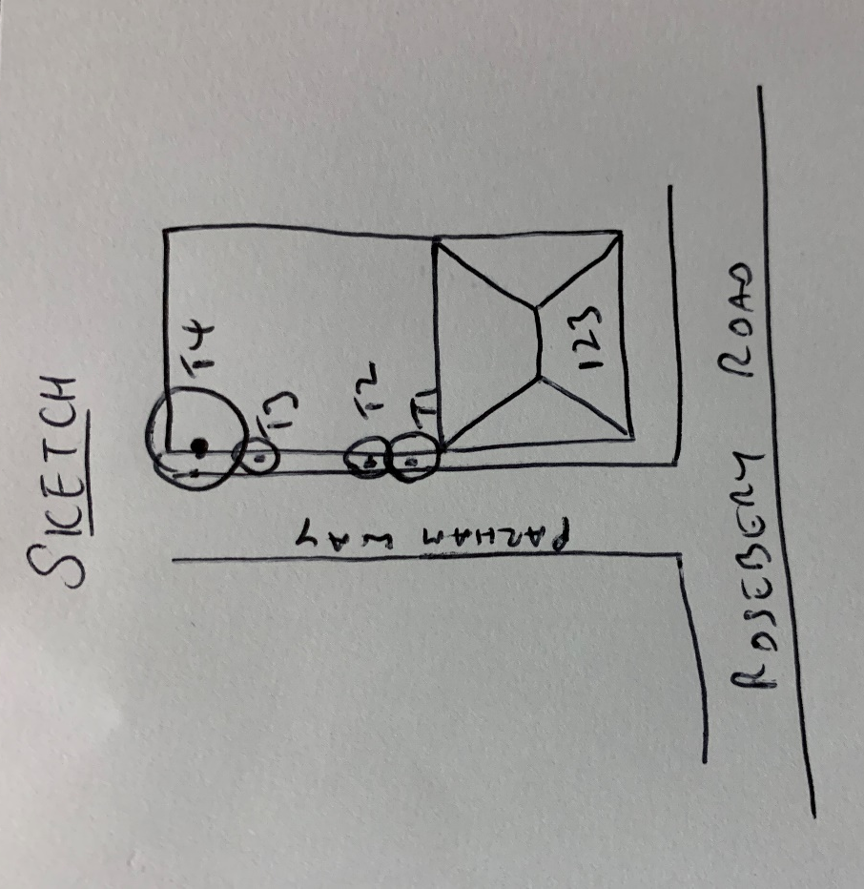

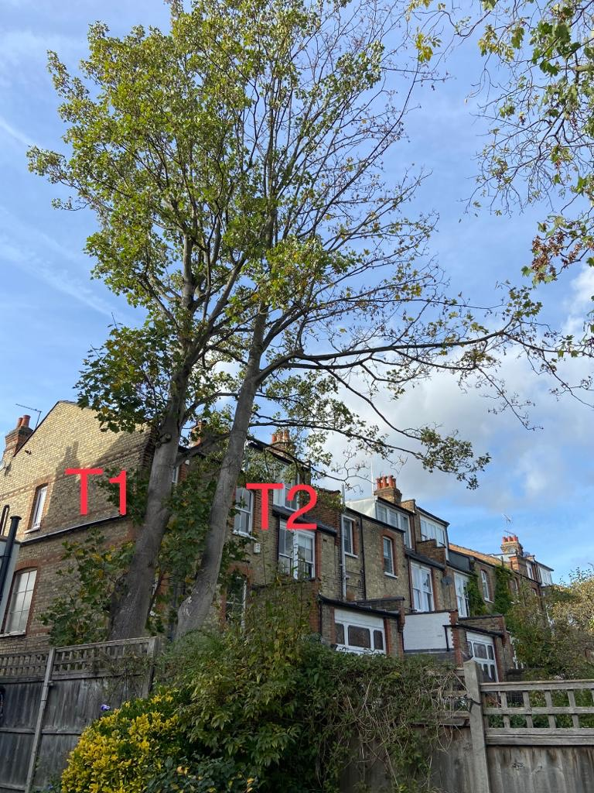

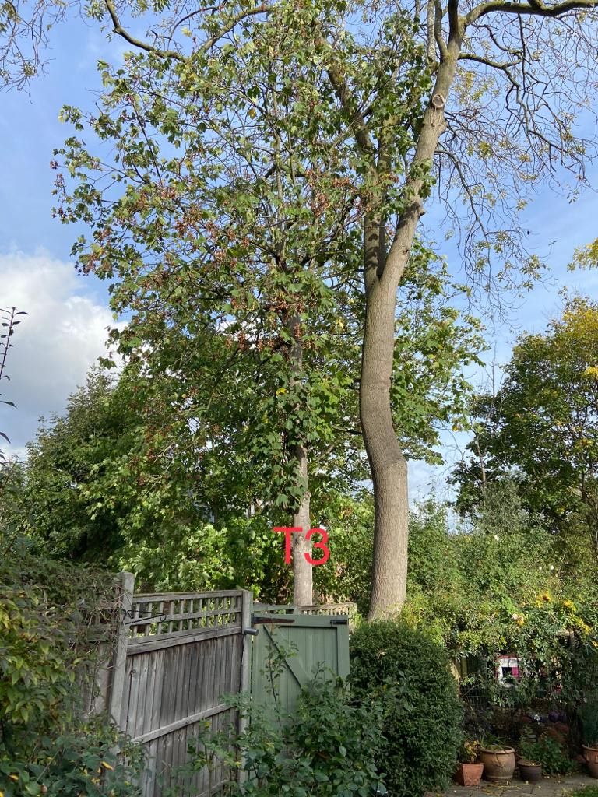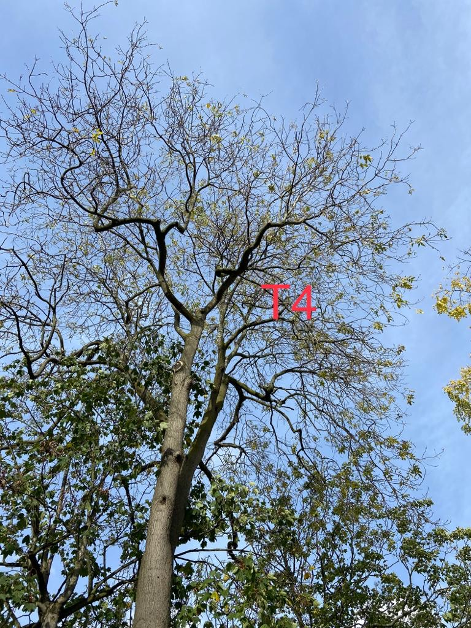

T1: Sycamore (14m): Crown reduce by 2m due to close proximity to building and fence
T2: Sycamore (12m): Fell due to die back
T3: Sycamore (8m): Fell as it is a poor specimen
T4: Ash (20m): Fell due to die back

