Mallinson Centre, Highgate School, Bishopswood Road N6 4NY
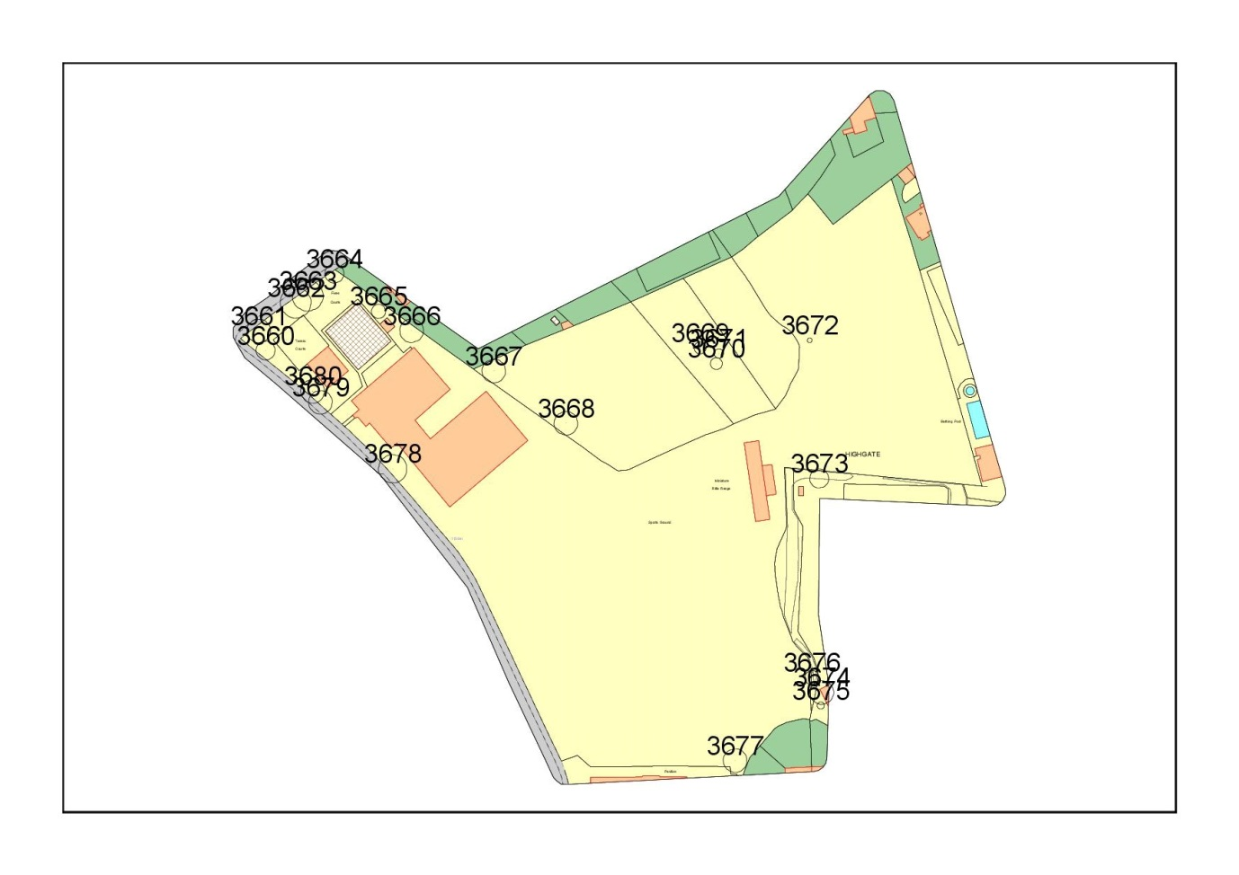
Tree ID | Common Name | Height (m) | DBH (mm) | Crown spread (m) | Age Class | Physiological Condition | Structural Condition | Observations | Recommendation | Priority | Insp Freq
3660 | Common Lime | 20 | 800 | 8 | M | Good | Good | Tall tree with extending limbs. Significant dead wood over road. | Remove significant dead wood. Reduce canopy by 5m to reduce risk of failure | 6 | 12
3661 | Common Lime x 4 | 15 | 600 | 10 | M | Good | Good | Line of 4 lime trees. Long limbs extending over road and parked cars. Dead wood. | Reduce overextending limbs by 2-3m to reduce risk of failure. Remove significant dead wood. | 6 | 12
3662 | Common Lime | 25 | 800 | 13 | M | Good | Good | Tall tree with long extending limbs. | Reduce canopy by 5m to reduce risk of failure. | 6 | 12
3663 | Common Lime | 25 | 600 | 13 | M | Good | Good | Tall tree with long extending limbs. | Reduce canopy by 5m to reduce risk of failure. | 6 | 12
3664 | Common Lime | 25 | 800 | 8 | M | Good | Good | Tall tree next to road. | Reduce canopy by 5m to reduce risk of failure. | 6 | 12
3665 | Sycamore | 9 | 1100 | 6 | OM | Good | Poor | Kretzschmaria fruiting bodies on tension side at base and up stem. Root girdling, dysfunction and decay at base. | Fell. | 6 | 12
3669 | Sycamore | 18 | 300 | 5 | OM | Poor | Fair | 2x dying trees. It is possible that nitrogen leaching from the grass clipping pile up hill is contributing to the significant number of dying trees. | Fell | 6 | 12
3670 | Sycamore | 17 | 500 | 5 | OM | Poor | Fair | Dying tree. | Fell. | 6 | 12
3671 | Sycamore | 18 | 300 | 4 | OM | Poor | Fair | Dying tree. | Fell. | 6 | 12
3672 | Dead tree | 3 | 150 | 2 | D | Dead | Fair | Dead tree. | Fell. | 6 | 12
3675 | Sycamore | 10 | 150 | 3 | M | Good | Fair | Regrowth from stump. | Fell. | 6 | 12
3676 | Common Ash | 18 | 500 | 6 | M | Fair | Good | Significant dead wood throughout canopy. | Remove significant dead wood. | 6 | 12
3679 | Sycamore | 18 | 800 | 10 | M | Good | Good | Extended limb over road. | Reduce extended limb by 3m. | 6 | 12
3680 | Common Lime | 18 | 700 | 10 | M | Good | Good | Dead wood over footpath. | Reduce canopy by 5m to reduce risk of failure. Remove significant dead wood. | 6 | 12

