Highgate Junior School, 3 Bishopswood Road, Highgate N6 4PL
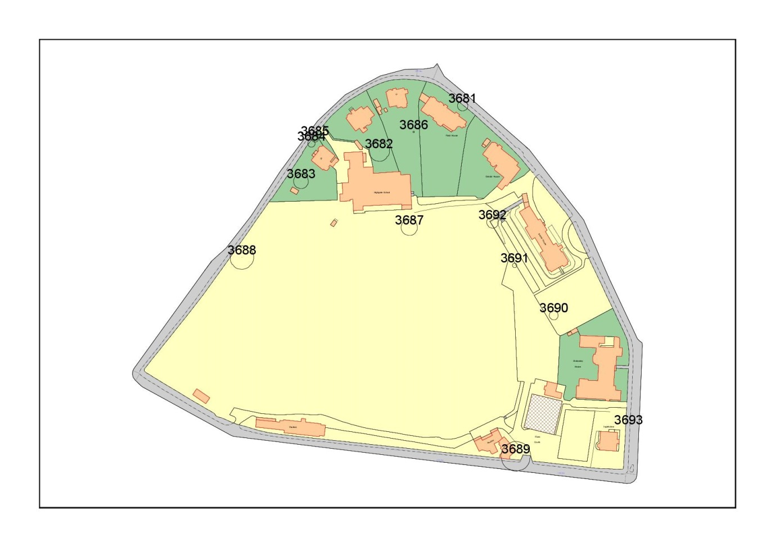
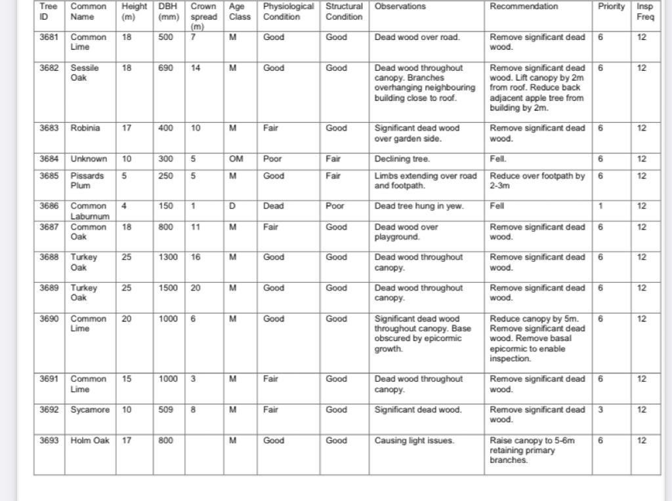
T3682: Sessile Oak (18m)
T3684: Box Elder (10m)
T3685: Pissards Plum (5m)
T3690: Common Lime (20m)
T3693: Holm Oak (17m)

