57 Muswell Avenue N10 2EH
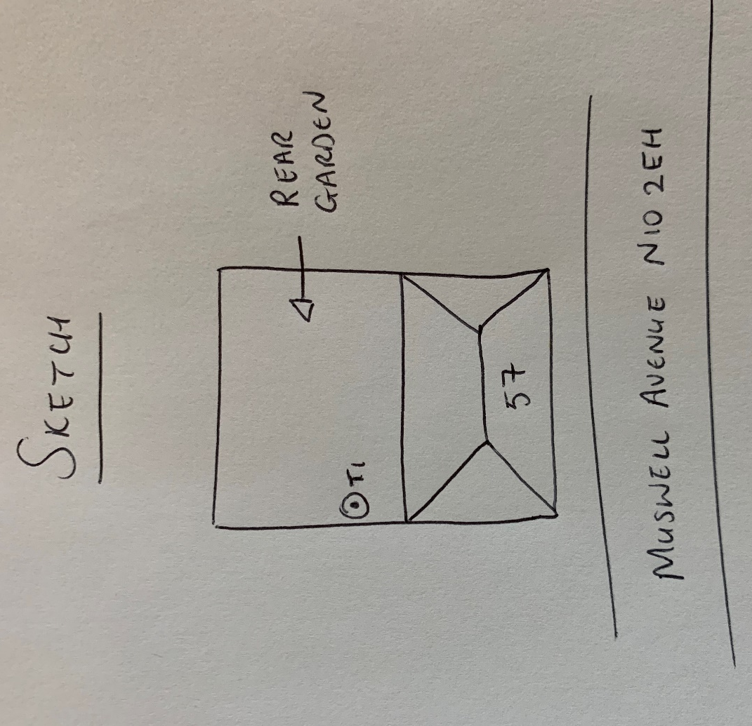
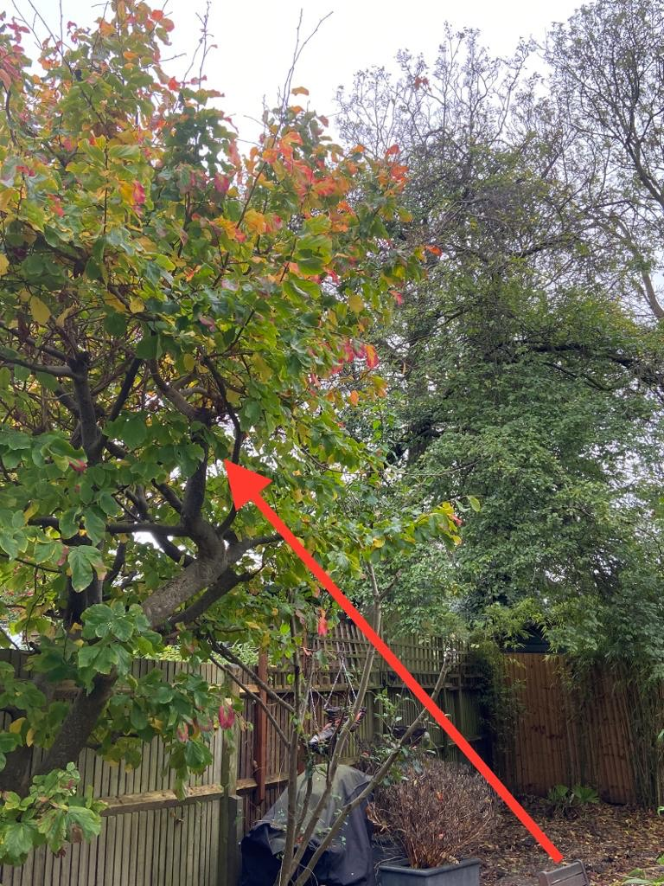
T1: Hazel (5.5m): Crown reduce by 0.5m to keep tree at a size suitable for its location

