55 Muswell Avenue N10 2EH
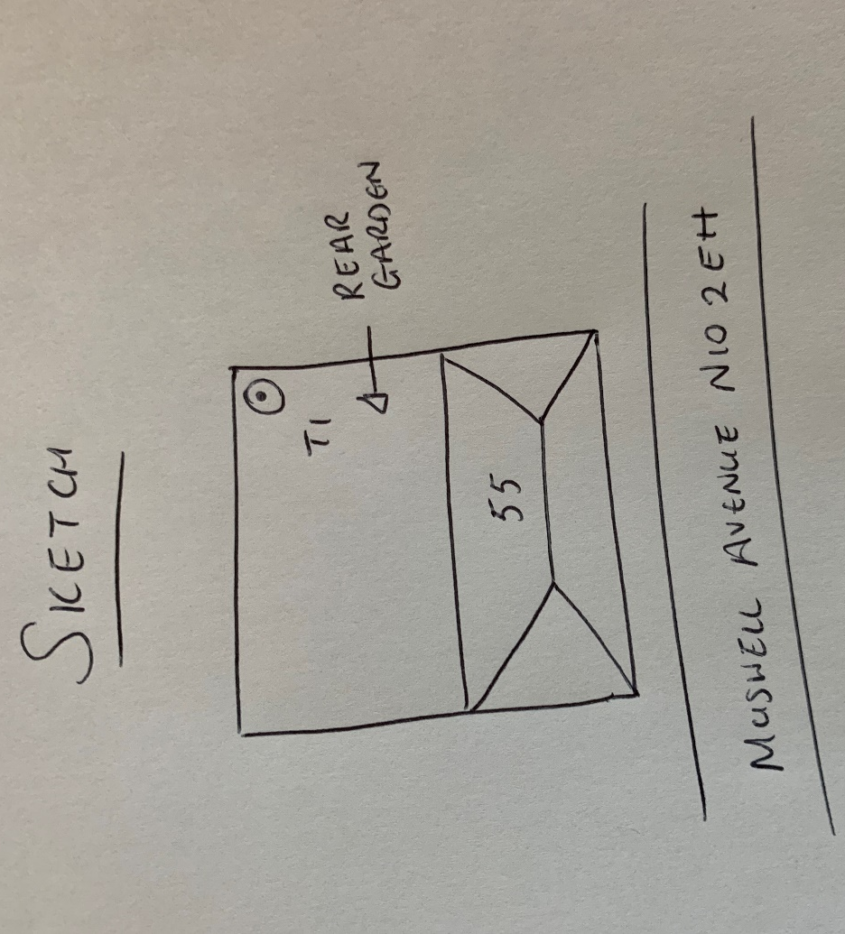
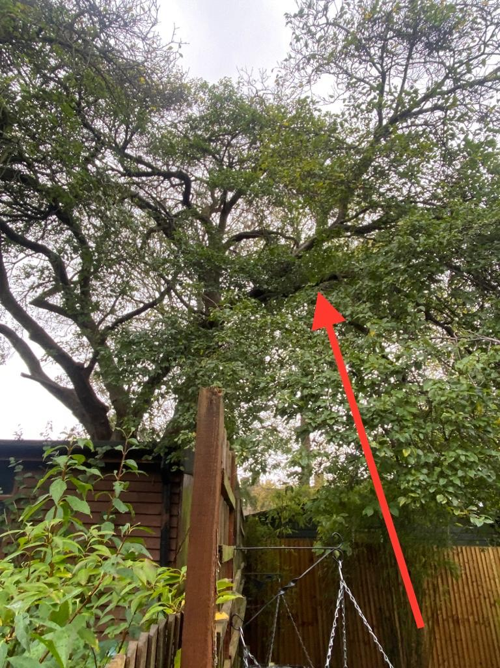
T1: Prunus (10m): Remove large overextending branch into 57 to reduce risk of failure and to allow more light into the garden for plantings

