Garage Area, 36 Barnard Hill N10 2HB

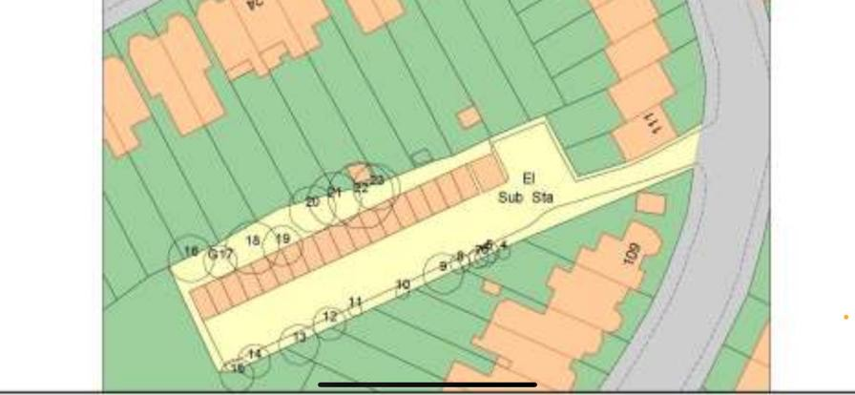

T22: Sycamore (16m): Crown reduce by 2m due to overextending branches over garages
T23: Elder (7m): Fell due to close proximity to garage and to prevent branches snapping over garages roof
G17: Group of self-seeded ash (trunks are up to 150mm in diameter) (9m): Fell due to close proximity to garages and if left to grow unmanaged, there is a future risk of them causing damage to the garages

