


186 Creighton Avenue,
London. N2 9BJ

CIBSE TM59
Overheating Assessment

Revision P01

30 October 2022

CONTENTS

1. INTRODUCTION 3
2. METHODOLOGY 3
2.1 Design parameters 3
2.2 Model images below 5
3. DESIGN ASSESSMENT 5
4. IES REPORTS (APPENDIX) 7

INTRODUCTION

P3R have undertaken a dynamic thermal and natural ventilation simulation of the above property to assess the risk of overheating. The project is a new 5 bed 3 storied dwelling. The building has large percentage of glazing on the south and north façades, which presents a challenge to provide summertime thermal comfort within the dwelling and demonstrate compliance with Approved document Part O with simplified method. This report demonstrates dwelling overheating compliance with dynamic thermal modelling.

Internal comfort within a home will always be a subjective issue, individual to the people using the space. However, as detailed in the Approved Document “Part O”, the Chartered Institute of Building Services Engineers (CIBSE) recommended Technical Memorandum, TM59: Design methodology for the assessment of overheating risk in homes is used as a benchmark.

The thermal model will follow the methodology of CIBSE TM59 whilst employing overheating mitigation measures detailed in Part O.

The dwelling has external blinds and low g-value glazing to limit the solar gain. The windows & rooflight open to provide cross ventilation and night-time purge.

METHODOLOGY

The CIBSE recommends that the simulation is carried out in accordance with the guidance and data sets in CIBSE Technical Memorandum TM59 which defines the limits of thermal comfort for residential buildings. It is a standardised approach to predicting overheating risk for residential building designs for new-build or major refurbishment.

CIBSE TM59 Compliance is based on passing both of the following two criteria:

- For living rooms, kitchens and bedrooms: the number of hours where internal temperature exceeds or equals the external temperature by one degree (K) during the period May to September inclusive shall not be more than 3 per cent.

- For bedrooms only: to guarantee comfort during the sleeping hours the operative temperature in the bedroom from 10 pm to 7 am shall not exceed 26°C for more than 1% of annual hours. (Note: 1% of the annual hours between 22:00 and 07:00 for bedrooms is 32 hours, so 33 or more hours above 26°C will be recorded as a fail).

A dynamic modelling has been undertaken with AD Part O compliant modelling software, to check the project and the natural ventilation strategy to ensure that thermal comfort levels and the elimination of overheating risks were compliant with CIBSE Technical Memorandum 59 (TM59)

TM59 sets the requirements and parameters for occupancy levels and internal gains, and AD Part O sets window opening schedule.

Design parameters

Fabric

Insulation measures will be utilised to ensure the calculated U-values exceed the Building Regulations minima, with specific guidance taken from the design team
- New timber frame wall constructions will be utilized with a target U-Value of 0.14.
- New Roof constructions achieving a U-Value of 0.13 will be targeted.
- The ground floor slabs will be of cast in situ concrete, with target u-value of 0.13.

Glazing

- The new glazing for windows and doors will be double glazed with an area weighted average U-Value of 1.4w/m2K with a g value of 0.4 to minimize the overheating risk.
- The use of internal blinds has been assumed
- External shutter for south and west facing windows.
- All the openable windows are openable to 30 degrees, side/Top hung
- Window opening times as per TM59 guidance

Air Tightness
- The dwelling be tested to 3m3/hr/m2 in line with best practice for new timber framed dwellings.

Internal Gains

- All occupancy & Internal gain as per TM59, in line with Part O guidance.

Weather data

- CIBSE 2020 London DSY1 (moderately warm weather file) in line with Part O guidance.

Model images below

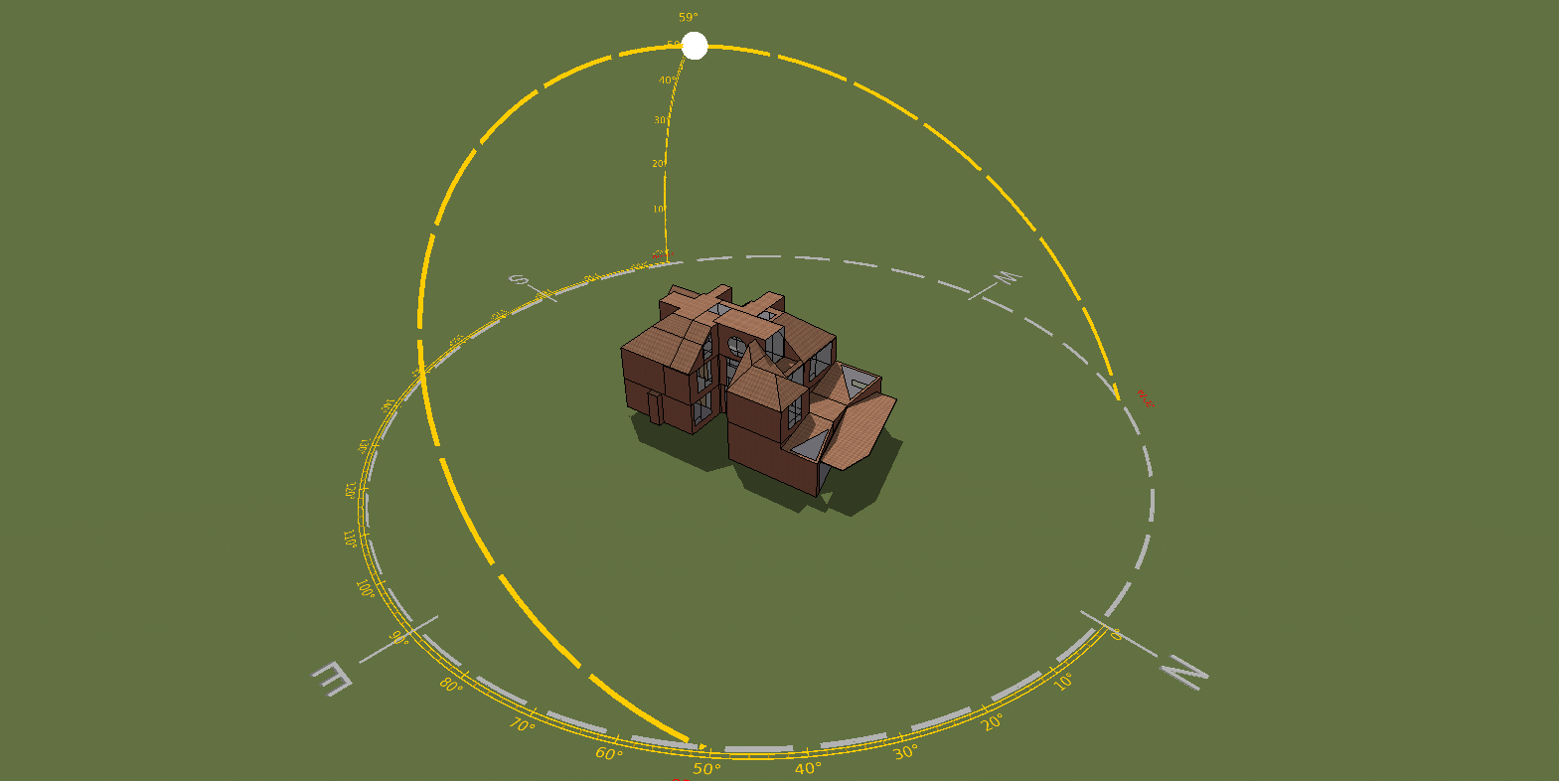
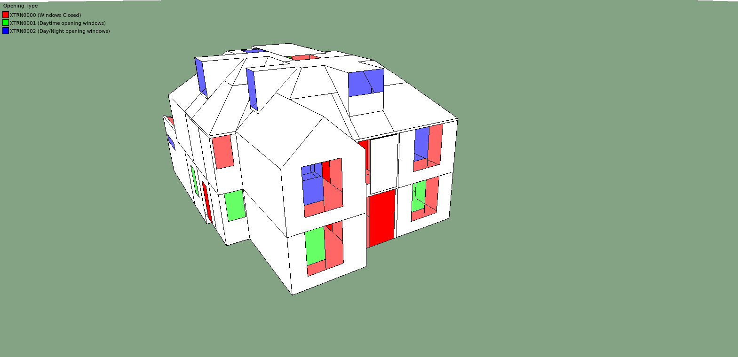 | 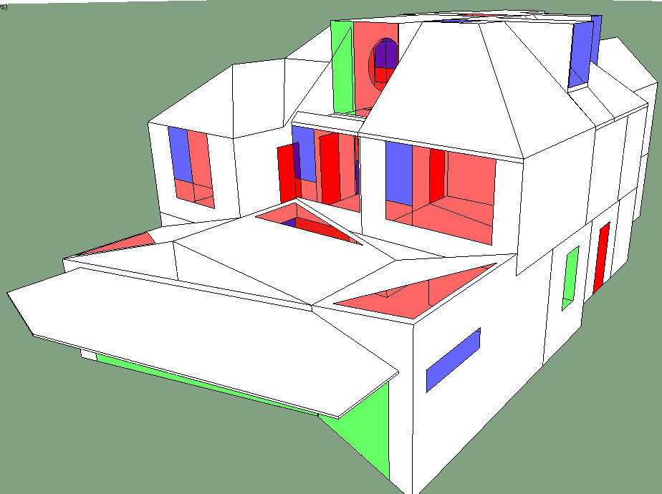
South Elevation | Northwest Elevation

DESIGN ASSESSMENT

Based upon the above-mentioned design criteria a dynamic simulation was run to assess whether the dwelling as designed has an overheating potential when assessed against the appropriate weather data.

The TM52 results are shown in the table below. It is clear that overall, there is no risk of overheating when tested against DSY 1. The dwelling has been assess under DSY 2: the extreme climate change summer of 2050 where couple of rooms fails, but given the 100% pass achieved under DSY1, it is fair to assume that the passive design measures in place have met with the analysis requirements.

However, upon occupation, residents will be provided with a user guide that explains to occupants the key features of the scheme; this should be a short and visual document in simple language. It should cover measures they can take to prevent overheating in their home and include the following information as a minimum:

Blinds that are white or light in colour, offer an increased reflectivity than darker colours. Vertical fin blinds work more effectively to as the offer least restriction to the airflow, which provides an element of free cooling.

During days of peak summer temperatures, occupants will be advised to keep the windows closed when the building is left unoccupied when the external air temperature exceeds that of the internal air temperature – i.e. feels uncomfortably warm, if done in conjunction with closing the blinds the internal air temperature will be kept to a minimum.

Finally, advice will be given on evening purge ventilation; once the external air temperature has reduced, this will subsequently reduce the likeliness of night-time overheating between the hours of 2200 – 0700.

Criteria 1 results

Room Name | Occupied hours | No. hours ΔT ≥ 1⁰K | % Occupied hours ΔT ≥ 1⁰K | Pass/Fail
GF-Reception+Playroom | 1989 | 36 | 1.8 | Pass
GF-Study | 1989 | 32 | 1.6 | Pass
1F-Bedroom-01 | 3672 | 16 | 0.4 | Pass
1F-Bedroom-02 | 3672 | 17 | 0.5 | Pass
1F-Bedroom-04 | 3672 | 40 | 1.1 | Pass
1F-Bedroom-03 | 3672 | 20 | 0.5 | Pass
GF-Kitchen+Living+Dining | 1989 | 45 | 2.3 | Pass
2F-Yoga Room | 1989 | 32 | 1.6 | Pass
2F-Guest Bedroom | 3672 | 32 | 0.9 | Pass

Criterion 2 results

Room Name | No. hours > 26⁰C 22:00-24:00 | No. hours > 26⁰C 00:00-07:00 | Total hours > 26⁰C | Pass/Fail
GF-Reception+Playroom | NA | NA | NA | NA
GF-Study | NA | NA | NA | NA
1F-Bedroom-01 | 20 | 12 | 32 | Pass
1F-Bedroom-02 | 18 | 10 | 28 | Pass
1F-Bedroom-04 | 15 | 5 | 20 | Pass
1F-Bedroom-03 | 18 | 11 | 29 | Pass
GF-Kitchen+Living+Dining | NA | NA | NA | NA
2F-Yoga Room | NA | NA | NA | NA
2F-Guest Bedroom | 13 | 5 | 18 | Pass

Overall Result

Natvent room name | Natvent criterion (a) result | Natvent criterion (b) result | Pass/Fail
GF-Reception+Playroom | Pass | NA | Pass
GF-Study | Pass | NA | Pass
1F-Bedroom-01 | Pass | Pass | Pass
1F-Bedroom-02 | Pass | Pass | Pass
1F-Bedroom-04 | Pass | Pass | Pass
1F-Bedroom-03 | Pass | Pass | Pass
GF-Kitchen+Living+Dining | Pass | NA | Pass
2F-Yoga Room | Pass | NA | Pass
2F-Guest Bedroom | Pass | Pass | Pass

IES REPORTS (APPENDIX)

