SUPPLEMENTARY INFORMATION
- Site Details

Site Name: | Video Court | Site Address: | 2 Mount View Road  London  N4 4SJ
National Grid Reference: | E: 530483 N: 187865 | Site Address: | 2 Mount View Road  London  N4 4SJ
Site Ref Number: | CS 20763026 | Site Type: | Macro

- Pre Application Check List

Site Selection

Was a local planning authority mast register available to check for suitable sites by the operator or the local planning authority? |  | No
If no explain why:

After a phone call to the LPA it was established the council do not hold this information.

Were industry site databases checked for suitable sites by the operator: | Yes
If no explain why:

Site Specific Pre-application consultation with local planning authority

Was there pre-application contact: | Yes
Date of pre-application contact: | 03/11/2022
Name of contact: | The Director of Planning
Summary of outcome/Main issues raised:

Prior to the submission of this application the applicant-initiated pre-consultation discussions with the local planning authority. This provides an opportunity for the LPA to discuss development proposals and identify site specific issues.

Strategic level pre-rollout meetings are held with the LPA to discuss the necessities of the project, benefits and best practice going forward.

Annual area wide information to planning authority

Has annual area wide information been provided? | No
If no explain why: | See below
Summary issues raised:

“Cornerstones commercial relationship with VMo2 has changed, effectively increasing our independence to work with other companies in the deployment of mobile infrastructure. It means we no longer have visibility of VMo2 full update plan. However, Cornerstone is fully committed to working closely with Local Planning Authorities and following best practice guidance.

We aim to engage and work with the planning department at the earliest opportunity from when we are instructed to deliver new infrastructure within your Local Authority area and often conduct strategic pre-rollout engagement meetings to discuss our wider rollout. If your Local Authority would like a meeting to discuss wider Cornerstone rollout plans then please advise. We recognise the importance of developing long term partnerships and will always work with you to deliver improved mobile connectivity.

Community Consultation

Rating of Site under Traffic Light Model: |  | Amber
Outline of consultation carried out:

Prior to the submission of this application the applicant initiate pre-consultation discussions with the local planning authority. This provides an opportunity for the LPA to discuss development proposals and identify site specific issues.

No comments were received in respect to the consultation submitted at the time of submission.

Further consultation with the local Ward Councillors for Stroud Green Ward (Councillors Alexandra Worrell, Eldridge Culverwell and George Dunstall,) and Catherine West MP.

Summary of outcome/main issues raised:

No site-specific responses had been received at the time of submission.

School/College

Location of site in relation to school/college:

St Gildas' Catholic Junior School, St Peter's and St Gildas' Infant & Junior Schools, William Elliott Nursery School and Bowlers Community Nursery Is in relatively close proximity to the site.

Outline of consultation carried out with school/college:

St Gildas' Catholic Junior School, St Peter's and St Gildas' Infant & Junior Schools, William Elliott Nursery School and Bowlers Community Nursery Have been notified prior to submission.

Summary of outcome/main issues raised (include copies of main correspondence):

There has been no response from St Gildas' Catholic Junior School, St Peter's and St Gildas' Infant & Junior Schools, William Elliott Nursery School and Bowlers Community Nursery at the time of submission.

Civil Aviation Authority/Secretary of State for Defence/Aerodrome
Operator consultation

Will the structure be within 3km of an aerodrome or airfield? |  | No
Has the Civil Aviation Authority/Secretary of State for Defence/Aerodrome Operator been notified? |  | No
Details of response:

N/A

Site Provider Letter

Copy of Site Provider Letter enclosed? |  | Yes
Date served: | 18/11/2022

- Proposed Development

The proposed site:
The current roof equipment at Video Court is being upgraded with limited impact but significant new 5G connectivity benefits. The existing site can be seen below in Figures 1 – 3, the site is located off Mount View Road. It is important to note that this is an existing site, thus meaning the LPA have already deemed this an acceptable location to house telecommunications equipment. There are numerous semi-mature trees within the area, which obscure views from street level.

Figure 1:
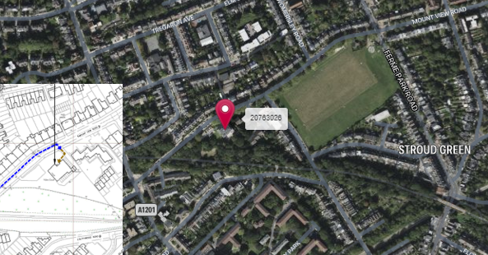

Figure 2:
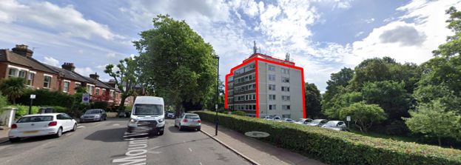

Figure 3:
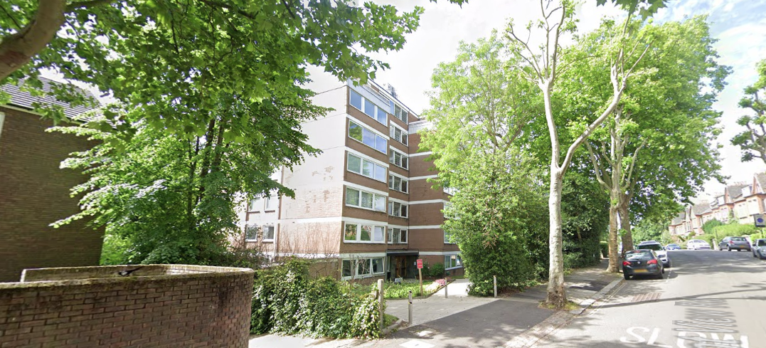

The applicant appreciates that the site is located in a Conservation Area (Article 2 (3) land) however, the alternative to upgrading this site is a new standalone large 5G installation in the immediate area. Upgrading the proposed site is from a sequential site selection process the optimum planning solution. A new mast in the area would be contrary to policy.

Central Government attaches great importance to the design of the built environment and outlines this within Section 12 (para. 126) of the 2021 National Planning Policy Framework. It states:

“Good design is a key aspect of sustainable development, creates better places in which to live and work and helps make development acceptable to communities.”

In keeping with the 2021 National Planning Policy Framework (NPPF). guidelines of using: “high quality communications” (Section 10), the proposed design has been selected to minimise visual impact upon the street scene by integrating with the existing built environment. The design of the proposed equipment is considered to be the least visually intrusive option available. Although it is accepted that there will be an intensification in the amount of equipment it is felt that such a minor increase would not detract from the character of the area in which the proposal sits.

The design of the proposed equipment is considered to be the least visually intrusive option available. Although it is accepted that there will be an intensification in the amount of equipment it is felt that such a minor increase would not detract from the character of the area in which the proposal sits. Any other proposal to satisfy the identified requirement would result in the addition of a separate ground based column elsewhere in close proximity to the existing structure. In our opinion, such a proposal would, in this instance, unnecessarily add to the clutter in the street scene and result in a greater visual impact.

Site Ref: | 20763026 | Site Address: | Video Court, 2 Mount View Road, Haringey, London, N4 4SJ

Local Planning Authority: LB Haringey

Development Plan: Haringey Strategic Policies 2013 (with alterations 2017) /
Haringey Development Management DPD (2017)
Site and its surrounds

Fig.1 – LP Map Extract (reference only)

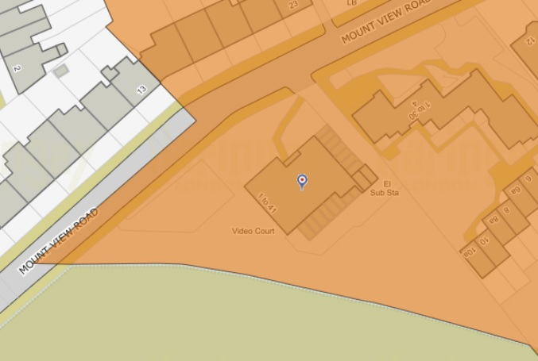

Policy Relevant to the Development Site:

The site is designated as being in the settlement boundary, with urban uses to the north, east, south and west. The site is in the Stroud Green Conservation Area. The land designation that this site is located in is considered to be a material consideration.

This is an existing telecommunications site.

LB Haringey does have a specific telecoms policy. This, together with the NPPF is of relevance. The National Planning Policy section of this supporting statement goes into detailed analysis of why this site is in compliance with the NPPF.

Policy Analysis:

Policy DM3 states:

“Telecommunications equipment

D Proposals for the installation of telecommunications equipment will be permitted where:

a. It is demonstrated the equipment is limited to the minimum operational requirement, which should include any future-proofing requirements to accommodate anticipated improvements in infrastructure;
b. Opportunities for sharing facilities, such as masts, cabinet boxes and satellite dishes, and erecting antennae on existing buildings or other structures has been fully explored and taken advantage of;
c. There is no significant adverse impact on the visual amenity of neighbouring occupiers;
d. There is no adverse effect on the external appearance of the building, street scene, or spaces in which they are located;
e. The size of any equipment visible from the street is minimised (including satellite
dishes, other domestic equipment and any supporting structures);
f. They are located discretely and do not detract from the special character and appearance of heritage assets or conservation area (see Policy DM9);
g. They are appropriately designed, coloured and landscaped. For dishes, this may include installing a mesh or transparent structure;
h. A minimum residual footway width on main pedestrian roads is preserved, in line with the Manual for Streets.

E. All telecommunications equipment should be removed as soon as reasonably practicable after it is no longer required.”

Policy DM9 states that:

“Management of the Historic Environment

Haringey’s Heritage Assets

A. Development that conserves and enhances the significance of a heritage asset and its setting will be supported.

B. Proposals affecting a designated or non-designated heritage asset and its setting will be assessed against the significance of the asset and its setting, and the impact of the proposals on that significance. Applicants are required to submit with their planning application a statement describing the significance of the heritage asset(s) concerned, including any contribution made by its setting, along with an assessment and justification of the impact of the new development on the asset and its setting.

2.52 Haringey has several vibrant town centres including historic centres such as Highgate, Muswell Hill, Crouch End, Green Lanes, Bruce Grove and West Green Road. These have their own local distinctive character and history (further detail can be found in the Urban Characterisation Study). Historic shopfronts should be retained, and replacement shopfronts should respect, and where lost, reinstate, traditional features such as shop front framework features, pilasters, brackets, fascias and projecting signs. This is especially important where the shopfront would have an impact on the significance of a heritage asset or its setting.

2.53 Poorly designed or excessively bright illuminated shop fascias, over-large or inappropriately sited fascias or signage can detract from the visual quality of the shopping area. Attention must therefore be given to designing fascias and signs that are in scale and character with the building and surrounding streetscape.

2.54 On-street dining facilities can add to the vibrancy of shopping centres or public squares. However, these should not disrupt normal pedestrian movement or other high street activities. Where possible, such facilities should integrate with the public realm of the surrounding area. Temporary furniture is important as it allows flexibility of the space to be converted back to public use. Consideration of smoking areas or
shelters will be necessary and may require planning permission. The Council may consider limiting the hours of use through the use of planning conditions.

C. When considering the impact of proposals on the historic environment, the Council will have regard to:

a. The priority given to sustaining and enhancing the significance of a heritage asset and its setting;
b. Character appraisals and management plans or other guidance, where they are available;
c. The preservation or reinstatement of original or historic form, fabric, function or character of the asset and its setting;
d. The relationship with adjoining and neighbouring uses, particularly where these
are heritage assets of significance in their own right;
e. The desirability of securing a viable use for a heritage asset consistent with its
conservation;
f. An understanding of and respect for significance of heritage assets as parts of
measures to mitigate and adapt to climate change; and
g. The contribution that the sensitive utilisation of heritage assets can make to sustainable regeneration.

Conservation Areas

D. Subject to (A-C) above the Council will give consideration to, and support where
appropriate, proposals for the sensitive redevelopment of sites and buildings where these detract from the character and appearance of a Conservation Area and its
setting, provided that they are compatible with and/or complement the special characteristics and significance of the area.

E. Proposals for alterations and extensions to existing buildings in Conservation Areas should complement the architectural style, scale, proportions, materials and details of the host building and should not appear overbearing or intrusive.”

Policy DM54 states that:

“Facilitating Telecommunications Development

A. The Council will promote the development of advanced, high-quality communications infrastructure to support economic growth and more accessible, inclusive communities. This will be achieved by requiring new development proposals to:

b. Be designed in such a way as to be capable of facilitating delivery of high speed
broadband technology;
c. Demonstrate how they will improve communications infrastructure in areas of poor broadband connectivity, as identified in Haringey’s Infrastructure Delivery Plan, including through connection of the development to a nearby trunk network; and
d. Deliver “ultrafast” connections in Regeneration Areas; and
e. Be designed to meet the requirements of Policy DM3.”

The proposed works at this existing site, with minimal but necessary changes, would not result in demonstrable harm (less than substantial harm) to the character and setting of the wider conservation area, yet would provide the requisite coverage needed in the area, so according with the principles of the policy.

The scheme would deliver considerable and tangible coverage and connection improvements for residents and businesses in the location, qualifying as significant public benefits sufficient to counter less than substantial harm.

It fully accords with the requirements of the NPPF and the objectives of the London Plan (Policy 4.11 Encouraging a Connected Economy (March 2015)). Given the minimal nature of the proposal the scheme will both preserve and enhance the CA will significantly improved connectivity

Enclose map showing the cell centre and adjoining cells if appropriate:
This can be emailed to the LPA on request.

Type of Structure:
Description:

Proposed removal and replacement of existing 3No. Antennas with proposed 6No. Antennas and 9No. RRU’s with 15No. RRU’s. Proposed installation of 2No. 300ᴓ Dishes. Existing equipment’s on raised equipment grillage to be refreshed internally and associated ancillary works.

Overall Height: 25.50m AGL
Height of existing building: | Upper roof level 20.30m AGL
Equipment Housing:
Length: | Existing enclosures to be refreshed x2 - 600
Width: | Existing enclosures to be refreshed x2 - 750
Height: | Existing enclosures to be refreshed x2 - 1975
Materials: See Drawings
Tower/mast etc – type of material and external colour: | Galvanised
Equipment housing – type of material and external colour: | Grey

Reasons for choice of design:
Cornerstone is the UK's leading mobile infrastructure services company. We acquire, manage and own over 20,000 sites and are committed to enabling best in class mobile connectivity for over half of all the country's mobile customers. We oversee works on behalf of telecommunications providers and wherever possible aim to:

• promote shared infrastructure
• maximise opportunities to consolidate the number of base stations
• significantly reduce the environmental impact of network development

As stated above the National Planning Policy Framework advocates site sharing, and as such we believe that there are no sequentially preferable locations within the defined site search area. The proposed facility will provide coverage including 2G/3G/4G services and essential 5G coverage all from the same installation. This is fully in line with national guidance which supports the use of high-quality communications infrastructure and states that local planning authorities should support the expansion of electronic networks.

Health and Safety
International Commission on Non-Ionizing Radiation Protection Declaration attached (see below)

International Commission on Non-Ionizing Radiation Protection public compliance is determined by mathematical calculation and implemented by careful location of antennas, access restrictions and/or barriers and signage as necessary. Members of the public cannot unknowingly enter areas close to the antennas where exposure may exceed the relevant guidelines.

When determining compliance, the emissions from all mobile phone network operators on or near to the site are taken into account.

In order to minimise interference within its own network and with other radio networks, Cornerstone’ operates its network in such a way the radio frequency power outputs are kept to the lowest levels commensurate with effective service provision

As part of Cornerstone’s network, the radio base station that is the subject of this application will be configured to operate in this way.

All operators of radio transmitters are under a legal obligation to operate those transmitters in accordance with the conditions of their licence. Operation of the transmitter in accordance with the conditions of the licence fulfils the legal obligations in respect of interference to other radio systems, other electrical equipment, instrumentation, or air traffic systems. The conditions of the licence are mandated by Ofcom, an agency of national government, who are responsible for the regulation of the civilian radio spectrum. The remit of Ofcom also includes investigation and remedy of any reported significant interference.

The telecommunications infrastructure the subject of this application accords with all relevant legislation and as such will not cause significant and irremediable interference with other electrical equipment, air traffic services or instrumentation operated in the national interest.

- Technical Justification

Customers will inadvertently be aware of this by finding that sometimes they need to go near windows, a higher floor of a building or even outside in order to achieve a stronger signal for their mobile devices.

Tree Clutter

The effects of trees on signal degradation should never be underestimated. Signal absorption and shadowing effects vary according to vegetation and density, and are caused by the main tree trunk, branches and leaves.

Cell sites located in or near trees will have signals significantly reduced. As a result a number of extra sites may need to be built locally in order to counter-effect this.

Signal variation throughout the seasons is also a practical concern. Leaves on trees in the spring and summer can cause shadowing and reduce radio voice quality and increase the number of dropped calls.

As a result the bottom of an antenna should be

a) above the top level of the trees,
b) allow greater height due to the antenna down tilt at build or for future requirements and c) allow some room for future growth of the trees.

In the case where the cell site utilises point-to-point microwave backhaul transmission the microwave dish should not be obscured at all.

Propagation Models

In essence these are mathematical formulae used to characterise radio wave propagation, in order to determine the received signal strength at a receiving device.

The most well-known propagation model used for mobile telecommunications is ‘Okamura-Hata’. More specific studies have been performed to investigate specific clutter and terrain such as dense-urban and urban environments. Resulting from these are propagation models for specific clutter types.

Coverage Planning Tools

Radio planning engineers plan cellular networks using highly sophisticated computer programs that incorporate the above propagation models. Armed with data on cell site location, cell site configuration, maps, terrain etc they are used to predict areas of coverage deficiency (so called ‘coverage holes’), new site requirements and configurations.

Network Changes

Over time the topography and clutter in an area is subject to change. For example, building developments, housing and tree growth can all change. As a consequence, the signals received from local phone masts can degrade, as they are dependent on these factors. These reasons along with customer complaints, network consolidation (mast sharing) and new technologies (5G) require a re-evaluation of a network operator’s telecommunications infrastructure.

Mast sharing can result in some masts no longer being needed. As a result, they are decommissioned and physically removed.

Technical surveys undertaken for reasons above may highlight that antenna height increases are required – this is more likely for sites with low antenna heights around 15m AGL, particularly street furniture sites. More details on these reasons below.

While thus far this document is generic to mobile telephony masts it should be noted that each mast has to be dealt with on a case-by-case basis.

ICNIRP Compliance

The addition of new technologies and mast sharing affects ICNIRP compliance – a higher minimum mast height is required in some cases.

- Site Selection Process

If no alternative site options have been investigated, please explain why:

This is an upgrade to an existing site thus no other standalone new facilities have been investigated. A new additional mast to facilitate the upgrade would not be in line with NPPF. By upgrading the current facility the most sequentially preferable option has been progressed.

Land use planning designations:

Site Ref: | 20763026 | Site Address: | Video Court, 2 Mount View Road, Haringey, London, N4 4SJ

Local Planning Authority: LB Haringey

Development Plan: Haringey Strategic Policies 2013 (with alterations 2017) /
Haringey Development Management DPD (2017)
Site and its surrounds

Fig.1 – LP Map Extract (reference only)

Policy Relevant to the Development Site:

The site is designated as being in the settlement boundary, with urban uses to the north, east, south and west. The site is in the Stroud Green Conservation Area. The land designation that this site is located in is considered to be a material consideration.

This is an existing telecommunications site.

LB Haringey does have a specific telecoms policy. This, together with the NPPF is of relevance. The National Planning Policy section of this supporting statement goes into detailed analysis of why this site is in compliance with the NPPF.

Policy Analysis:

Policy DM3 states:

“Telecommunications equipment

D Proposals for the installation of telecommunications equipment will be permitted where:

a. It is demonstrated the equipment is limited to the minimum operational requirement, which should include any future-proofing requirements to accommodate anticipated improvements in infrastructure;
b. Opportunities for sharing facilities, such as masts, cabinet boxes and satellite dishes, and erecting antennae on existing buildings or other structures has been fully explored and taken advantage of;
c. There is no significant adverse impact on the visual amenity of neighbouring occupiers;
d. There is no adverse effect on the external appearance of the building, street scene, or spaces in which they are located;
e. The size of any equipment visible from the street is minimised (including satellite
dishes, other domestic equipment and any supporting structures);
f. They are located discretely and do not detract from the special character and appearance of heritage assets or conservation area (see Policy DM9);
g. They are appropriately designed, coloured and landscaped. For dishes, this may include installing a mesh or transparent structure;
h. A minimum residual footway width on main pedestrian roads is preserved, in line with the Manual for Streets.

E. All telecommunications equipment should be removed as soon as reasonably practicable after it is no longer required.”

Policy DM9 states that:

“Management of the Historic Environment

Haringey’s Heritage Assets

A. Development that conserves and enhances the significance of a heritage asset and its setting will be supported.

B. Proposals affecting a designated or non-designated heritage asset and its setting will be assessed against the significance of the asset and its setting, and the impact of the proposals on that significance. Applicants are required to submit with their planning application a statement describing the significance of the heritage asset(s) concerned, including any contribution made by its setting, along with an assessment and justification of the impact of the new development on the asset and its setting.

2.52 Haringey has several vibrant town centres including historic centres such as Highgate, Muswell Hill, Crouch End, Green Lanes, Bruce Grove and West Green Road. These have their own local distinctive character and history (further detail can be found in the Urban Characterisation Study). Historic shopfronts should be retained, and replacement shopfronts should respect, and where lost, reinstate, traditional features such as shop front framework features, pilasters, brackets, fascias and projecting signs. This is especially important where the shopfront would have an impact on the significance of a heritage asset or its setting.

2.53 Poorly designed or excessively bright illuminated shop fascias, over-large or inappropriately sited fascias or signage can detract from the visual quality of the shopping area. Attention must therefore be given to designing fascias and signs that are in scale and character with the building and surrounding streetscape.

2.54 On-street dining facilities can add to the vibrancy of shopping centres or public squares. However, these should not disrupt normal pedestrian movement or other high street activities. Where possible, such facilities should integrate with the public realm of the surrounding area. Temporary furniture is important as it allows flexibility of the space to be converted back to public use. Consideration of smoking areas or
shelters will be necessary and may require planning permission. The Council may consider limiting the hours of use through the use of planning conditions.

C. When considering the impact of proposals on the historic environment, the Council will have regard to:

a. The priority given to sustaining and enhancing the significance of a heritage asset and its setting;
b. Character appraisals and management plans or other guidance, where they are available;
c. The preservation or reinstatement of original or historic form, fabric, function or character of the asset and its setting;
d. The relationship with adjoining and neighbouring uses, particularly where these
are heritage assets of significance in their own right;
e. The desirability of securing a viable use for a heritage asset consistent with its
conservation;
f. An understanding of and respect for significance of heritage assets as parts of
measures to mitigate and adapt to climate change; and
g. The contribution that the sensitive utilisation of heritage assets can make to sustainable regeneration.

Conservation Areas

D. Subject to (A-C) above the Council will give consideration to, and support where
appropriate, proposals for the sensitive redevelopment of sites and buildings where these detract from the character and appearance of a Conservation Area and its
setting, provided that they are compatible with and/or complement the special characteristics and significance of the area.

E. Proposals for alterations and extensions to existing buildings in Conservation Areas should complement the architectural style, scale, proportions, materials and details of the host building and should not appear overbearing or intrusive.”

Policy DM54 states that:

“Facilitating Telecommunications Development

A. The Council will promote the development of advanced, high-quality communications infrastructure to support economic growth and more accessible, inclusive communities. This will be achieved by requiring new development proposals to:

b. Be designed in such a way as to be capable of facilitating delivery of high speed
broadband technology;
c. Demonstrate how they will improve communications infrastructure in areas of poor broadband connectivity, as identified in Haringey’s Infrastructure Delivery Plan, including through connection of the development to a nearby trunk network; and
d. Deliver “ultrafast” connections in Regeneration Areas; and
e. Be designed to meet the requirements of Policy DM3.”

The proposed works at this existing site, with minimal but necessary changes, would not result in demonstrable harm (less than substantial harm) to the character and setting of the wider conservation area, yet would provide the requisite coverage needed in the area, so according with the principles of the policy.

The scheme would deliver considerable and tangible coverage and connection improvements for residents and businesses in the location, qualifying as significant public benefits sufficient to counter less than substantial harm.

It fully accords with the requirements of the NPPF and the objectives of the London Plan (Policy 4.11 Encouraging a Connected Economy (March 2015))

Additional relevant information:

Siting

We have considered the detailed siting and design carefully to ensure that the scheme has a limited impact on the locality, and general visual amenity.

Visual appearance

We would repeat that we have carefully placed and designed the scheme to ensure the principles of good siting and appearance are adhered to. The overall impact of the installation on the environment and building is very limited.

Consultation

In accordance with the industry ’10 commitments’ and the Code of Best Practice, consultation has been attempted with the planning department prior to submission of this proposal.

Conclusion

We consider the development complies with both central government and local planning policy guidance where the underlying aim is to provide an efficient and competitive telecommunication system for the benefit of the community while minimising visual impact.

Taking into account the factors of technical constraints, available sites and planning constraints we consider that this site and design clearly represents the optimum environmental solution.

On the basis of a recognised need to expand and promote telecommunications networks across the region, it is considered that the proposal fully accords with the requirements of the National Planning Policy Framework and the Council’s Local Plan Policies.

Education

The relationship between 5G and education is evolving at a massive rate with educators exploring the relevance of Virtual Reality (VR) technologies for education and training. Crucially, VR can support remote learning, allowing students a presence in the classroom even when working elsewhere.
5G’s ability to deliver real-time information (low latency), ultra-fast speeds (critical for high definition images and video), increased capacity and heightened security will also allow learning on the job, thanks to technologies such as Augmented Reality (AR) goggles, which can give engineers real-time instructions on how to fix a machine on a production line, for example.

Health

Patients across the country are now becoming accustomed to relying on remote healthcare services such as NHS 111, virtual GP appointments, and ordering online deliveries of essential medical supplies.
5G will prove critical in providing the infrastructure required to deliver remote health services over the next decade. By design, 5G’s ability to deliver real-time information (low latency), ultra-fast speeds (critical for high definition images and video), increased capacity and heightened security are going to be fundamental in scaling the patient benefits of remote healthcare and keeping medical records secure and private. For instance, trials have shown that connecting ambulance crews to expert resources using 5G allows paramedics to work with doctors and conduct specialist procedures in real time whilst on the road.

Sam Wismayer BSc (Hons)
Planning Manager
Email: s.wismayer@whptelecoms.com

Confirmation that submitted drawings have been checked for accuracy

Name: (Agent) | Sam Wismayer BSc (Hons) | Telephone: | Emailed on request
Company: | Cornerstone
Company Address: | WHP Telecoms Ltd  1a Station Court  Station Road  Guiseley  Leeds  LS20 8EY | Email Address: | s.wismayer@whptelecoms.com
Signed: |  | Date: | 19th November 2022
Position: | Planning Manager | (on behalf of Cornerstone)

Macro or Micro

