Image 01 of 04 - Corner of Milton Park and Milton Road looking at flat 1
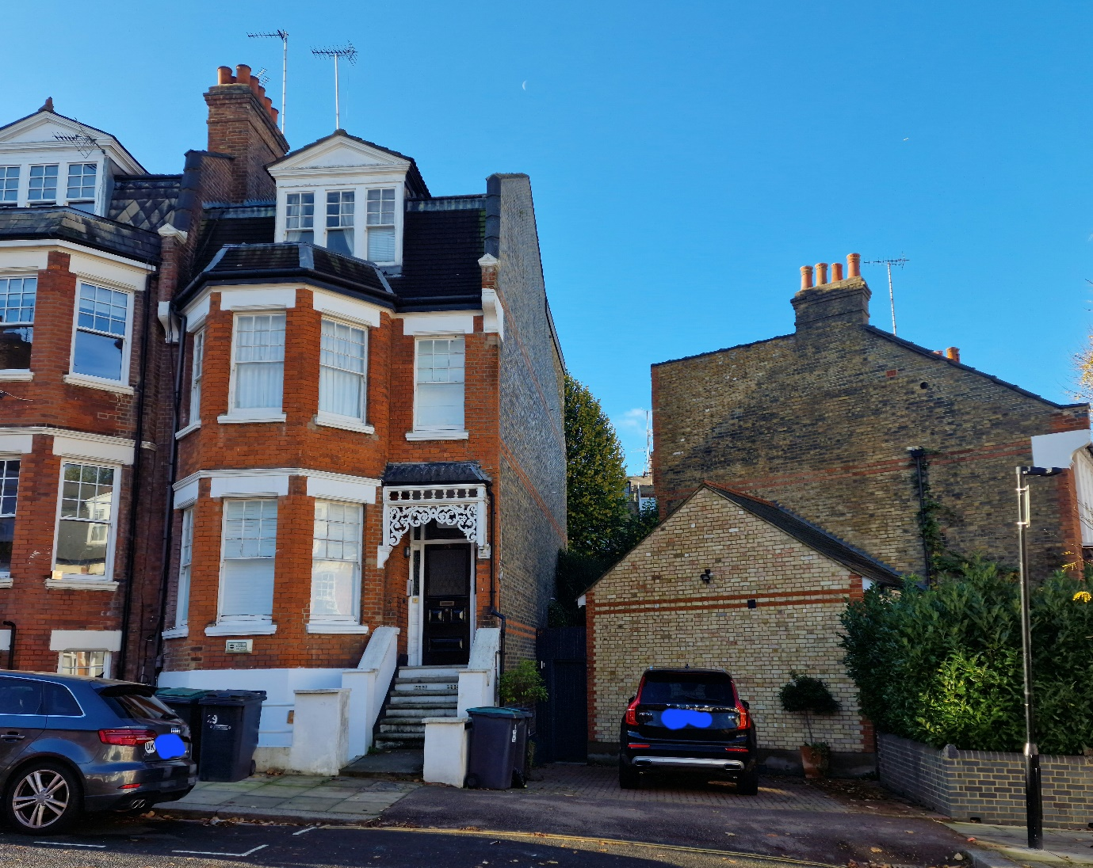

Image 02 of 04 - Shed location to flat 1
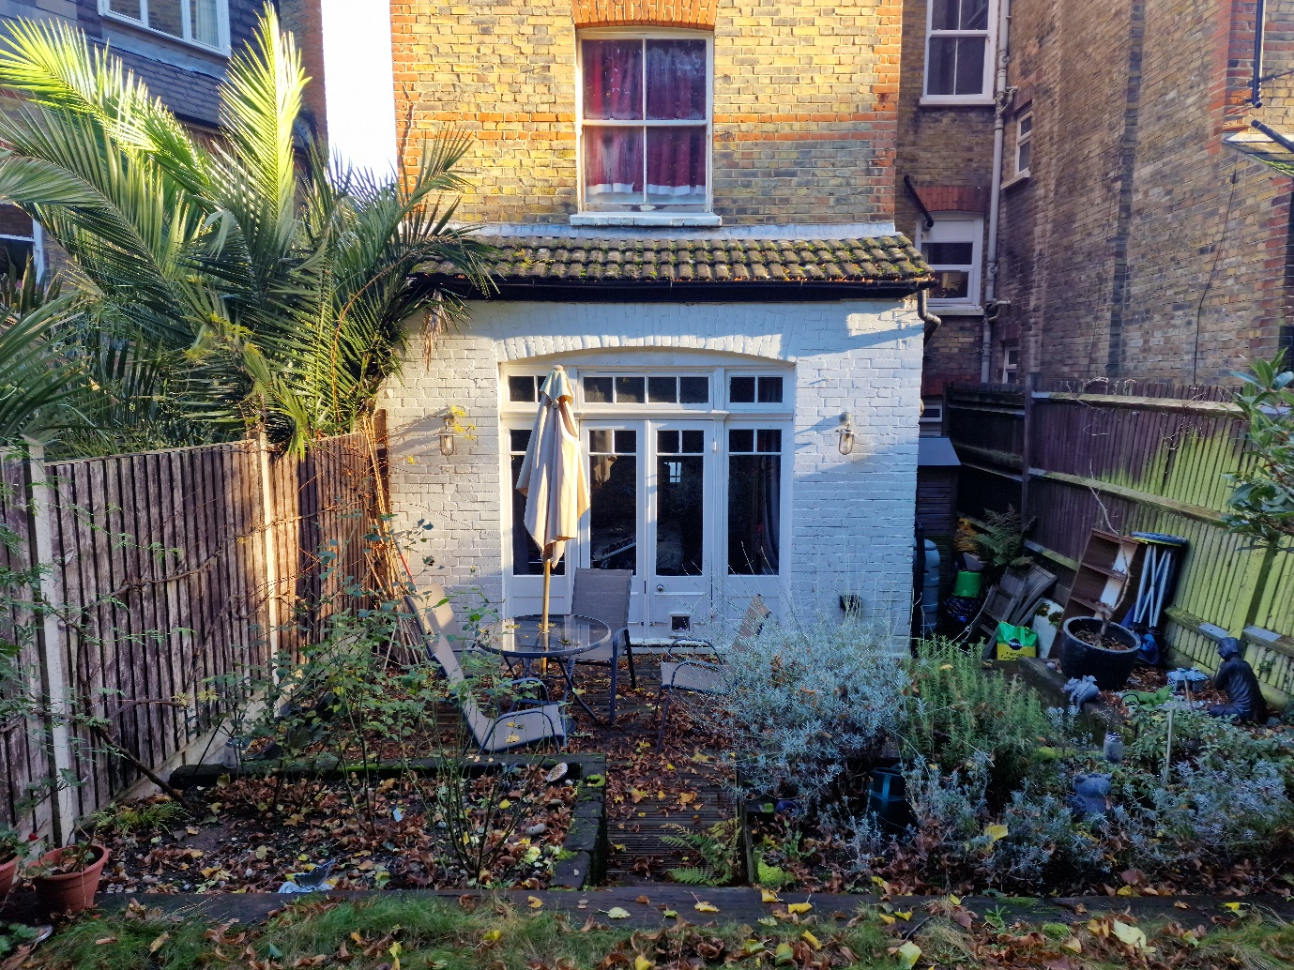

Image 03 of 04 - Flat 1 towards location of shed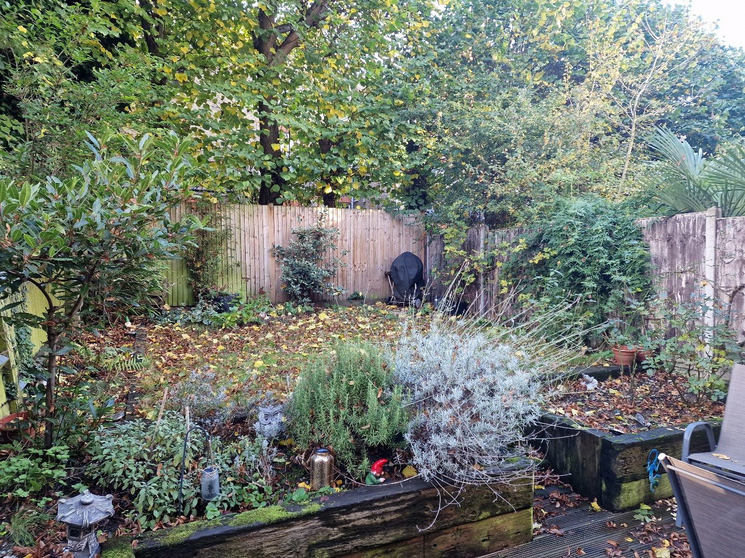

Image 05 of 05 - Flat 1 towards location of shed
