Coach House, 27 Highgate Avenue N6 5SJ
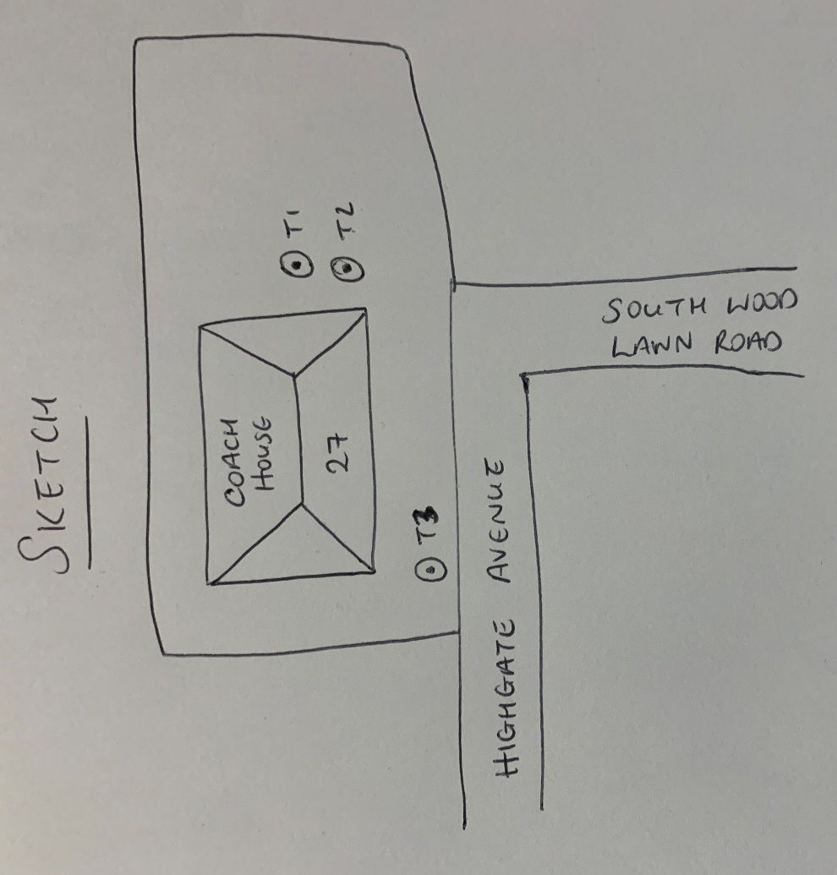
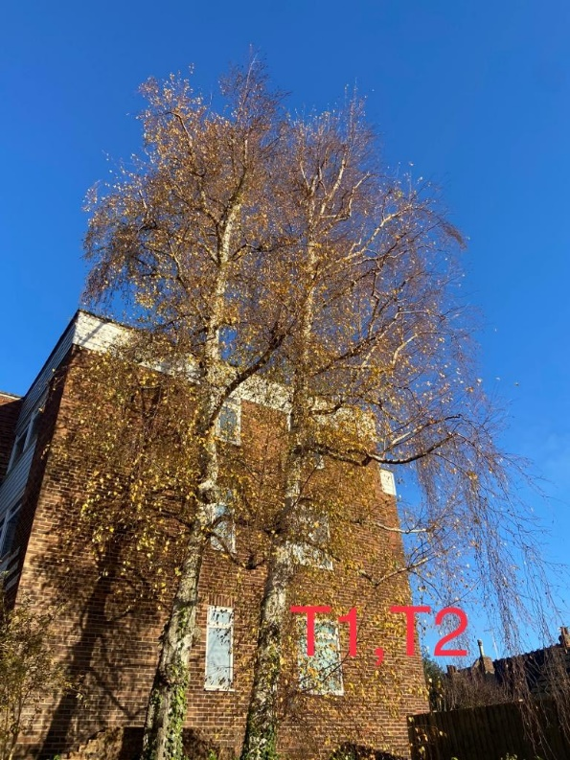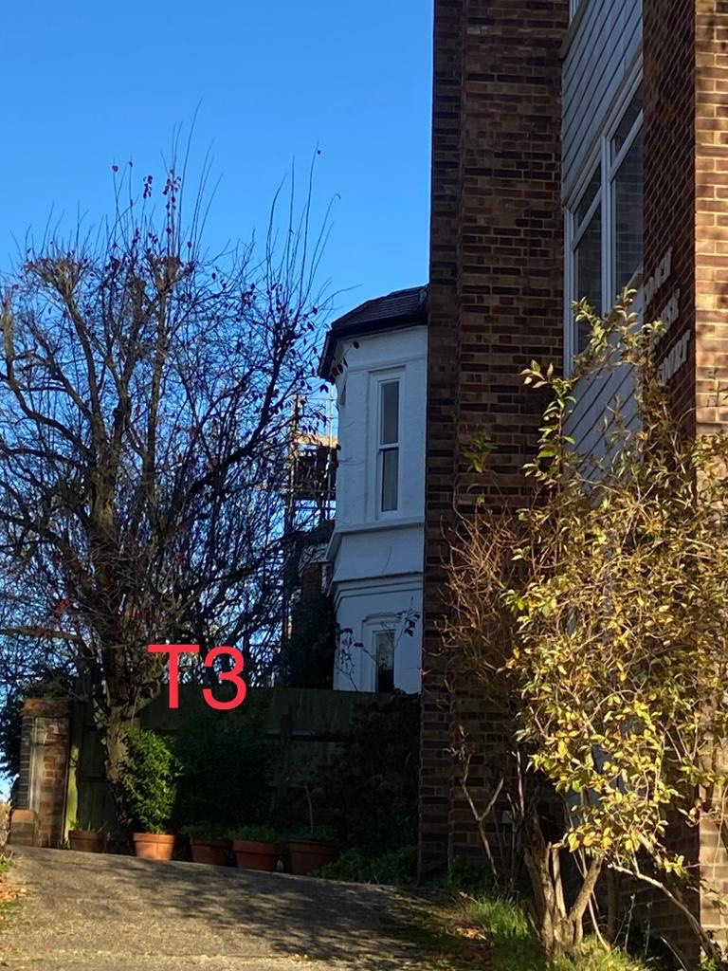
T1: Silver birch (14m): Crown reduce by 1m and shape as part of regular maintenance
T2: Silver birch (14m): Crown reduce by 1m and shape as part of regular maintenance
T3: Purple plum (6m): Crown reduce by 1m to previous points as part of regular maintenance

