25 Highgate Avenue N6 5SB
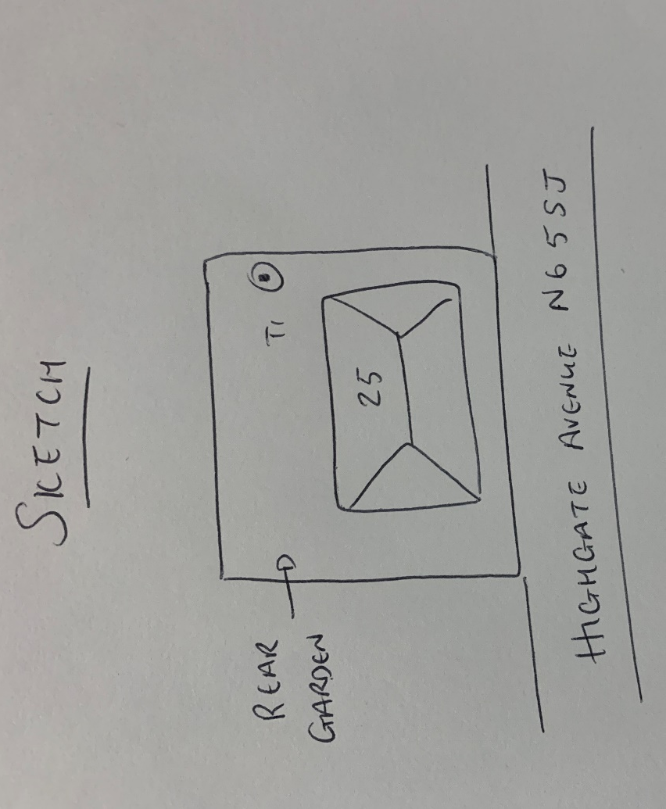
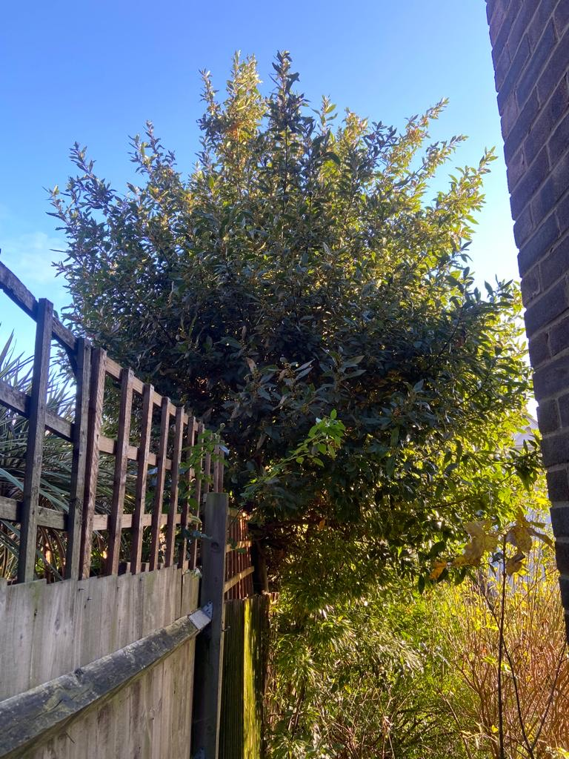
T1: Bay (6m): Reduce height by 50% to keep tree at a size suitable for its location

