HERITAGE STATEMENT – 4C Oakfield Road

4C Oakfield Road is a top floor one bed flat that resides in a street of Victorian terraced houses within the Stroud Green conservation area.
The application shows that the proposal would be in keeping with the current character of the building and it respects the architectural integrity of the immediate area. It has a roof terrace and backs onto a railway line so isn’t overlooked. The front would comprise of 2No. conservation Velux windows which reflects a modest change.
The proposal is a mansard conversion which would create an additional bedroom and a ensuite bathroom.

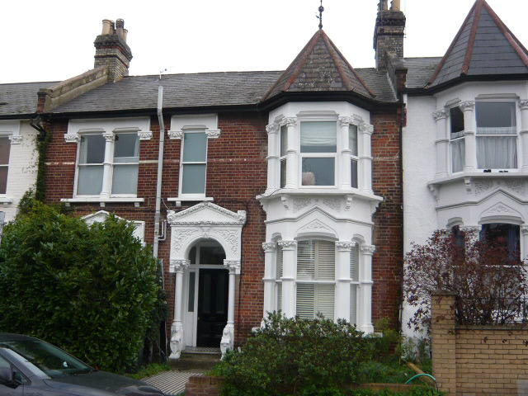The front elevation

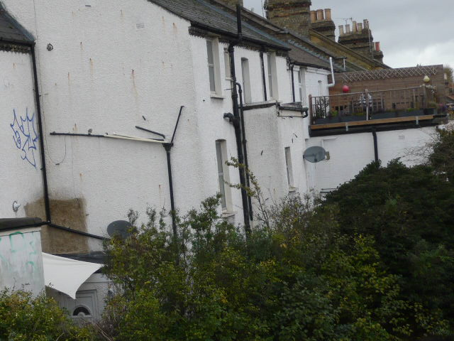

The rear photo showing the roof terrace from the railway bridge.

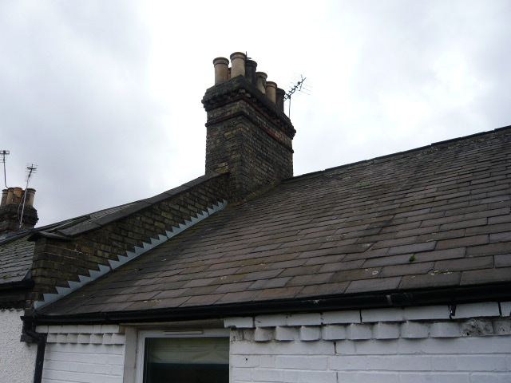
Rear photo of the roof
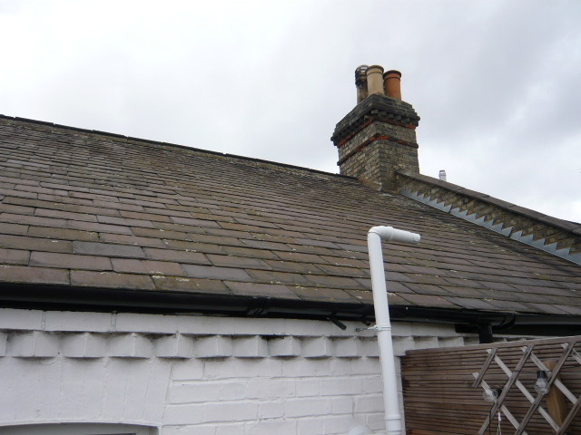

Opposite rear photo of the roof

