SITE PHOTOS

E025327 - BELLE CONGOLAISE, 105 WEST GREEN ROAD, LONDON, N15 5DE

ATM SITE
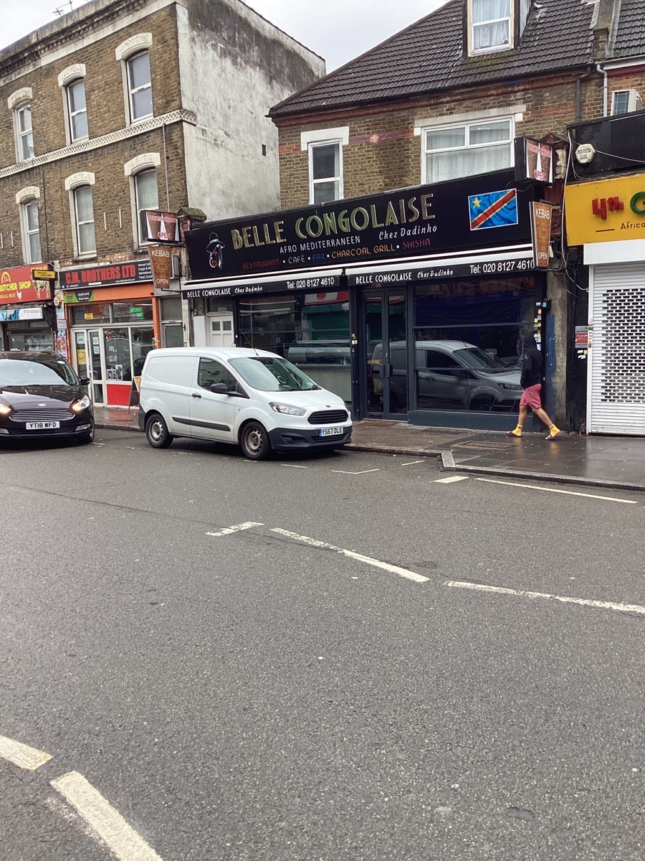

ATM LOCATION
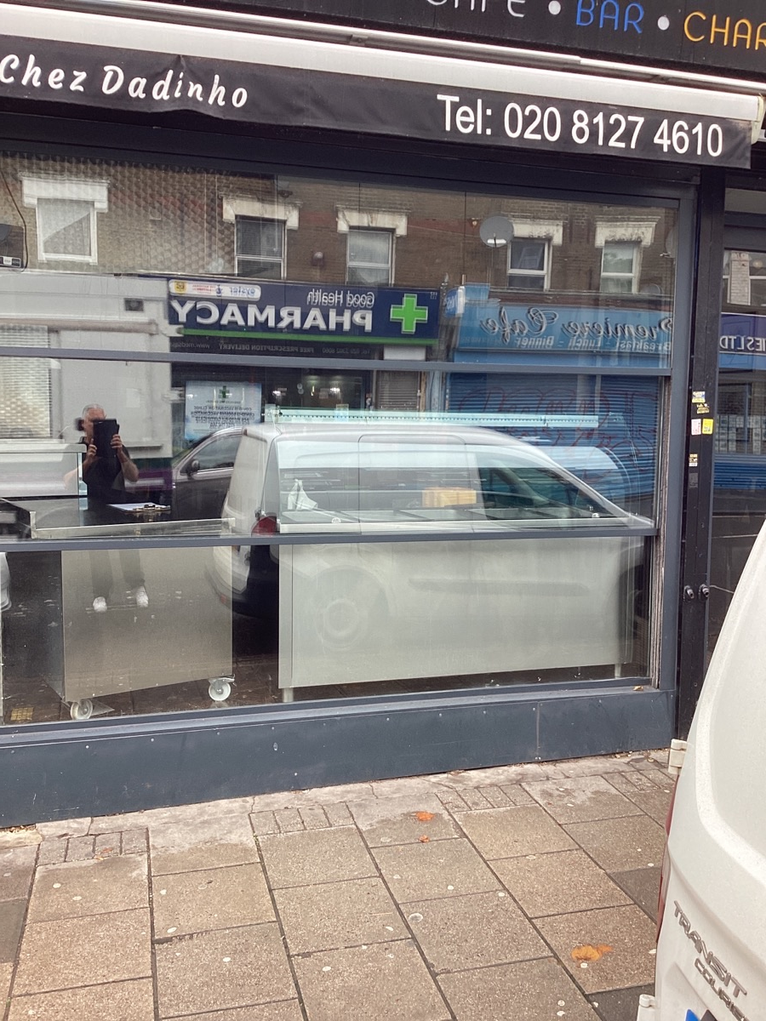

EXTERNAL CCTV CAMERA

