56 Queens Avenue N10 3NU
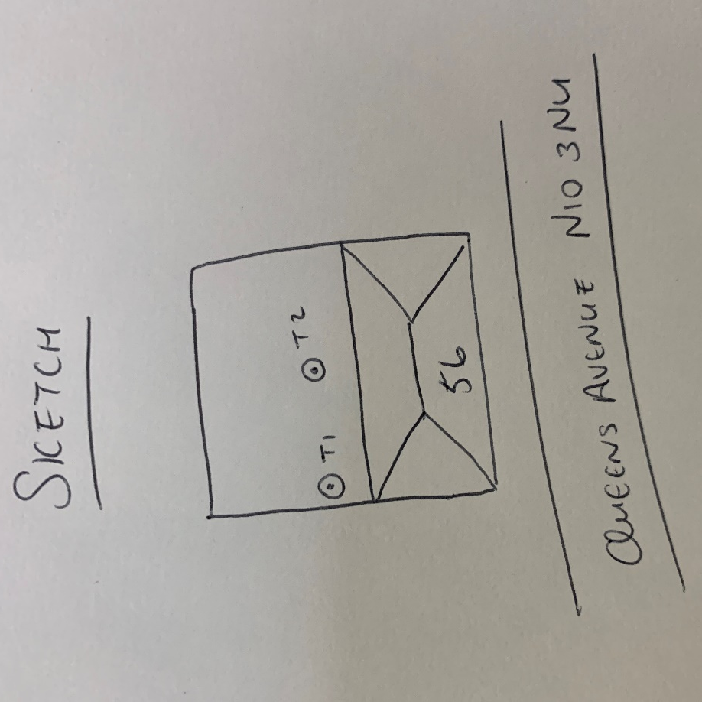
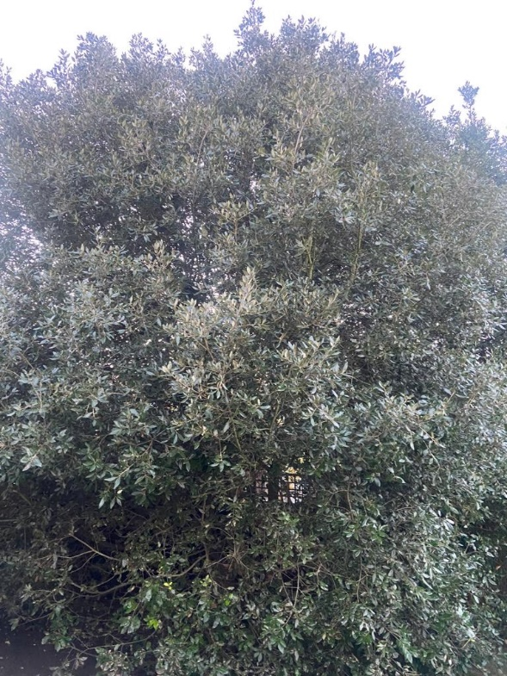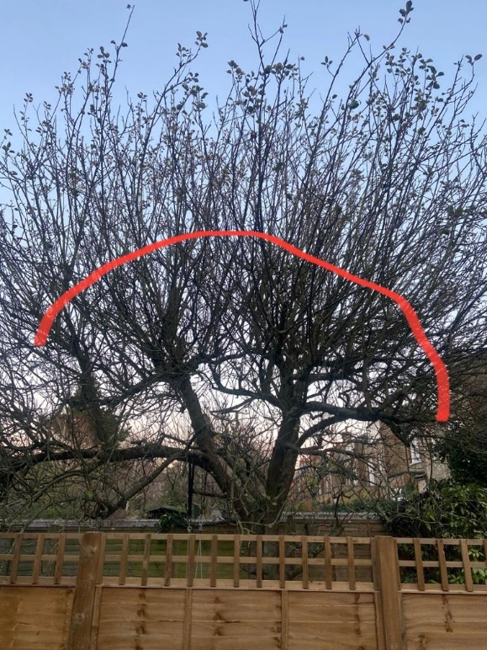
T1: Holm oak T2: Apple
T1: Holm oak: Crown reduce by 2.5m to previous points to keep tree at a size suitable for its location and as part of regular maintenance
T2: Apple: Crown reduce by 2.5m to previous points to keep tree at a size suitable for its location and as part of regular maintenance

