40 Crouch Hall Road N8 8HJ
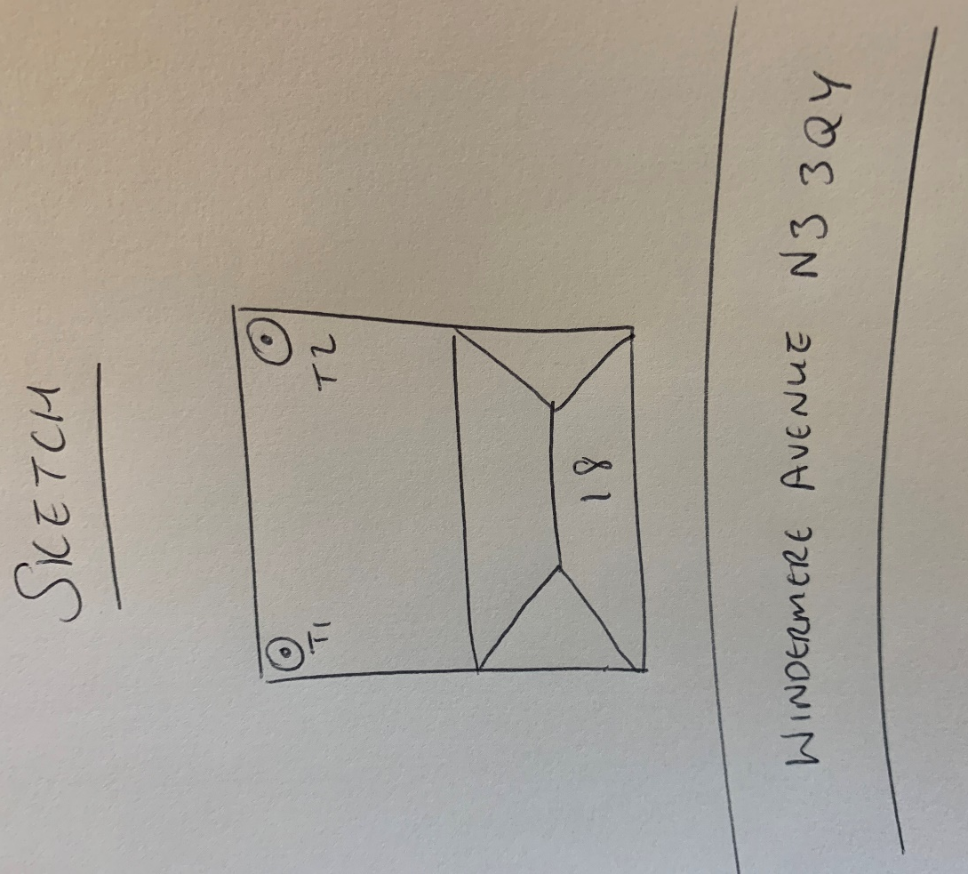
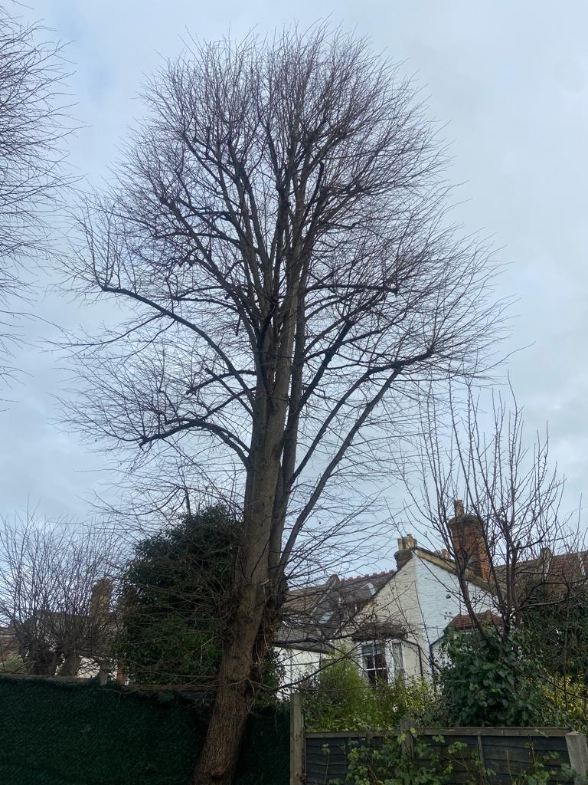
T1: Lime (12m): Re-pollard to previous points removing up to 2m of growth to keep tree at a size suitable for its location and as part of regular maintenance.
T2: Lime (14m): Re-pollard to previous points removing up to 2m of growth to keep tree at a size suitable for its location and as part of regular maintenance.

