29 Southern Road N2 9LH
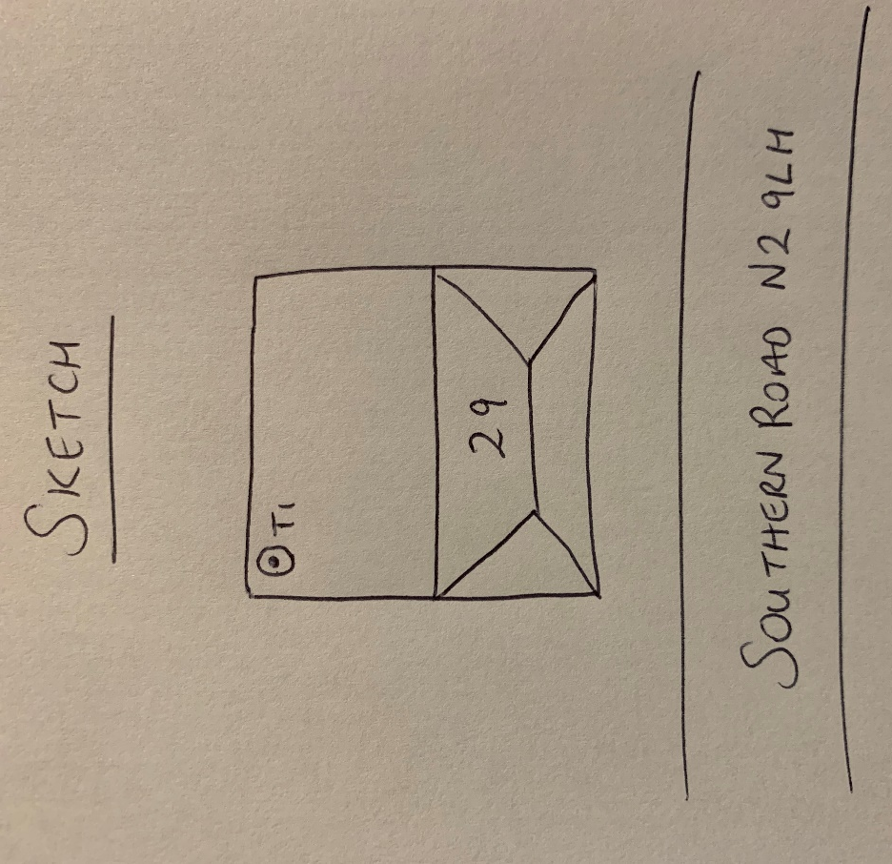
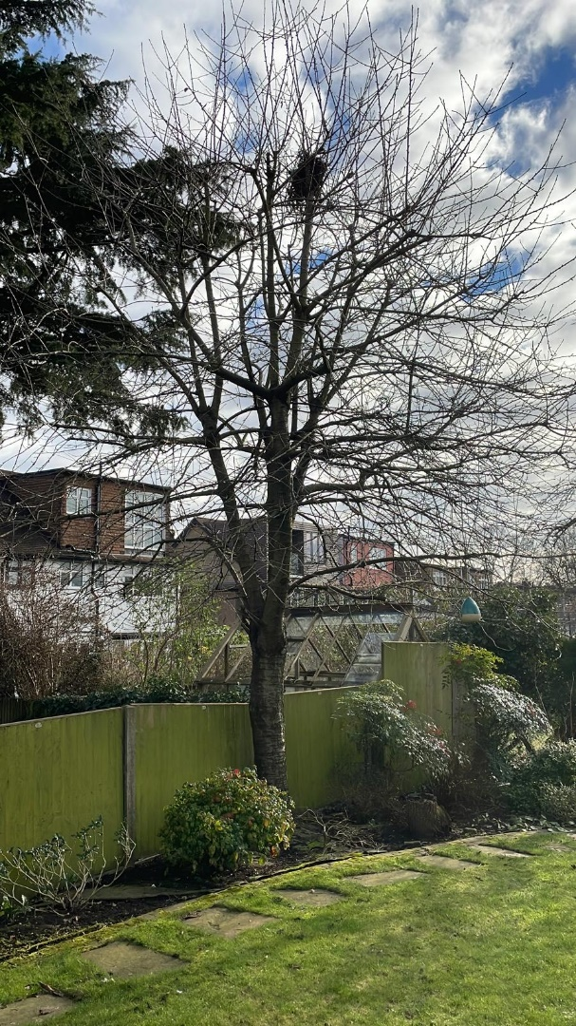
T1: Cherry (7m): Crown reduce by 1.5m to keep tree at a size suitable for its location and as part of regular maintenance

