17 Tetherdown N10 1ND
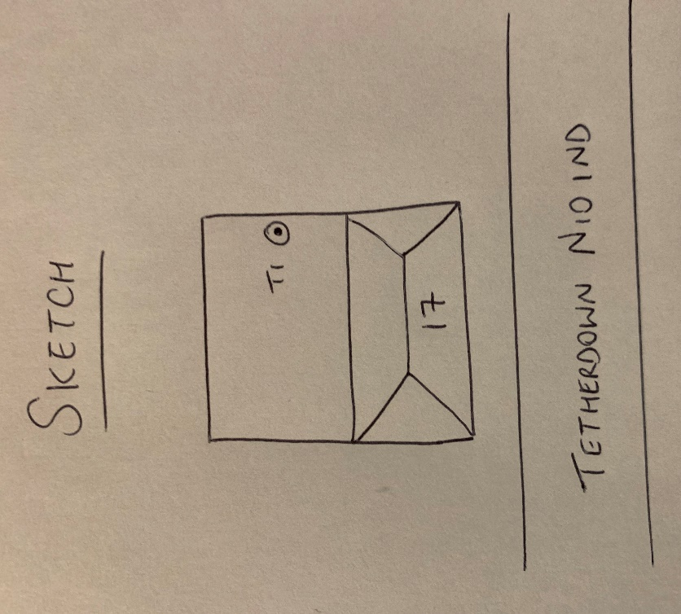
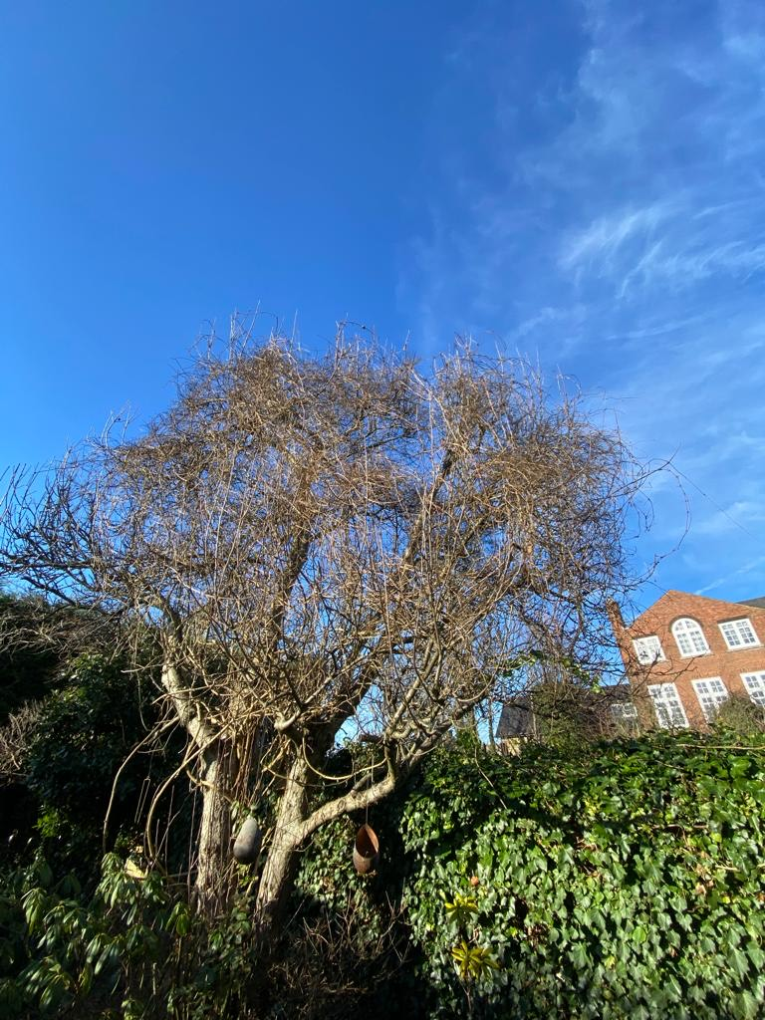
T1: Apple (6m): Crown reduce to previous points to keep tree at a size suitable for its location and as part of regular maintenance

