Dyne House, Highgate School, Southwood Lane, Highgate N6 5EE
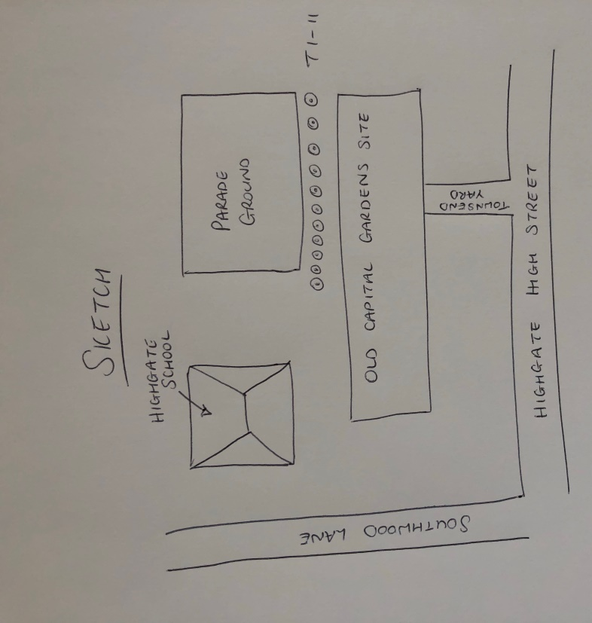

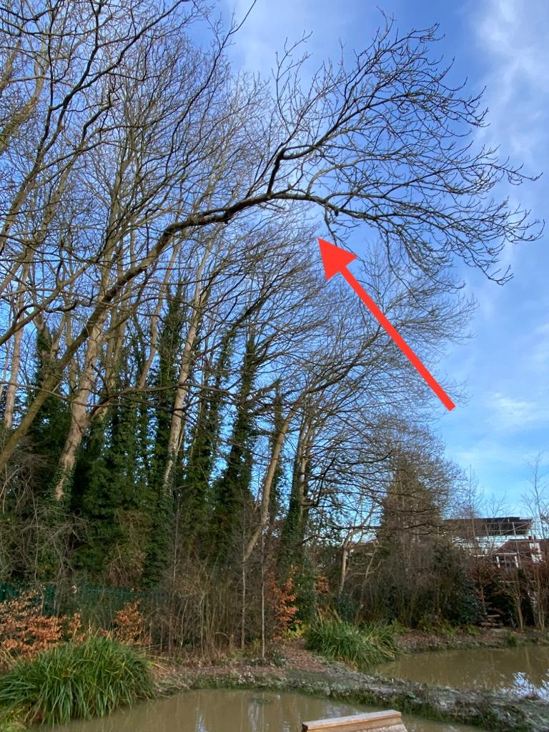
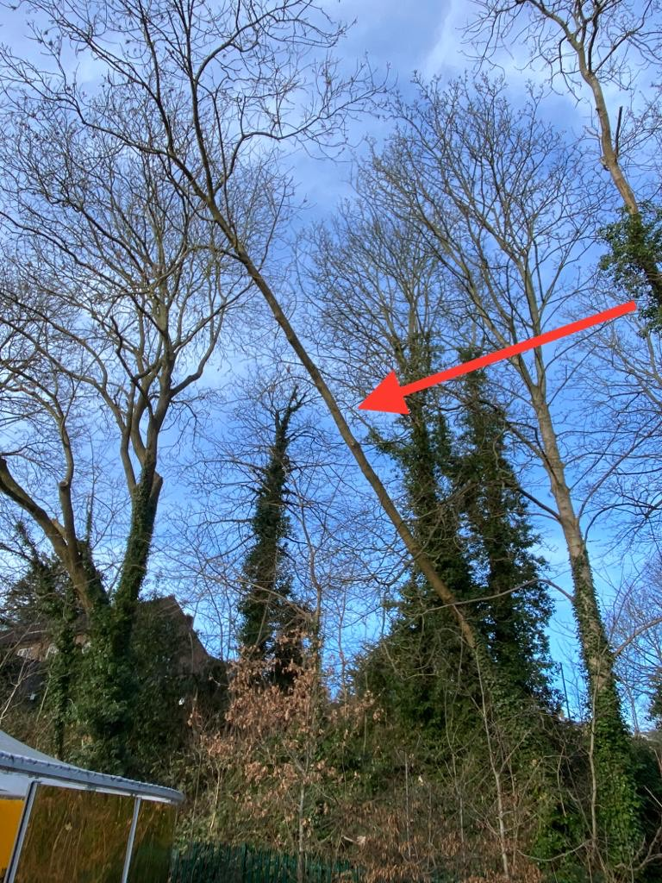
T1: Ash (10m): Fell due to reduce risk of failure as shown in photo
T2: Ash (10m): Fell due to reduce risk of failure as shown in photo

