Mallinson Centre, Highgate School, Bishopswood Road N6 4NY
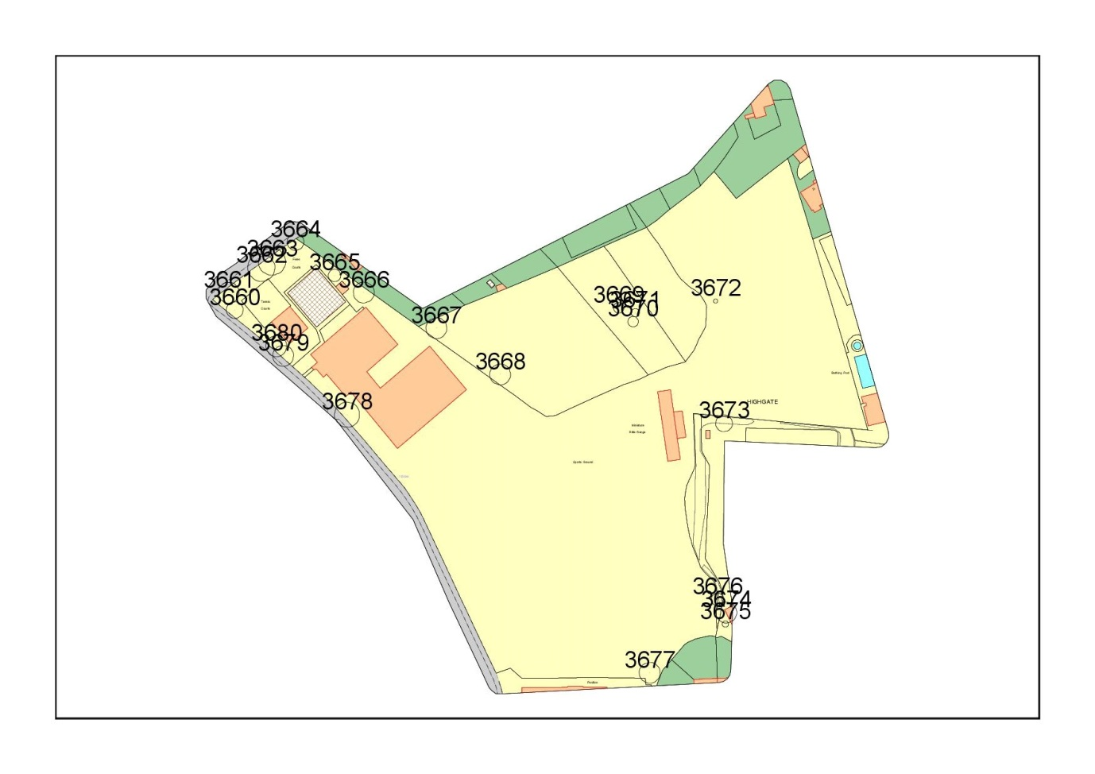
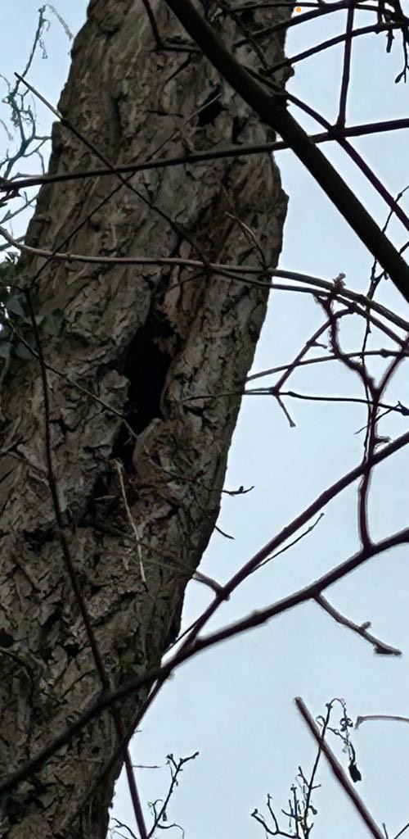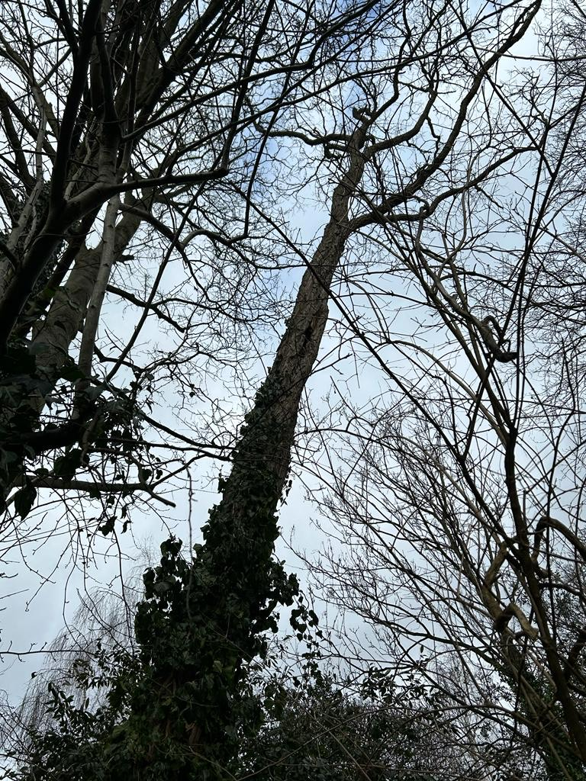
T3667: Robinia (14m): Fell due to poor condition, there is decay on main trunk

