Coleridge Primary School, Crouch End Hill N8 8DN
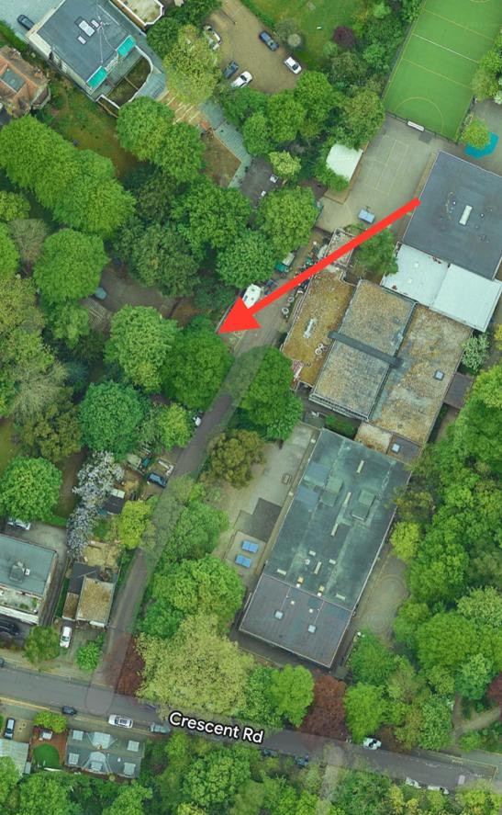
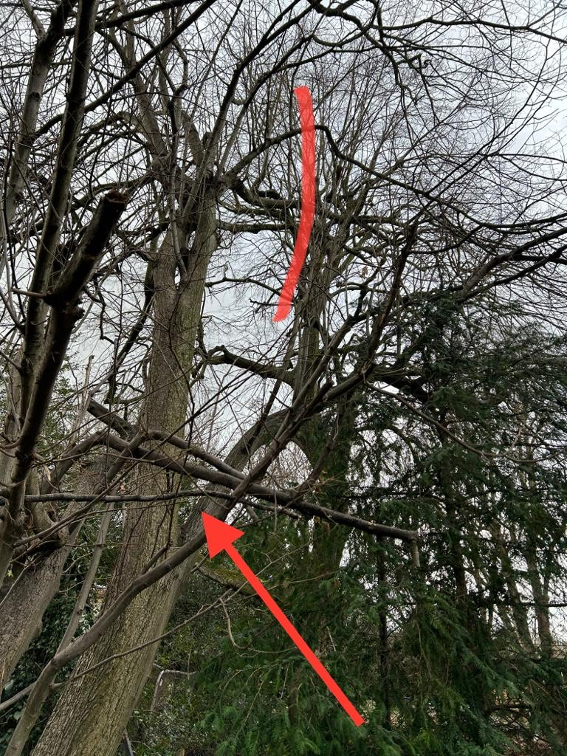
T1: Lime (next to flat roof) (12m): Reduce overhang by 3m and remove lower branch to avoid damage to the flat roof

