79 Stapleton Hall Road N4 4EH
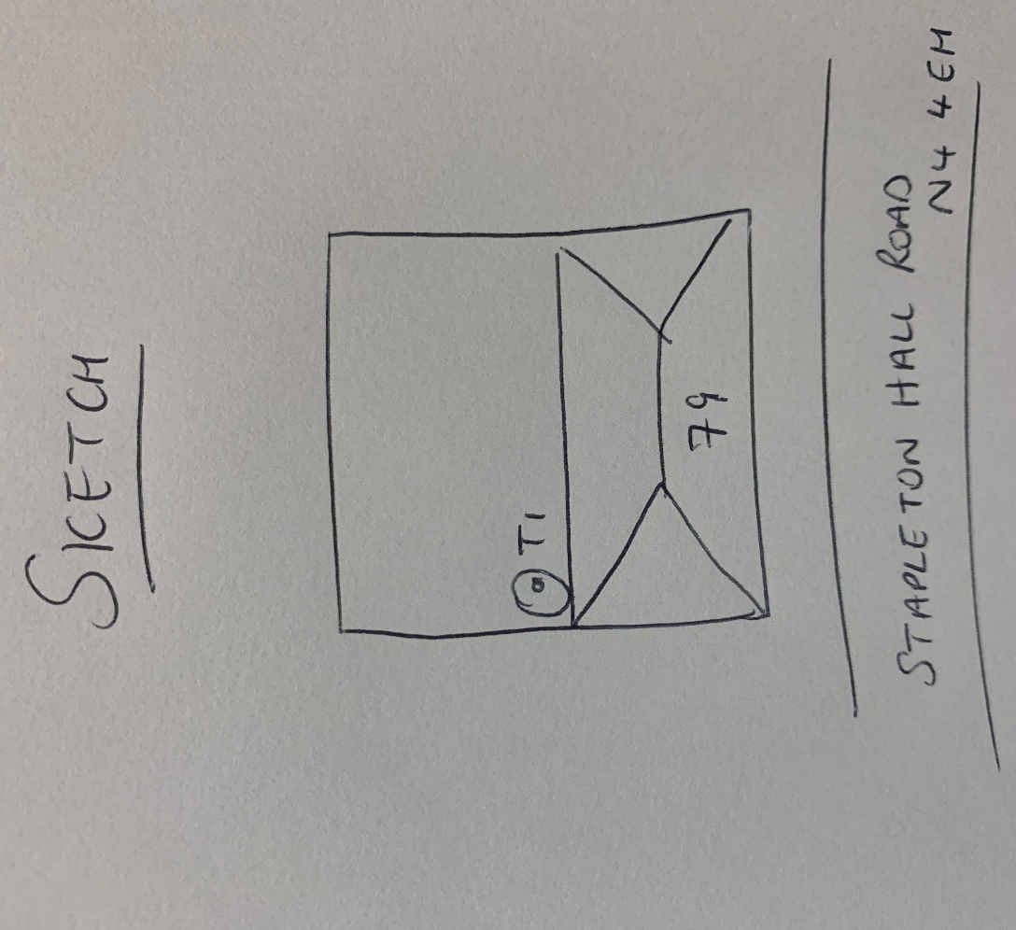
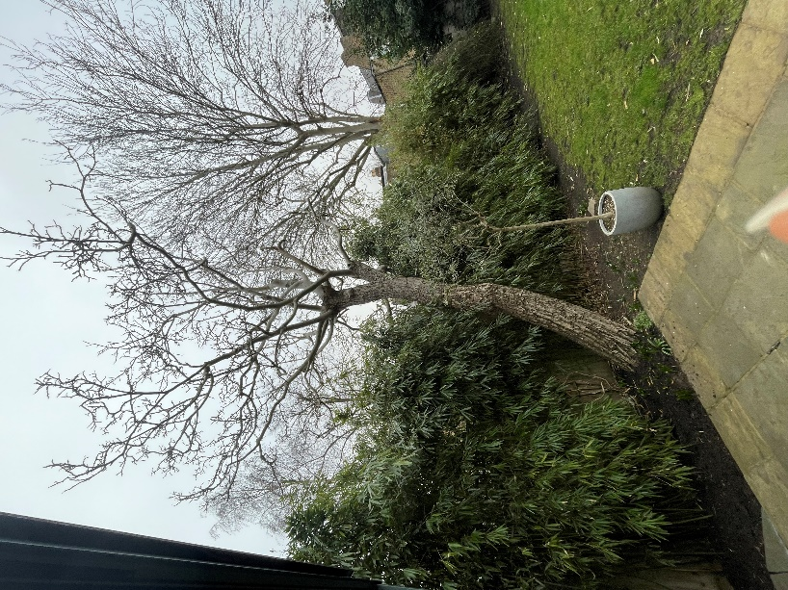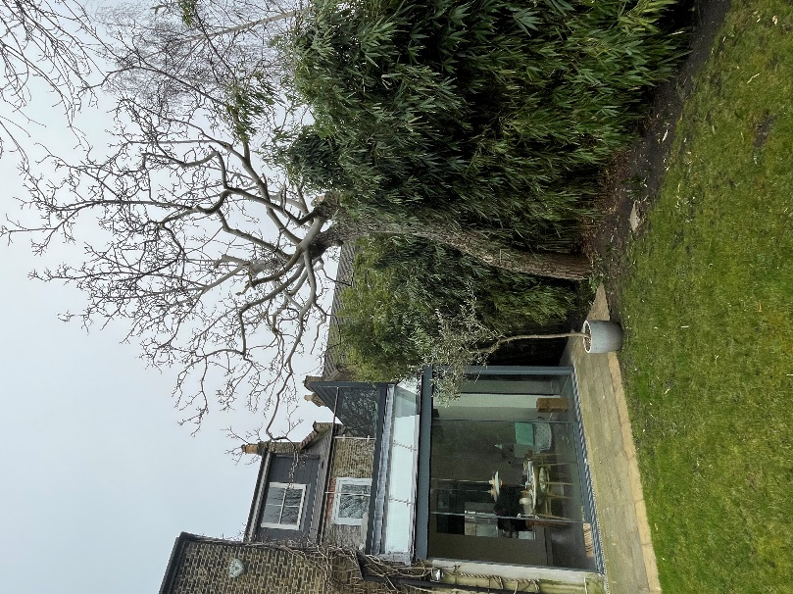
T1: Walnut (6m): Crown reduce by 1.5m and remove major dead wood to keep tree at a size suitable for its location due to close proximity to house

