18 Ferme Park Road N4 4ED
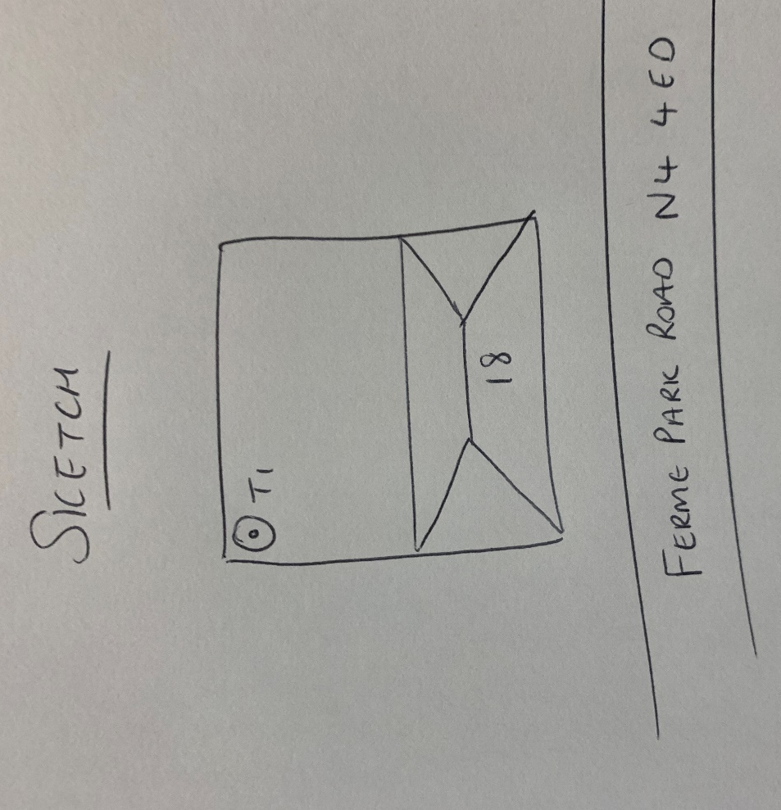
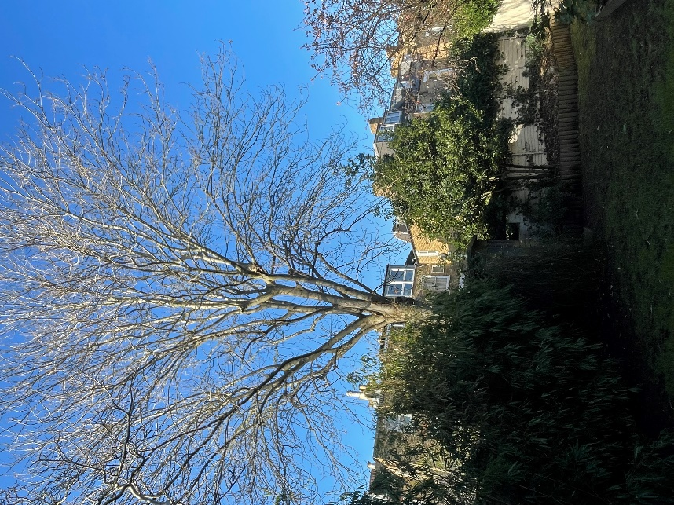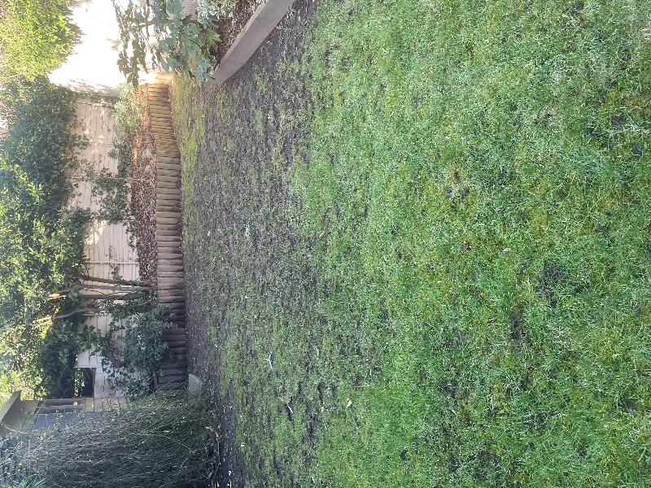
T2: Ash (15m): Crown thin by 30% to allow more light into gardens

