8 Thirlmere Road N10 2DN
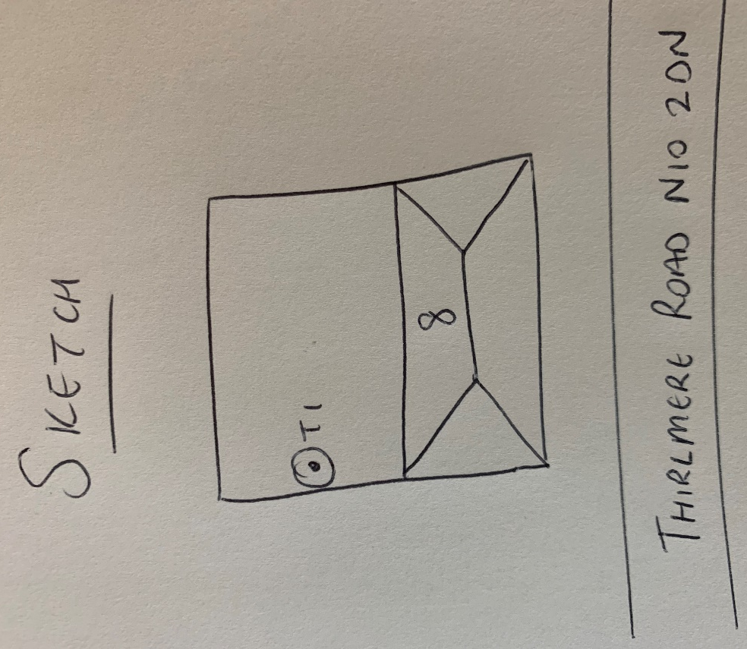
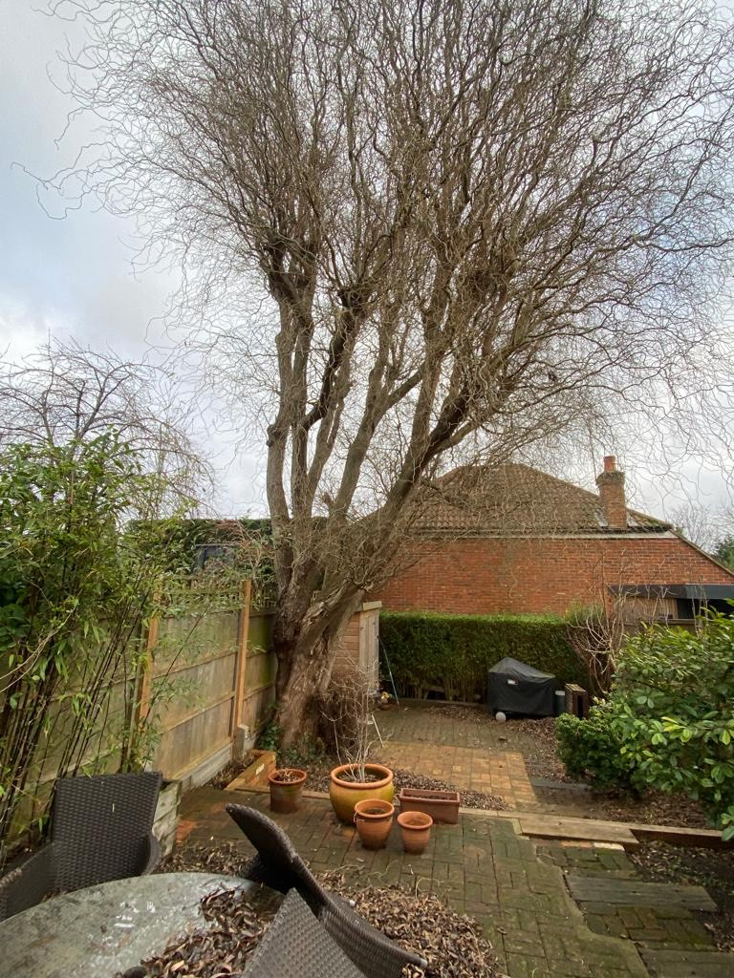
T1: Willow (13m): Pollard to 5m from ground level to keep at a size suitable for its location, make ongoing maintenance easier and to allow more light into the garden

