Current flooring:
- Brown, grey and beige stone
- Square/rectangular shaped
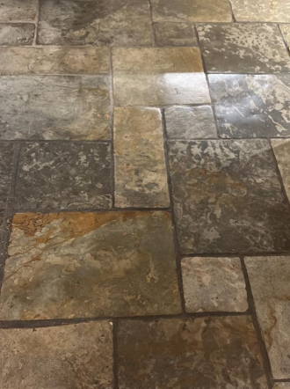
- Sizes vary
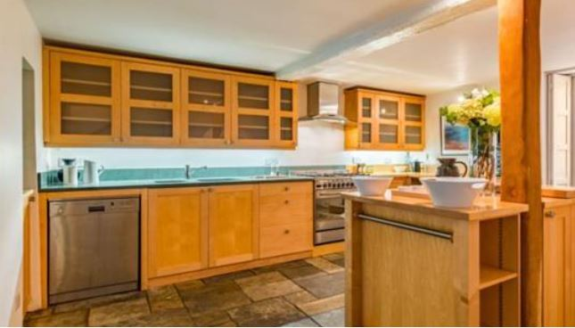

Proposed flooring spec:
- Neutral stone tiles
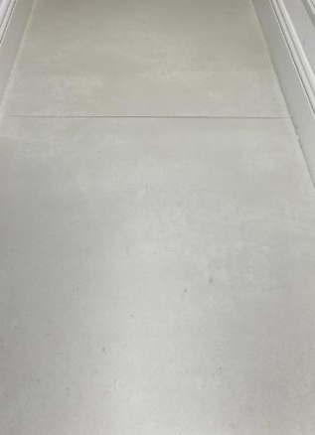
- The style emulates large natural stone flagstones
- 100 x 50cm
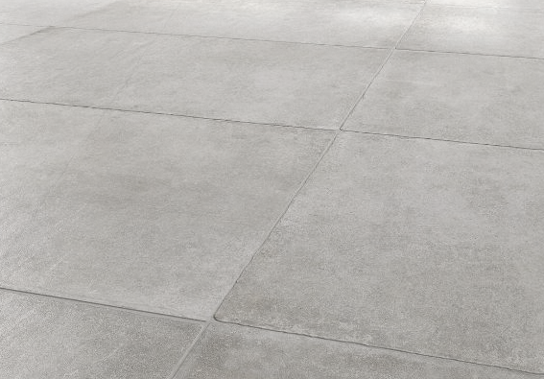

Note: no plans or drawings have been created due to the nature of the project, and an architect or designer not being required

