24 Elm Grove N8 9AJ
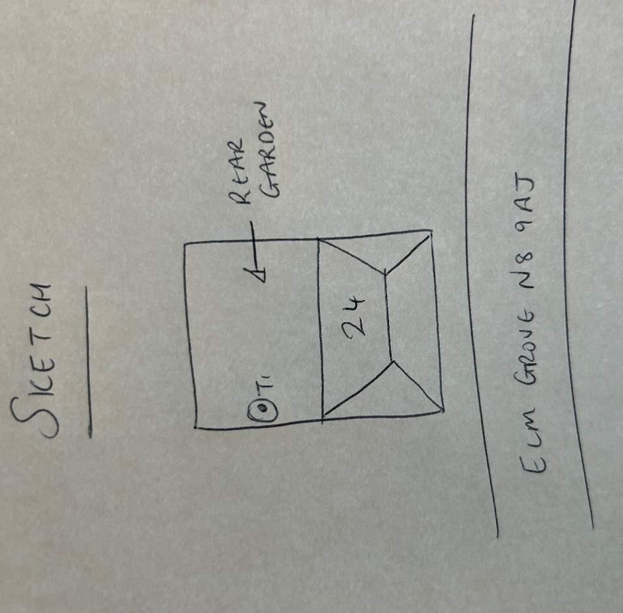
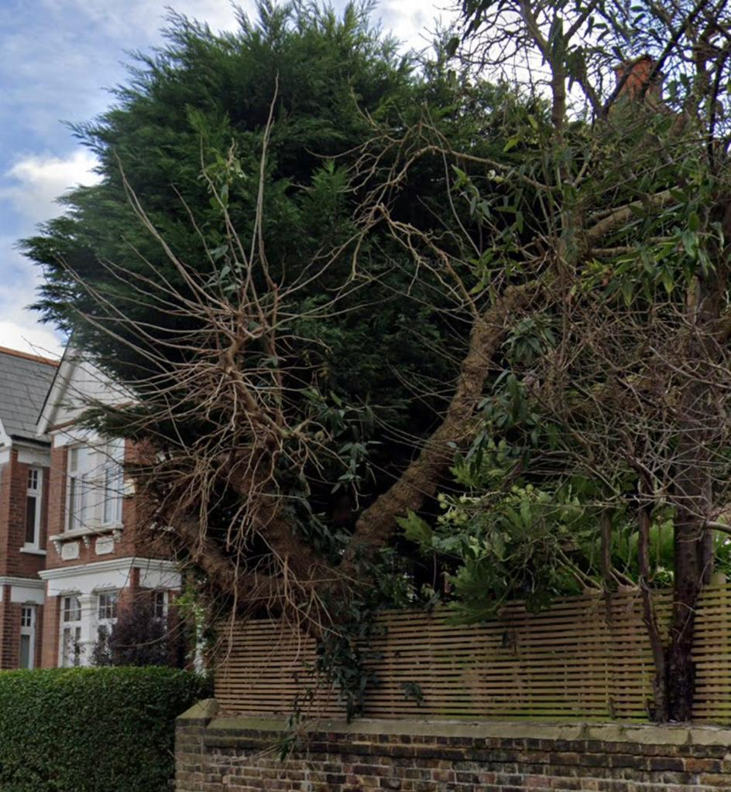
T1: Mulberry (7m): Crown reduce by up to 1m to previous points to keep tree at a size suitable for its location and as part of regular maintenence

