Design & Access Statement
  - Princess Elizabeth House, Winchester Place, London N6 5BQ
JMS Estates (IOM) Ltd
9 Bloomburg Street
London
SW1V 2SB

March 2023
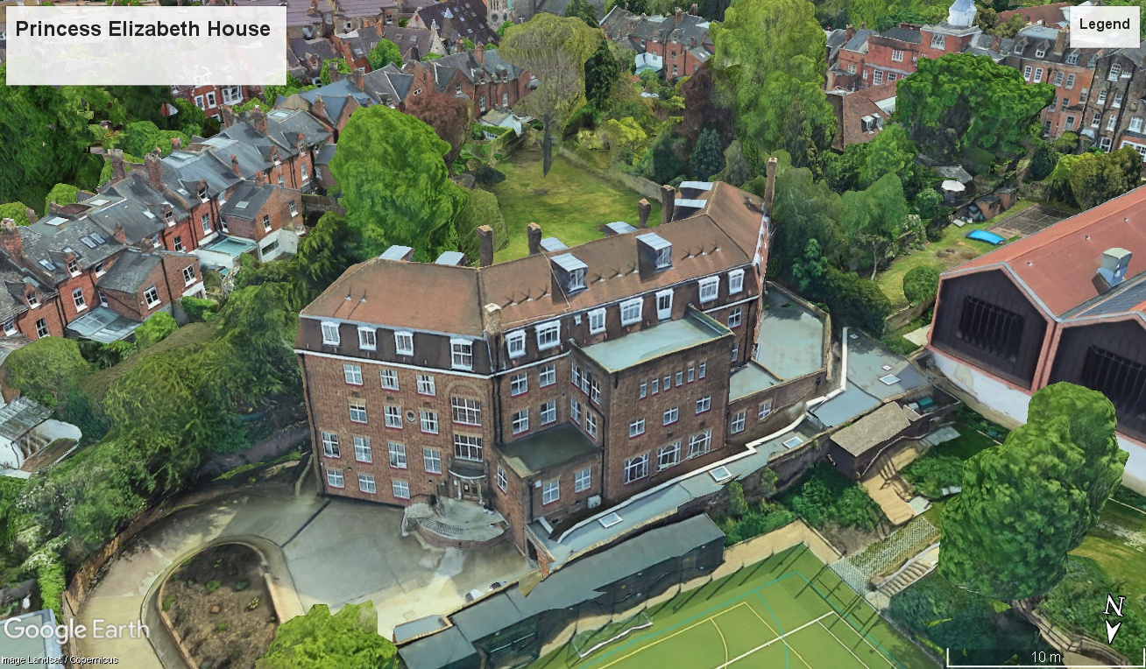

Contents

Introduction 2
Background 2
The Existing Site and Building 3
The Proposal 6
Design Considerations 7
Highways 8
Conclusion 8

Introduction

This Design & Access Statement is a supporting document for a planning application submission to London Borough of Haringey relating to a PV solar panel installation at roof level at Princess Elizabeth House, Winchester Place, London N6 5BQ.
The Statement has been produced on behalf of JMS Estates (IOM) Ltd by Peter Thompson of PTCM. Any query in connection with the document should be addressed to:

Peter Thompson
Project Manager
PTCM
Boytons Farm
Bumpstead Road
Hempstead
Saffron Walden
Essex CB10 2PW

Peter100@ptcm.co.uk

Background

In 2022 JMS Estates Ltd commissioned a survey of the energy-efficiency of their buildings in Central London. The ensuing report identified a number of strategies to render the sites more energy-efficient and which would lower their carbon footprint. Prominent among these was a recommendation to install, where practicable, PV solar panels at roof level at the sites, including at Princess Elizabeth House.

The Existing Site and Building

Elizabeth House was built in 1928-30 to the designs of Richardson and Gill and at the instigation of the Mothercraft Training Society (formerly the Babies of the Empire Society). The building was originally called the Princess Elizabeth Hostel and was opened by its namesake (the wife of George VI and mother of Elizabeth II) in 1930. The building remained in the Mothercraft Society's ownership until 1951 when it was sold to the Metropolitan Police and was used to house police officers. Since the late 1980s Elizabeth House has been in private ownership and is currently in use as student accommodation. The building became Grade II listed in 2005.

Princess Elizabeth House features a two-pitched red tiled mansard roof with lead-sheeted dormer windows at its highest level. The north elevation includes a number of flat GRP roofs and terraces surrounded by brick parapet walls. By virtue of its siting and elevation, and its extensive private grounds, the building is not easily overlooked from the immediate surrounding area. Hence the property is considered a suitable and discrete location for the PV solar array as proposed. Nor will the scheduled installation inflict any irreversible damage to the fabric of the listed building. Should there be any future necessity to dismantle the arrays, all fixings used to support panel tracks will prove readily removable, and making good to tiled/flat roof areas, a straightforward process.
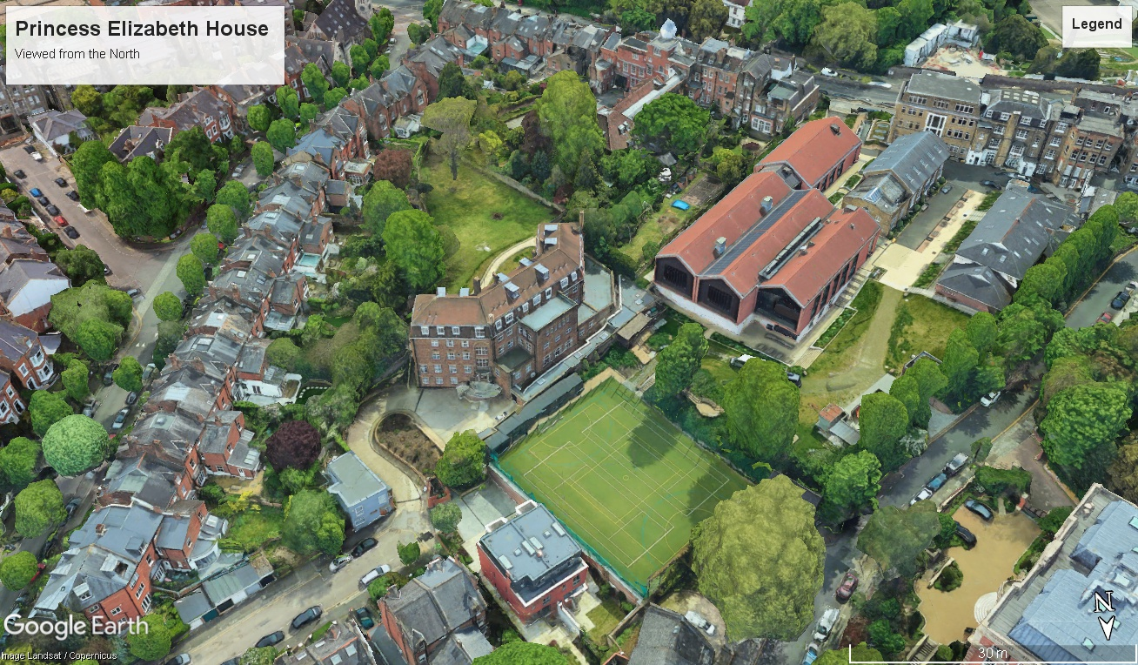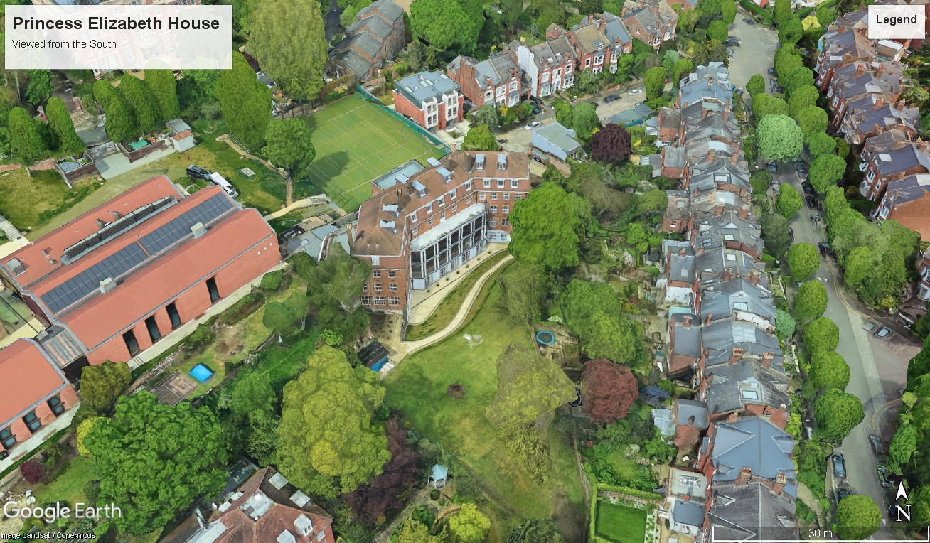

The Proposal

Installation of 51 photovoltaic solar panels at high level: viz on the flat roofs on the northern side of the building and on some areas of the pitched tiled roofs on the south side, as illustrated below:

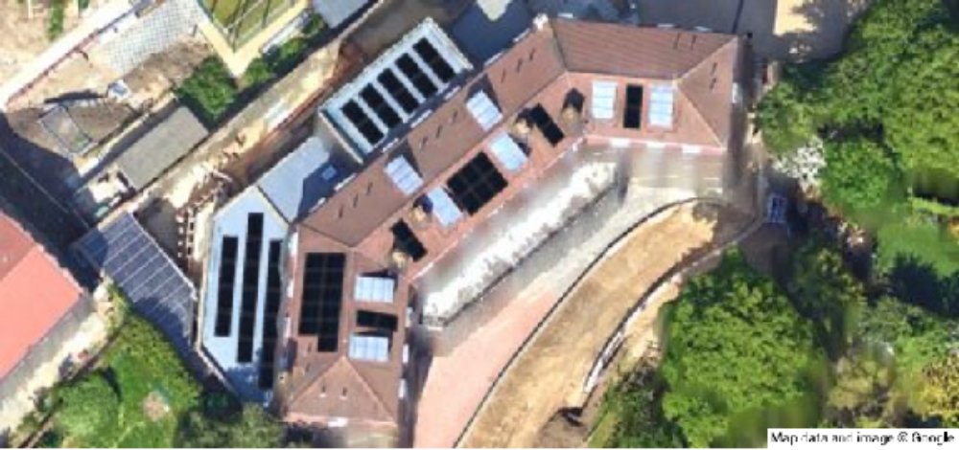

Positioning of Proposed PV Solar Arrays

Design Considerations

This development is proposed to assist the UK in meeting is stated sustainable energy objectives with renewable energy sources. The proposal supports both Energy Security and Climate Change considerations.

A comprehensive technical data sheet forms part of this application providing details regarding the electricity produced annually by the development. In selecting a photovoltaic array producing 20.6kW, designers have been mindful of the need to strike a balance between achieving a worthwhile level of energy production for a commercial building on this scale, and the context of the building in the Highgate conservation area, and the listed status of the property. The proposed installation will result in 15 000kWh of renewable energy being produced each year- and annual saving of 3.8 tons of CO2- with very little impact on the built environment.

The scale of the building ensures the proposal is not excessive in visual appearance. The extent of the solar array has thus been discretely limited to roof areas which not only have a suitable aspect to sunshine, but are not easily glimpsed from the highway at ground level. There are no panels on the steeply-pitched (approx. 70 degrees) mansard roof areas- only the shallower, less visible, upper mansard slopes- and these face into the grounds of the property rather than the Winchester Place ( highway) side.

Panels on the pitched tiled roof are designed to sit within 20 cm of the roof surface. They are not at the highest point of the roof, in accordance with current Planning guidance. Panels on the flat roof are inclined at 10 degrees, raising the top edge to approx. 30cm above the roof surface. However these panels are hidden from view by surrounding parapet walls 60cm in height, and will effectively be invisible in the context of the surrounding area.

The development proposal will not generate noise pollution. It has no moving parts and does not therefore engender any safety concerns in this regard during operation.

The proposed installation will not generate any electro-magnetic interference and will not cause glare issues.

The development proposal will have no impact on the local highway network.

Designers have been mindful of the Health and Safety considerations of installing and maintaining the PV solar array. A discrete man-safe roof safety system is to be installed at high level prior to the works.

Overall, the proposed positioning of PV solar panels at roof level will not impact the character, appearance, or visual amenity of the site and surrounding conservation area.

Highways

The proposal it is considered not to have a significant or material impact on highway safety.

The design poses no risk to pedestrians or residential amenity.

Conclusion

With the above taken into consideration we believe this proposal has no adverse impact upon the site and surrounding area and should be recommended for approval.

END

