26 Avenue Road N6 5DW
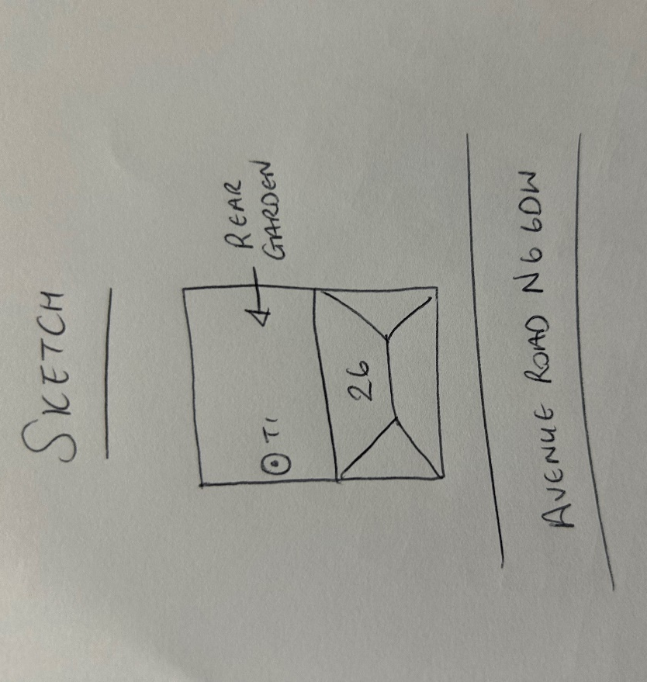
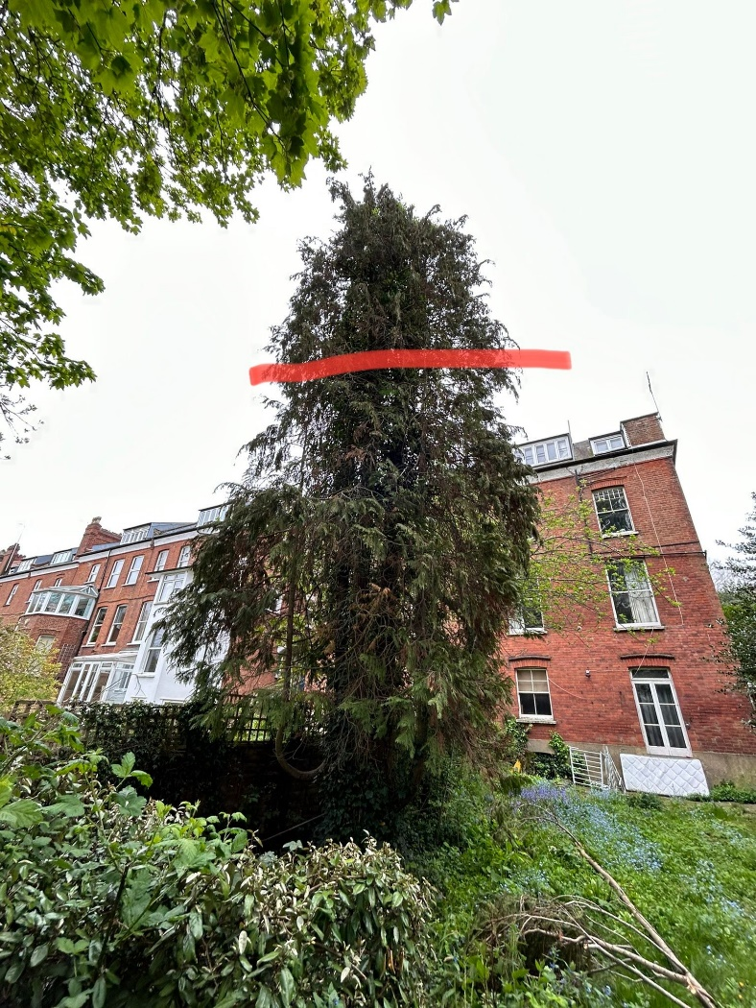
T1: Cypress (12m): Reduce height by 2-3m to reduce risk of branches snapping out and to keep tree at a size suitable for its location

