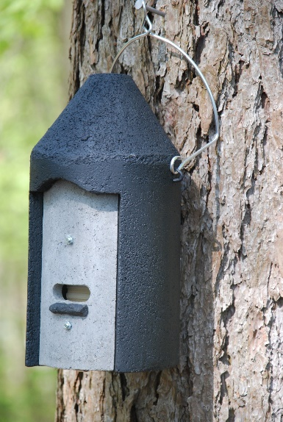 Schweiger 2F Bat Boxes (8 No.)

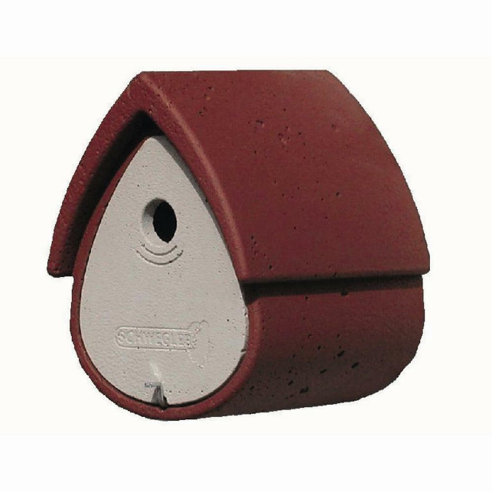 Schweiger 1B Bird Boxes (15 No.)

