DESIGN & ACCESS STATEMENT – 26 LANGDON PARK ROAD

This is a property is an Edwardian, terraced property in a quiet residential road within the Highgate Conservation area.
The proposal is to extend the ground floor with a wrap around.
The design reflects the same principles as the original part of the house and it is viewed that the architectural integrity of the property is not being compromised as a result.
PRECEDENTS
HGY/2015/2438 Flat 1, 58, Langdon Park Road, London, N6 5QG

26 Langdon Park Road Front View
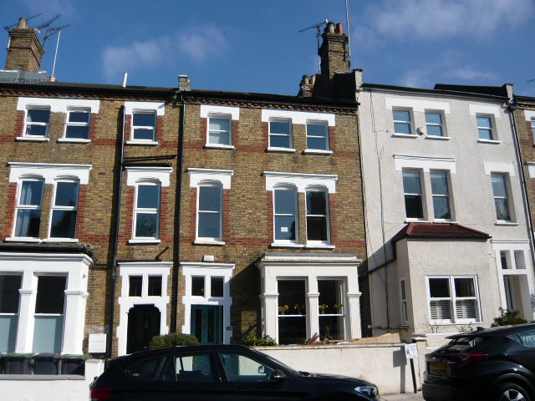

26 Langdon Park Road Rear View
