11 Rookfield Avenue N10 3TS
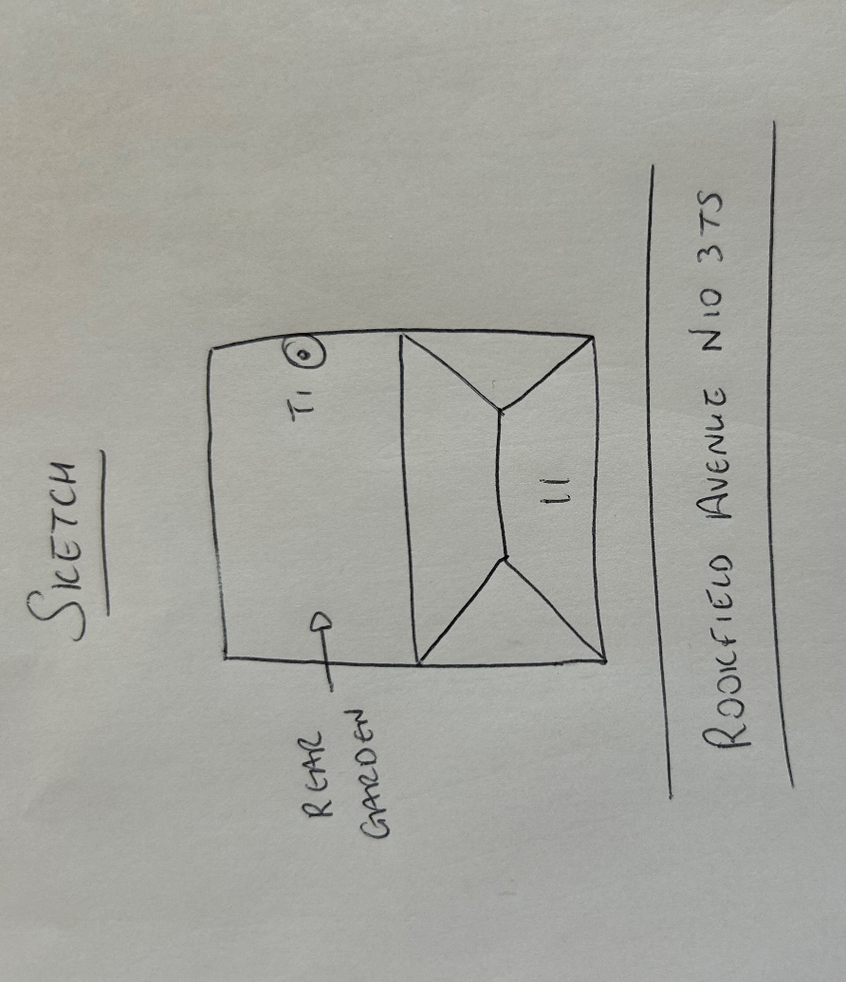
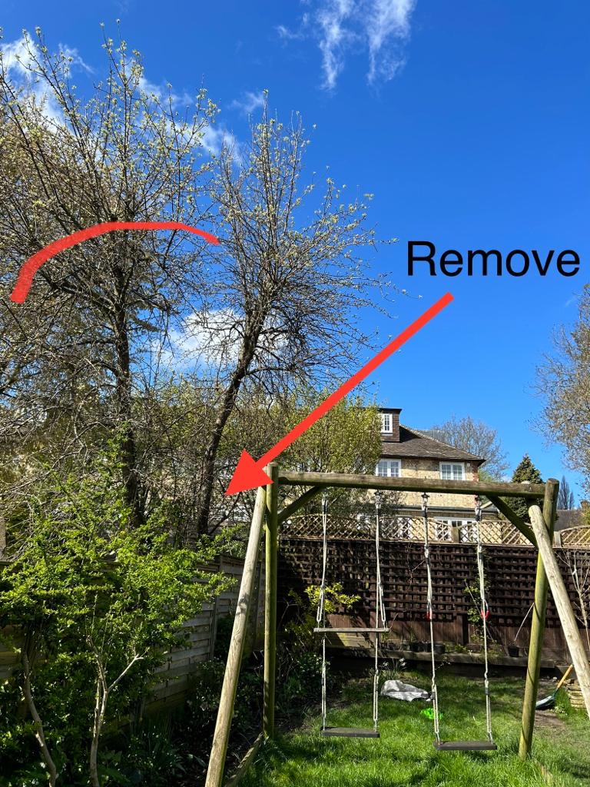
T1: Prunus (6m): Remove 1 stem and reduce remaining stem to allow more light into the garden

