Engineers Report
Risk Address | 9 Grand Avenue  London  London  N10 3AY
360 Reference | LIV-SN-22-005397
Insurer Reference | 100-50-196543
Policy Holder | Mr. John Illman
Date Instructed | 16/09/22
Report Date | 22/11/22

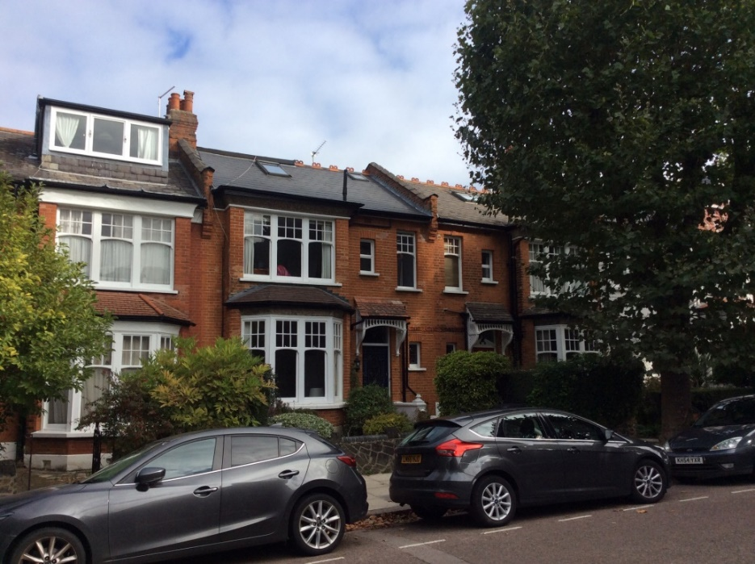

Description of Premises

The insured property is a 5 bedroom mid terrace house constructed in traditional masonry circa 1910. The external walls are understood to be a cavity construction with facing brickwork.
The roof is a traditional pitched roof covered in tiles.
We understand the policyholder purchased the property approximately 36 years ago.
The property is in a residential area of similar type properties, with no apparent adverse site features.
Discovery of Damage
We understand that the policyholder became aware of the cracks to the front of the property in June 2022.

Externally, there are cracks through the mortar joints and stonework at the bay window to the front of the property.

Internally, there are cracks and opening of timberwork at the lounge bay window area.

Video media and photographs were received on 28th September 2022 following our site visit. All information supplied was subsequently reviewed by our Engineer and discussed in detail with the customer on 19th November 2022
Focus of Damage and Report

This document addresses damage notified to insurers in relation to the external cracking and internal investigations.
It should not be considered an exhaustive list. All directions are stated when viewing the property from the front as indicated by the arrow on the below aerial view.
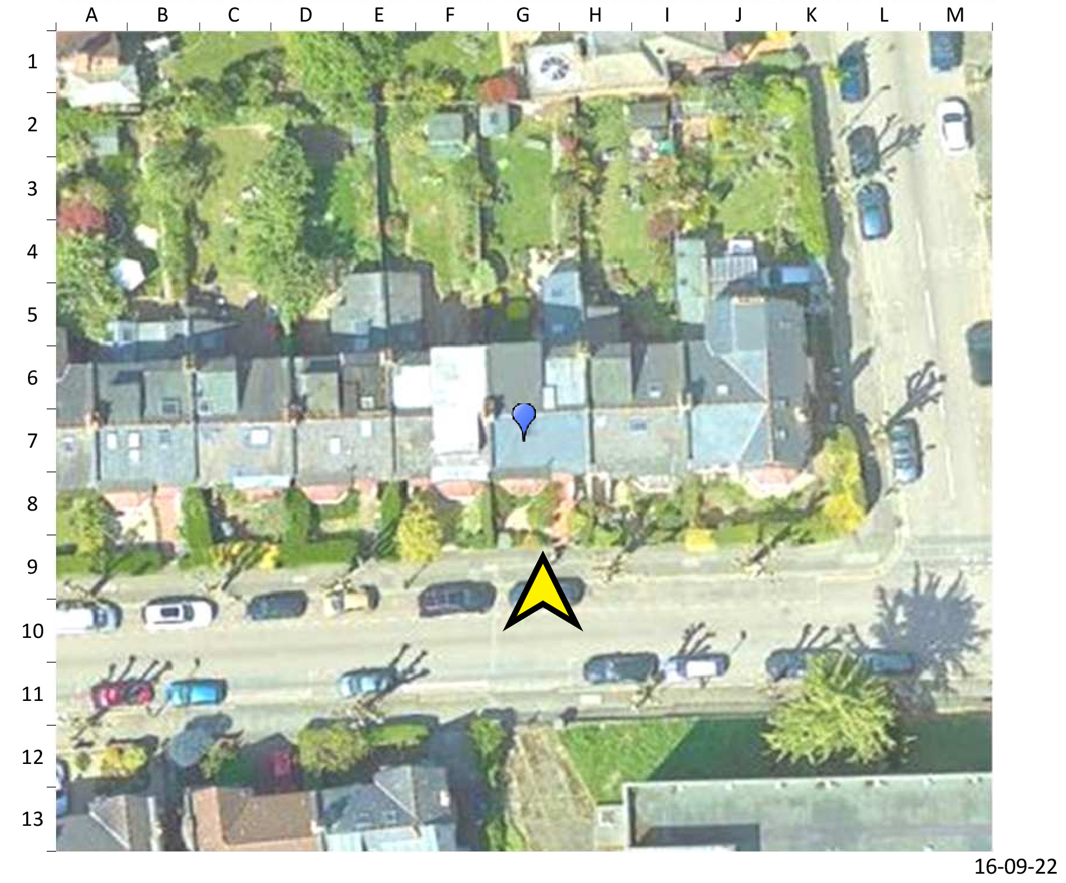

Internal Damage

Internally, damage is present around the bay window joinery with window timberwork and skirting joints opening up. Some movement is apparent.

External Damage

Cracks externally are observed horizontally and diagonally to the brick mortar joints at the front bay window. The stone window sill is cracked and opening joints.
The window timber work is opening up.

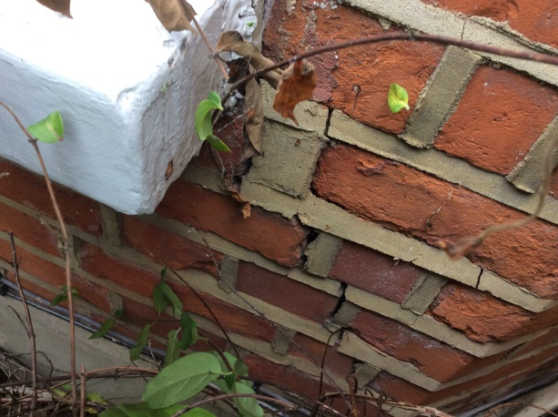 | 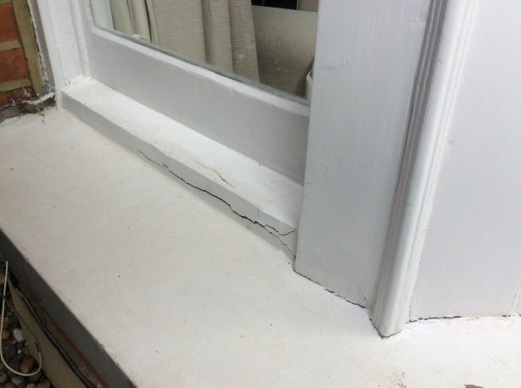
Picture 1: Bay window brickwork | Picture 2: Bay window joinery
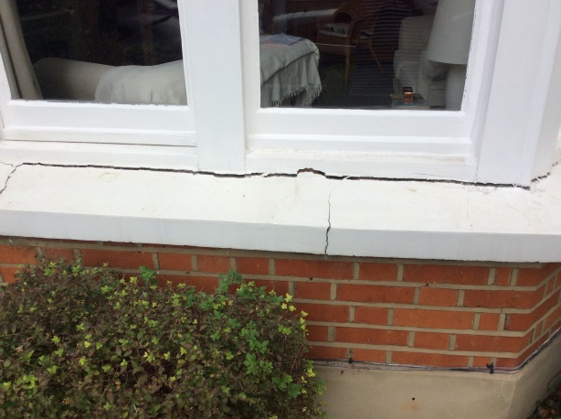 | 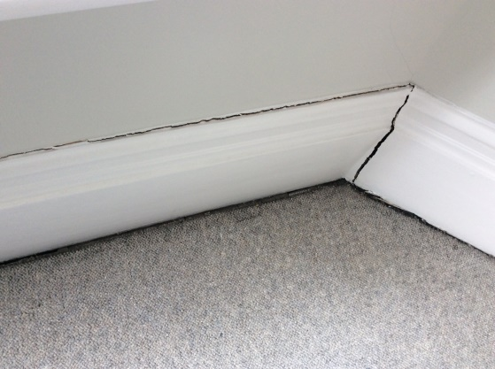
Picture 3: Bay window stonework cracks | Picture 4: bay window skirting
.

Classification of Damage

It is common practice to categorise the damage in accordance with B.R.E. Digest 251 “Assessment of Damage in Low-Rise Buildings”. In this case, the damage falls into Category 3 “Moderate” as there are several cracks up to approximately 5mm wide.

Category | Crack Width | Degree of Damage
0 | Hairline cracks of less than 0.1 mm | Negligible
1 | Typical crack widths are 0.1 to 1mm. | Very slight
2 | Typical crack widths are 1 to 5mm. | Slight
3 | Typical crack widths are 5 to 15mm, or several of, say, 3 mm. | Moderate
4 | Typical crack widths are 15 to 25mm, but also depends on number of cracks. | Severe
5 | Typical crack widths are greater than 25mm but depends on number of cracks. | Very Severe

Site Geology and Ground Conditions

The geological data indicates the superficial make up of the ground to be a London Clay Formation, which has properties of significant shrinkage and low collapsible deposits.
The general soils description is of clay and gravel.

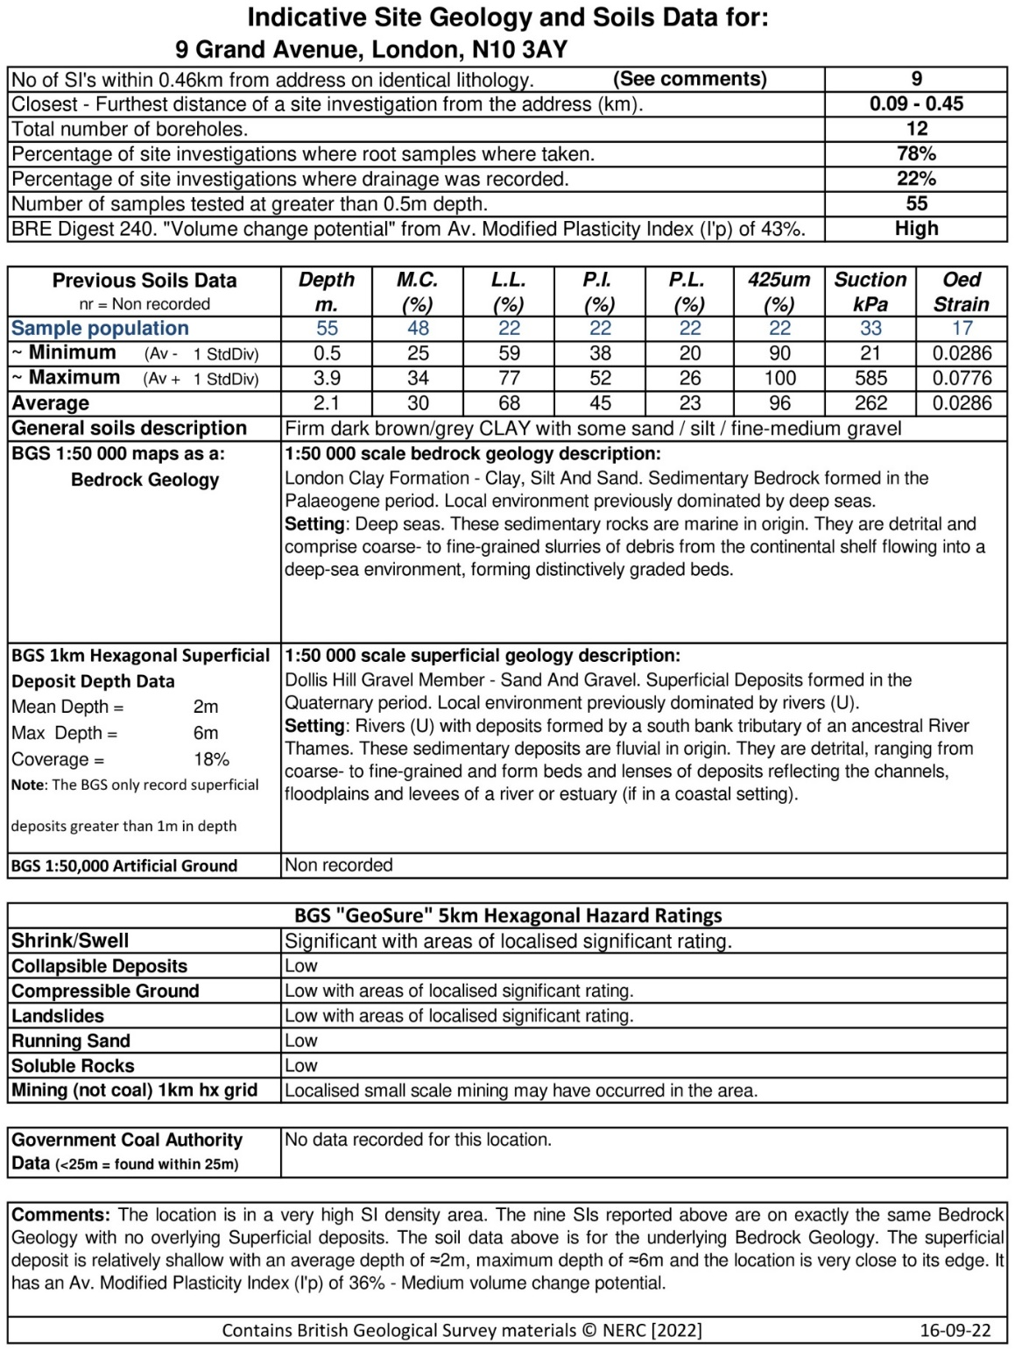

Evidence of External Influences
Trees
There are various shrubs in the garden, and a large Local Authority tree on the highway
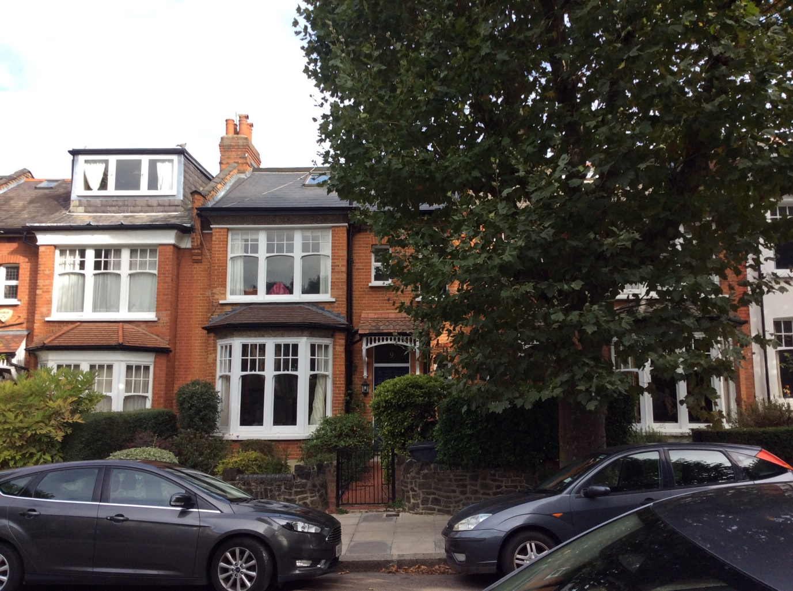

Drains

The property is served by a domestic drainage at the front of the property and surface is dealt with in the same location.
As the tree is close proximity to the drains, and the damage to the property is consistent with affected substrate, we propose to check the drains for collapse or root penetration.

Summary and Conclusions

The pattern and orientation of damage noted to the dwelling is indicative of localised subsidence. A valid claim is therefore accepted for the damage to the property, subject to the subsidence policy excess of £1000.
The cause of the localised subsidence generally orientated at the front of the property and appears to be due to movement caused by changes to the substrate. It is likely that the tree located in the vicinity has caused changes to the ground. It is also possible that the tree has affected a localised drain. The ground is noted as being vulnerable to change given the local changing ground levels.
In order to mitigate further subsidence damage occurring, it will be necessary to investigate the cause of the problem, and this will involve investigations of the drains by use of CCTV.
Should the issue be found to be relating to tree roots, removal of the tree may be necessary. Investigations and communications will take effect accordingly.
Unless there is clear evidence relating to tree damage, removal of trees or vegetation that are protected under the Town & Country Planning Act 1990 or those belonging to third parties can be problematic, and the success of securing any agreement can vary dependant on the individual circumstances. A course of level monitoring may need to be introduced over a 6-month period to obtain evidence that will support our request to the local authority for tree removal, along with any further site investigations deemed necessary.
In any event, it will be necessary to dig trial pits adjacent the house to investigate any issues with the substrate at the foundation. At this point, we will take the opportunity of soil samples.
Following completion of the mitigation works described above, crack repairs and redecoration to the affected areas of the property can proceed. A repair schedule will be drawn up and agreed in due course.
Next Steps
A valid claim arises under the terms of the insurance policy, subject to the applicable excess of £1000, for the localised subsidence damage to the house, generally orientated towards the front.

The key steps required to progress the claim are as follows:

- Contact policyholder and arrange for site investigations to be undertaken at a suitable date. These will include a drainage CCTV survey to be completed
- A trial hole excavation at the front of the house will be necessary
- Instruct an Arborist to survey and identify extent of tree works required to mitigate further damage.
- Liaise with the relevant owners of any implicated vegetation to arrange any recommended tree works if necessary.
- Arrange repairs to leaking drains where required, under the terms of the insurance policy.
- Following completion of above mitigation, allow ground to rehydrate, before proceeding with repairs to the property.

The investigations will reveal the extent of works to vegetation removal/and or drains. After which, it is anticipated that we can establish a period for the ground to recover.
Works will then be required to repair and reinstate the property at the affected areas.
A repair schedule has been drawn up, although this will be finalised following completion of any mitigation measures, as applicable.

Dean Harding-Dempster
360Globalnet Subsidence Team

