Construction Phase Plan
Client | UK Properties One Ltd
Project Site Address | 155 TOTTENHAM LANE, CROUCH END, LONDON N8 9BT
Document Number | CPP-001
Current Revision No | Rev 00
Reason for Issue | Issued for Approval
Date | 22/05/2023

Issue and Revision Record

Principal Contractor | Baffoe Building Services Ltd
Responsible Person | Sam Baffoe
Site Supervisor / Manager | Sam Baffoe
Client | UK Properties One Ltd
Principal Designer | Bla Architects
Site Address | 155 Tottenham Lane, Crouch End, London N8
Expected Duration | 24 Months
Project Start Date | September 2023 | Projected Completion Date | March 2025

Revision | Date | Originator | Checker | Approver | Description
Information class: | Standard
We accept no responsibility for the consequences of this document being relied upon by any other party, or being used for any other purpose, or containing any error or omission which is due to an error or omission in data supplied to us by other parties.
This document contains confidential information and proprietary intellectual property. It should not be shown to other parties without consent from us and from the party which commissioned it.

Contents
Page

Executive Summary 4
  - Our Commitment
  - Our Approach

- Introduction 6

- Safety to the Public 6

- Site Rules 7

- Site Inductions 8

- Welfare 8

- Access and Egress 9

- Demolition and new build works 9

- Internal Finishes and Services 9

- Final External Finishes 11

- Communication 11

- Emergency Procedures 11

- In the case of a accident 12

- Emergency Contact Details 13

- Arrangement for Contractors risks to Health and Safety 15

- Development of the Health and Safety Plan 19

- Pollution control 19

- Noise 20

- Waste Management 21

- Security 21

- Party wall act 1996 22

- Transport and Logistics 22

- Good Neighbouring Policy 23

- Nearest Hospital 24

- Travel Links 25

Executive Summary

Our Commitment
Baffoe Building Services Ltd is committed to supporting the health, safety, and security of all its employees and to ensuring that high standards of health, safety and security at work are embedded as life skills to keep everyone safe all the time.

We take all reasonably practicable measures to eliminate hazards and minimise the risks to staff or others, both those of whom we have a duty of care and those who may be affected by our work, and to continually improve our systems and practices.

We are committed to integrating health, safety, and security into everything we do, to achieving zero harm, and to continually improve our systems and practices.

Continuous improvement is essential to eliminating harm in our workplaces.

Our Approach
- We use hazard identification and risk assessment to ensure that we have the right risk controls in place that minimise the chances of injury or ill health through safe systems of work.

- We have channels of communication which encourage all employees and their representatives to contribute to improvements in our health and safety performance.

- We make sure that health and safety is an essential factor in the selection and management of supply chain partners.

- Our employees are provided with information, training, instructions, behavioural observations, and supervision/monitoring (as appropriate) to ensure they are competent to perform their roles.

- We utilise external Health & Safety Services to undergo regular audit reviews and training to ensure we meet our legal responsibilities under the Management of Health & Safety at Work Regulations.

Introduction
The property known as 155 Tottenham Lane, Crouch End, London N8 9BT is a combination of a retail unit on the ground floor previously used as a retail store with offices and further storage to the rear. On the 1st floor at the rear commercial office space is allocated on the 1st floor. To the front elevation on the side is access to the 1st floor residential accommodation which is to remain habitable throughout the construction phase. Planning permission has been granted on the 9th February 2022 for:- Change of use and conversion of the warehouse/ office part of the buildings into residential use to provide 4 new flats.

This retail element of the site is currently occupied as a decorator’s business with storage to the rear and will be made vacant prior to construction works commencing. The warehouse/office will also be made vacant for the conversion process to commence. Notice has been served to the current tenants and property has been planned for full vacant possession in July 2023.

The property is on the A103 Tottenham Lane and has no restrictions of a listed or Archaeological historical interest.

- It is recognized that when construction sites are poorly managed, they often have a detrimental impact on the local neighbourhood. The purpose of this plan is to strategize a method to minimize the negative effects that could arise as the result of construction works.

Safety to Public
The security measures above will prevent accidental trespass by the public onto the site. Measures will be taken to minimise injury through any form of unauthorised entry by way of the erection of pedestrian barriers and through clear warning signage. In the event of members of the public gaining access to the site for whatever reason the following measures will be put in place.
    - All ladder access to scaffolds to be made unusable at the end of each working day.
    - All appropriate signage is in place to warn the public of the dangers of entering unauthorized onto a construction site. Signage is in place to prescribe the health and safety requirements to make an authorized entry onto the site, including hard hats and shoes, high visibility clothing and report to site manager directly upon entering as a visitor.

Site Rules

Site Rules
- ALL operatives and Visitors must sign in prior to entering the site
and sign out each time they leave.
- Operatives and personnel must wear hi-viz jackets and safety footwear at all times EXCEPT where agreed on site with the site manager, any breach of this will result in asking that person to leave site until this is rectified. The wearing of shorts is prohibited.
- Safety hats must be worn in all areas where overheads works are being carried out. These areas shall be designated by suitable barriers and signs provided by the contractor undertaking the works.
- Whilst on site everyone must conduct themselves with due regard for the safety of themselves and others.
- The drinking of alcohol or the illegal use of drugs whist on site is not permitted. ANYONE suspected of being in breach of this rule will be refused entry onto site or removed from site.
- Smoking will not be allowed except in designated external areas.
Personnel must not Interference with scaffolding or other safety equipment designed for safety purposes such as fire extinguishers, machine guards etc…
- Mobile phones MUST NOT be used while simultaneously undertaking work activities. Similarly, the use of MP3 players or personal equipment involving the use of headphones or earpieces is strictly prohibited on site.
- All access and egress routes to be kept clear of obstruction clean and free of debris and materials at all times.
- All accidents, near misses, dangerous occurrences, and any injuries to any operative or visitor must be reported in the accident book on site.
- Method Statements and Risks assessments will be in place for each site activity and must be understood and followed by the operative concerned.
- All hazardous substances must be formally risk assessed by the contractor, under COSHH, before work commences.
- Electrical, Roof Access and Hot Works will only be carried out by operatives trained in such works. Baffoe Management Project Manager, prior to commencing work.
- All equipment brought onto site must have an in-date test record and comply with current regulations. This equipment only to be operated by trained and qualified person(s).
- Access to any areas not directly associated with the work in hand is strictly prohibited.
- Any substances suspected as being asbestos or any similar hazardous material must NOT be disturbed by unauthorised personnel, but they should be reported immediately to the Site Manager for further action.
- Loading, unloading and parking of vehicles to be carried out under the supervisor’s directions and must be adhered to at all times.
- In the event of fire, all personnel must follow the procedures outlined on the Fire Action Notices located at call points throughout the building.

Site Inductions

Site Induction
All Operatives on this project will attend Site Induction to be made aware of the risks to each of them and the measures in place to protect them from harm, prior to commencing work on site. This information will be updated as and when changes occur and will be supplied to all
operatives i.e. employed, self-employed; by either Toolbox Talks or Team Briefings. Baffoe Building Services are aware or their duties and will give notice of changes to all concerned. The Construction Phase Management Plan will be brought to the attention of all Contractors
before their commencement on site and they will return, before start of their works, a full method statements and risk assessments identifying any significant hazards involved in their works. Every Contractor is responsible for ensuring all their operatives have been taken through risk assessments and method statements etc and have signed and dated an acknowledgement. to this effect. All documentation will be available for inspection in the site office and Baffoe Building Services will be responsible for ensuring all information that may be required by others will be added to the plan, i.e. Health and Safety Policies, COSHH, Noise, PPE, Manual Handling Assessments, Statutory Inspection Records, Lifting plans etc.

Welfare

Welfare
Temporary welfare facilities and water will be available throughout the duration of the project located within the existing commercial premises to the front of the building. Welfare facilities will comply with current Welfare and ‘CDM’ regulations as a minimum requirement. It is a requisite that persons using the welfare facilities are to ensure that they are left in a clean state. This will be discussed at site induction.

Access and Egress

Access and egress – During the Construction phase.
To the rear of the property has 2 access points, 1 is located via communal road off Ferme Park Road. A shutter is located via this access and this will be kept closed at all times other than when access for materials is required. Material will be off loaded in manageable quantities and either manually transported to the side access or via a moffet or fork lift provided by the logistics supplier. Materials will be transported to the rear access in a controlled manner preventing minimal disturbance for local residents. The residents will be contacted on a daily basis and agree mutual times to transport materials and clear debris. All debris to be bagged and using manual lifting facility to be transported down to Ferne Park Road. To the west of 155 Tottenham Lane a communal access is available at 157 Tottenham Lane. Access will only be granted via a agreed route with the neighbouring building owners. This is not a preferred route and works to be planned to prevent access to be used. There is a low-level canopy and a materials will only be transported via this route with prior agreement. The access area will eventually be made good on completions should any damage be found. All access areas will be kept closed out of working hours and maintained as required.

Demolition & New Build Works

Demolition phase –
- The extent of the demolition phase covers the demolition of internal walls and floors to suit the approved plans.
- Prior to beginning works an intrusive asbestos survey will be carried out and asbestos will be disposed of via the correct method.
- All services will be located and isolated.
- There will be a temporary site office and welfare facilities set up within the existing building isolated for the construction works area.
- The first stage demolition will commence to clear out the existing building including ceilings, non-supporting walls, floor coverings, and existing services.
- Any demolition of the structure will be via the top-down method, all the demolition works will be carried out by hand tool method and to prevent minimum disruption to adjacent businesses and residents..
- All debris from demolition will be bagged and segregated and then will be disposed of in relevant segregated mobile skips.

Construction Phase – Duration 20 months with a 3-month snagging period inclusive.
- During this phase following works will be carried out:
- Foundation work to the rear of the development.
- Construction of the external envelope include structural alteration to form proposed building as approved planning design.
- Install the new primary steelwork to first floors (to structural engineer’s design).
- Remove and replace existing timber floors to levels required (to structural engineer’s design).
- Remove the existing ground floor structure and replace with composite steel and timber floor.
- Install new drainage below ground to suit new design.
- Commence the new brickwork extensions to construct new upper level.
- Install new steelwork to form top level and support roof.
- New timber joist floors in the upper levels.
- Install roof structure and corresponding vapour membrane with new roof to match existing.
- Install of windows to enable building to be watertight.
- Install of party walls to for residential units to ground and 1st floor.
- Timber partition walls internally constructed to form the new room layouts.
- Install of utility services to development
- Internal fit out
- Landscape to courtyard
- Fit out of commercial unit
- Commissioning and final completion
- Handover to client completed development.

During the construction phase, all the waste materials will be bagged up and at agreed times be off loaded to mobile skips with waiting time.

Internal Finishing’s and Services
The mechanical, electrical and gas rising services and mains will be installed to the riser ducts, etc. working up the building to the top floor.

At the same time, the plumbing installation of stacks/SVP will continue followed by 1st fix plumbing and electrics. The internal plasterboard partitions and dry lining will commence working up the building.

The second fix joinery and the installation of the 2nd fix electrical and mechanical services and final testing of systems and commissioning will be followed by the decorations and floor coverings.

Each flat and communal parts will be snagged and de-snagged. The final client’s inspection and handover will follow on after de-snagging.

Final External Finishes
The external works will commence once the envelope is complete and all external furniture and decoration will be completed prior to scaffold being struck.

Communication
At the start of the works on site, the contractor will nominate a member of staff to be the point of contact for any comments on the works.

This person will be fully aware of the vehicle movements on site as well as the expected works in the fourth coming weeks.

Emergency Procedures
Operatives will be informed at the site induction of Fire Points and the notices that denote their location. Operatives and other occupants will again be informed if Fire Point locations change i.e. due to works progress. Particular attention will be paid to fire protection and security; arrangements will be made to safeguard the access and emergency exits during the progress of the works.

Baffoe Building Services Limited has allocated one fire safety co-coordinator for this project to ensure the maintenance of the above and to implement emergency evacuation procedures in the event of serious and imminent danger. Routes will be identified on site using signs as necessary.

Baffoe Building Services Limited will have an Accident Book on site for recording any incidents, however due to Data Protection Act it’s envisaged the Safety-First Online portal is utilised for all accident reporting. Any incident which is governed by the current ‘Reporting of Injuries Diseases and Dangerous Occurrences Regulations’ (RIDDOR) legislation will be recorded / reported by the Site Manager.

The Site Manager must immediately be informed of any occurrence on site.
The projects emergency procedures as well as the Site Safety Plan will be discussed during the site induction.

In the Case of a Accident
- DO NOT ATTEMPT TO MOVE ANYONE
- ENSURE THE SAFETY OF OTHER PERSONNEL
- INFORM BAFFOE CONSTRUCTION STAFF AND ALL OTHERS ON SITE
- USE A MOBILE PHONE TO SUMMON EMERGENCY SERVICES
- THE FIRST AID BOX IS LOCATED IN THE SITE OFFICE

In the Case of Fire

- IF SAFE TO DO SO AND SUITABLY TRAINED - EXTINGUISH FIRE WITH SITE APPLIANCES LOCATED AT EACH DWELLING
- RAISE THE ALARM BY SHOUTING ‘FIRE’ AND ACTIVATE THE ALARM
- NOTIFY ALL BAFFOE BUILDING SERVICES STAFF AND ALL OTHERS ON SITE
- CALL EMERGENCY SERVICE FROM PHONE IN SITE OFFICE
- GO TO THE ASSEMBLY POINT THAT HAS BEEN ESTABLISHED AND WAIT TO BE ADVISED ON WHEN IT’S SAFE TO RE-ENTER

13.1 Fire & Emergency Procedures
- Every effort will be made to prevent the outbreak of fire.
- There will be NO SMOKING on site other than in designated smoking zones, a mandatory requirement of the Client and Principal Contractor in compliance with the Health Act 2007.
- Fire boards and manual alarms will be positioned on each floor for the duration of works.
- Emergency escape route arrows will be positioned throughout the development.
- All personnel will be responsible for following the Emergency Procedure.

Emergency Contact Numbers
Emergency Telephone Numbers: Should undetected services not shown on drawings become affected during works, emergency telephone numbers are listed below.

Baffoe Building services Limited. Contact Numbers

Sam Baffoe Site Manager Mobile 07952 406 877
sam@baffoebuildingservices.co.uk

Sarah Baffoe Administration Manager Mobile 07484 704 236
sarah@baffoebuildingservices.co.uk

For detailed information of Utilities

SERVICE | COMPANY | ADDRESS | TELEPHONE | EMERGENCY TEL.
Gas | Corona Gas  British Gas  Total Gas & Power  SSE Gas  Utilities Warehouse |  | 0800 804 8589  0333 202 9802  0333 003 7874  0345 026 2658  0800 111 999 | 0800 111 999  0800 111 999  0800 111 999  0800 111 999  0800 111 999
Electricity | UKPN |  | 0800 028 0247 | 0800 028 0247  0800 111 999
Water | Thames Water | Clearwater Court,  Vastern Road,  Reading RG1 8DB. |  | 0800 316 9800
Drainage | Thames Water | Clearwater Court,  Vastern Road,  Reading RG1 8DB. |  | 0800 316 9800
Telephone Comms | TBC
Environment Agency |  | National Customer Contact Centre  PO Box 544  Rotherha  S60 1BY |  | 03708 506 506
Hospital | NHS | Whittington Hospital Magdala Avenue London N19 5NF |  | 0207 272 3070
Police |  | Wood Green Police Station  347 High Road London N22 8HU |  | 0207 230 1212  999  112  Deaf or Hard of hearing 18000

Health and Safety Executive
Construction HSE office: -
10 South Colonnade London E14 4PU, Tel: 0300 003 1647

The Health and Safety Executive RIDDOR incident reporting centre contact number is 0345 300 9923. Websites: www.riddor.gov.uk or www.hse.gov.uk

Serving of notices by the Health and Safety Executive

The Principal Contractor must issue written notification to the Client, Principal Designer and all named Designers within 24 hours of receipt of any of the following from the Health and Safety Executive:
- Fee for Intervention (FFI)
- Improvement Notice
- Prohibition Notice
- Summons

Arrangements for controlling Risks to Health & Safety
The following information is a compilation of risks relevant to this site and is in addition to the requirements and controls to be met and detailed in the Health and Safety Policy of Baffoe Building services Ltd.

15.1 General

This will remain a hard hat site with hi vis and toe protection worn at all times, by all trades. Specific PPE will be worn as denoted by the individual RAM’s.

All equipment on site is to be 110 V or battery powered with all leads etc to IEE 18th Edition Wiring Regulations or battery powered.

All steps or ladders are to be either CLASS ONE or BS EN 131 specifications only on site, and to be used for access only.

Public and communal areas will be maintained free of obstructions at all times and when necessary protected e.g. guarding of skips. The presence of the general public, surrounding units, staff, delivery personnel, and passing traffic will be given due consideration at all times.

Removal of existing persons belongings will be a critical element required at the outset. The works will be carefully reviewed in conjunction with the particular S/C or if completed by Baffoe Building services Ltd directly managed in a controlled manner.

Baffoe Building services Ltd will consider what precautions will be employed during the execution of normal building activities and in particular hot or noisy work. If, during the course of the works, woodworking operations are to take place on site, Baffoe Building services Ltd will ensure the limitation or control of the production of dust arising from such operations, particularly in relation to hardwoods. Similar consideration will also be given to chasing existing surfaces for preparatory cable and pipe work installation, as may be required.

All operatives have regular “toolbox talks” on Baffoe Building services Ltd sites where relevant site issues are covered. These TBT’s will be completed in line with the programme of works, i.e. “Weill’s Disease” at the outset due the removal of waste at ground level which maybe housing vermin; “Working at Height” in conjunction with the roofing works.

An up to date visitor’s book will be available in the site entrance to record those persons present on site, including all visitors. The Security team monitors persons access and egress.

All statutory notices required by law will be displayed in suitable positions.

15.2 Manual Handling

Manual handling operations will be avoided where reasonably practicable by using mechanical or automatic means, however where manual-handling operations cannot be avoided, operatives will be instructed in load reduction and suitable lifting techniques, using kinetic lifting as a basis.

15.3 Hazardous substances

The works include, but not exclusive to, elements of plastering, cement-based products and painting which may involve the use or encounter with plasters, glues, varnishes and noxious paints. Consideration will be given to executing works using less hazardous substitutes when available, or the using of such materials off site in a controlled environment.

Where the use of any such material on site is unavoidable, Safety Data Sheets will be obtained and a COSHH Assessment generated to provide recommendations and precautions necessary for safe use of the product as part of Baffoe Building services Ltd development of the Health and Safety Plan.

15.4 Electrical Supplies on site
Temporary 110-volt supply will be used to provide supply to low volt power tools and festoon lighting. A temporary 240-volt supply protected by RCD’s may also be connected to provide power for computer, chargers and low current appliances for welfare needs. Total loadings must be within the rated capacity of supply. All works to be compliant with Electricity Regulations BS 7671:2018 and IEE 18th Edition, installed by competent persons.

15.5 Protection from falls and falling objects.
All open edges must be highlighted and over 600 mm high be protected by fixed barriers to prevent falls.
All work at height must be carried out from podiums, Fixed or Zip Scaffold erected by competent personnel in compliance with TG 20 or PASMA and manufacturer specification and current Work at Height Regulations.
Ladders and Step ladders should only be used for access to a platform or in areas where a platform cannot be easily erected. They should only be used for tasks of short duration (< 30 minutes). Ladders should be mounted off a secure level base and footed or lashed to prevent slipping. Steps should be used in accordance with manufacturer instruction. (the apex must never be used to gain height). The top 2 steps must not be used. Only step ladders with purpose designed handrails may be used to the standing platform. An assistant must be used to aid stability of these during all works. All ladders and Step Ladders must be Class 1 and comply with BS 131 Industrial Grade and be individually identified and regularly inspected for damage or fault, and records maintained.
Work with or near fragile materials / structures will be carried out under Permit to Work conditions following consideration of a submitted, detailed Method Statement and Risk / COSHH assessment. Control measures will be identified and affected.

15.6 Work in confined spaces
Potential for confined spaces where there is a likelihood of an oxygen deficient atmosphere being present must be identified by a competent person. All works within this area must be risk assessed and adequate measures put in place to minimise the risk of poisoning or suffocation. Measures must include monitoring at all times during the works; means of escape; on site emergency response; a suitable Confined Space Permit to Work management system. All personnel involved must be trained and deemed competent to work under these conditions
Elements of the contract which this may affect include, drainage installations, lift works, however, will not be known until all areas are made safe and access can be facilitated. If needed a suitable plan will be implemented in conjunction with RAM’s being completed.

15.7 Work on or near excavations
Adequate controls must be put in place to prevent personnel, public or plant accidentally falling into an excavation. Suitable barriers must enclose the excavation and notices be posted informing of the presence. Mobile plant operating in close proximity must be protected by suitable stop blocks and use of banksman when tipping loads into the excavation.
Upon completion of the full design and drain inverts ascertained this section can be expanded and the works covered by site specific RAM’s.

15.8 Work on or near live services
This work must be carried out by competent personnel under Permit to Work conditions following consideration of submitted method statement and risk / COSHH assessment. Location of services must be identified, and the area closed off from others not involved, by barrier or cordon as necessary. Services must be isolated and disconnected from supply where possible. Electrical works must be carried out using tools suitably insulated and a safe system of work employed to ensure safe working conditions. Any excavation must be by hand within 500 mm of known live services using spade only. Pointed implements must not be used.

15.9 The storage, use and distribution of materials including those of a hazardous nature.
A suitable and sufficient COSHH Assessment must be created for each identified hazardous substance. All users must be familiar with the COSHH assessment and controls to prevent harm.
Hazardous materials must not be stored within the building.
Flammable materials must be stored in small quantities only, within a fireproof container with closed cover / doors at all times. Containers must be sealed to prevent release of fumes and prevented from falling over. The main container must be located in a cool area clear of any heat source or activity likely to generate heat or naked flame. It must be secured accordingly.
All substances must be used and stored in compliance with manufacturer instructions, COSHH assessment and suitable safe system of work. Personnel using materials must follow a suitable safe system of work and wear personal protective equipment as specified for the duration of task.
Measures must be in place for dealing with accidental spills to prevent leaching into ground systems and to ensure safe collection and disposal. Substances must not be disposed of into foul or surface water sewers but should be held in containers for safe disposal via authorised waste management. Waste must be removed to designated waste skips by the end of every shift.

15.10 Delivery of materials and removal of waste will be arranged such that all risks are minimised in respect of public pedestrians and road traffic. The busy carriageway has significant sections of ‘double yellows’ and significant constraints on parking. The Site Manager will make suitable arrangements in order to comply with road traffic regulations etc.
A materials delivery and traffic / pedestrian site plan will be created and will identify drop off / storage areas.
Deliveries will be pre-planned to ensure a back log of vehicles does not happen, especially on Brixton Road. Parking of deliveries in the near vicinity is to be discouraged, due to the potential impact on surrounding occupants. To reduce potential problems with deliveries peak times will be avoided for large deliveries, i.e. 08.00 – 09.00 and 15.00 – 18.00. Small deliveries via transit vans maybe facilitated, however reviewed continually and if deemed problematic managed in the same way as large deliveries

15.11 Storage of Materials
Locations are to be identified within the area and to be clear of access & egress routes.
At no time will material stacked exceed 1 pallet1 high or advised floor loadings.

Development of the Health and Safety Plan
Baffoe Building Services Limited, throughout the life of the project, will continually develop this Health and Safety Plan/ Construction Phase Plan. It will become a site specific document which sets out the arrangements for securing the Health and Safety of all those carrying out the work and all others who may be affected by it.

While developing the Health and Safety Plan, Baffoe Building Services will identify the hazards and assess the risks at each of the main stages of the construction phase. And will also ensure the Safety Plan is kept up to date, modified and altered in the light of changing circumstances. Any Information from contractors will invariably mean parts of the Health and Safety Plan will have to be amended and updated. All amendments will be highlighted for ease of review.

Reviews of parts of the Health and Safety Plan may also need to be made if there are design changes, unforeseen circumstances etc. It is vital that such changes are notified to all those working on site who may be affected. Baffoe Building Services will update, amend and modify as necessary the Safety Plan to address any Health and Safety risks associated with individual design elements modified during the works. To ensure at all times that the Plan may be considered suitable and sufficient.

Pollution Control
Emissions from internal combustion engines in lorries, construction plant, diesel generators etc., are recognized as air pollutants on construction sites.

To limit the emissions produced during construction the following rules and procedures will apply.
    - All vehicles awaiting loading / unloading will switch off engines.
    - All construction plant will switch off engines during periods of waiting between operations.
    - All plant and site vehicles will be serviced on a regular basis to ensure maximum efficiency.

Risk of leakage from stored fuel
A potential risk of ground pollution lies in the spillage of diesel fuel oil if not stored and handled in an environmentally sound manner. As a precaution Baffoe Building Services Ltd will not be storing fuel on site. As a precaution the following will be adhered should fuel storage be required.

    - All fuel oil stored on site will be kept in purpose made, double skinned and bunded tanks.
    - Fuel filler guns will be locked and operated only by authorized personnel.
    - On no occasion will fuel be kept and dispensed from drums or other containers.

Dust from construction and demolition activities
During dry weather the dust generated from some demolition and construction activities can impact on the local environment by not only contaminating the atmosphere but by the deposits on neighbouring property and possessions.

To avoid this situation occurring, the following methods of control will be adopted.
    - Delay or suspend dust producing operations.
    - If operations must continue, initiate a “wetting down” regime to prevent the production of dust. This would normally take the form of using hoses to treat the area of concern.

Noise
Noise from construction sites cannot by the nature of the activities and machinery used, be eliminated.

It can however be controlled and reduced to a minimum level by a number of measures as outlined below, all of which will form a part of the operating strategy for the site.
    - Switch off all engines when not operating or are waiting on other operations to take place.
    - Ensure that all vehicles and items of plant are fitted with effective silencers.
    - Ban the use of radios and portable music devices on site.
    - Plan operations to limit noise generation to the least sensitive times of the working day, i.e. avoiding early mornings, Saturday mornings etc.
    - Observe the permitted hours of working and ensure that plant “start-up” is not in advance of the earliest permitted working time

Waste Management
When dealing with waste at the site we will detail in a site waste management plan ensuring.
- All waste from site is dealt with in accordance with the waste ‘Duty of Care’ in Section 34, Environmental Protection Act 1990 and the Environmental Protection (Duty of Care) Regulations 1991; and
- The material will be handled efficiently, and waste managed appropriately.
- Material reuse, recycling, and recovery are maximized where reasonably practicable.
- The Plan will be reviewed, revised, and refined as necessary, to ensure that any changes irrespective roles and responsibilities are clearly communicated to those affected.
- Take reasonable steps to ensure that sufficient site security measures are in place to prevent the illegal disposal of waste from the site.

Security
An effective system of site security will be instigated to minimize the risk of theft and vandalism which often plagues an area where construction activities are taking place.
    - The site will be enclosed with metal shutters, secured in place to prevent unauthorised access to the front on Tottenham Lane.
    - To the rear of the property has 2 access points, 1 is located via communal road off Ferme Park Road. A shutter is located via this access, this will be kept closed at all times other than when access for materials is required. Large materials will be transported to the rear access in a controlled manner preventing minimal disturbance for local residents. To the west of 155 Tottenham Lane a communal access is available, but access will only be granted via a agreed route with the neighbouring building owners. There is a low-level canopy and a materials will only be transported via this route with prior agreement. The access area will eventually be made good on completions should any damage be found. All access areas will be kept closed out of working hours and maintained as required.
    - Any scaffolding erected, access ladders will be removed when there is no one on site to prevent unauthorised access.
    - Relevant health and safety signs will also be placed around site to ensure that sufficient information is provided to anyone on/near the site.
    - The working hours to respect neighbours and members of the public Baffoe Building services Ltd will operate within the hours of Monday to Friday 8.00am to 6.00pm and Saturday 8.00am to 1.00pm. No works are to commence out of these hours and on Sundays or Public holidays.

Party Wall Act 1996
Under this act the owner of this site is obliged to serve formal notices on any adjoining owners who share a common boundary. The works will be analysed, and obligation satisfied as necessary.

Transport and Logistics (Appendix A)
Baffoe Building Services Ltd are to ensure all vehicles arriving on site comply with regulations to provide the site with a safe delivery and or collection.

155 Tottenham Lane is located on the A103 and also a TFL red route bus lane. We will ensure all deliveries will be approached North or Southbound and turn into Ferme Park road. A suspension bay application will be applied for on Ferme Park Road to enable safe delivery of materials and clearance of debris. to ensure vehicles have a safe delivery area and any unloading of materials are to be immediately transferred into the building.

    - Delivery drivers will contact the Site Foreman prior to arrival to ensure loading bay is clear and delivery parking is available.
    - The delivery driver will be greeted by a banksman who will confirm the intention for offloading materials.
    - Dependent the material arriving and method of unloading, barriers will be enclosed around the delivery vehicle and materials to be off loaded into the suspended bay.
    - They will then be moved to the relevant working area immediately.
    - All plant machinery used for lifting the materials will be separated from any pedestrian areas via a temporary Chapter 8 barriers. This will be then removed once the deliveries are completed and stored in the relevant area.

All delivery drivers will be informed of the required route to the site to minimize disruption to residents and businesses.

All site operatives will be encouraged to make use of the local public transport that is available. There will be no parking available on site for those opting to use a car.

Site workers will be expected to utilize public transport. Hornsey and Harringay Mainline station is located a 10-minute walk. Crouch Hill underground station is also located within walking distance of the site. The area also has exceptional bus links directly outside the development. Buses 41, 91, W3 and W7 Serve the site.

A drawn plan is available on Appendix B.

Good Neighbouring Policy
Baffoe Building Services Limited objective is to maintain high standards on our site.
Employees and contractors working on behalf of the company are encouraged to do their best to respect the people and neighbours around them and to keep noise and disruption to a minimum.

Everyone affected by the works should be advised before it begins.

Employees and contractors of Baffoe Building Services are instructed to give maximum consideration at all times for the safety of the public, public access to site where agreed and any visitors to site including those working on or adjacent to the site.

Traffic movement, deliveries and parking will be kept to a minimum on site, along with all forms of site pollution. No fires are allowed on site.

Site areas and perimeters should be clean, tidy and well presented with materials stored neatly.

Employees and contractors working on behalf of the company will act in a respectable, conscientious and professional manner at all times, to maintain a positive image for Baffoe Building Services Limited.

Everyone associated with Baffoe Building Services Limited, including sub-contractors, are expected to adhere to the points in this Good Neighbour Policy.

Nearest Hospital (Appendix A)

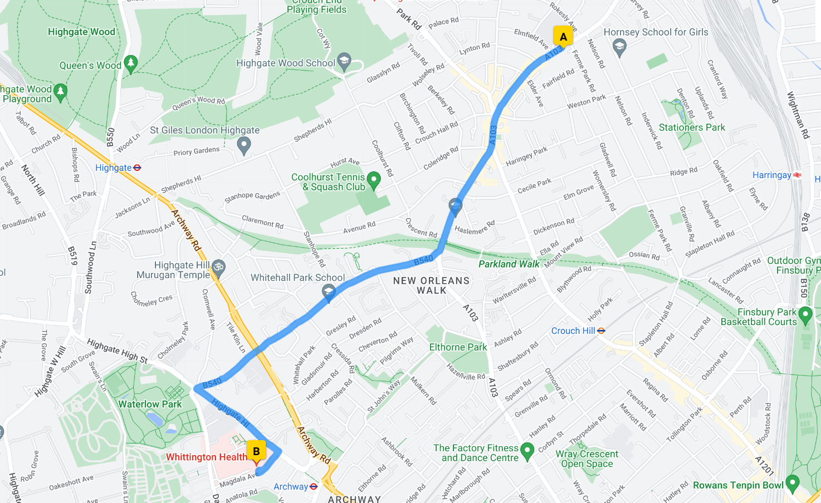

Travel links (Appendix B)
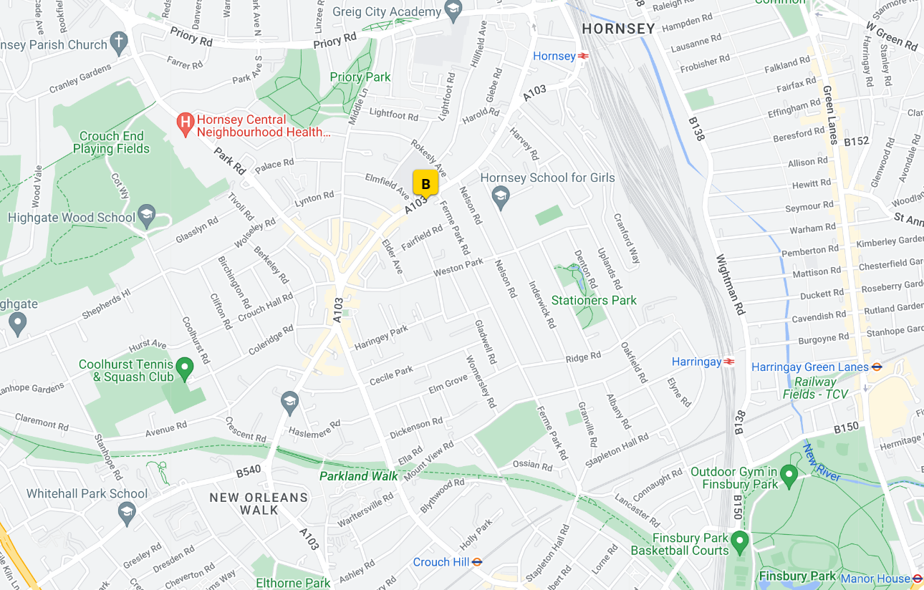
155 Tottenham Lane, N8 9BT

