Supporting evidence re application for certificate of “lawful development: Existing use” re chimney flue/stove back reading room, ground floor. 114 Chesterfield Gardens, N4 1LR

Please get in touch if you require any more evidence
Margaret Greenfields 07788545777 moregreenways@btinternet.com

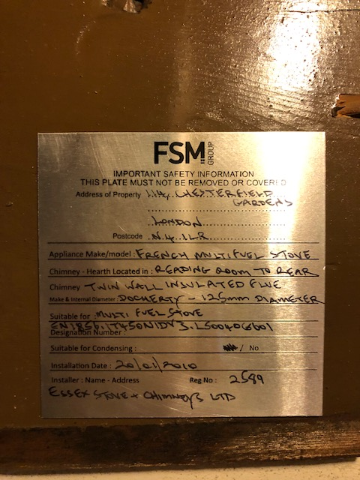

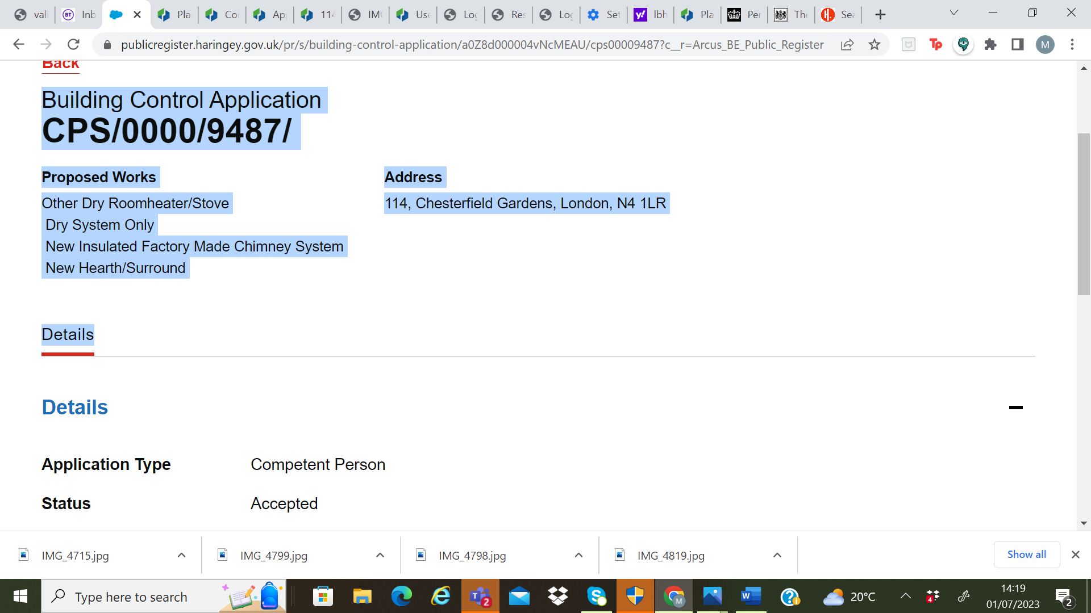
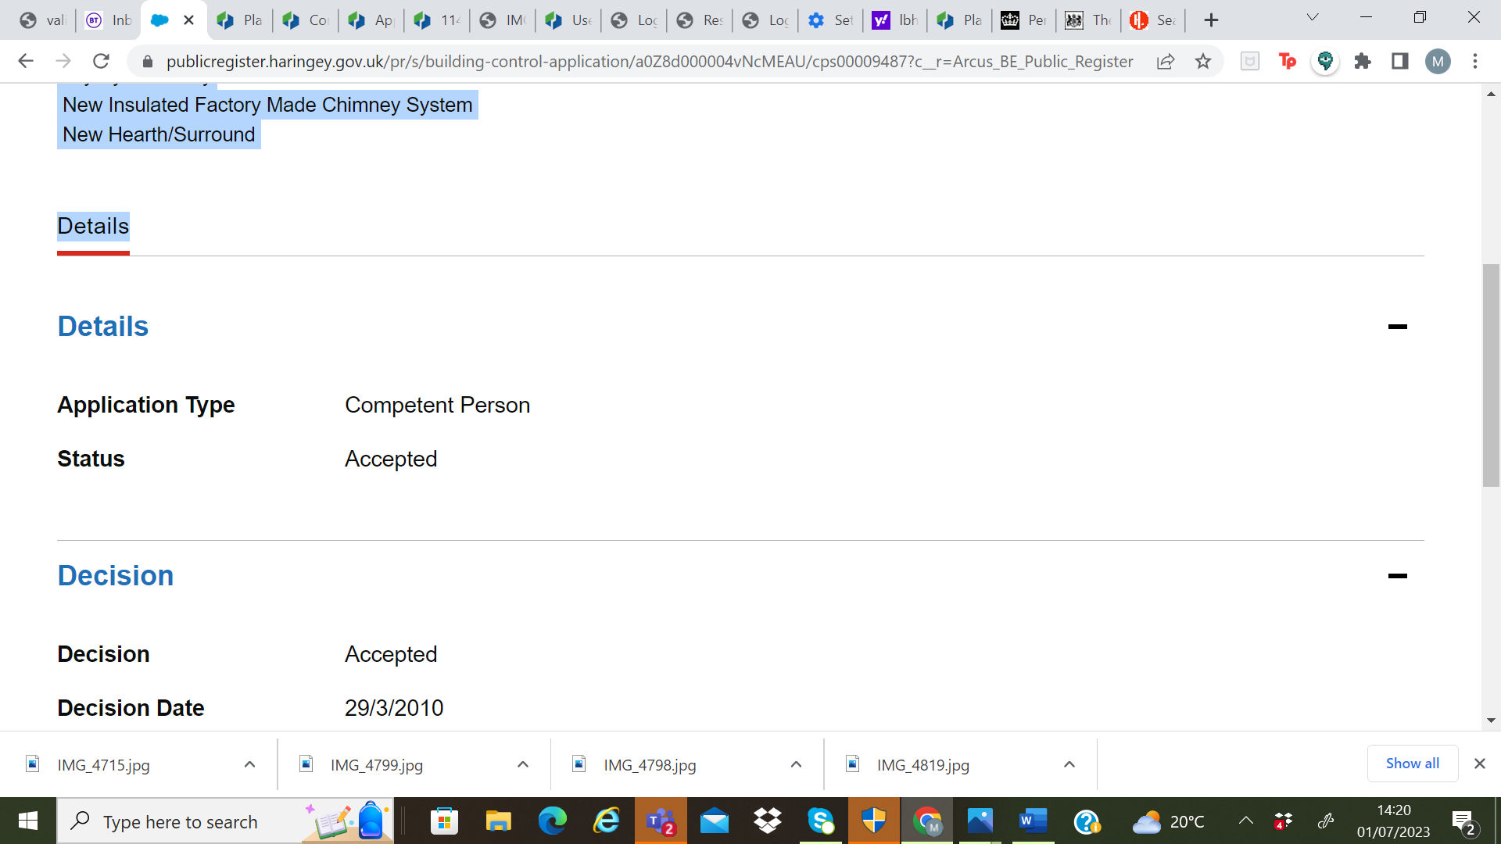

Image of location of flue exiting wall of -ground floor reading room – taken from next door garden with permission prior to dispute - showing the line down which the flue runs and that just inside my fence line which the then owner didn’t want to have reinstalled as liked the old (reused) London brick used to build the extension).

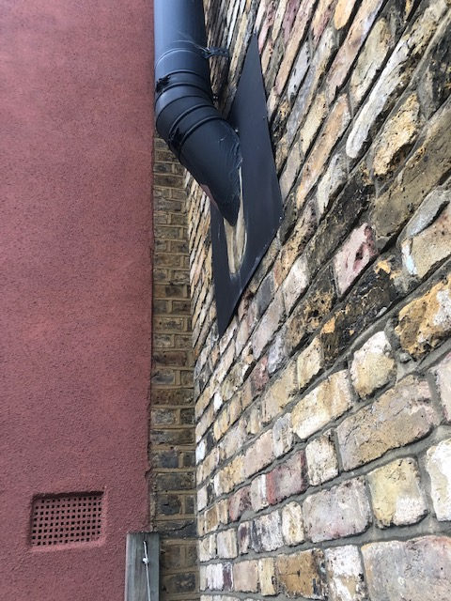

Evidence of ownership of property (2004) and redemption of mortgage (2019)
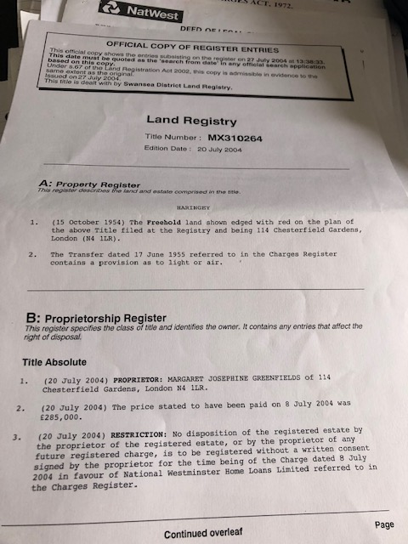

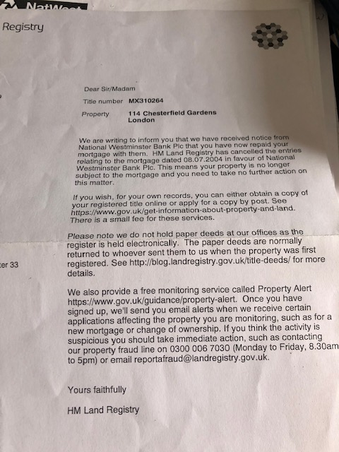

+ planning permission granted for extension into which the flue/stove has been added (see images above for snap-shot of installation plate and building regs.
