10-July-2023
Design and Access Statement
Property: 27 Wycombe Road, London, N17 9XN
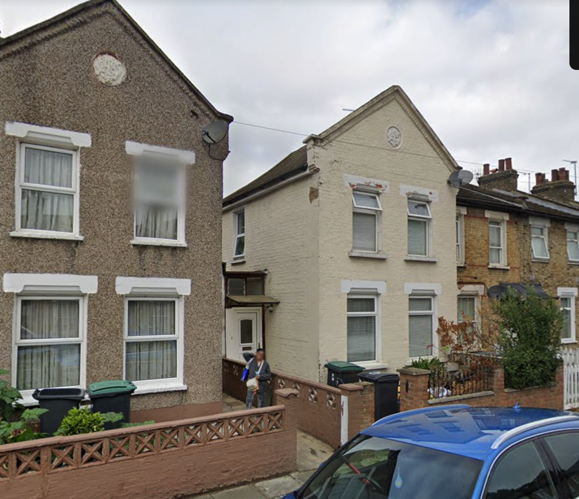
Wycombe Road, in London's N17 9XN, is a typical urban street with a variety of homes and buildings, most of which are two-story terraced homes.

THE DESIGN PROPOSAL:

To make place for a new kitchen and dining/family room, it is suggested that the home be extended at the back by around 3 meters from the existing extension. Additionally, it is proposed that the current porch enclosure be moved forward, and a new join party wall be built all the way around the back to accommodate the new extension.
The design also proposed to relocate the staircase to the side extension, to reflect a traditional terrace house of the area. There are two properties on the same road that has similar work done, number 13 and 15 Wycombe Road, N17.
As the existing porch and extension don't comply with current regulations as the house was altered by the previous owner, who did the work himself, the house needs safety updates to its structure and to the electrics. The changes are being made to improve the quality of space and increase the thermal performance of the property.

SITE LOCATION & ACCESS
The location is adjacent to Bruce Grove Station, Northumberland Station, Tottenham Hale Station, as well as a number of other public transportation link, parks, and commercial centers, in addition to the Tottenham Stadium.
There won’t be any change to Wycombe Road's access to the existing residence. The front door, which is at the side way of the property and connected to number 29 Wycombe Road by a timber frame building, is used to enter the property and it will remain as the entrance to the house.
This application won't have an impact on on-street parking.
DESIGN PROPOSAL USE and LAYOUT
These modifications won't change how the house is used, but they will enhance the family spaces and improve the way the rooms flow.
The new structure will improve the building's thermal performance, and the additional windows will increase natural light and enhance the space's quality.
SCALE AND APPEARANCE
The total added footprint from original house is less than 6 m in length (including previously built extension), and the height is to be kept at 3m. The proposed windows and doors don’t affect the privacy of neighbouring houses and has been designed to complement the proportions of the existing and neighbouring dwellings and to allow more daylight into the space.

The proposed development is designed to complement the existing built form.
The porch replacement for masonry and the proper roof, would be an improvement as well as a safety upgrade as the way it had been built is very easy to break in and doesn’t offer any thermal benefits.

All new materials would be to match existing.

Existing Appearance
Most of the properties in this area are in natural yellow Brick, painted brick and Render or Pebble-dash finish with tiled pitched roofs/flat roofs. The property has a combination of both, painted bricks at the front and rendered painted walls at the back and side.

Proposed Appearance
The extension is proposed to have a rendered painted finish to match existing.
The roof of the extension is proposed to be a flat felt roof sloping to the back, where new gutter system will be installed, the reason a flat roof was design instead of a tiled pitch roof is to keep the height of the extension to a minimum, we have taken into consideration the right of light to the neighbours and any impact the extension will have on the adjoining properties.

PROPOSED THERMAL EFFICIENCY & SERVICES
All new walls, roofs, windows, and doors will be constructed to meet current Building Regulation requirements and British Standards, in respect of thermal insulation and air tightness. Any existing elements replaced, will also meet these standards.

CONCLUSION

The proposed alterations are in keeping to planning rules and with the character of the neighbourhood. There is no harm to the character and quality of the subject building.

It is considered that the said proposal will provide more efficient use of the floor area. The new development will have no adverse effects on the surrounding buildings The development is considered to be appropriate for this site and the Council is requested to grant planning permission for it.

Existing photos of the property:

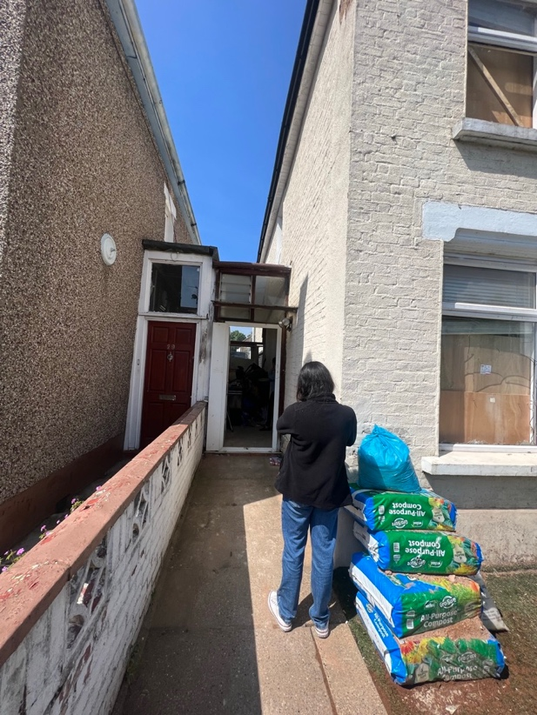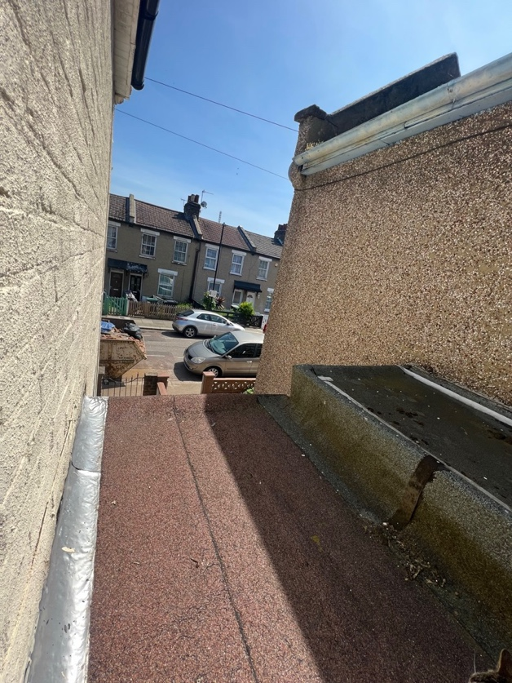

Existing Front Porch Existing Flat roof

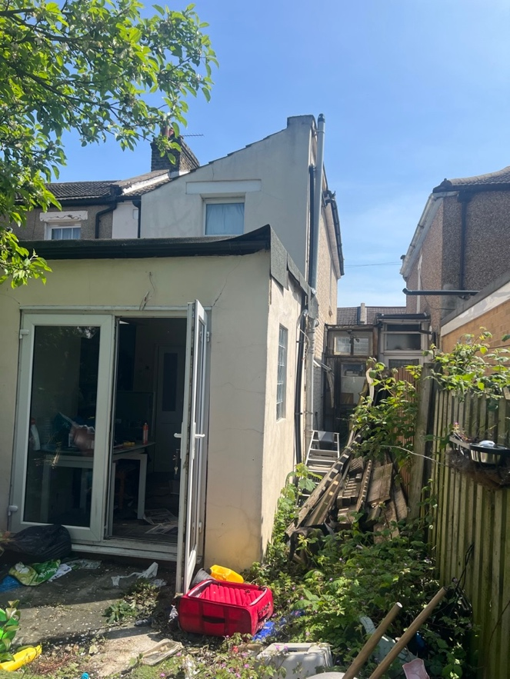
Rear Extension and side of the property

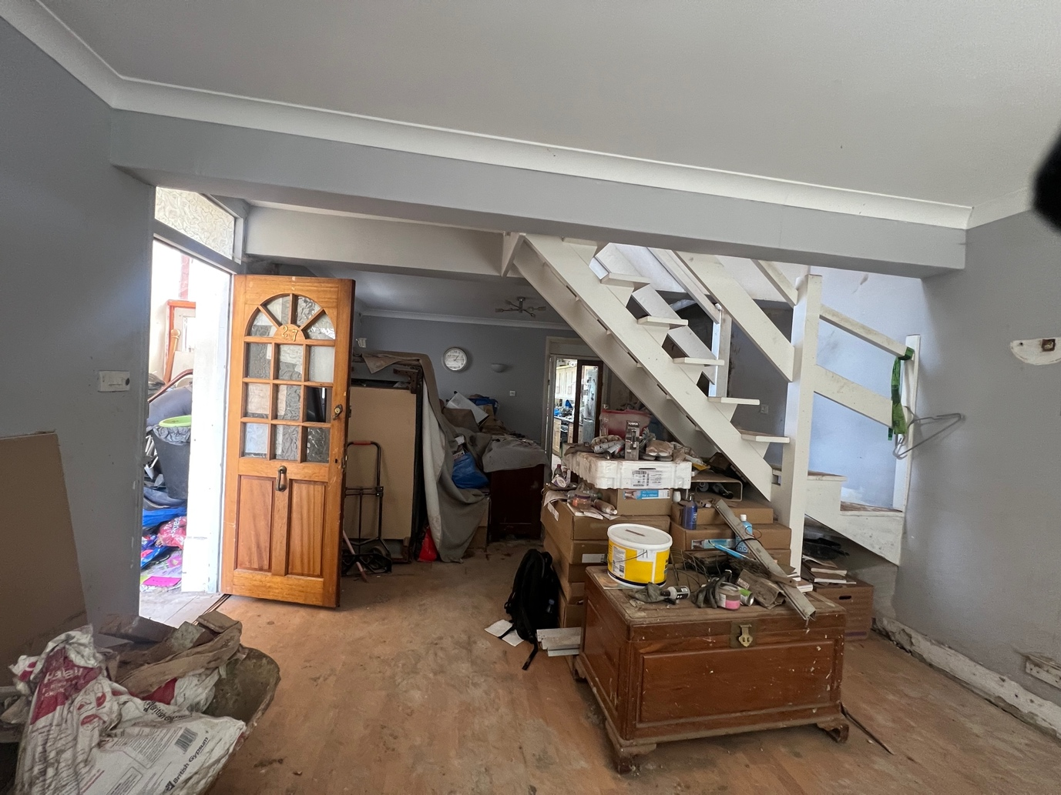

Internal view after you come into the living rooms from the porch, with the stairs in the middle of the two reception rooms.

