DESIGN and ACCESS STATEMENT
for

20 Steel Road, London, N17 6YA

The property is a mid-terraced Victorian two storey house converted into two self-contained flats on steel road. The site is not within a conservation area. There is easy access to public transport. The closest overground station is Bruce Grove.

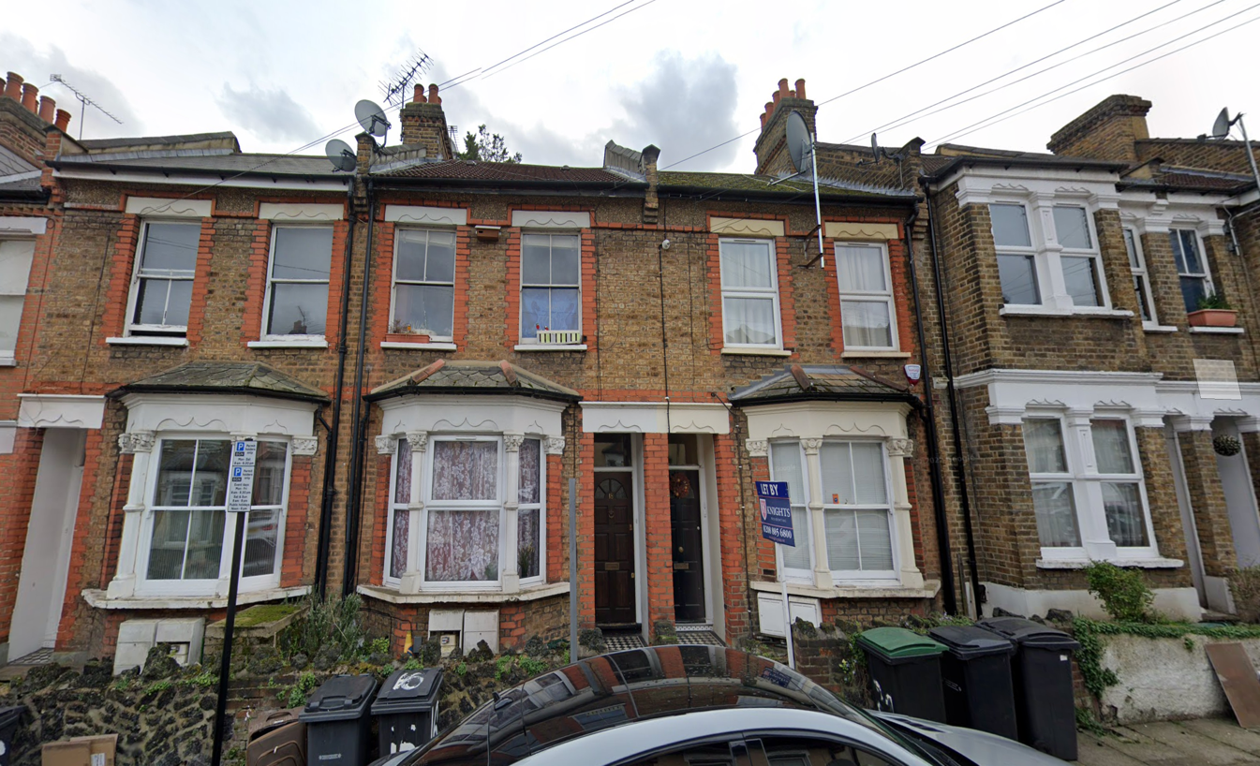

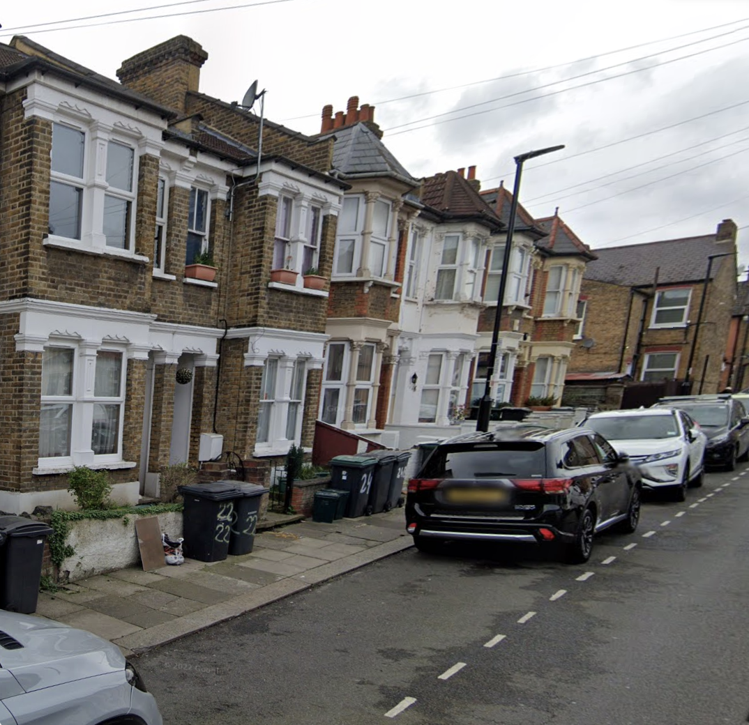

- Introduction

  - This Design and Access Statement is prepared by Saadet Eriten on behalf of the client Patrizia Zorzut

It seeks proposal Loft conversion, converting the main loft and part of the rear addition with flat roof, French door and windows.

The applicant is a owner of the first floor of the property and applying to get Loft conversion to extend the property for growing family.

2.00 The Site

2.01 The application site is located at 20 Steel Road N17 6YA.

3.00 Use

3.01 The site in application last use was Residential

3.02 We aim to convert to loft area and adding more space to give benefit the client of having better quality of the life with high respect to the neighbourhood, architecture, respect to the site history and also protected them privacy, security and comfort.

4.00 Proposal

4.01 This application seeks proposal Loft conversion, converting the main loft and part of the rear addition with flat roof, French door and rear and side windows and two Velux windows on the front of the house roof slope.

5.00 Appearance

5.01 The proposed loft conversion design and installation will be in context with the existing appearance of the buildings and general appearance of the adjoining buildings on the main road.

The materials and details used on external wall will be the same as the building and architecture or any features about the building. Loft conversion, converting the main loft and part of the rear addition with flat roof, French door and windows to allow to maximise benefit to get daylight. And also scale and proposal of the loft conversion would not result in loss of sunlight or daylight or have an overbearing appearance to the neighbouring property. The proposal is for creating two bedrooms, one shower / toilet and two Velux window to the front of the roof slope.

6.00 Access

6.01 There is on street parking with permits from the council.

