Engineers Report
Risk Address | 26 Gladwell Road  London  N8 9AA
Claim Reference | 86886223
Policy Holder | Dr Diane Rosenthal
Date Notified | 21/06/2023
Date Instructed | 21/06/2023
Report Date | 27/06/2023
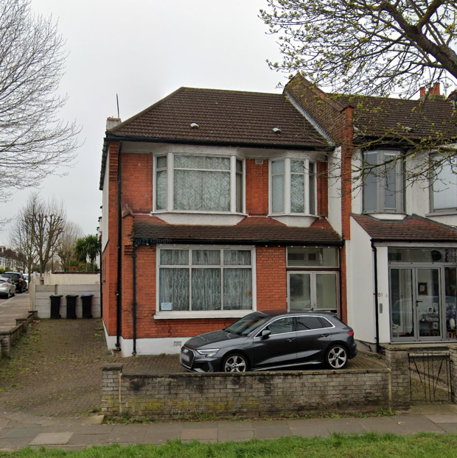
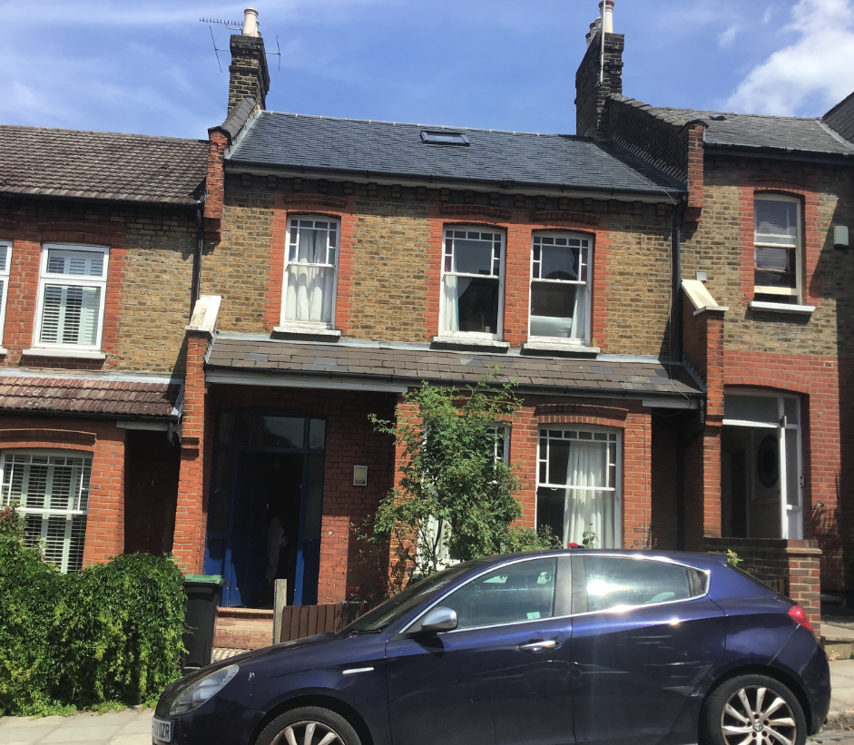

Description of Premises

The property is a mid-terrace, 4-bedroom house, constructed between 1900-1910. It features brickwork for its main external walls and a pitched slate roof. The house has been occupied by the policyholder since 1985, and during this period, no alterations or extensions have been made to the original property.

The property is located on a ground that slopes from the front towards the back and from the right to the left, and it was reported that trees were removed from the site during previous repairs. Notably there is still substantial vegetation immediately adjacent to the damage. Mr McGrath reports that in prior claims he was told these could remain in place.

Discovery of Damage

Mr McGrath first noticed the damage on 1st September 2022. Initially, he observed displaced bricks and cracking in the external structures of the house. On further inspection, he discovered dropping windowsills, cracked and displaced tiles, and a cracked footpath. Internally, he noted horizontal cracking above the bay and cracks appearing on either side of the bay.

Focus of Damage and Report

The damage is distributed both internally and externally. Externally, the most significant damage includes displaced bricks, dropping sills, cracked tiles and the pathway, and a cracked doorstep. The bay area is the most affected internally, with horizontal cracking observed above the bay and cracks on either side of the bay.

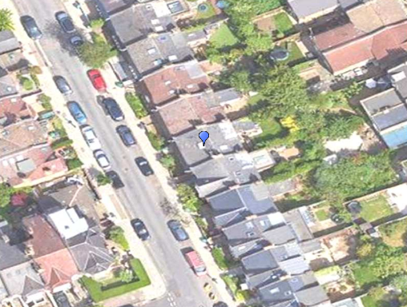

Please note that in this report all reported directions (e.g. “on the right”) are relative to when facing the front of the property

Internal Damage

Cracking has been observed within the property, predominantly around the bay area. This includes horizontal cracking above the bay and cracks appearing on either side of the bay. Notably the most sever cracks (on the left-hand side of the bay window) correspond to the location of the more significant vegetation in the front garden.

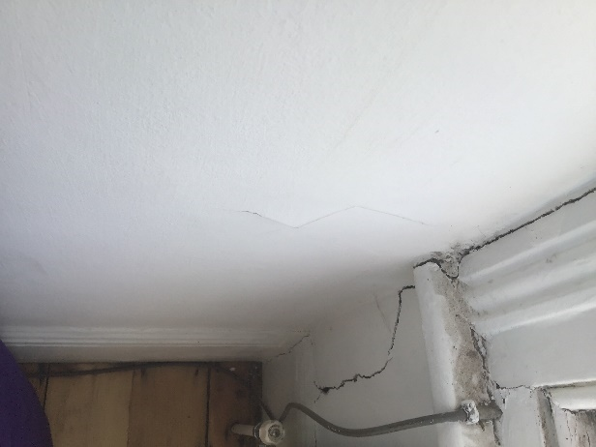 | 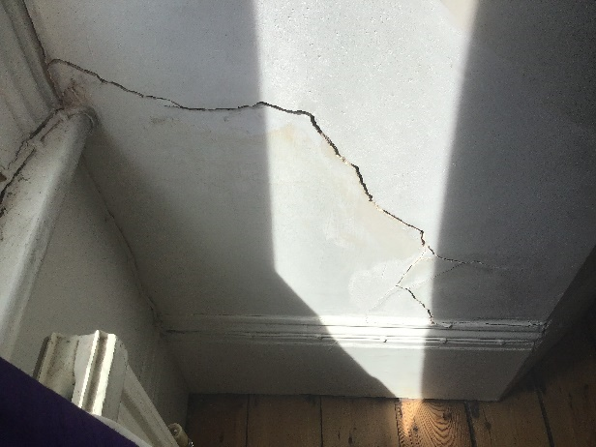
Picture 1: Cracking around front bay window on right. | Picture 2: Diagonal cracking around front bay window on right (2nd view).
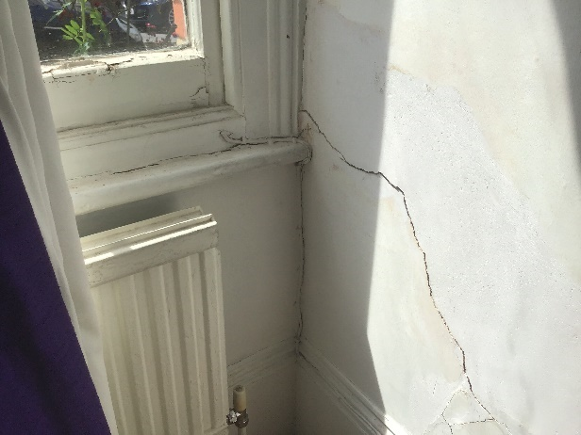
Picture 3: Diagonal cracking around front bay window on right. | Picture 4: Further cracks to far right side of front bay window.
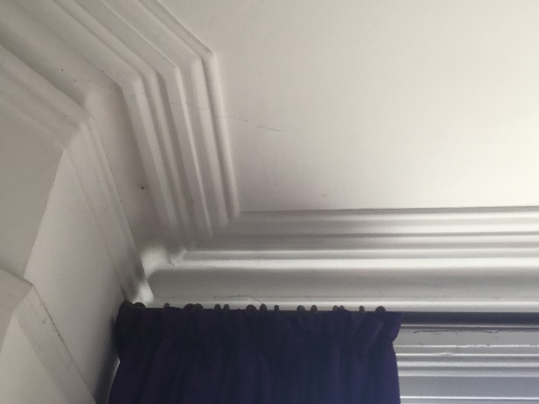
Picture 5: More minor cracks along coving and ceiling around bay window on right.
External damage

Externally, the most significant damage includes displaced bricks, dropping windowsills, cracked tiles, a cracked footpath, and a cracked doorstep.

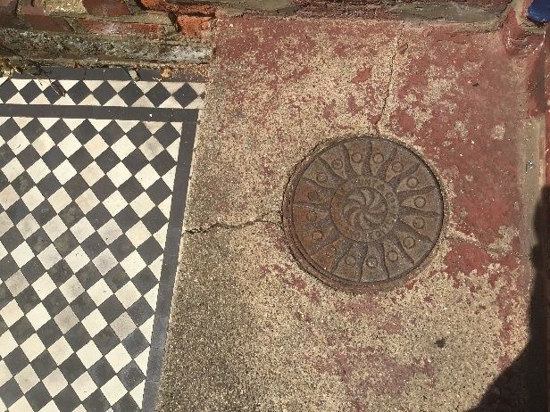 | 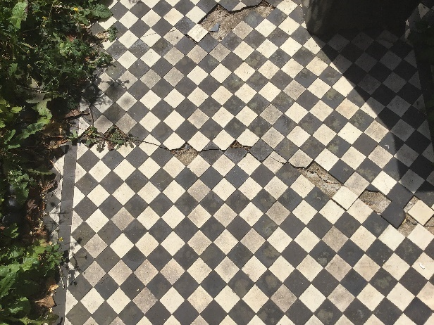
Picture 6: Cracking on doorstep. | Picture 7: Cracks across entrance path.
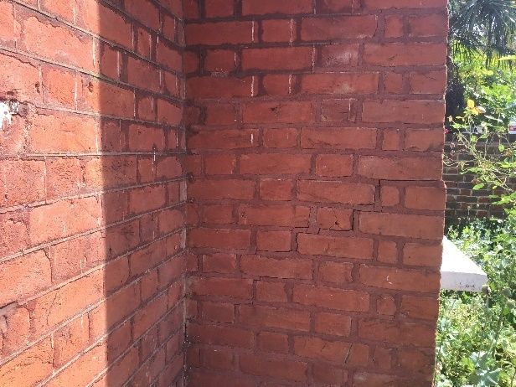 | 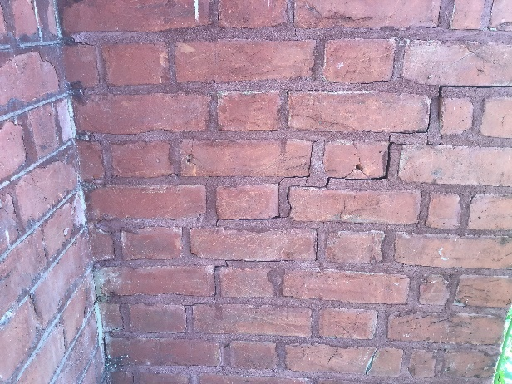
Picture 8: Diagonal cracking at front of property around ground floor bay windows on right (2nd view). | Picture 9: Diagonal cracking at front of property around ground floor bay windows on right.
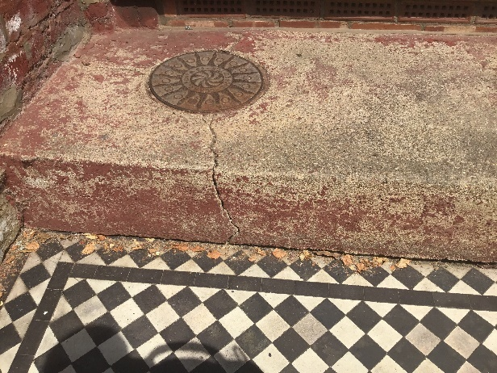 | 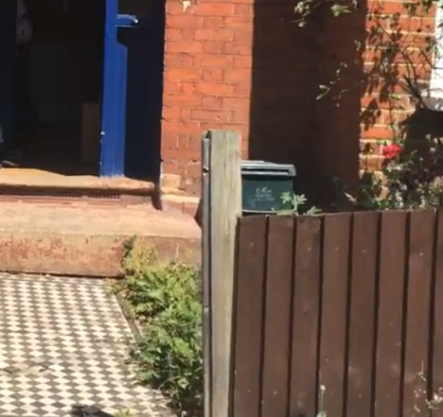
Picture 10: Doorstep and entrance pathway show signs of damage. | Picture 11: Front path appears to have dropped to the right.
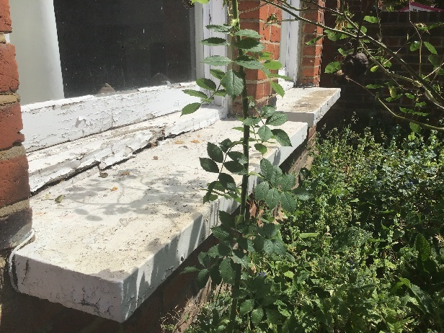
Picture 12: Windowsills appear to have dropped on front right.

Site Geology and ground conditions
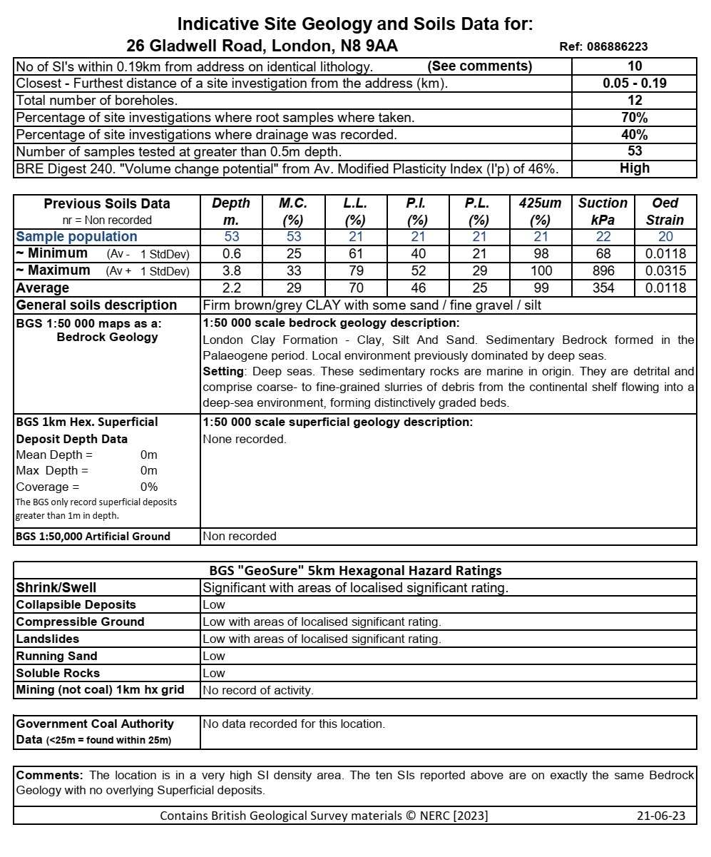

Classification of Damage

It is common practice to categorise the damage in accordance with B.R.E. Digest 251 “Assessment of Damage in Low-Rise Buildings”. In this case, the damage falls into Category 3 “Moderate”.

Category | Crack Width | Degree of Damage
0 | Hairline cracks of less than 0.1 mm | Negligible
1 | Typical crack widths are 0.1 to 1mm. | Very slight
2 | Typical crack widths are 1 to 5mm. | Slight
3 | Typical crack widths are 5 to 15mm, or several of, say, 3 mm. | Moderate
4 | Typical crack widths are 15 to 25mm, but also depends on number of cracks. | Severe
5 | Typical crack widths are greater than 25mm but depends on number of cracks. | Very Severe

Evidence of external influences
Vegetation
The cause of the damage here appears highly likely related to the vegetation (including rose bushes) immediately in front of the bay window which has subsided. The geology in this area (London Clay), is well understood to be a highly active soil with a high-volume change potential. In the summer months this type of clay shrinks as vegetation extracts moisture from the ground, which can cause damage such as this.

It is recommended that all vegetation be fully removed in the front garden and replaced with potted plants if desired to prevent further issues in future.

Photograph showing shrubs immediately in front of area of damage.

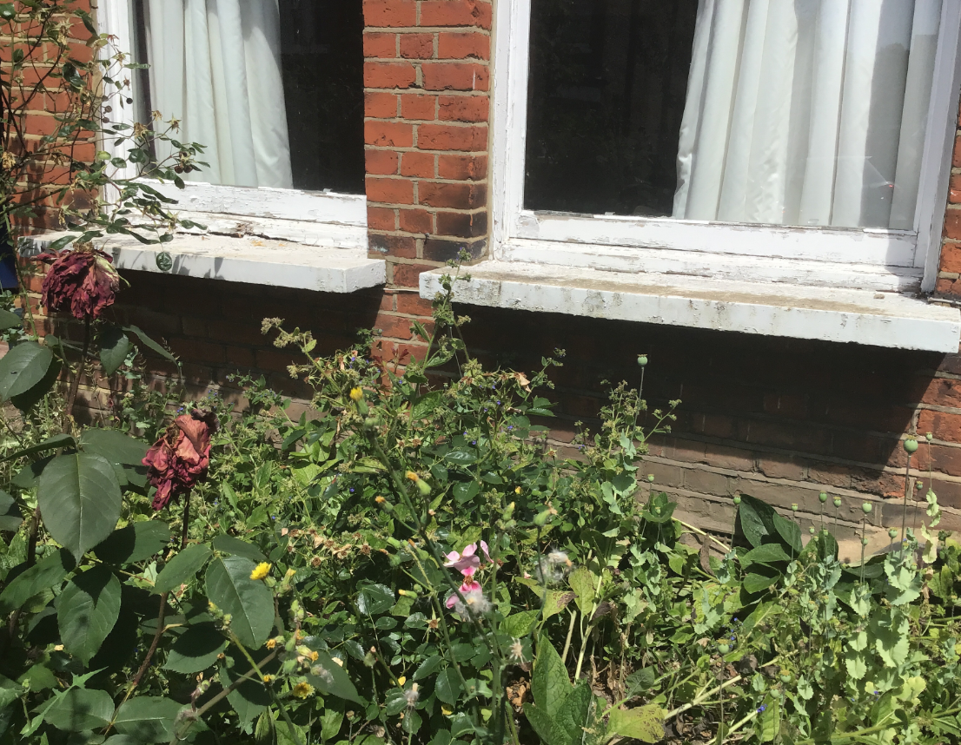
Photograph showing vegetation growing immediately in front of damaged area.

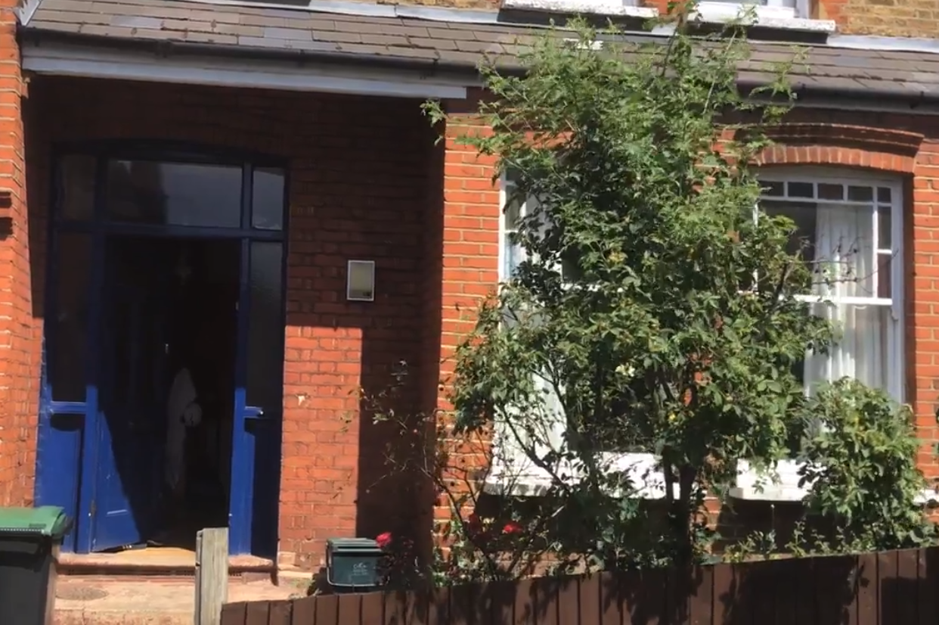

Summary and Conclusions

It is evident that there has been movement affecting the property, particularly towards the front right-hand side and bay window area. The nature of the cracking is indicative of an episode of subsidence.
A valid claim arises under the terms of the insurance policy, subject to the applicable excess of £1000, for the localised subsidence damage to the property.

Rarely does new movement develop or accelerate without a new external influence such as advancing root growth or a drainage issue. The cause of the movement in this instance appears very likely linked to the nearby vegetation.
The timing of the event, the presence of suspected shrinkable clay beneath the foundations, and the proximity of tree(s)/vegetation suggest the shrinkage may be root induced. This is a commonly encountered problem, accounting for around 70% of subsidence claims notified to insurers. Fortunately, the cause of the problem (dehydration) is reversible.
Clay soils will rehydrate somewhat in the winter months, causing the clays to swell and the cracks to close. Provided the cause of movement is dealt with, this should resolve the present problem.
All vegetation in the front garden should be removed immediately to prevent further movement of the front bay window area.

The property will then be monitored for the next 6 to 12 months to confirm that the movement has ceased and that the ground has recovered over the winter before repair work commences.

Following successful mitigation and confirmation of stabilisation, a schedule of works will be compiled for the above ground repairs necessary, subject to your policy excess of £1000, a copy of which you will receive.

Next Steps
- Suspected vegitation is to be removed (all vegitation at front).
- Monitorimng to be instructed.
- Provide a schedule of work for repairs to be considered.
- Obtain and programme start dates for repair works to commence from appointed contractors if required.
- Validate and programme the superstructure works in conjunction with the policyholders requirements.
- Update all parties on a regular basis.

