Engineers Report
Risk Address | 22 Methuen Park  London  N10 2JS
360 Reference | DLG-SN-22-005817
Insurer Reference | 084814508
Policy Holder | Mrs Josephine Wick
Date Notified | 12/10/2022
Date of Assessment | 29/11/2022
Report Date | 29/11/2022

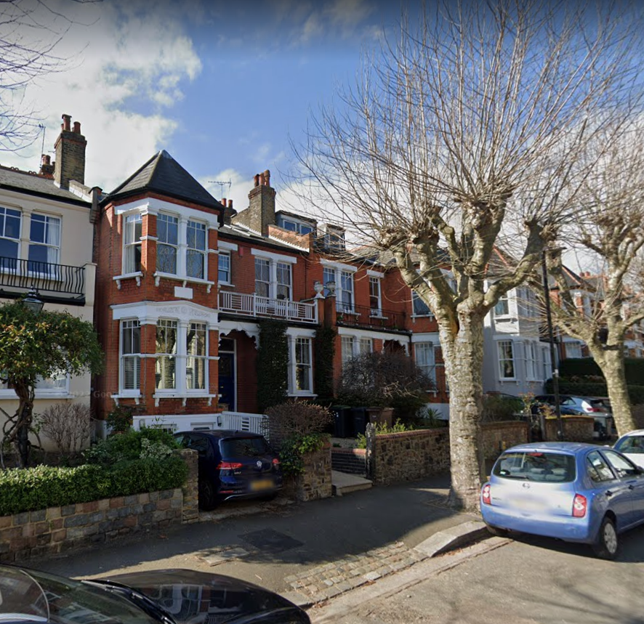

Description of Premises

The insured property is a 5-bedroom mid terrace house of traditional construction. A pitched
and slate timber roof is bearing on brick walls. The property is located on site that slope from the rear to the front, in a residential location amongst other properties of a similar style and vintage.
Discovery of Damage
We understand that the damage was recently discovered, and Insurers were therefore subsequently notified, and a subsidence claim registered, in view of the policyholder’s concerns.

Focus of Damage and Report

This document addresses damage notified to insurers in relation to cracking, focussed mainly to the front of the property. It should not be considered to be an exhaustive list. All directions are stated when viewing the property from the front.

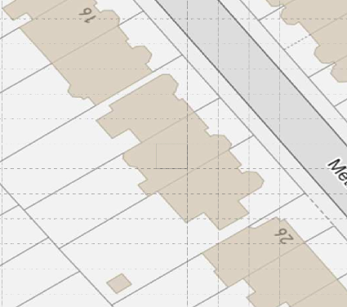

Internal Damage
Hallway, stairs, and landing
- Tapering cracking up to 4mm wide.

Lounge
- Tapering cracking up to 4mm wide.

External Damage
- Stepped cracking up to 4mm wide.

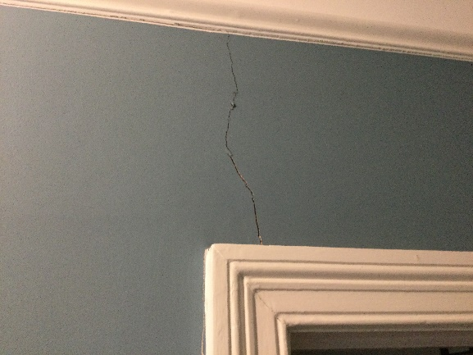 | 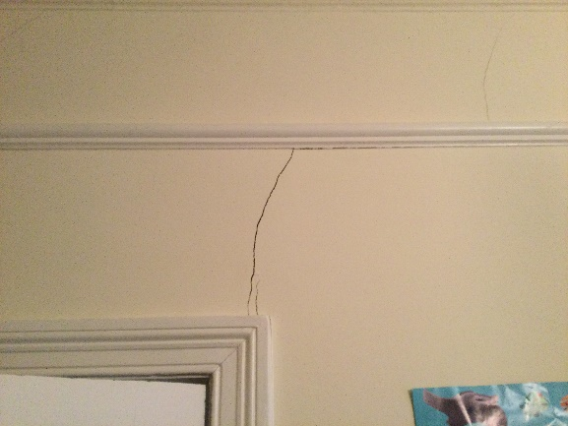
Cracking to hallway. | Cracking to lounge corresponding with hallway.
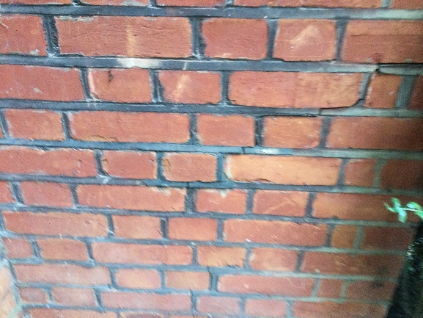 | 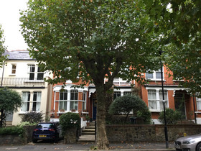
Stepped cracking to front elevation. | Vegetation to the front of the property.

Classification of Damage
It is common practice to categorise the damage in accordance with B.R.E. Digest 251 “Assessment of Damage in Low-Rise Buildings”. In this case, the damage to the property falls into Category 2 “Slight”.
Category | Crack Width | Degree of Damage
0 | Hairline cracks of less than 0.1 mm | Negligible
1 | Typical crack widths are 0.1 to 1mm. | Very slight
2 | Typical crack widths are 1 to 5mm. | Slight
3 | Typical crack widths are 5 to 15mm, or several of, say, 3 mm. | Moderate
4 | Typical crack widths are 15 to 25mm, but also depends on number of cracks. | Severe
5 | Typical crack widths are greater than 25mm but depends on number of cracks. | Very Severe

Site Geology and Ground Conditions
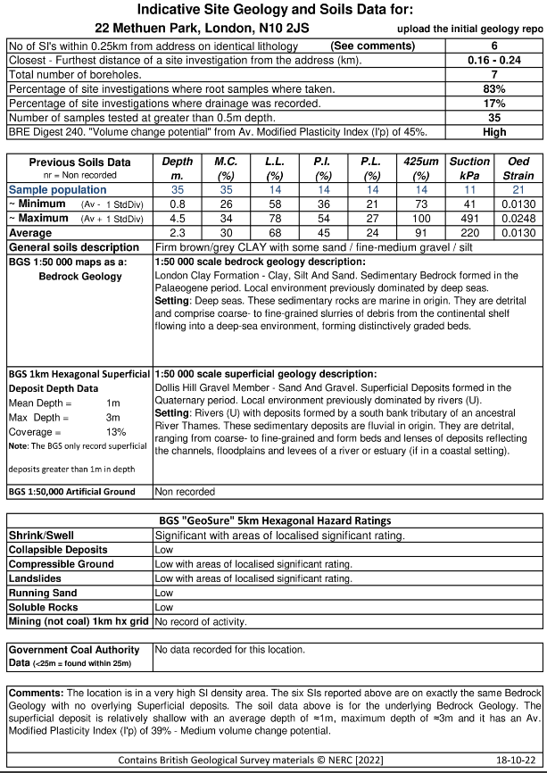

Evidence of External Influences
Trees
There is significant vegetation in close proximity to the area of damage in the form of mature shrubs in the front garden and Local Authority plane trees on the main road.

Drains

The property is served by a domestic drainage system, and this is concentrated at the rear of the property however there is a rainwater pipe close to the area of damage.

Summary and Conclusions
The pattern and orientation of damage noted to the house is indicative of localised subsidence. A valid claim is therefore accepted, subject to the subsidence policy excess of £1000.00.
The pattern and nature of the cracks is indicative of a minor episode of subsidence. The cause of movement appears to be clay shrinkage. Clay soils shrink and swell seasonally, and this can cause minor damage following particularly dry spells of weather where footings are relatively shallow.
Although the cause of the movement needs to be dealt with, we note the potential involvement of Local Authority plane trees. Unfortunately, they will require certain investigations to be carried out to demonstrate the influence of their vegetation.
Typically, these investigations would involve trial pit(s) to determine the depth and type of footings, boreholes to determine the nature of the subsoil/influence of any roots and monitoring to establish the rate and pattern of movement. It may also be necessary to obtain a specialist Arboricultural Report.
We will report further once these investigations have been completed.
Next Steps
A valid claim arises under the terms of the insurance policy, subject to the applicable excess of £1,000.00.

The key steps required to progress the claim are as follows:
- Contact policyholder and arrange for site investigations to be undertaken at a suitable date. These will include trial hole excavations at the front the building a drainage survey of any drains along the front of the building.
- Due to the potential involvement of Local authority vegetation, we will set up a period of level monitoring for an initial 12-month period.
- Once we have received and reviewed the site investigations then an arborists report will be obtained.
- A repair schedule has been drawn up, although this will be finalised following completion of any mitigation measures, as applicable.

Graeme Caird BSc (Hons) MCIOB, MFPWS, AssocRICS, ACABE, BDMA.insTech, Cert CILA
360Globalnet Subsidence Team

