Your Ref: | PP-12492713
Our Ref: | HPD/AH/SW/23/065
Date: | 10 October 2023 |  | Hybrid Planning & Development Limited  The Old Vyner Street Gallery  23 Vyner Street  London  E2 9DG  www.hpduk.com  +44 (0)20 3633 1678  +44 (0)75 9770 0050  sward@hpduk.com
Haringey Council
Planning Services
6th Floor, River Park House
225 High Road, Wood Green
London
N22 8HQ

Dear Sir/Madam,

RE: Application for approval of details reserved by Condition 4 (Refuse) in respect of planning permission HGY/2020/3223 – gROVE COURT, 11 MARKFIELD ROAD, N15 4QA

Please find enclosed an application to discharge Condition 4 (Refuse) in relation to planning permission LPA ref: HGY/2020/3223.

The documents accompanying this application are listed below:

- Duly completed Application Form;
- Site Location Plan at scale 1:1,250 with the site edged in red;
- A copy of Decision Notice ref: HGY/2020/3223.; and
- Consented Site Plan (Dwg. No: 940-50).

The statutory application fee of £116.00 has been paid electronically by card following submission of this application via the Planning Portal.

Accordingly, we trust that you will have sufficient information to discharge Condition 4, but should you require any further information, please do not hesitate to contact Simone Ward (075 9770 0050) of this office, in the first instance.

Yours faithfully,
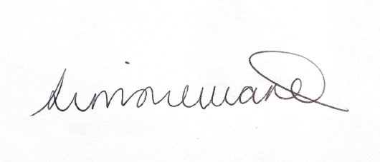
Simone Ward
PLANNER

