
Planning Statement

Date: 20/01/2026

Site Address: 123 Plevna Crescent, London, N15 6DY
Introduction:

The Planning Statement is in support of a Certificate of Lawful Development for the erection of a rear dormer roof extension and front roof lights.

Site Characteristics:

The application site is a 2-storey terraced dwellinghouse located on the southwestern side of Plevna Crescent. The surrounding area is characterised by residential developments. The application site is not located within a conservation area and the building is not listed
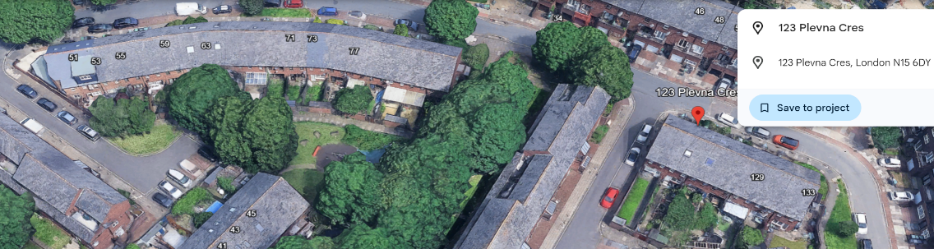

Relevant Planning History:

Proposal: Prior approval Part 1 Class A.1(ea): Larger home extension - Not Required Reference No: HGY/2025/ 2148
Policy

The Town and Country Planning (General Permitted Development) (England) Order 2015. (as amended) Schedule 2, Part 1, Class B & C

CLASS B - Proposed Roof Alterations

Does the volume of the proposed, and any existing roof extensions, exceed the permitted
development allowance?
NO

Does any part of the dormer project forward of the plane of a roof which forms a principal elevation and fronts a highway?
NO

Does any part of the extension encroach on the neighbouring property - including eaves and
foundations?
NO

Would the dormer be higher than the highest part of the roof?
NO

Is the building Listed/ in a conservation area?
NO

Does the roof alteration include a Veranda, balcony or raised platform?
NO

Conditions to Class B: (If the answer to any of these questions is NO then planning permission is required):

Are the materials proposed similar in appearance to the property?
YES

Is the enlargement/dormer set in 20cm (200mm) from the roof margins?
YES

Are any side facing windows obscurely glazed?
YES

CLASS C - Any Other Alteration to the Roof of a Dwellinghouse

Would the alteration protrude more than 150 millimetres beyond the plane of the slope of the original roof when measured from the perpendicular with the external surface of the original?
N/A

Would it result in the highest part of the alteration being higher than the highest part of the original roof?
NO

Would it consist or include the installation, alteration or replacement of a chimney, flue or soil and vent pipe?
NO

Would it involve the installation, alteration or replacement of solar photovoltaics or solar thermal equipment?
NO

Summary:

On the basis of the above, the proposed roof extension constitutes permitted development by virtue of the provisions of Schedule 2, Part 1, Class B & C of the Town and Country Planning (General Permitted Development) (England) Order 2015. (as amended)

