Design and Access Statement


T: 020 8909 9433 M: 07739 427 023
E: kevin@kdadesigns.co.uk
21 Clifton Avenue, Stanmore, Middlesex, HA7 2HR
Address: 37 Clyde Road, London N22
Proposal: Raising of ridge height and construction of L-shaped rear dormer to facilitate
loft conversion.
Applicant: Mr D. Horan
Date: 9th January 2026
- Introduction
This Design and Access Statement has been prepared in support of a planning application for the proposed loft conversion at 37 Clyde Road, N22. The proposal includes raising the existing roof ridge height and constructing an L-shaped dormer at the rear with rear terrace. The intention is to create additional habitable accommodation while maintaining the architectural integrity and character of the property and surrounding area.
- Site and Surroundings
37 Clyde Road is a two-storey mid-terraced Victorian property located within a predominantly residential street in the heart of the Alexandra Park area. The surrounding properties are of a similar age and architectural style, with a mixture of converted loft spaces and rear extensions visible throughout the street.
The property is not listed, nor is it located within a conservation area. The area benefits from good transport links and local amenities, making it a desirable residential location.

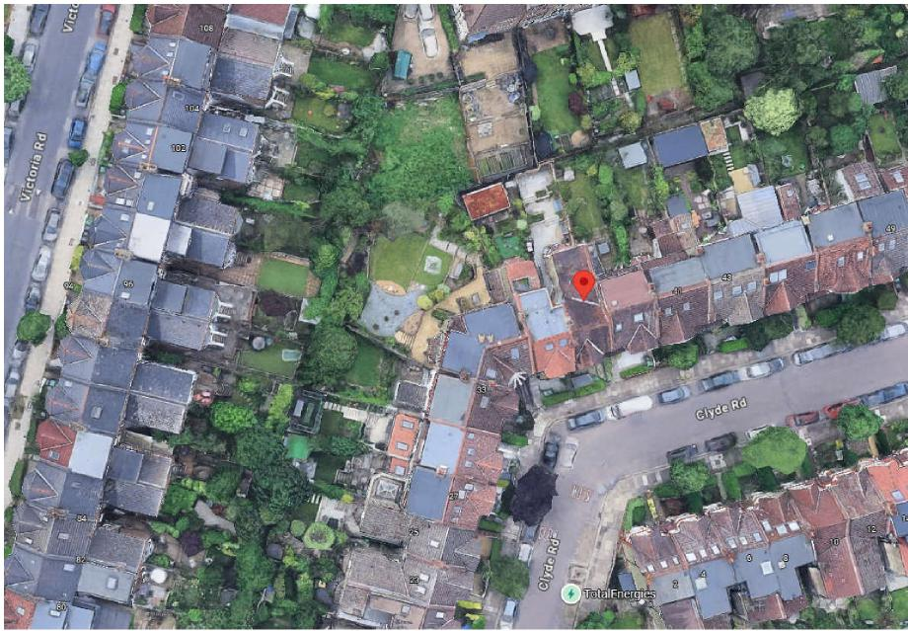
3. Design Proposal
3.1 Design Intent


T: 020 8909 9433 M: 07739 427 023
E: kevin@kdadesigns.co.uk
21 Clifton Avenue, Stanmore, Middlesex, HA7 2HR
The proposal seeks to make use of the loft space through modest alterations to the existing roof form. The design aims to respect the proportions of the existing dwelling and maintain consistency with similar extensions in the street.
3.2 Description of Works
- Raise the existing ridge height by approximately 500mm to keep a consistent roof line with neighbouring properties.
- Construct an L-shaped rear dormer extending over the main roof and rear outrigger to provide two additional bedrooms and en-suite with a small terrace for added amenity space.
- Install two roof lights on the front roof slope, and roof light on rear dormer to provide natural light and ventilation to the new staircase and landing.

- Materials used will match the existing property, including clay tiles for the roof to maintain a cohesive appearance.


T: 020 8909 9433 M: 07739 427 023
E: kevin@kdadesigns.co.uk
21 Clifton Avenue, Stanmore, Middlesex, HA7 2HR
- Scale and Appearance
The scale of the dormer has been carefully designed to ensure it remains subordinate to the original roof. The proportions follow local guidance, and the materials replicate those used in the existing structure. The modest ridge height raise has been minimised to avoid visual dominance while achieving practical ceiling heights.
Rear dormers are already a common feature on Clyde Road and neighbouring streets. As such, the proposed development will be in keeping with the established pattern of loft conversions in the area.
A section of the existing pitched roof to the outrigger will be retained, preserving the character and appearance of the property.
- Access
The proposed works will not alter the existing access arrangements to the property. The internal staircase will extend from the existing first-floor landing to the loft level. There will be no changes to the external access or parking provision.
- Amenity Considerations
The proposed dormer windows will face the rear garden and will not introduce any undue overlooking or loss of privacy to neighbouring properties, as they replicate the existing relationship of similar houses on the street, and the property itself is already significantly overlooked.
There will be no significant increase in massing that would cause overshadowing or appear overbearing to adjoining dwellings.
The proposal will create additional amenity space in the form of a rear terrace, similar to the terrace at No. 35 Clyde Road. The proposed terrace is modestly sized and will be unable to accommodate large groups of people, thereby avoiding unacceptable levels of noise and disturbance to neighbouring occupiers.
The proposals have been carefully designed to ensure compliance with DPD Policy DM1 ‘Delivering High Quality Design’, which states that development proposals must ensure a high standard of privacy and amenity for a development’s users and neighbours, and to provide an appropriate amount of privacy to neighbouring properties to avoid overlooking and loss of privacy and detriment to amenity of neighbouring residents.
The dormer protrudes slightly further than the dormer at No. 35. This has been purposefully designed to ensure the angle of views is such that there is no unnecessary overlooking to the No. 35 windows or roof terrace. The existing chimney stack may also be retained (subject to survey and detailed design) to enhance privacy and retain the character and appearance of the existing property and local area. The existing wall adjacent to no. 39 Clyde Road will be retained to avoid overlooking the garden at no. 39.

- Sustainability
The project will improve the energy efficiency of the property by upgrading the roof’s thermal insulation to meet current Building Regulations standards. All windows will be double-glazed and energy-efficient.

8. Conclusion


T: 020 8909 9433 M: 07739 427 023
E: kevin@kdadesigns.co.uk
21 Clifton Avenue, Stanmore, Middlesex, HA7 2HR
The proposal for raising the ridge height and constructing an L-shaped rear dormer at 37 Clyde Road, N22, constitutes a sympathetic and well-considered design that respects the character of the area while providing much-needed additional living space. The scheme aligns with local planning policies promoting the efficient use of existing residential buildings.
The overall design is modest, proportionate, and consistent with the established pattern of development in the locality.

