First Floor Flat 236 Victoria Road, London, N22 7XQ
DESIGN & ACCESS STATEMENT
January 2026
Contents:
· Site Location & Existing Site
· Planning History
· Design Proposals
· Access
· Sustainability
· Conclusion
This Design and Access Statement provides an explanation of the proposals put forward by the applicant, Lorraine Coady, to redevelop her home at First Floor Flat 236 Victoria Road.

Site Location & Existing Site
First Floor Flat 236 Victora Road is a mid-terrace dwelling house in the Alexandra Park ward of the London Borough of Haringey. The property and the site are not within a conservation area. Victoria Road is located within an established residential area with primary and secondary schools within easy walking distance and a range of local shops are available nearby. The area is well served by transport links including numerous bus stops connecting to local underground and train stations providing access to central London and other destinations.
First Floor Flat 236 Victora Road sits within a run of terraced dwelling houses dating from the turn of the nineteenth/twentieth century. The buildings are two storeys, with pitched roofs incorporating a gable end, to the front elevation. The houses are set back from the pavement with small front gardens creating a consistent street elevation. To the rear is an enclosed garden bounded on each side by the gardens of neighbouring properties on Victoria Road. The end of the garden backs on to Albert Road and opposite this is the woodland area outdoor learning site for Rhodes Avenue Primary School. Adjacent to this woodland area is the Oliver Tambo Recreation Ground.

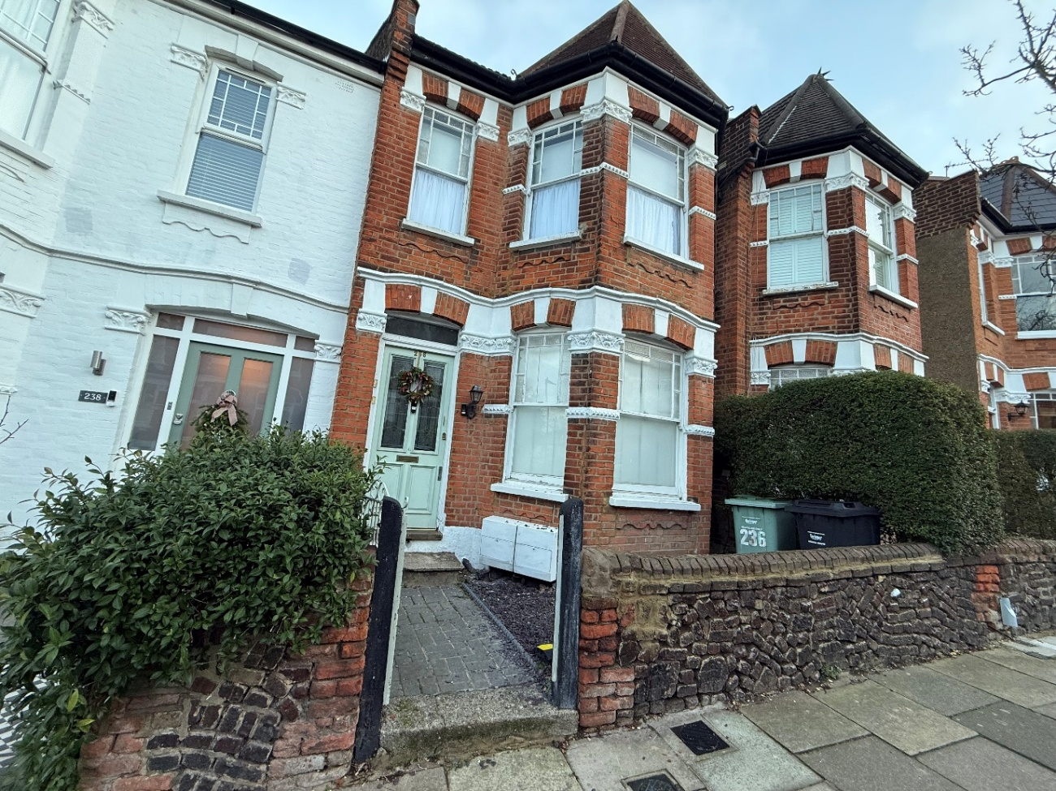
Existing Site Photos

Front elevation of 236 Victoria Road

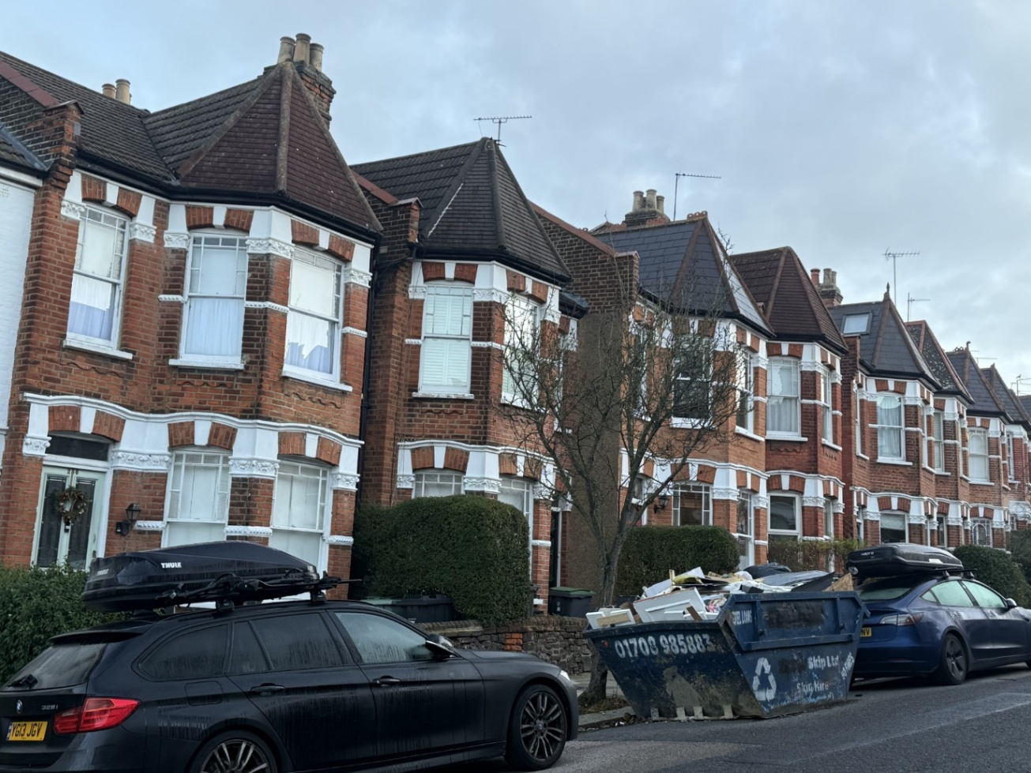

Street elevation to Victoria Road
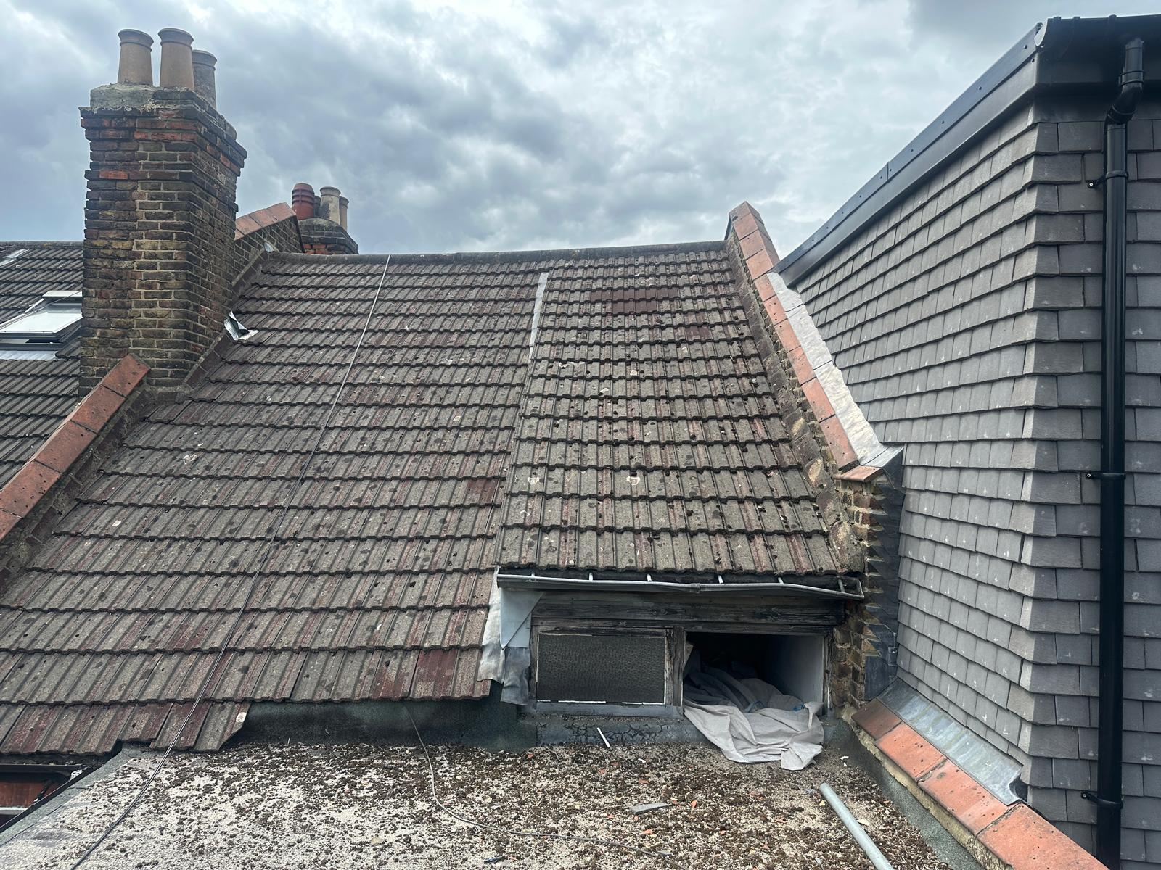

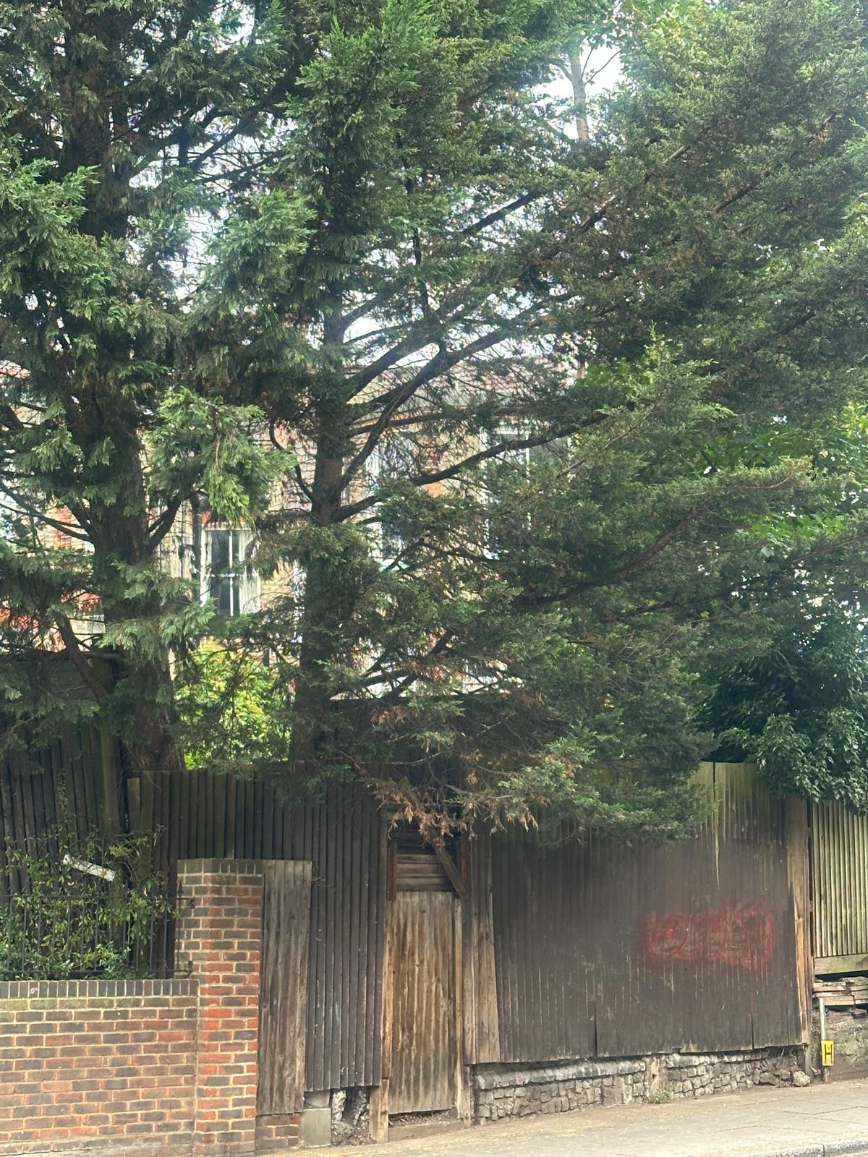
Above: Rear of property showing location of proposed dormer.
Left: Rear elevation viewed from Albert Road.

Planning History
No. 100 Oak Road
There have been a number of residential planning applications on Victoria Road that have been granted permission in recent years. Most recently:
Application Reference HGY/2025/2268 on 21/8/2025 for 196 Victoria Road was granted permission; “Loft conversion with erection of a rear dormer extension and insertion of 3no. rooflights on front roof slope. Construction of roof terrace with obscure glazed balustrade.”
Application Reference HGY/2023/1644 on 25/8/2023 for First Floor Flat 166 Victoria Road was granted permission; “Erection of rear dormer roof extension with associated rear roof terrace”.
Application Reference HGY/2023/0117 on 12/1/2023 for 162 Victoria Road was granted permission; “Loft conversion including the erection of a dormer roof extension to the rear and the installation of two rooflights to the front roof slope.”
Application Reference HGY/2022/4400 on 13/12/2022 for Flat B 176 Victoria Road was granted permission; “Rear dormer roof extension with private roof terrace to flat.”
Application Reference HGY/2020/0880 on 27/3/2020 for First Floor Flat 2 214 Victoria Road was granted permission; “Formation of rear dormer roof extension, installation of front roof lights, and formation of roof terrace on part of the flat roof of the existing rear outrigger projection.”
Application Reference HGY/2018/3335 on 20/11/2018 for 142 Victoria Road London was granted permission; “Creation of a roof terrace to roof of rear outrigger.”
There are also many other dormers which have been constructed over the years on this stretch of Victoria Road and the surrounding roads, as seen on the image below.
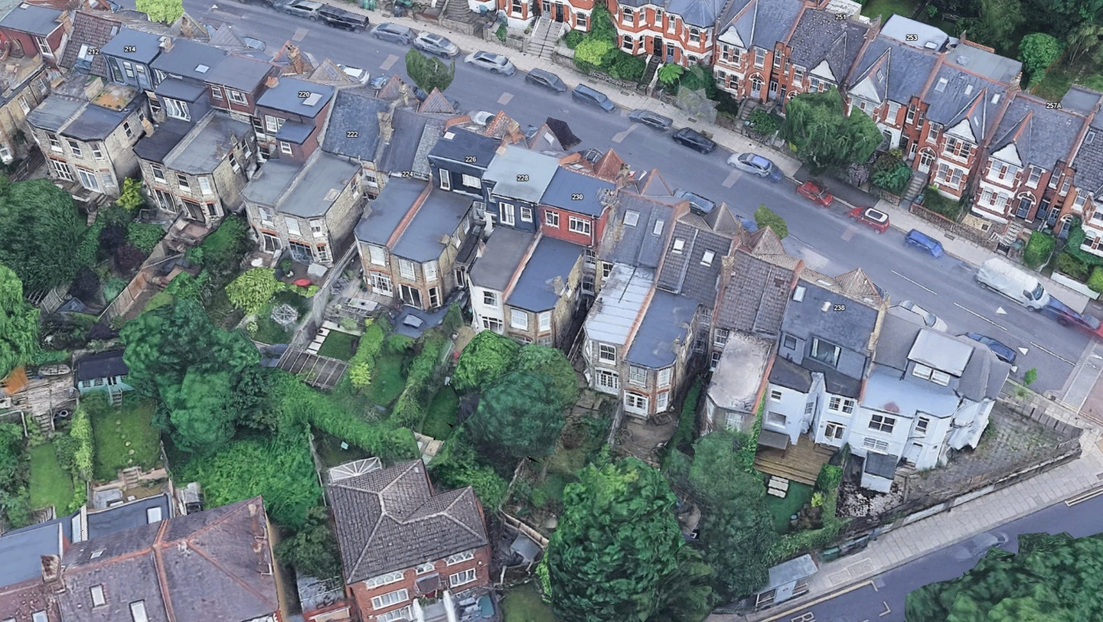

The images below show the previously approved dormer loft conversion to the neighbouring adjoining property at 238 Victoria Road.
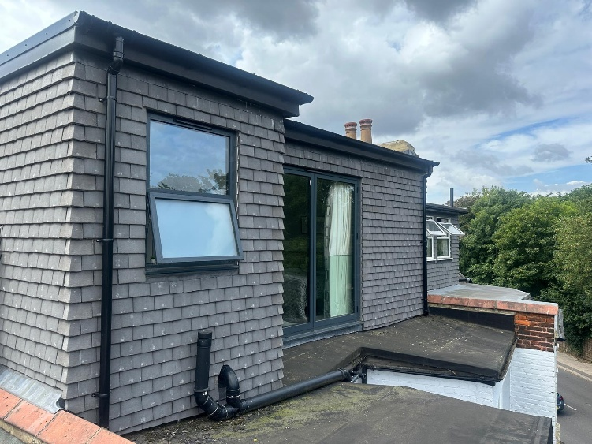
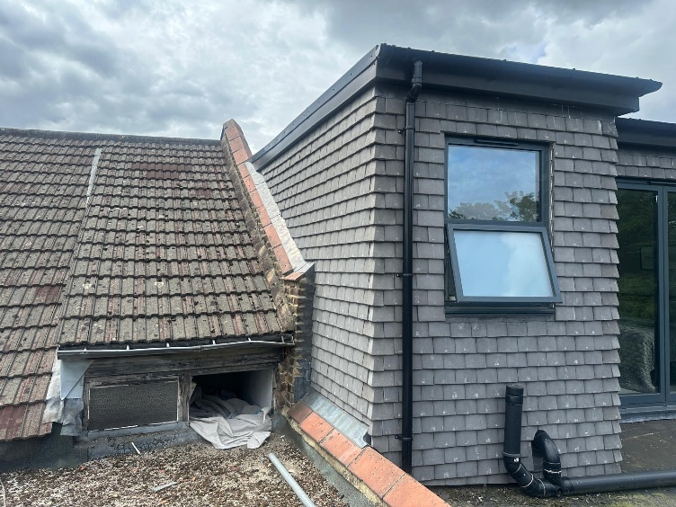

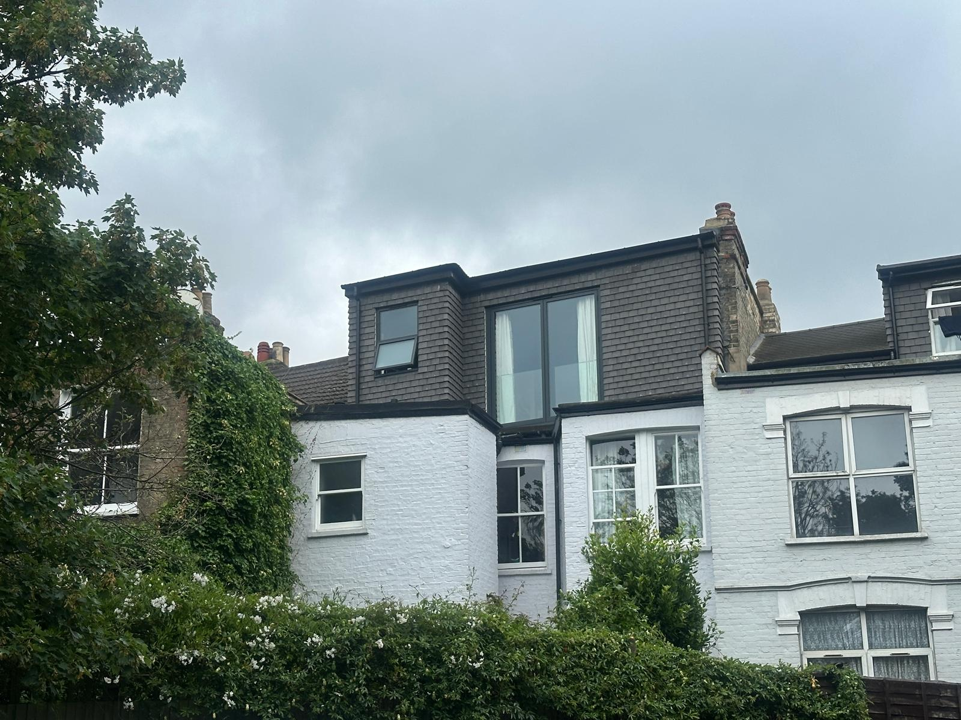

Design Proposals
No. 100 Oak Road
The applicant seeks permission to convert the existing loft area to create two additional bedrooms and a shower room, with a small roof terrace on the rear flat roof. She wants to refurbish the property to create a family home to meet her living requirements for both present and future needs.
Use
There is no change of use. The building is currently a residential dwelling; the use will not change as a result of this application.
Amount
The existing flat has two bedrooms, a living room and separate small kitchen and bathroom. The proposed works include the removal of the bedroom to the rear and the creation of two new bedrooms and a shower room in the loft conversion to create a total of three bedrooms, a living room, two bathrooms and a larger kitchen/dining room. The proposals also include the creation of a roof terrace to provide much needed outside space for the residents as there is no access to the rear garden. The loft conversion will create additional 29.3m² of internal accommodation (useable space with a minimum head height of 1200mm) and 12.2m² external space.
Layout
The proposals include the removal of the rear bedroom to create a larger kitchen/dining room. The bathroom, main bedroom and living room will remain as existing. The new loft conversion with proposed dormer will provide two new bedrooms and a new shower room. The proposed roof terrace will be located above the existing bathroom and kitchen and will be accessed from the half landing of the stairs to the loft.
Scale
The massing to the front of the building will remain unchanged apart from the insertion of five conservation style roof windows. To the rear, the dormer will be set back from the neighbour’s rear dormer and just below the ridge line. This will ensure that it is not visible from the front elevation to Victoria Road. Due to the surrounding houses and the existing vegetation to Albert Road the proposed dormer will be unobtrusive and in context with the local built environment.
Appearance
There will be no alterations to the front elevation to Victoria Road with the exception of the roof lights. The proposed rear roof dormer will not be visible from the street.
The new dormer will be a timber frame construction with grey tiled cladding similar to the neighbour’s door. The windows double glazed aluminium framed in a colour to match the cladding. The roof lights to the front elevation will be conservation style roof lights to be in keeping with the property.
The proposed roof terrace is surrounded by a permanently obscured glazed balustrade which restricts the length of the terrace to 3.6m from the rear dormer walls. The balustrade will prevent overlooking and provide privacy. There are existing precedents for rear dormers with roof terraces on Victoria Road including those at numbers 202, 204, 208 and 214.
Landscaping
The proposed roof terrace will have planters which will have a variety of biodiverse planting.

Access
The pedestrian access into the property is from Victoria Road and will remain unchanged. Currently there is no parking provision on the site with on street parking provided on Victoria Road, the proposals will not alter this.
Sustainability
The proposed loft conversion, roof terrace and roof dormer will be constructed to meet and where possible exceed current building regulations with good levels of insulation and high-quality double-glazed fenestration and finishes. All works will be carried out according to the best sustainable practice. All new materials will be considered for their environmental impact and all materials removed from site will be recycled where possible.

Conclusion
To conclude, the proposed works include the construction of a new loft conversion with rear dormer extension and rooflights to the front elevation. It also includes a roof terrace to provide external amenity space. The design aims to create much needed additional space for a growing family which makes the most of natural light and the space available, whilst considering the need to be respectful of neighbouring properties and the character of the local area.

