Image | Description
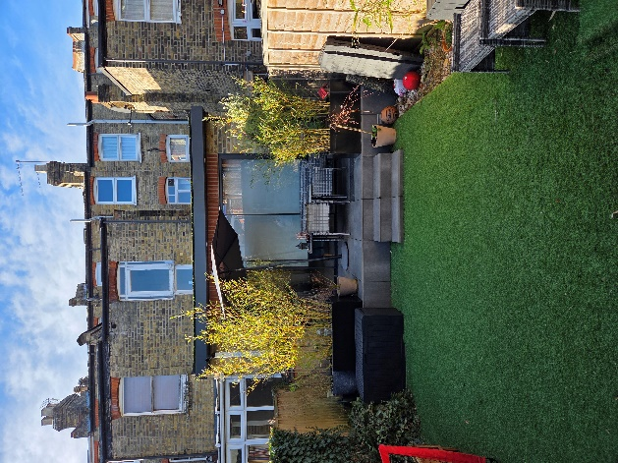 | Facing rear of the existing residential property
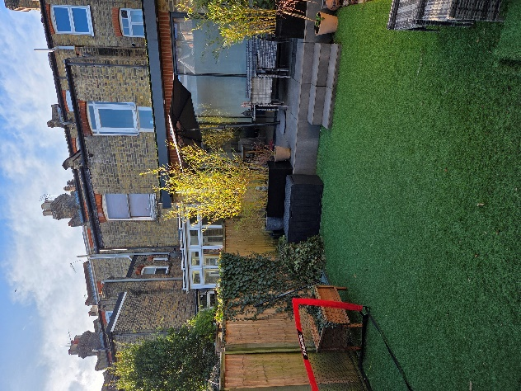 | Facing rear of the existing residential property, showing boundary 1
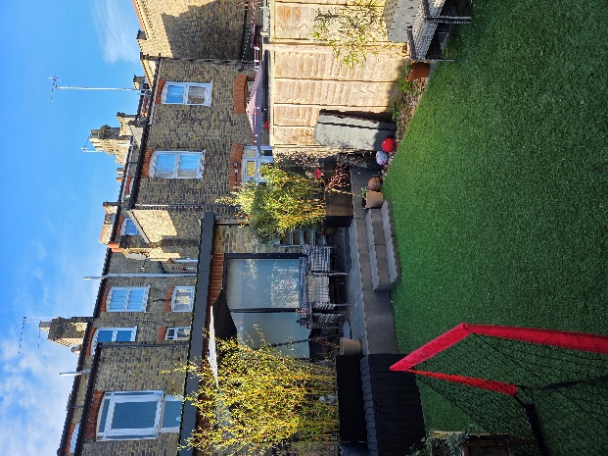 | Facing rear of the existing residential property, showing boundary 2
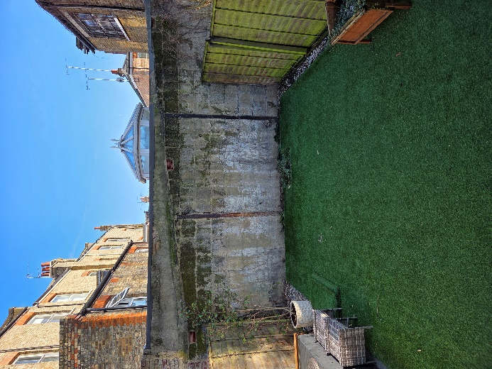 | Facing back of the garden (the site for the proposed build of the garden office)
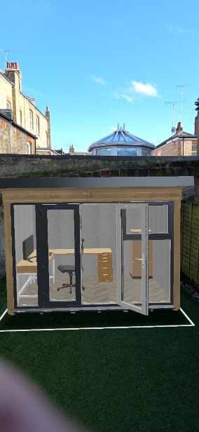 | AR view of the garden office, showing virtually where it will be constructed (1)
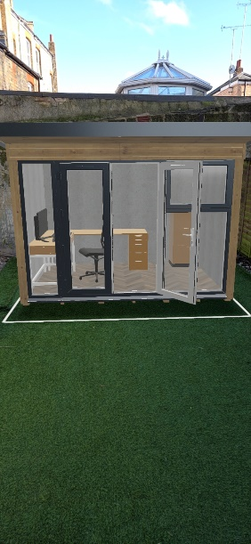 | AR view of the garden office, showing virtually where it will be constructed (2)

