
Basement Impact Assessment
63 Sheldon Avenue, N6 4NH, London

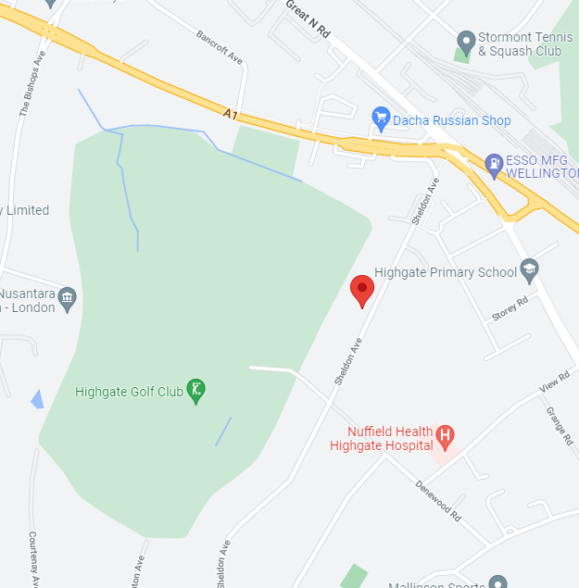
October 25, 2022

20-22 Wenlock Road, London N1 7GU

Table of Contents

Basement Impact Assessment 0
Introduction 2
About us 3
Existing Structure 3
Site Assessment 4
Section 4: Screening Questions 5
Structural stability 6
Impact on Archaeology 6
Noise, Disruption and Vibrations 6
Logistics and Site Management 8
Construction Sequence Plan 9
Conclusion 10
Engineers Comments / Recommendations 10
Appendix A Site Location Map & Photos of the site 11
Appendix B DEFRA Groundwater Maps 13
Appendix C Geotechnical Data 18
APPENDIX D Architect’s Scheme Drawings 22
APPENDIX E Structural Method Statement 34
Basement Retaining Wall Calculations 38
Design Philosophy – Basement Design 38
Indicative Retaining Wall Calculation (Below External Walls) 40
Retaining wall analysis 40
Retaining wall analysis 42
Hit & Miss Layout 45
Hit and Miss Sequence Drawings 45
APPENDIX F 53
General Construction Notes 54
Additional Notes 56
Appendix G Party Wall Act 1996: 58

Introduction
This report has been prepared for Hamid Ipakchi in relation to the proposed basement.
No responsibility is accepted to any third party for all or part of this study in connection with this or any other development.
Imperium Engineering Ltd was appointed by its client to provide a Basement Impact Assessment (BIA)
to achieve Planning Approval at said property.
This report has been structured to cover the topics outlined below:
- Basement impact assessment including highlighting the locations of the retaining walls to determine the structural stability of the basement extension.
- A Flood Risk Assessment to highlight the possible impact of the basement extension on increasing the flood risks in the local area.
- Impact of the proposals on surface flow and flooding.
- Impact of the proposals on groundwater flow, levels and quality.
- Impact of the proposals on structural stability including potential impacts on adjacent /nearby properties.
- Impact on archaeology.
- The identification of suitable construction methods and mitigation measures for developments.
- A method for monitoring local ground conditions, water movement, subsidence and drainage.
- The cumulative impact of basement development (built or proposed) in the surrounding area.
Note that the structural ‘design’ is sufficiently comprehensive for planning purposes only.
It is not intended as a fully worked up design to comply with current Building Regulations.
Documents Provided to Imperium Engineering Ltd for the BIA
The following documents have been referred to during the preparation of this report:

Document Description | Document Reference | Document Author | Date
Proposed Block and Landscape Plan | 166/005 | Studio Y2 Partnership Architecture & Planning | 04/2022
Proposed Lower Ground floor | 167/005 | Studio Y2 Partnership Architecture & Planning | 05/2022
Proposed Ground Floor | 167/016 | Studio Y2 Partnership Architecture & Planning | 05/2022
Proposed First Floor | 167/017 | Studio Y2 Partnership Architecture & Planning | 05/2022
Proposed Second Floor | 167/018 | Studio Y2 Partnership Architecture & Planning | 05/2022
Proposed Roof Plan | 167/019 | Studio Y2 Partnership Architecture & Planning | 05/2022
Proposed Section X-X | 167/025 | Studio Y2 Partnership Architecture & Planning | 05/2022
Proposed Front Elevation | 167/035 | Studio Y2 Partnership Architecture & Planning | 05/2022
Proposed Rear Elevation | 167/036 | Studio Y2 Partnership Architecture & Planning | 05/2022
Proposed Side – East Elevation | 167/037 | Studio Y2 Partnership Architecture & Planning | 05/2022
Proposed Side – West Elevation | 167/038 | Studio Y2 Partnership Architecture & Planning | 05/2022

About us
Imperium Engineering Limited

We are experienced in undertaking both private and public civil and structural engineering projects. Members of our board have been providing engineering services since 1987 in fields as diverse as the residential, transportation, oil and gas industries, and a broad range of commercial projects. We have specialists in each of these fields and draw on the knowledge of associates outside of our organisation when necessary to provide high-quality services.

In our history we have completed many basement designs in and around the London area. This has given us a significant amount of experience with all the idiosyncrasies of building and designing basements in one of the world’s biggest cities where detailed knowledge of the soil conditions is of vital importance is finding the correct course of action for the type of soil on site.

Our engineers have worked in the Structural Engineering field for more than 20 years. The majority have only worked in the Greater London and Kent area and are especially suited to dealing with London Clay Formation and the challenges it can sometimes present.

This report has been prepared by:
Christopher Holt BSc Structural Engineer
Jorden Irwin BEng, MEng Temporary Works Engineer
Report Checked By:
Matthew Hargreaves: BSc, CEng, MICE, MIStructE

Existing Structure

The Property in question is an existing Two Storey detached property with rear dormer at loft level. There is currently no full basement at any point and no structural retaining walls present. The only recorded use for the property is for residential accommodation. The existing Structure is of traditional construction, comprising loadbearing masonry flank, front, and rear elevation walls. These walls support a timber-pitched roof and timber-suspended floors.
The existing foundations are traditional strip footings.
The suggested sequencing of the basement construction has been provided in order to limit the potential effect on the neighbouring detached properties and to the existing structure.
The calculations in this report are for the purposes of impact assessment only.

Please refer to Appendix A for the site location.
Please refer to Appendix D for the existing and proposed drawings.

Site Assessment

Site Details
Site Details | Applicant Information
Planning application reference (if applicable) | N/A
Address & postcode | 63 Sheldon Avenue, N6 4NH
Brief description of the proposed works | Excavation and underpinning of the existing building
Geology type | London Clay Formation
Presence of aquifer? | No
Total site area (Ha) | 0.1 Ha (Estimated)
Is the site currently known to be at risk of flooding from any sources? | No

Chartered Professional Verification
Professional Details | Applicant Information
Name | Matthew Hargreaves: BSc, CEng, MICE, MIStructE
Profession / area of expertise | Structural and Civil Engineering
Chartered institution and membership level | Chartered Member IStructE & ICE
Brief description of assessment involvement | Checking Engineer for BIA and Screening Assessment
Brief summary of the assessment results | BIA Impact Low Risk
Declaration of assessment results | BIA Required
Signature | Matthew Hargreaves

Section 4: Screening Questions

Subterranean Characteristics
Does the recorded water table extend above the base of the proposed subsurface structure? | NO
Is the proposed subsurface development structure within 100m of a watercourse or spring line? | NO
Are infiltration methods proposed as part of the site’s drainage strategy? | NO
Does the proposed excavation during the construction phase extend below the local water table level or spring line (if applicable)? | NO
Is the shallowest geological strata at the site London Clay? | YES
Is the site underlain by an aquifer and/or permeable geology? | NO
Land Stability
Does the site, or neighbouring area, topography include slopes that are greater than 7˚? | NO
Will changes to the site’s topography result in slopes that are greater than 7˚? | NO
Will the proposed subsurface structure extend significantly deeper underground compared to the foundations of the neighbouring properties? | YES – BY approximately 3m
Will the implementation of the proposed subsurface structure require any trees to be felled or uprooted? | NO
Has the ground at the site been previously worked? | NO
Is the site within the vicinity of any tunnels or railway lines? | NO
Flood Risk and Drainage
Will the proposed subsurface development result in a change in impermeable area coverage on the site? | NO
Will the proposed subsurface development impact the flow profile of throughflow, surface water or groundwater to downstream areas? | NO
Will the proposed subsurface development increase throughflow or groundwater flood risk to neighbouring properties? | NO
Please refer to Appendix B for the Aquifer map, Flood Zone map and Ground water map.

Structural stability
Provide details of ongoing drainage measures and their maintenance regimes; include appropriate basement construction methods to maintain the structural stability of the host building and neighbouring properties.

Please check Appendix E for our structural method statement which assesses how the structural stability of the existing structure will be maintained during construction and provides both temporary works and permanent works proposals. Appendix E also includes the following: Basement Retaining Wall Calculations, General Details, Hit and Miss Layout, Hit and miss Sequence Drawings, Temporary works Calculations, in addition to these we have also provided general construction notes and additional notes detailing the regulations to which the construction must adhere too.

Impact on Archaeology
The site has already been developed with existing foundations however, due to the depth it is possible that there might be some artifacts, we suggest that an archaeologist is instructed to determine if the area is an area of significant historical interest and if so what measures they deem necessary for the site. It is possible that they will request to be present on site during the excavation works and that all excavation is carried out using hand tools only, however, as part of our SMS we have already suggested that any excavation worked are carried out using hand tools.

Please check appendix F which shows the archaeology map showing that there are no areas of interest.

Noise, Disruption and Vibrations
Include details of how noise, disruption and vibrations to neighbouring properties would be minimised during the construction process.
Vibrations:
Due to the sectional staged approach for constructing the basement, the risk of movement between the basement and the neighbour’s foundations is negligible, especially since the properties are detached and not terraced.
We are not able to state that the neighbours will have no damage; however, the existing properties are in good order, and we consider (based on previous projects of this nature) that any cracking would be within Category 1 of the Burland Scale. This is defined as fine cracks which are easily treated during normal decoration and forms part of the BRE Digest 251.

Noise and Disruption:
The contractor must ensure that working hours adhere to the council’s code of practice for construction sites. The contractor must identify and implement measures to minimise noise and vibration impacts throughout the construction process. Such measures are related to but not limited to the selection of plant. For example, selecting plant with the lowers decibels is possible and using acoustic dampening methods such as acoustic screens and covers whenever possible.
We suggest that the excavation is carried out using small plant or by hand, no large machinery is to be used.

The main contractor and any subcontractors shall take reasonable steps to minimise any noise disruption to adjacent occupiers.
- Design and use of site hoardings and sound shielding around noisy work areas. Keep doors and windows closed where possible.
- Where it is necessary to carry out noisy activities, identify any adjacent neighbours in advance and give notice.
- Operatives working in noisy areas will be monitored to ensure they are wearing the necessary protective equipment and that they are not exceeding their permitted exposure periods. Careful selection of quiet equipment and processes, programming, and the use of local screening of plant:
- Use, where practical, electrically powered tools rather than air-powered tools - electrical tools do not need a compressor unit.
- Use relatively low-power handheld breaking tools for demolitions.
- Use, where practical, non-percussive methods for removing concrete, including diamond saws, diamond drills, concrete bursters and concrete crunchers.
- Using cutting methods for demolition, such as sawing or water-jetting, to eliminate the use of high volume pneumatic and hydraulic breakers, before further breaking down of demolition materials is carried out off-site using conventional techniques.
- Adoption of manual excavation techniques instead of diesel-powered excavators, where appropriate.

All plant and equipment associated with the construction works should be properly maintained, provided with effective silencers and operated in such a manner as to avoid causing excessive noise emission.
Where plant has been designed to operate with engine covers to reduce noise, these should be used and remain closed while the plant is in operation.
Unless otherwise directed by the project manager, items of plant in intermittent use should be shut down during idle periods.
No externally audible radios or other audio equipment will be allowed on site. Audible warning systems, such as vehicle reversing sirens, would normally be set to as low a setting as it compatible with safety requirements. The transport of materials on or off site should be generally taking place during normal daytime working hours and would use routes agreed in the Construction Traffic Management Plan.
Site personnel should be informed about the need to minimise noise to the neighbouring community as well as about the health hazards of exposure to excessive noise. Their training should include advice relating to the proper use and maintenance of tools and equipment, the positioning of machinery on site to reduce noise emissions to neighbouring communities, and the avoidance of unnecessary noise when carrying out manual operations and when operating plant and equipment. Construction contractors should adhere to the codes of practice for construction working set out in BS 5228 'Code of Practice for noise and vibration control on construction and open sites' as far as these are reasonably practicable and applicable to the construction works.
Dust management and mitigation:
Water should be used as a suppressant to reduce the amount of dust created during construction activities for example, when diamond disk cutters are used, and when excavation is carried out, the ground should be lightly wetted prior to digging. The contractor should ensure that they comply with The Control of Pollution Act, 1972; The Health & Safety at Work Act, 1974; The Environmental Protection Act, 1990; Construction Design and Management Regulations, 1994 and The Clean Air Act, 1993.
The contractor should ensure that Noise, vibration, and dust monitoring is implemented, and all skips are covered.
The contractor shall make reasonable attempts to wash and clean vehicles before leaving site and to make sure vehicles are not left idling.
Measures shall be taken to avoid creating a dust nuisance, including the following practices:
- Provision of easily cleaned hard-standing areas for vehicles
- Demolition activities will use water as a dust suppressant.
- Adjacent road surfaces will be frequently swept clean.
- All loads delivered to or collected from the site will be covered where appropriate.
- All road vehicles will be requested to comply with set emission standards.
- Skips will be securely covered.
- The air quality within the site will be continually monitored
- Establishing and enforcing appropriate speed limits over all unmade surfaces.

Management of Mud and site runoff
Measures will be adopted to prevent site runoff of water or mud these are listed below:
Measures shall be taken to minimise mud on roads. These will include, but not necessarily be limited to:
- The provision of easily cleaned hard standings for vehicles parking next to the site. This also serves to minimise dust nuisance.
- The provision of wheel washing facilities
- The use of an approved mechanical jet washer to clean the site hard-standing and any mud or debris deposited by the site vehicles on roads or footpaths in the vicinity of the site.
- The adequate sheeting of each load of spoil removed, to prevent spoil falling off during its journey; and measures will be taken to ensure that mud and detritus is not swept into gullies.
Fly-tipping will not be permitted. Loads must only be deposited at licensed tips or to designated sites. Deposition will be in accordance with the requirements of the Environment Agency under the Landfill (England and Wales) Regulations 2002.

Logistics and Site Management
The assessment should also detail the programme duration, construction vehicles' routing and movements, the number, and types of construction vehicles; site access and egress arrangements, and any temporary arrangements proposed for the highway.

The contractor will be required to submit their own Construction Management Plan and Site Waste Management Plan prior to the work commencing on site. The contents of this plan must be in accordance with the council’s guidance and be agreed by them. The Contractor will be required to follow the principles and adhere to councils Code of Practice for Construction Sites as well as the requirements of this basement impact assessment in relation to sequencing and temporary works.

The contractor shall be required to establish a local point of contact for any enquires and or complaints relating to the construction works and nominate a member of staff to consult with the Council, residents, and commercial operators.

They will be required to circulate a regular newsletter explaining the forthcoming programme of works, progress so far and key events scheduled in the next phase of works. Prior to any unavoidable noisy periods of activity, the contractor will be required to write to the residents to inform them of these works.

The main contractor shall display on the site boundary details of their name, address, and telephone number, together with an indication of the likely duration of the works.

The Contractor shall avoid road closures where practical. All vehicles parked on the road will need to be aware of parking restrictions. The contractor must ensure that any skips do not inhibit the flow of traffic and, if possible, to use the property’s driveway.

For any necessary road closures, the Contractor shall follow the council’s procedures with regards to advance notification.
The contractor will need to produce a Traffic Management Plan. This should carefully consider vehicle movements and their impact on other road users, pedestrians, residents and the environment. Mitigation measures should be implemented where necessary.

Access to the site is to be via the front of the property. All personnel, plant and equipment will be brought to and from site via this route. The size of plant and construction methods used will reflect this constraint.

Deliveries and collections will be scheduled to coincide with normal working hours, and the Contractor shall aim to stagger vehicle movements to avoid queueing on the road. There is space for skips and some construction vehicles on the front driveway.

The contractor will be required to be signed up to the Considerate Constructors Scheme.
The contractor will be required to demonstrate due diligence and commitment toward minimising environmental disturbance to residents and will be required to complete the work in accordance with the Considerate Constructors Scheme standards.

All temporary works are to be designed by an engineer with appropriate qualifications.
Movements of surrounding structures should be monitored throughout construction, the results reviewed, and action taken to mitigate movements greater than anticipated.

A temporary hoarding will be erected to safely secure the site.
In terms of vehicles a list has been supplied below of anticipated vehicles:
Mini excavator, Site vans, Delivery lorries/trucks, Conveyors (Not a vehicle but is a form of plant), Concrete mixer truck for deliveries Skip delivery trucks.

Construction Sequence Plan
General Scope
It is proposed to construct a basement the materials and debris present within the structures will consist predominantly soil and fill material along with the existing patio, swimming pool, and outbuilding. The contractor will ensure that they are safely removed from the site and that they are disposed of at an appropriately licenced waste site.
Imperium Engineering does not take any responsibility for the construction sequence should the contractors work vary from what has been described below.
It is the contractors’ obligation to contact Imperium Engineering should there be any doubts over the demolition sequence or the drawings.
Preparation works before the structural demolition
All workers employed to work on the project will be briefed about the project and be informed of the potential hazards by attending site induction sessions.
All equipment will be tested and properly stored and maintained over the duration of the demolition. Protective screen covers will be placed, where necessary.
At all times during the construction works, the works will be supervised by a competent supervisor that will be appointed by the main contractor.
Only the required workers are to be present during any demolition works. Access points will be established and only worker(s) who have been inducted with the authority of the Project Manager or supervisor may enter these zones. Preparation works before the structural demolition.
All workers employed to work on the demolition will be briefed about the project and be informed of the potential hazards by attending site induction sessions.
Construction sequence
It is proposed to create a new basement which will be formed of a concrete box; the retaining walls forming the basement will be cast adjacent to the existing neighbouring foundations of the detached properties to either side.
The retaining wall will be cast in the hit-and-miss sequence as shown in the drawings provided.
A bay should be excavated and then cast with concrete using braced timber shutters at the sides. Allow for minimum 24 hours to cure and then before excavating the second adjacent bay.
The stems and bases are joined by distribution reinforcement hence every third bay, a full-width Slimshor prop should be used to restrain the RC walls during the construction. Once the ground slab has been cast, both the Slimshor and Acrow props can be safely removed. Temporary works specification: the structural specification of the permanent works is provided by the permanent works Engineer.
By following our construction sequence, the following material will be used. - 203UC 46kg/m steel needles – at minimum S275 steel should be used - Super Props – They can be hired from HSS (www.hss.com/hire/p/super-prop). Similar props could be used, once approved by the Engineer. At minimum, they should have a minimum safe working load of 118kN.

Conclusion

This report provides methods that mitigate most of the risks associated with these types of works and outlines sequencing, which maintains the stability of the existing surrounding structures without compromising their integrity. This report also covered best practices in terms of avoiding causing unnecessary disturbance to the neighbours.

We have prepared a structural scheme and construction sequence to demonstrate that the proposed works can be constructed safely by a contractor that follows the guidance provided in this report along with their own due diligence. We recommend that a skilled contractor with a proven track record of projects of this type is employed to carry out these works as they require a specialist.

The methods of construction mentioned in this report are typical for basement excavation and construction and are tried and tested, the Structural method Statement we have provided in this report has been created in a way that makes the design simple and easy to follow and has been created with buildability in mind.

Engineers Comments / Recommendations

- From the soil survey and topographic maps, it is unlikely that any groundwater will be present during construction. The contractor should however provide pumps in the event of adverse weather.
- Risk from Fluvial and Tidal Flooding is minimal, with the area at risk of flood less than 1 in 1000 years. The area is not within Flood Zone 2, 3a or 3b where there are strict restrictions on basement developments.
- The basement should be designed to resist some hydrostatic pressure, both during the construction phase and as a finished structure, as the permeable layers will be in contact with the retaining wall. The basement is also to be designed to have a 10kN/m surcharge load on the rear walls due to the proximity to the Existing Foundation.
- The depth of the existing footings should be confirmed prior to finalising the design structural design, an allowance should be made to create a mas poured foundation beneath the existing foundation to match the depth of the retaining wall to avoid surcharge loading on the retaining wall.
- During the excavation phase, groundwater levels should be monitored on-site and adequate pumps, and drainage should be provided. This should be detailed in the contractor’s method statement.
- The basement should be designed as a combined system to achieve a Grade 3 Waterproofing as required in NHBC 5.4.3. This is due to the contractor and engineer being unable to confirm that the water table will be permanently below the substructure.
- To use a singular system, Designers who have successfully completed the Certified Surveyor in Structural Waterproofing (CSSW) qualification available from the Property Care Association (PCA) are generally acceptable. An alternative demonstration of competence may be acceptable, subject to a successful review.

Appendix A
Site Location Map & Photos of the site
The site lies at a level of approximately 99m above sea level.
Latitude: 51.579 / 51°34'44"N
Longitude: -0.1592 / 0°9'33"W
OS Eastings: 527649
OS Northings: 188285OS Grid: TQ276882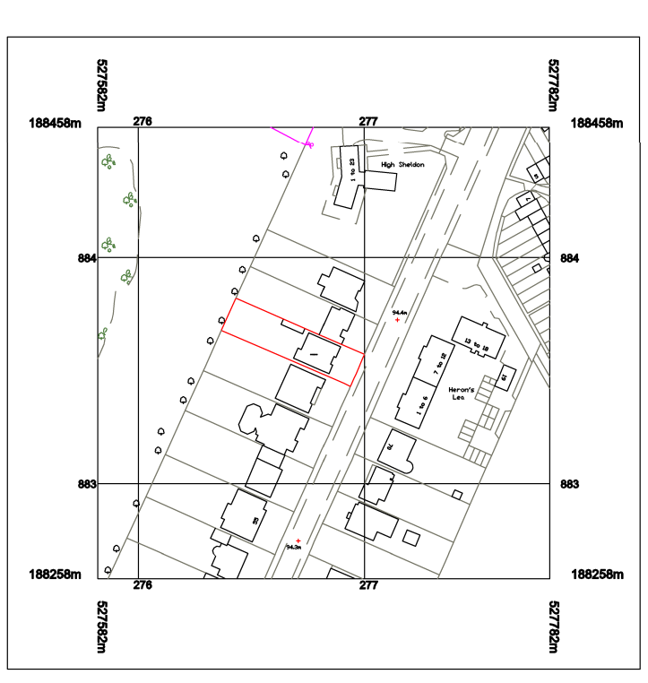
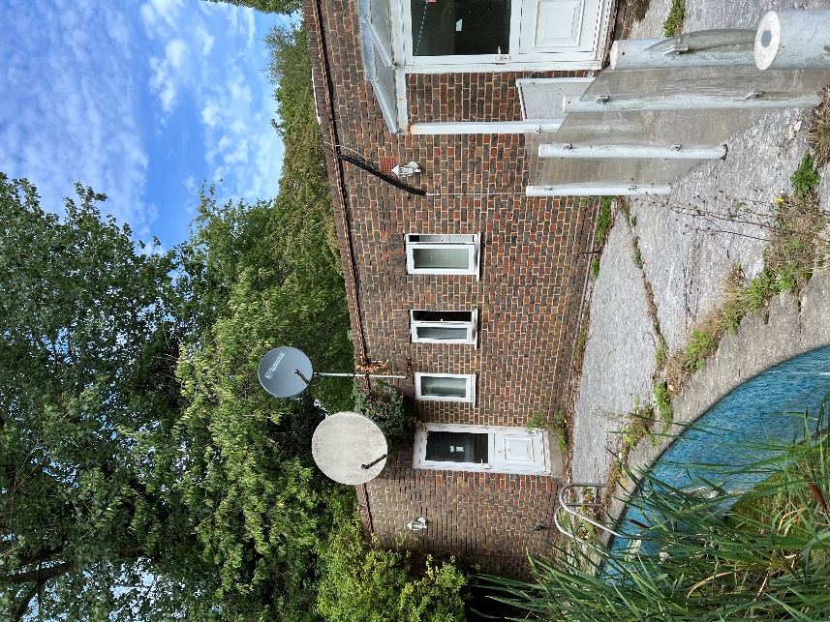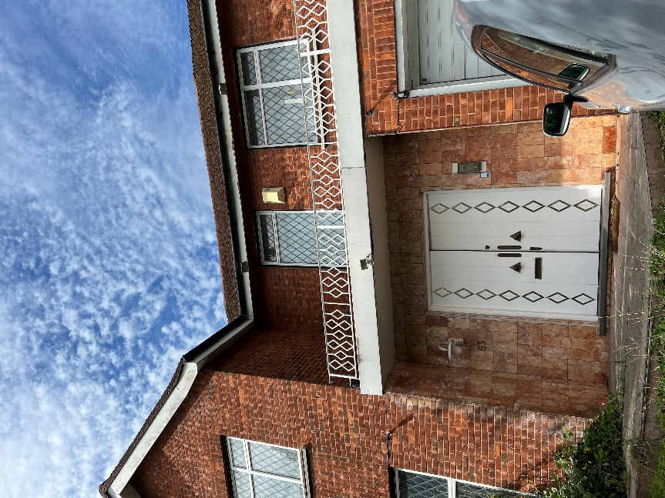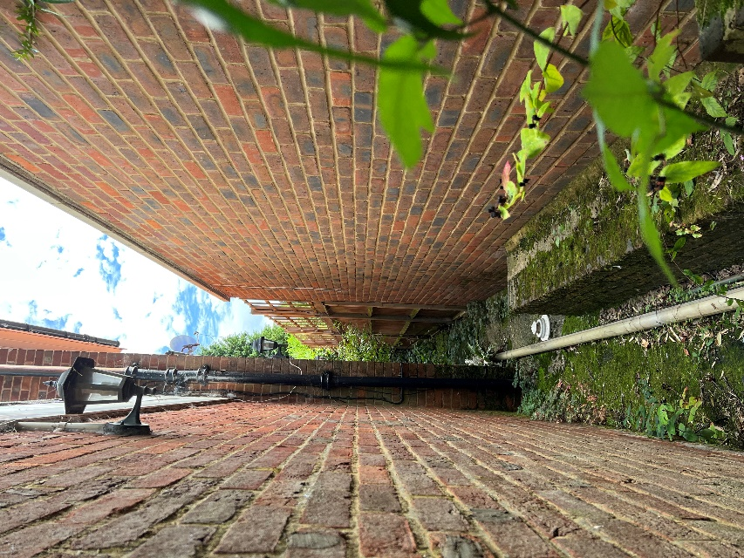

Appendix B
DEFRA Groundwater Maps
Aquifer Map (Bedrock)
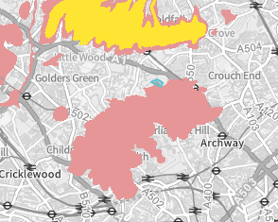
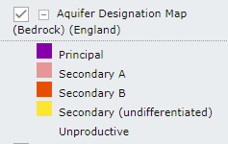
Comments
There are no active aquifers noted/ Unproductive
Source: Magic Map Application (defra.gov.uk)

Ground Water Map
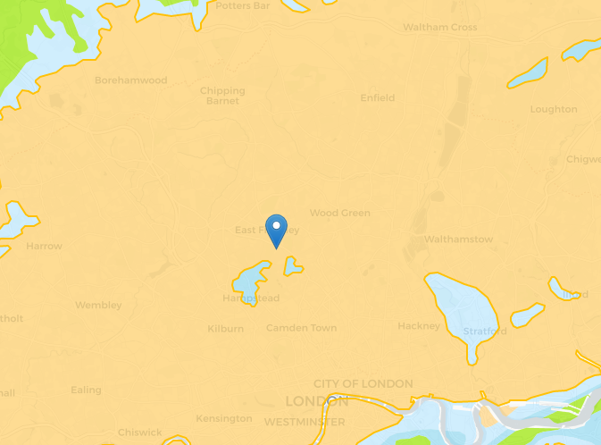
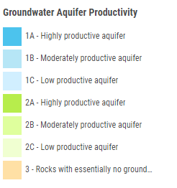
Comments
Rocks with essentially no ground water
Source: Groundwater Productivity - UK - Interactive Web Map (mangomap.com)
Flood Zones
Environment Agency: March 2021 – Source: https://parallel.co.uk/rofrs/#14.63/51.451/-0.31858
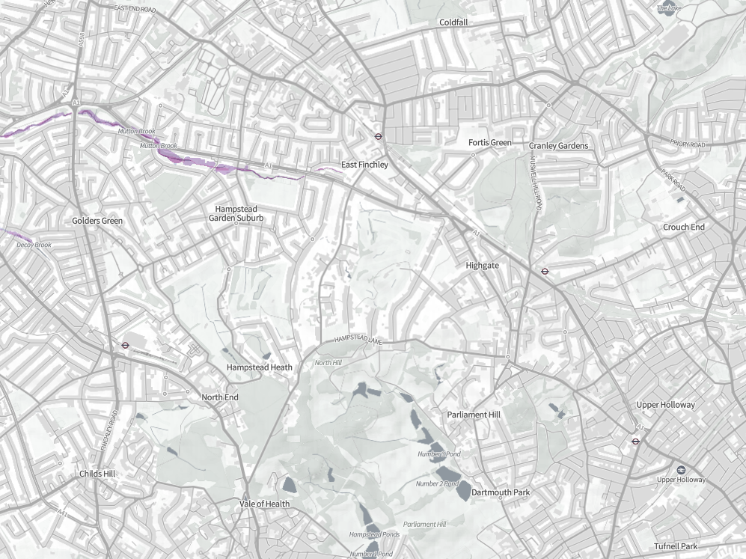
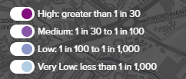
Comments
Flood risk negligible > 0.1% probability.
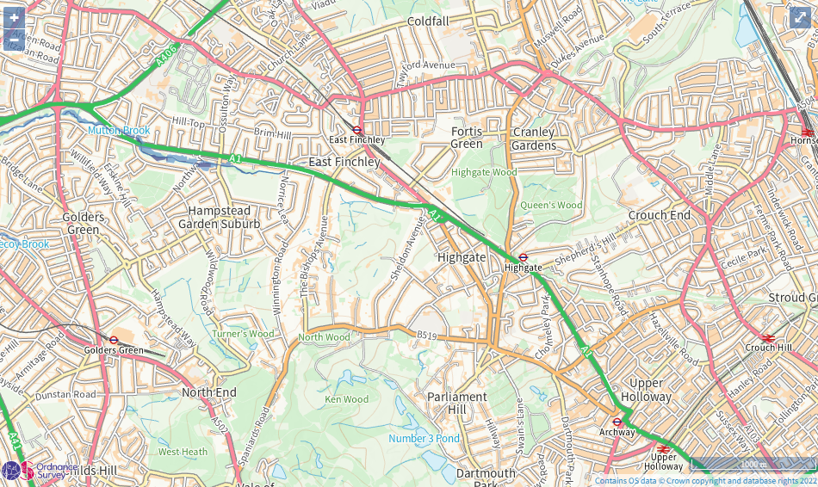
Source: Learn more about this area's flood risk - GOV.UK (check-long-term-flood-risk.service.gov.uk)

Site Topography
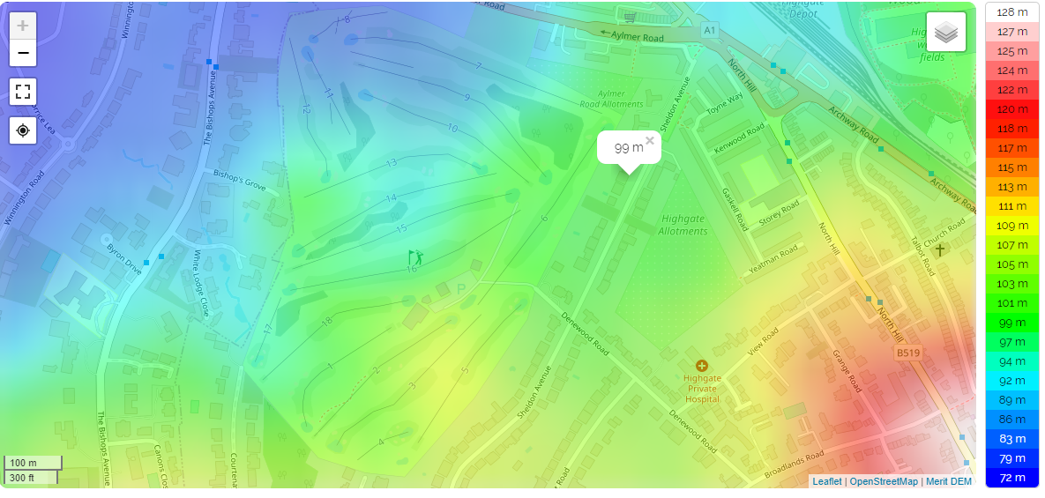
Source: England topographic map, elevation, relief (topographic-map.com)

Appendix C
Geotechnical Data
Source British Geological Survey
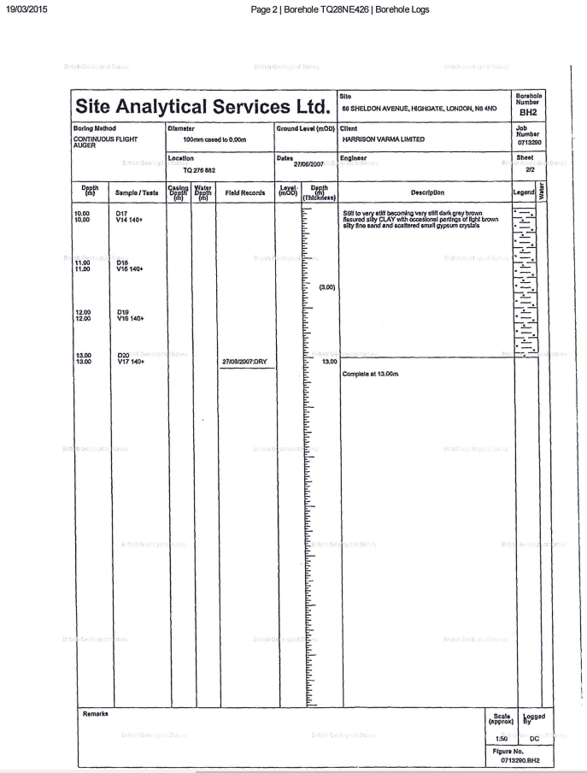
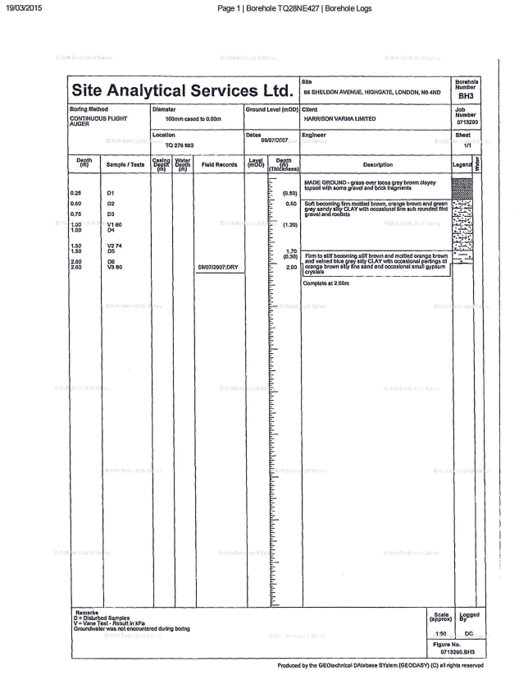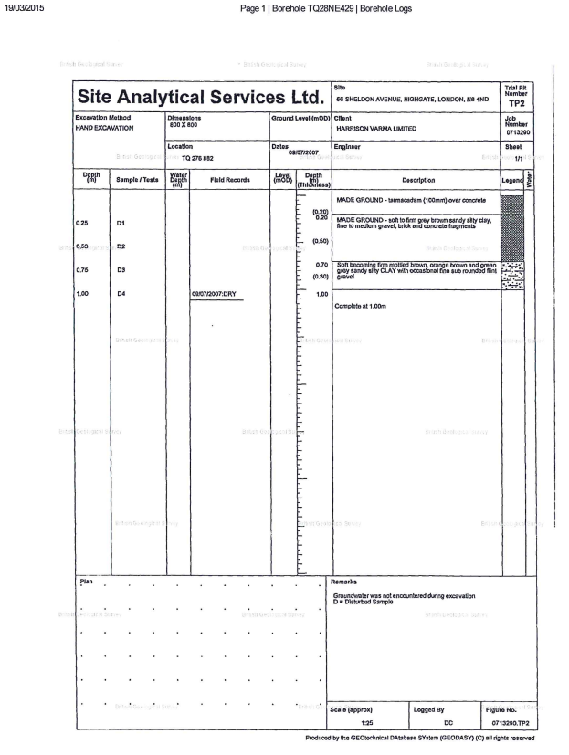
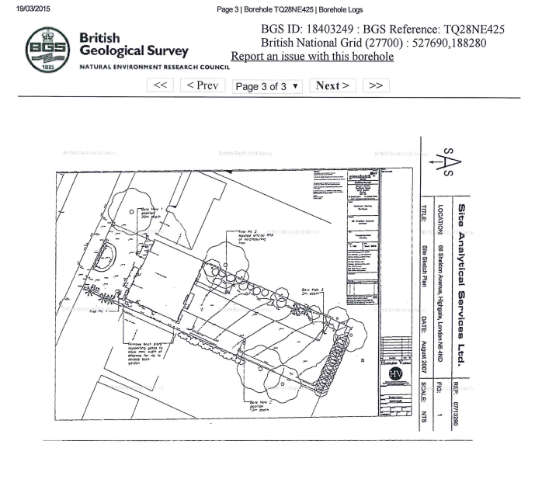

APPENDIX D
Architect’s Scheme Drawings
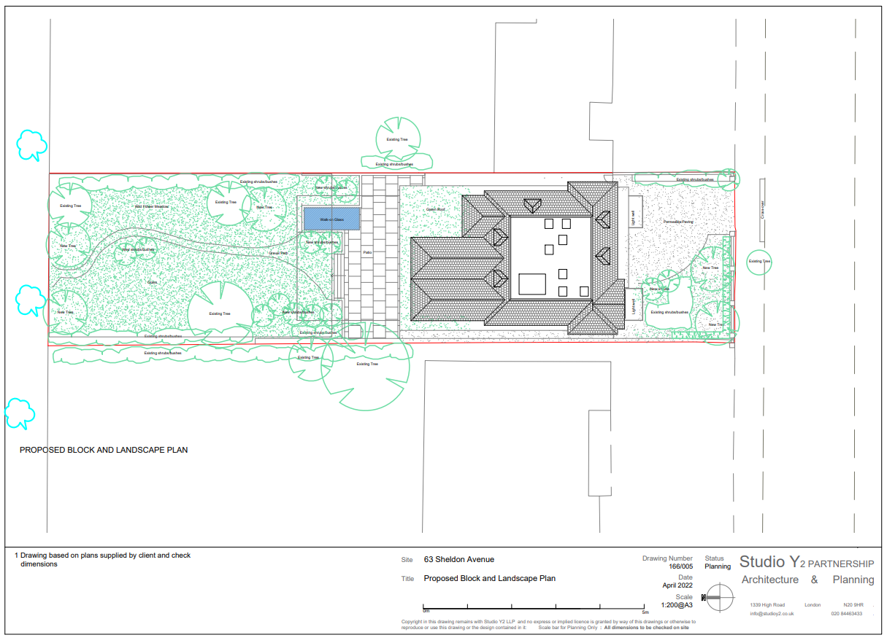
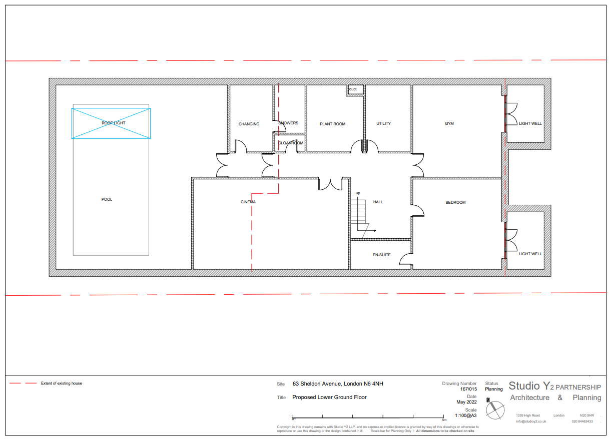
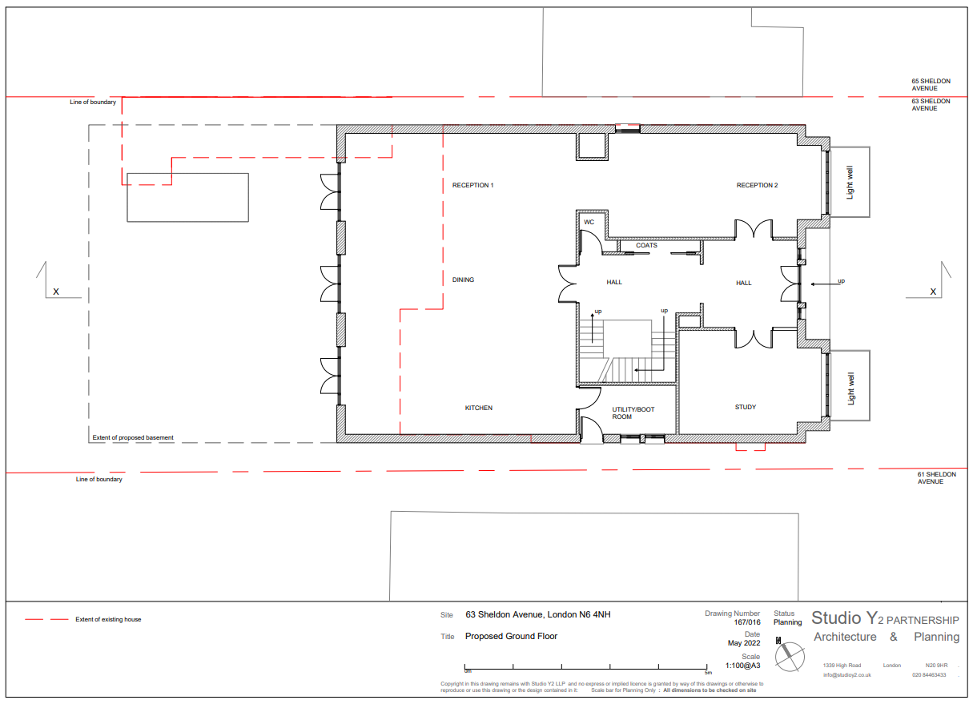
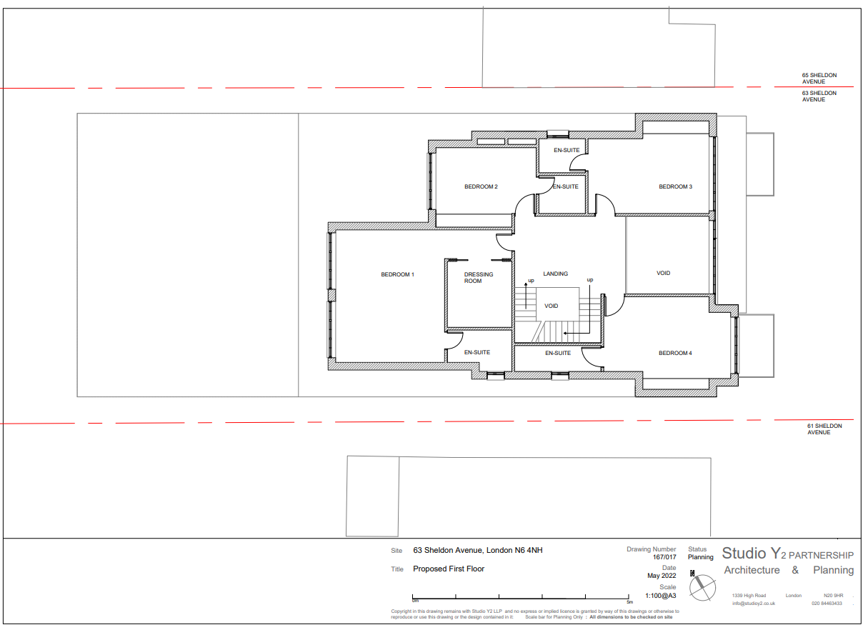
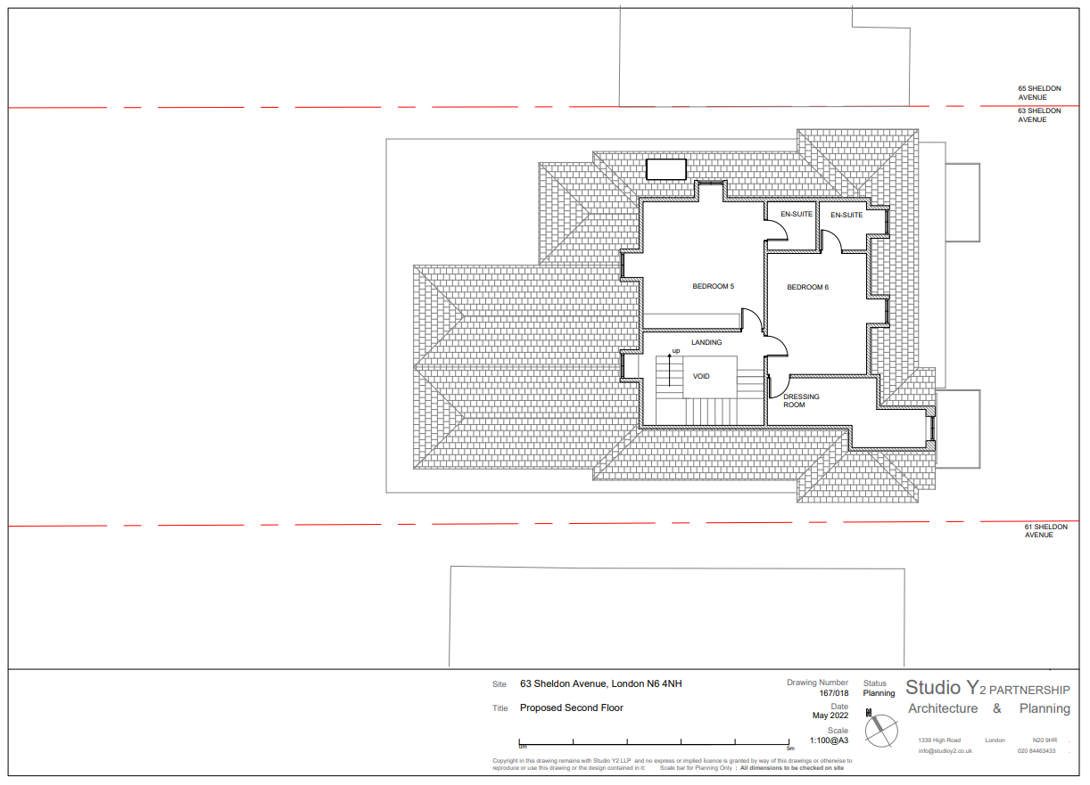
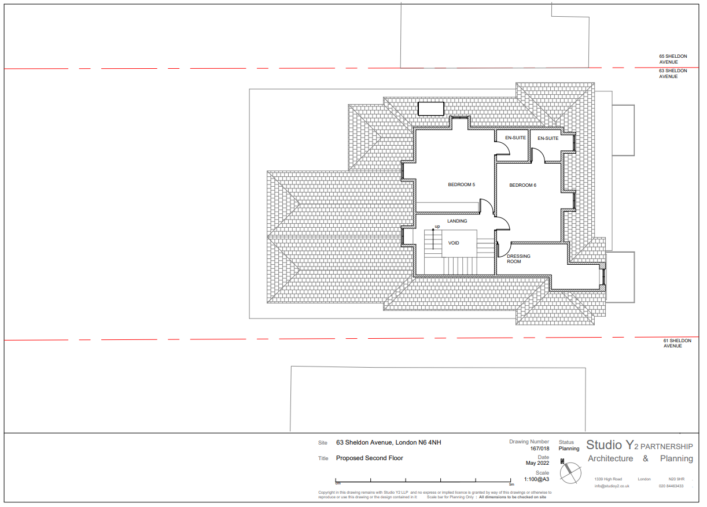
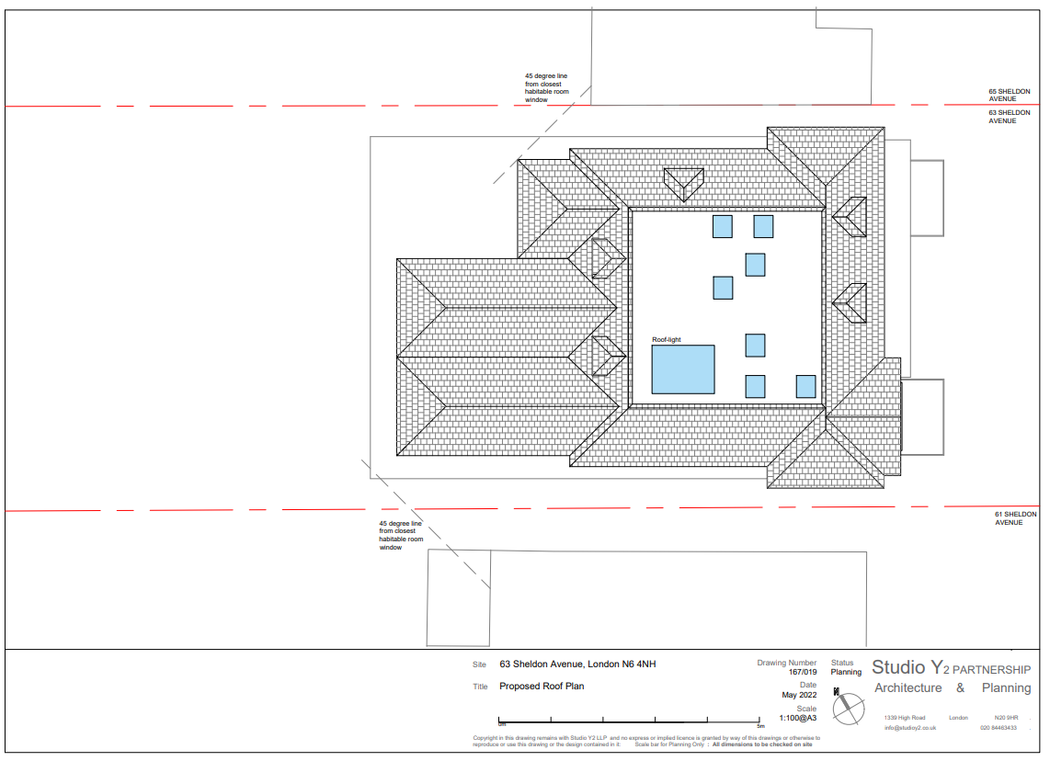
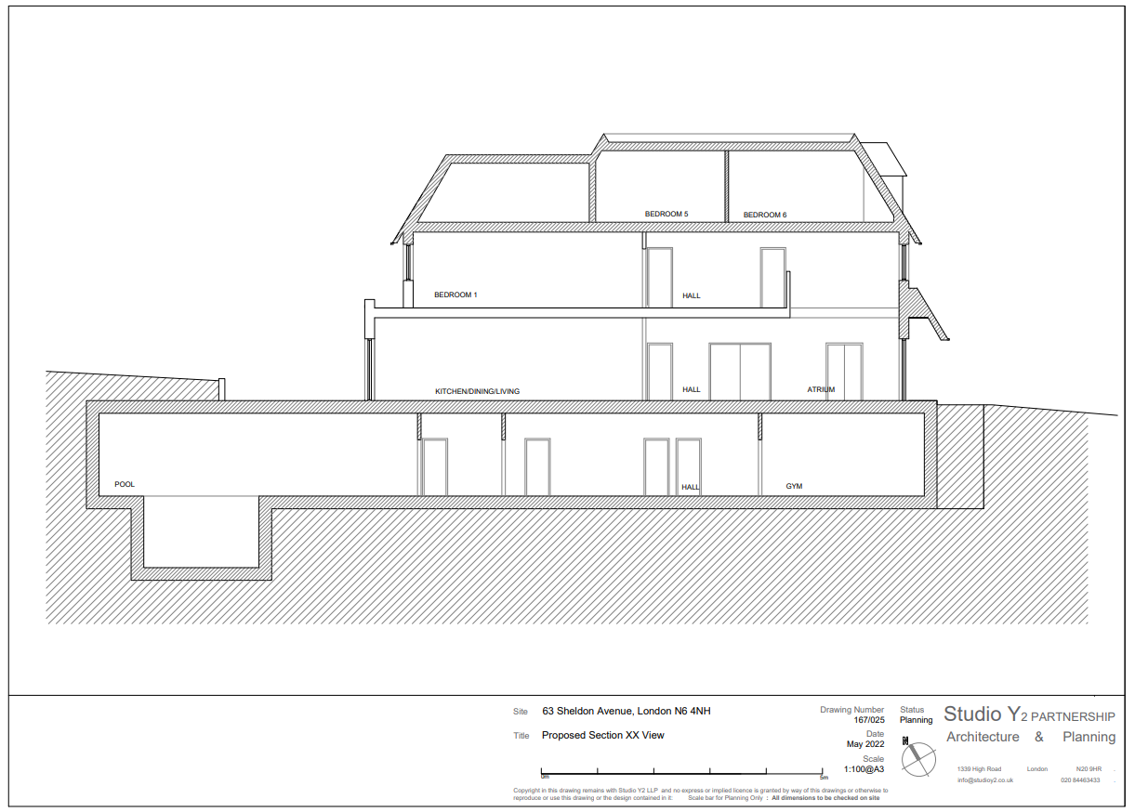
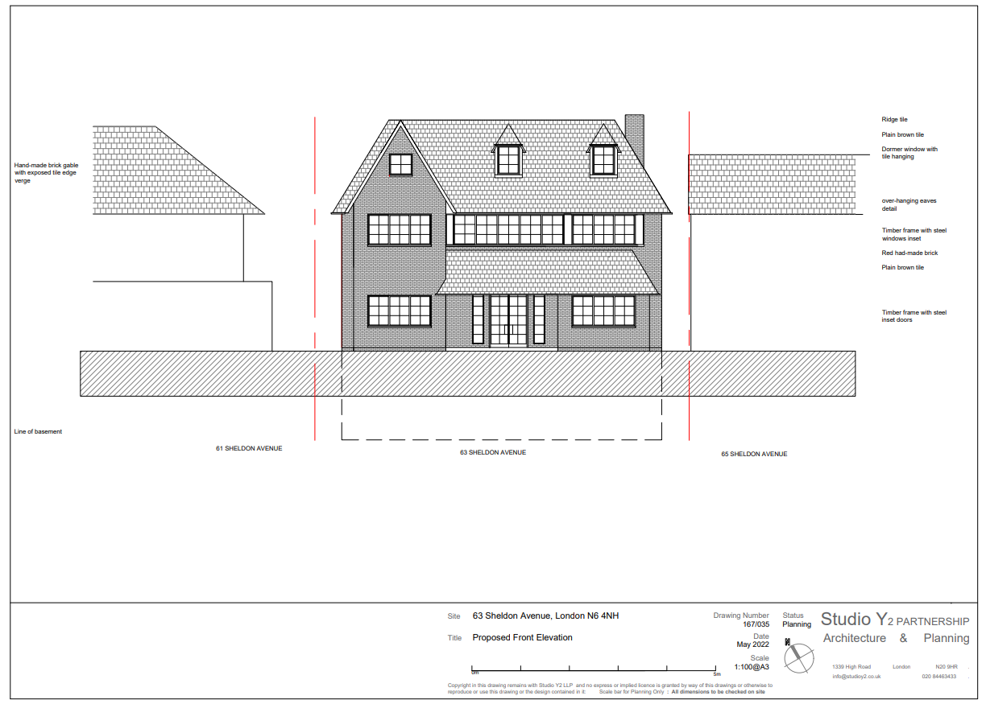
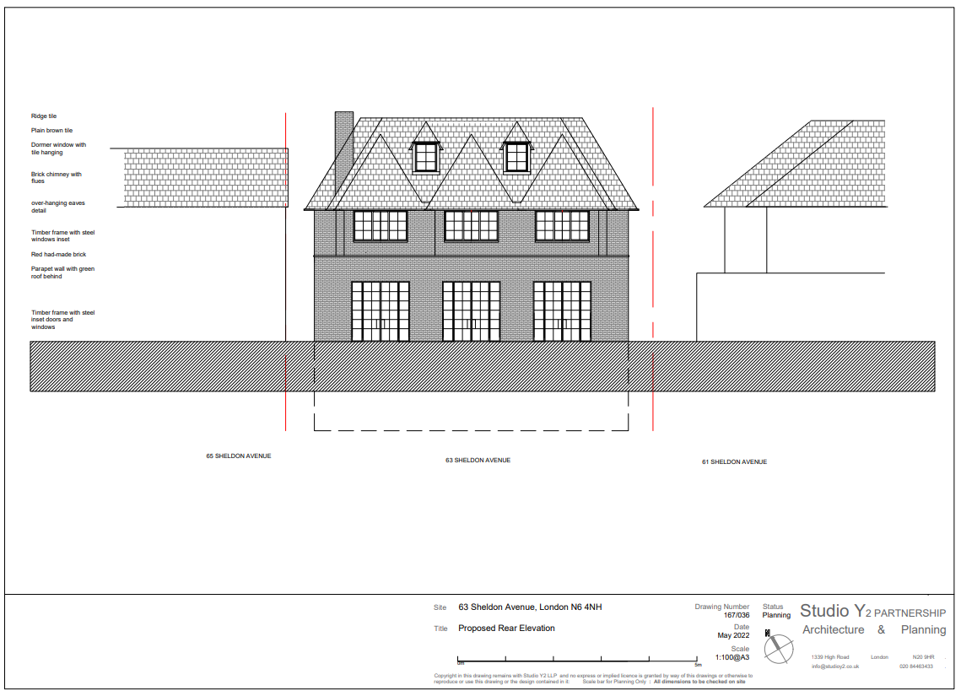
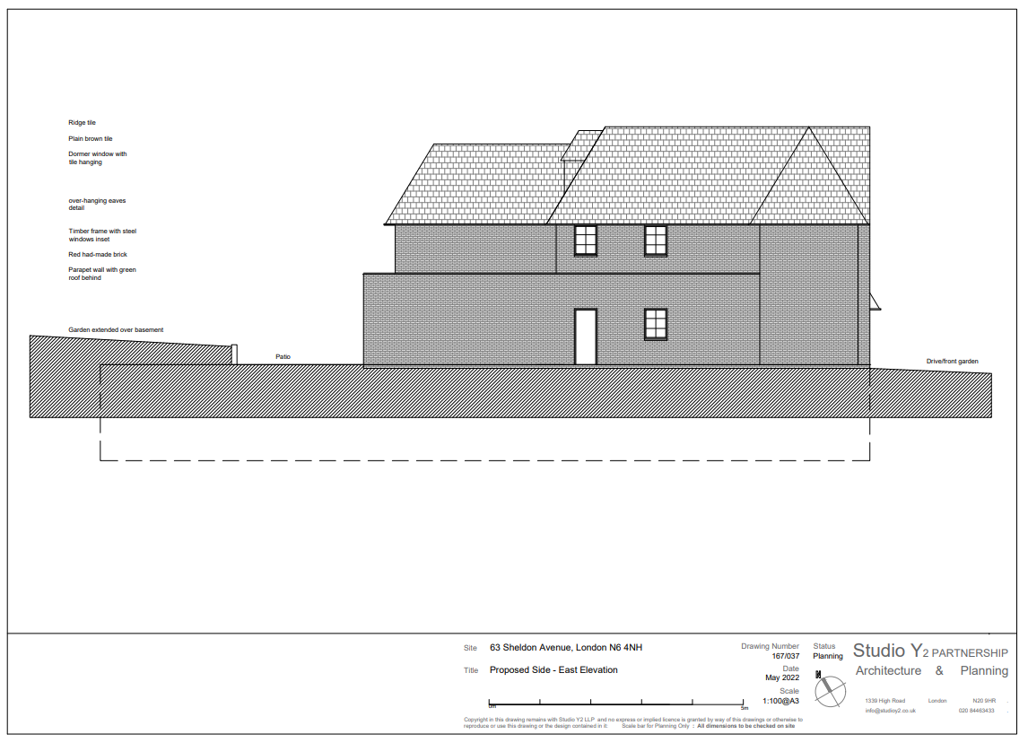
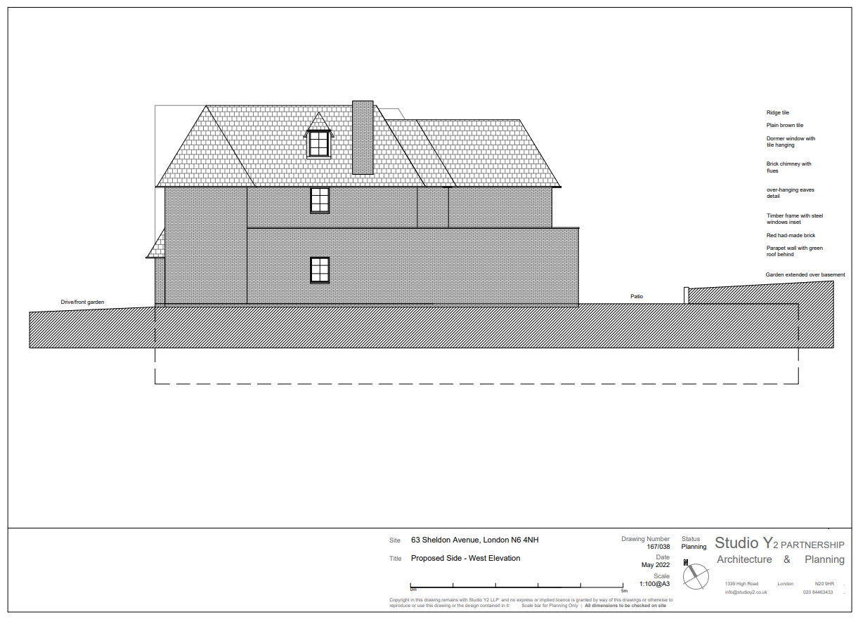

APPENDIX E
Structural Method Statement

We have been instructed to provide a methodology for carrying out the construction works to form a basement ensuring continued structural stability throughout the construction process, without adversely affecting the existing structure and the neighbouring properties. Therefore, we have completed a structural method statement otherwise known as an SMS. This SMS has been completed by Imperium Engineering Limited for use in support of the Basement Impact Assessment. The following method statement is related to the substructure works required for the construction of a basement and the underpinning of existing structural elements.

The works include the following alterations: Creation of a basement under the existing structure and to the rear where previous hard surfacing was located. This SMS only describes the construction of the basement works.

The basement construction will be completed in sections to avoid causing instability to the existing strip footing. These sections will be a maximum of 1000mm wide. Each strip is to be excavated and concreted. Minimum curing periods are to be observed to allow the sections to be stable before further works are carried out to the adjacent sections. Dry packing is to be completed tightly with expanding dry pack Conbex 100 or a similar (approved) expanding grout product if preferred by the Contractor.

Due to the sectional staged approach for constructing the basement the risk of movement between the basement and the existing foundations near to the property is negligible.

There should be no risk to the stability of the existing or the adjacent building during or as a result of these works. The reinforced concrete retaining walls are proposed to be carried out in a traditional hit and miss sequence. These will relate to steel dowels in the normal manner for this type of construction. The retaining walls must be back propped until cured. It is a normal procedure to strike the shutter 24 hours after pouring the wall and to then back prop the concrete to the earth using trench props.

The underpin will be within cohesive soils. These are usually stable in the medium term for the width of excavation proposed during these works. Once the perimeter of the excavation has been completed, waling beams and lateral props will be introduced, spanning the width of the basement. This will prevent inwards sliding of the newly formed wall and will allow the bulk excavation of the central bund to be carried out safely down to formation level and for the temporary props, initially taken back onto the central bund, to be removed.

The new basement slab will be designed as a reinforced concrete raft. Once installed and cured, it will act as lateral propping to the opposite retaining walls and will tie the basement level together robustly. At that stage, the temporary lateral props can be safely removed.

This method maintains the stability of the works and of the adjoining premises during construction and (given good workmanship by an experienced contractor) ensures that the proposed work does not have a detrimental impact on the existing or adjoining structures.

We are not able to state that the neighbours will have no damage; however, the existing properties are in good order, and we consider (based on previous projects of this nature) that any cracking would be within Category 1 of the Burland Scale. This is defined as fine cracks which are easily treated during normal decoration and form part of the BRE Digest 251.

The new foundations will be designed in accordance with the geotechnical information obtained. As one story is being excavated, advice on previous projects from other geotechnical consultants is that any movement would be of the same (or less) order than we would allow when considering the deflection of a suspended floor. This has been confirmed by past basement projects in London, where the has been no heave present which would cause any problems with the client’s house or their neighbours. In addition, settlement is not predicted to be a concern; the proposed basement will pose no significant threat to the structural stability of the existing property or adjoining premises.

As part of the party wall process, condition surveys of the adjoining properties will be prepared prior to the works commencing.

Due to access limitations the excavations will need to be hand dug using power tools. Only electric Kangos will be used; no compressors will be allowed. This will minimise any noise and vibrations to neighbouring properties. Special protections will not be required when these low impact techniques are employed.

Basement grade category 3 (habitable) will be required for the purpose of designing the waterproofing scheme. It is not practical to provide external tanking (as is preferred in new construction) given the sequential nature of the works. Therefore, an internal waterproofing strategy will be comprised by the architect of either a combined or proprietary single system will be used.

It is envisaged that the existing utilities serving the property will be maintained throughout the works or diverted if required. The exact location of these services will be investigated prior to the works commencing on site. Any impact on these will be negligible. The utility owners will be contacted should their services have to be diverted.

There are no underground tunnels near the site which would affect the proposed works. There are no other known man-made cavities near the proposed basement.

The basement proposals do not involve felling any existing trees during construction.

The proposed method of construction eliminates the risk of any potential slope instability. It should be noted that the surrounding area is predominantly level which reduces any risk of slope instability.

In areas where the basement is to be excavated, the works will be carried out in such a way as to eliminate the impact on local drainage, sewerage and surface water levels. Any utilities found, or any type of infrastructure next to and adjacent to the property will be adequately supported and reinstated using the appropriate specialist where required as part of the works. The fact that the works will be completed in a hit-and-miss fashion (in maximum 1m sections) will avoid damage or movement of the adjacent structures.

The basement will be constructed using concrete classed as grade C35. This is accepted as a watertight concrete mix. Which can be used in conjunction with the combined system mentioned above; there will be two lines of waterproofing. This is in accordance with BS8102 for a basement of category 3 habitable space.

A minor amount of additional water flow will be created because of the basement construction as the new footprint is where the existing decking is currently located, meaning that there will be only a small change in the hard surfacing.

The existing drainage systems already collect the surface water run-off; we suggest that the additional increase of surface water run-off should run into a newly installed soakaway; we suggest that any new soakaway is designed by a drainage engineer to suit the increased catchment area.

As part of the works, the foul and rainwater drainage systems will be rerouted to the existing sewers. All the new pipework will be below the proposed basement slab, and sump pumps will be used where required.
All new suspended floors are to have 5 x 30 galvanised restraint straps. These will be installed at 1200mm centres to provide horizontal lateral restraint. This is to be additional to joist hangers. These restraints will ensure that the joists are tied adequately to the external walls.
These restraint straps are to be fitted over a minimum of 3 timber joists and noggins, in both any new floor and in any replacement works to the timber roof.

Access for the works will be through the front of the property.

Proposed Construction Sequence
1. The excavation will progress from the front towards the rear with the spoil being removed via a conveyor and onto a skip placed on a suspended parking bay.
2. Excavate the first pin surface by removing the existing concrete floor.
3. Excavate and install the 1st underpin base following the agreed sequence.
4. Continue underpinning whilst maintaining all new pins back propped to the central earth mound.
5. With the perimeter fully underpinned and back propped to the central earth mound, install waling beams and lateral props spanning the width of the new excavation.
6. With the new underpinning laterally propped, reduce the central mound down to formation level..
7. Install the below ground drainage followed by the basement slab. Allow to cure for a minimum of 14 days prior to removing the lateral props.
8. Works to the upper floors are to be carried out on a floor-by-floor basis in order to maintain overall lateral stability of the party wall and the perimeter walls.
9. A drained cavity system; insulation and finishes will be installed to the basement, as detailed by others.

Any works carried out to the basement is to be supervised by a Chartered Structural Engineer throughout its duration.

The works to the basement are to be carried out by a specialist contractor who is experienced in dealing with the intricacies that occur during a basement construction. There is to be a project manager on-site supervising the works who will be appointed by the main contractor.

We recommend that any contractor carrying out the works should be a member of construction line, CHAS and the Considerate Construction Scheme.

In terms of the party walls, it is important to protect the interests of the client carrying out the works and of the neighbouring properties. Party Wall agreements are to be prepared to include condition surveys for both neighbouring properties.

Detailed temporary works, permanent works drawings and construction sequence requirements will be designed by a Structural Engineer and will comply with current Building Control requirements.

Hoarding is to be erected at the front of the site to provide adequate working space and space for skips will be in a suspended parking bay.

Sump pumps will be available during the excavation process to remove any water due to ponding. The superstructure is and will be watertight, and therefore, rainwater will not be directly affecting the excavations.

Reinforcing starter bars will be driven into the ground on each side. Shutters will be constructed to retain the wet concrete. Once the concrete is cast, leaving a 50 mm gap between the top of the concrete and the underside of the cleaned brick footing, the gap will be dry packed, but only after a minimum of 24 hours has been allowed for the concrete to cure. A further 48 hours must elapse before any further excavation can be carried out, within two bays of this new footing. A maximum of 20% of the building’s footprint can be undermined at any one time.

While the works are ongoing, the structure above will be propped as determined by the appointed temporary works engineer to maintain support, using heavy Acrow props or other similar supports. These will be propped from either the new concrete slab or cast concrete bases, purpose built to carry the main structure and any local areas of loading.

All demolitions are to be adequately sign posted and any demolitions are to be zoned and fenced off to prevent any unauthorised access.

Basement Retaining Wall Calculations

Design Philosophy – Basement Design

Geology
A safe ground bearing pressure of 140kN/m² has been taken from the Geotechnical information obtained from the BGS.

Retaining Wall Design
Retaining walls will be designed using “at rest” pressures to minimise the amount of movement in the walls. This will minimise the risk of damage to this and adjacent structures and when carried out in the correct sequence no structural damage is expected as experienced on many similar projects.

The basement retaining walls have been designed with the following geotechnical design parameters:

SOIL PARAMETERS

Dry soil = 18 kN/m³
Water = 10 kN/m³
φ = 33˚

Ground – bearing pressures below the underpinning bases will be calculated for the temporary condition. In the permanent condition, the new basement slab will be tied into the retaining wall bases, hence the entire substructure will act as a raft foundation. Ground – bearing pressures will not be an issue in this condition.

Water Table
We have check numerous borehole records for this area and therefore have made the assumption a high water table is not present.

An assumed accidental case will be assumed of 1.0 m below ground level for design of uplift on the slab and lateral forces on the retaining walls.

Temporary Works

The retaining walls will be designed where possible to be self-supporting under soil loading in the construction stage of the project. The underpins will need to be propped during construction to avoid any sliding failure at the base.

In the permanent case the retaining wall bases will be propped by the basement slab therefore the most onerous design case is the temporary condition.

All temporary works design is to be carried out by the contractor.
The basement retaining walls will follow the footprint of the existing external walls, the basement construction is to be completed in sections. These sections are to be a maximum of 1000mm. Each strip is to be excavated, concreted curing periods are to be observed to allow the sections to stabilise before further works are carried out to the adjacent sections, dry packing is to be completed tightly with expanding dry pack Conbex 100 or a similar product can be used if preferred.

Due to the sectional staged approach for constructing the basement the risk of long-term differential movement between the basement and the neighbour’s foundations is negligible.
There should be no risk to the stability of the existing or the adjacent building during or as a result of these works, since the reinforced concrete underpinning and retaining walls are proposed to be carried out in a traditional hit and miss sequence which are to be connected with steel dowels in the normal manner for this type of construction. Please note the walls must be back proposed until cured. It is normal procedure to strike the shutter 24 hours after pouring the wall and back prop the concrete to the earth using trench props.

The underpins will be within the granular materials. Excavations in granular materials need to be carried out with care. The contractor will need sacrificial steel trench sheeting or concrete poling boards and props to support any pockets of weak ground encountered. Excavations for each underpin will require temporary support using timber boards and props. Once underpinning the perimeter of the excavation has been completed, waling beams and lateral props will be introduced spanning the width of the basement. This will prevent inwards sliding of the newly formed underpinning and will allow the bulk excavation of the central bund to be carried out safely down to formation level.

The new basement slab will be designed as a reinforced concrete raft. Once installed and cured it will act as lateral propping to opposite retaining walls and will be tying the basement level together. At that stage, the temporary lateral props can be safely removed.

This method assists in maintaining stability of the works and of the neighbouring premises during construction and under good workmanship ensures the proposed work does not have a detrimental impact upon the existing or adjoining structures.
The new foundations will be designed in accordance with well-established permissible pressures. The granular soil underlying the basement is reasonably dense and provides adequate bearing strata for the new foundations. Settlement is not predicted to be a concern; the proposed basement will pose no significant threat to the structural stability of the existing property or adjoining premises.
Due to access limitations, the excavations will need to be hand dug using power tools. Only electric Kangos will be required, no compressors. This will minimise noise and vibrations to neighbouring properties. Special protection will not be required when these low-impact techniques are employed.

Basement grade category 3 (habitable) will be required for the purpose of designing its waterproofing. It is not practical to provide external tanking as in new construction, given the sequential nature of the works. Therefore, an internal waterproofing strategy comprising a drained cavity system to details by others will be required. It is envisaged that the existing utilities serving the property will need to be maintained throughout the works or diverted if required. The exact location of these services will need to be investigated prior to the works commencing on site. Any impact on these will be negligible. The utility owners would have to be contacted should their services have to be diverted.

Indicative Retaining Wall Calculation (Below External Walls)
This retaining wall calculation is partial and checks only sliding, overturning, and bearing pressure. A full detailed design will need to be provided during the structural design of the basement.

Front wall check

Retaining wall analysis

In accordance with EN1997-1:2004 incorporating Corrigendum dated February 2009 and the UK National Annex incorporating Corrigendum No.1
Tedds calculation version 2.9.16

Retaining wall details
Stem type; Cantilever
Stem height; h_{stem} = 3100 mm
Stem thickness; t_{stem} = 300 mm
Angle to rear face of stem; α = 90 deg
Stem density; γ_{stem} = 25 kN/m³
Toe length; l_{toe} = 2000 mm
Base thickness; t_{base} = 350 mm
Base density; γ_{base} = 25 kN/m³
Height of retained soil; h_{ret} = 3100 mm
Angle of soil surface; β = 0 deg
Depth of cover; d_{cover} = 0 mm

Retained soil properties
Soil type; Medium dense well graded sand
Moist density; γ_{mr} = 21 kN/m³
Saturated density; γ_{sr} = 23 kN/m³
Characteristic effective shear resistance angle; φ'_{r.k} = 30 deg
Characteristic wall friction angle; δ_{r.k} = 0 deg

Base soil properties
Soil type; Medium dense well graded sand
Soil density; γ_{b} = 18 kN/m³
Characteristic effective shear resistance angle; φ'_{b.k} = 30 deg
Characteristic wall friction angle; δ_{b.k} = 15 deg
Characteristic base friction angle; δ_{bb.k} = 30 deg
Presumed bearing capacity; P_{bearing} = 140 kN/m²

Loading details
Variable surcharge load; Surcharge_{Q} = 10 kN/m²
Vertical line load at 1000 mm; P_{G1} = 54.3 kN/m
; P_{Q1} = 12.3 kN/m
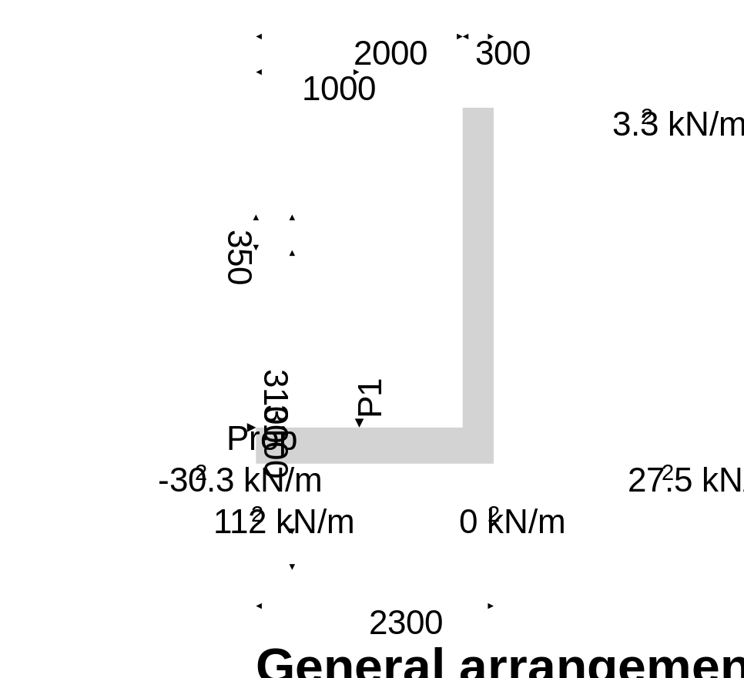

Calculate retaining wall geometry
Base length; l_{base} = l_{toe} + t_{stem} = 2300 mm
Moist soil height; h_{moist} = h_{soil} = 3100 mm
Length of surcharge load; l_{sur} = l_{heel} = 0 mm
- Distance to vertical component; x_{sur_v} = l_{base} - l_{heel} / 2 = 2300 mm
Effective height of wall; h_{eff} = h_{base} + d_{cover} + h_{ret} = 3450 mm
- Distance to horizontal component; x_{sur_h} = h_{eff} / 2 = 1725 mm
Area of wall stem; A_{stem} = h_{stem} × t_{stem} = 0.93 m²
- Distance to vertical component; x_{stem} = l_{toe} + t_{stem} / 2 = 2150 mm
Area of wall base; A_{base} = l_{base} × t_{base} = 0.805 m²
- Distance to vertical component; x_{base} = l_{base} / 2 = 1150 mm

Using Coulomb theory
Active pressure coefficient; K_{A} = sin(α + φ'_{r.k})² / (sin(α)² × sin(α - δ_{r.k}) × [1 + √[sin(φ'_{r.k} + δ_{r.k}) × sin(φ'_{r.k} - β) / (sin(α - δ_{r.k}) × sin(α + β))]]²) = 0.333
Passive pressure coefficient; K_{P} = sin(90 - φ'_{b.k})² / (sin(90 + δ_{b.k}) × [1 - √[sin(φ'_{b.k} + δ_{b.k}) × sin(φ'_{b.k}) / (sin(90 + δ_{b.k}))]]²) = 4.977

Bearing pressure check

Vertical forces on wall
Wall stem; F_{stem} = A_{stem} × γ_{stem} = 23.3 kN/m
Wall base; F_{base} = A_{base} × γ_{base} = 20.1 kN/m
Line loads; F_{P_v} = P_{G1} + P_{Q1} = 66.7 kN/m
Total; F_{total_v} = F_{stem} + F_{base} + F_{P_v} = 110 kN/m

Horizontal forces on wall
Surcharge load; F_{sur_h} = K_{A} × Surcharge_{Q} × h_{eff} = 11.5 kN/m
Moist retained soil; F_{moist_h} = K_{A} × γ_{mr} × h_{eff}² / 2 = 41.7 kN/m
Base soil; F_{pass_h} = -K_{P} × cos(δ_{b.k}) × γ_{b} × (d_{cover} + h_{base})² / 2 = -5.3 kN/m
Total; F_{total_h} = F_{sur_h} + F_{moist_h} + F_{pass_h} = 47.9 kN/m

Moments on wall
Wall stem; M_{stem} = F_{stem} × x_{stem} = 50 kNm/m
Wall base; M_{base} = F_{base} × x_{base} = 23.1 kNm/m
Surcharge load; M_{sur} = -F_{sur_h} × x_{sur_h} = -19.8 kNm/m
Line loads; M_{P} = (P_{G1} + P_{Q1}) × p₁ = 66.7 kNm/m
Moist retained soil; M_{moist} = -F_{moist_h} × x_{moist_h} = -47.9 kNm/m
Total; M_{total} = M_{stem} + M_{base} + M_{sur} + M_{P} + M_{moist} = 72 kNm/m

Check bearing pressure
Propping force; F_{prop_base} = F_{total_h} = 47.9 kN/m

Distance to reaction; ‾x = M_{total} / F_{total_v} = 655 mm
Eccentricity of reaction; e = ‾x - l_{base} / 2 = -495 mm
Loaded length of base; l_{load} = 3 × ‾x = 1964 mm
Bearing pressure at toe; q_{toe} = 2 × F_{total_v} / l_{load} = 112 kN/m²
Bearing pressure at heel; q_{heel} = 0 kN/m²

Factor of safety; FoS_{bp} = P_{bearing} / max(q_{toe}, q_{heel}) = 1.339
PASS - Allowable bearing pressure exceeds maximum applied bearing pressure

Side Wall Check

Retaining wall analysis

In accordance with EN1997-1:2004 incorporating Corrigendum dated February 2009 and the UK National Annex incorporating Corrigendum No.1
Tedds calculation version 2.9.16

Retaining wall details
Stem type; Cantilever
Stem height; h_{stem} = 3100 mm
Stem thickness; t_{stem} = 300 mm
Angle to rear face of stem; α = 90 deg
Stem density; γ_{stem} = 25 kN/m³
Toe length; l_{toe} = 2000 mm
Base thickness; t_{base} = 350 mm
Base density; γ_{base} = 25 kN/m³
Height of retained soil; h_{ret} = 3100 mm
Angle of soil surface; β = 0 deg
Depth of cover; d_{cover} = 0 mm

Retained soil properties
Soil type; Medium dense well graded sand
Moist density; γ_{mr} = 21 kN/m³
Saturated density; γ_{sr} = 23 kN/m³
Characteristic effective shear resistance angle; φ'_{r.k} = 30 deg
Characteristic wall friction angle; δ_{r.k} = 0 deg

Base soil properties
Soil type; Medium dense well graded sand
Soil density; γ_{b} = 18 kN/m³
Characteristic effective shear resistance angle; φ'_{b.k} = 30 deg
Characteristic wall friction angle; δ_{b.k} = 15 deg
Characteristic base friction angle; δ_{bb.k} = 30 deg
Presumed bearing capacity; P_{bearing} = 150 kN/m²

Loading details
Variable surcharge load; Surcharge_{Q} = 10 kN/m²
Vertical line load at 2150 mm; P_{G1} = 16 kN/m
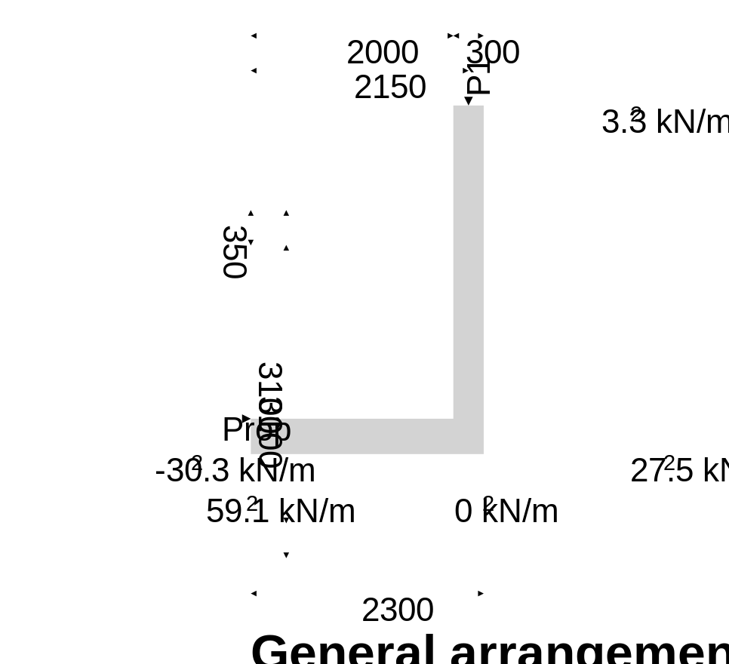

Calculate retaining wall geometry
Base length; l_{base} = l_{toe} + t_{stem} = 2300 mm
Moist soil height; h_{moist} = h_{soil} = 3100 mm
Length of surcharge load; l_{sur} = l_{heel} = 0 mm
- Distance to vertical component; x_{sur_v} = l_{base} - l_{heel} / 2 = 2300 mm
Effective height of wall; h_{eff} = h_{base} + d_{cover} + h_{ret} = 3450 mm
- Distance to horizontal component; x_{sur_h} = h_{eff} / 2 = 1725 mm
Area of wall stem; A_{stem} = h_{stem} × t_{stem} = 0.93 m²
- Distance to vertical component; x_{stem} = l_{toe} + t_{stem} / 2 = 2150 mm
Area of wall base; A_{base} = l_{base} × t_{base} = 0.805 m²
- Distance to vertical component; x_{base} = l_{base} / 2 = 1150 mm

Using Coulomb theory
Active pressure coefficient; K_{A} = sin(α + φ'_{r.k})² / (sin(α)² × sin(α - δ_{r.k}) × [1 + √[sin(φ'_{r.k} + δ_{r.k}) × sin(φ'_{r.k} - β) / (sin(α - δ_{r.k}) × sin(α + β))]]²) = 0.333
Passive pressure coefficient; K_{P} = sin(90 - φ'_{b.k})² / (sin(90 + δ_{b.k}) × [1 - √[sin(φ'_{b.k} + δ_{b.k}) × sin(φ'_{b.k}) / (sin(90 + δ_{b.k}))]]²) = 4.977

Bearing pressure check

Vertical forces on wall
Wall stem; F_{stem} = A_{stem} × γ_{stem} = 23.3 kN/m
Wall base; F_{base} = A_{base} × γ_{base} = 20.1 kN/m
Line loads; F_{P_v} = P_{G1} = 16 kN/m
Total; F_{total_v} = F_{stem} + F_{base} + F_{P_v} = 59.4 kN/m

Horizontal forces on wall
Surcharge load; F_{sur_h} = K_{A} × Surcharge_{Q} × h_{eff} = 11.5 kN/m
Moist retained soil; F_{moist_h} = K_{A} × γ_{mr} × h_{eff}² / 2 = 41.7 kN/m
Base soil; F_{pass_h} = -K_{P} × cos(δ_{b.k}) × γ_{b} × (d_{cover} + h_{base})² / 2 = -5.3 kN/m
Total; F_{total_h} = F_{sur_h} + F_{moist_h} + F_{pass_h} = 47.9 kN/m

Moments on wall
Wall stem; M_{stem} = F_{stem} × x_{stem} = 50 kNm/m
Wall base; M_{base} = F_{base} × x_{base} = 23.1 kNm/m
Surcharge load; M_{sur} = -F_{sur_h} × x_{sur_h} = -19.8 kNm/m
Line loads; M_{P} = P_{G1} × p₁ = 34.4 kNm/m
Moist retained soil; M_{moist} = -F_{moist_h} × x_{moist_h} = -47.9 kNm/m
Total; M_{total} = M_{stem} + M_{base} + M_{sur} + M_{P} + M_{moist} = 39.8 kNm/m

Check bearing pressure
Propping force; F_{prop_base} = F_{total_h} = 47.9 kN/m

Distance to reaction; ‾x = M_{total} / F_{total_v} = 670 mm
Eccentricity of reaction; e = ‾x - l_{base} / 2 = -480 mm
Loaded length of base; l_{load} = 3 × ‾x = 2010 mm
Bearing pressure at toe; q_{toe} = 2 × F_{total_v} / l_{load} = 59.1 kN/m²
Bearing pressure at heel; q_{heel} = 0 kN/m²

Factor of safety; FoS_{bp} = P_{bearing} / max(q_{toe}, q_{heel}) = 2.539
PASS - Allowable bearing pressure exceeds maximum applied bearing pressure

Hit & Miss Layout

The basement must not be excavated wholesale and must be carried out in maximum 1000mm wide pins in a piecemeal sequence as shown below. The contractor is to set out the pins according to the final permanent works design. Below is an example of a hit-and-miss layout.

The extent of the Excavation will be determined on site as to where the retained soil is deep enough to require a retaining wall.

Hit and Miss Sequence Drawings
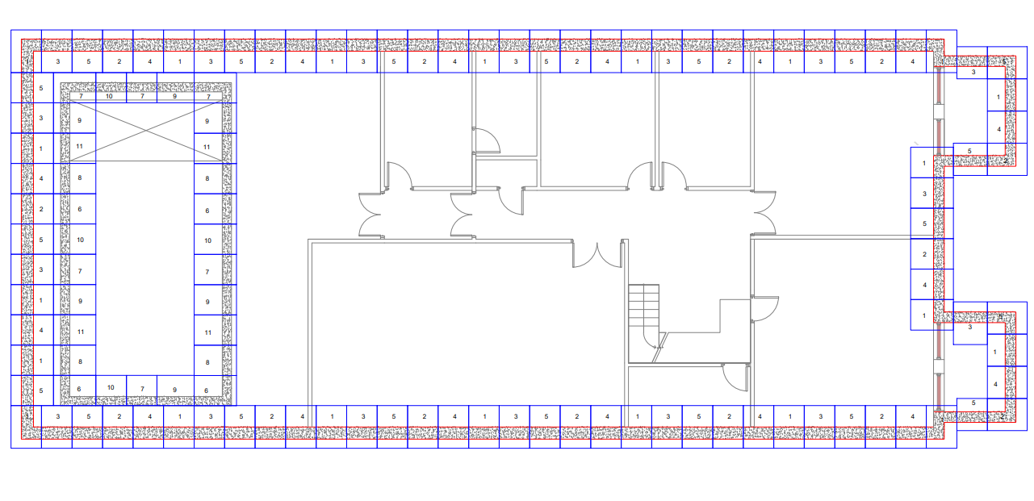

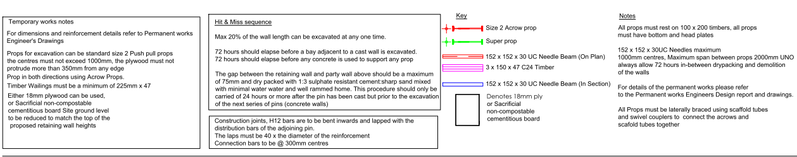

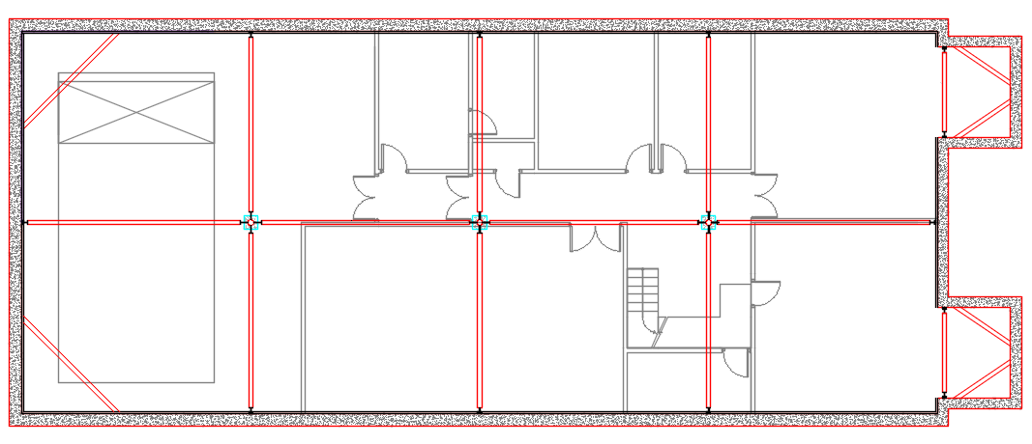

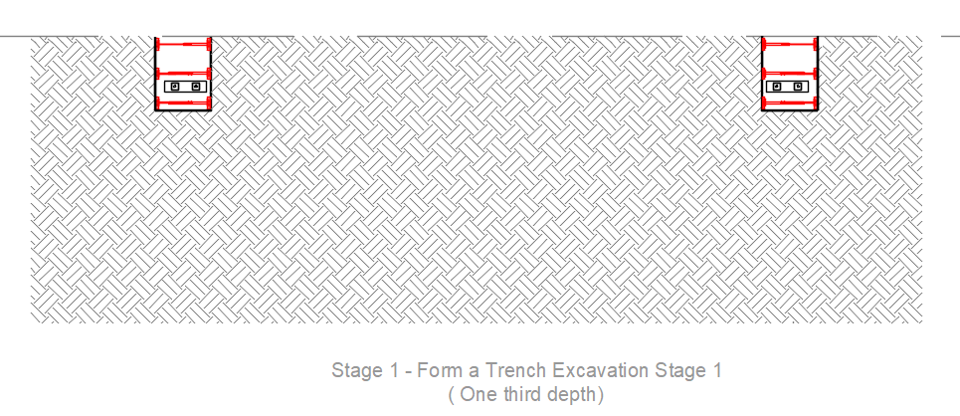
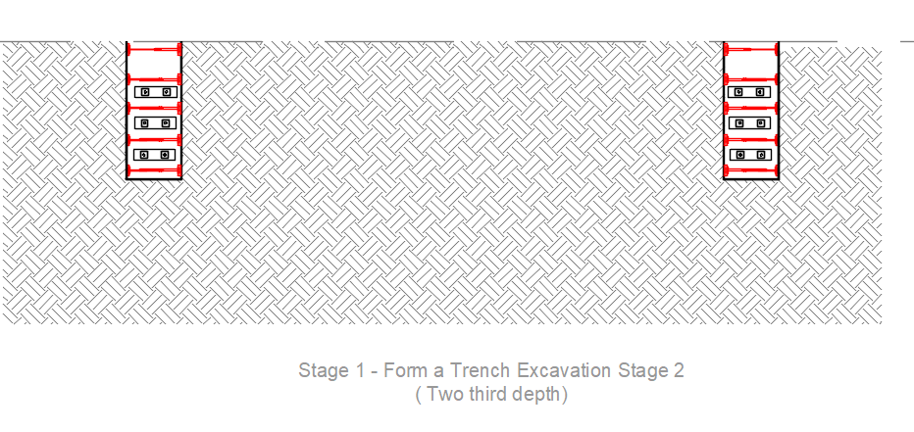
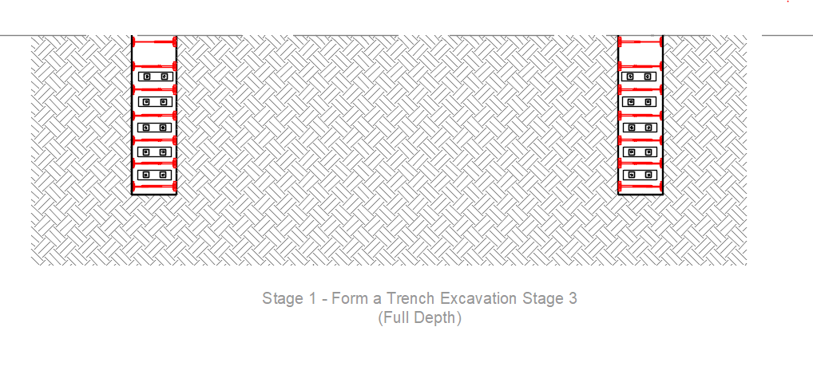
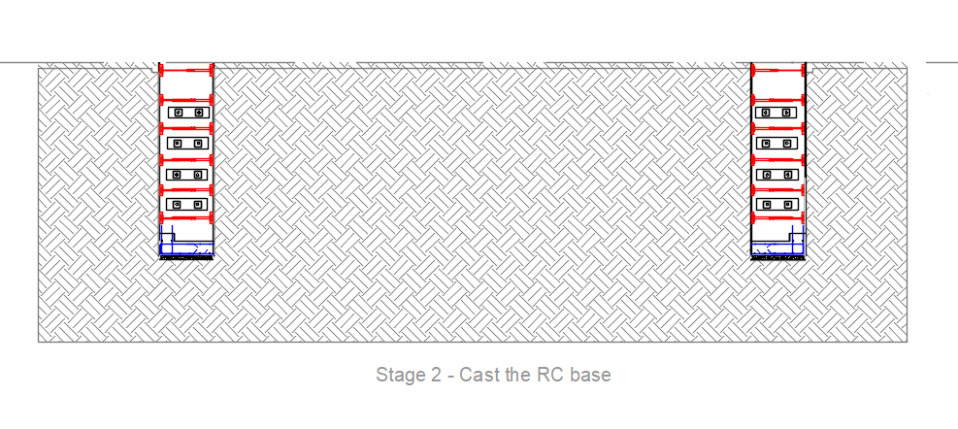
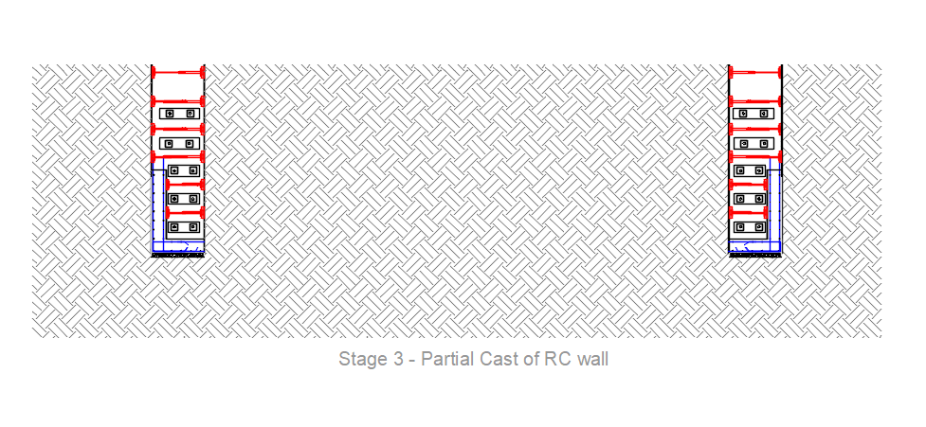
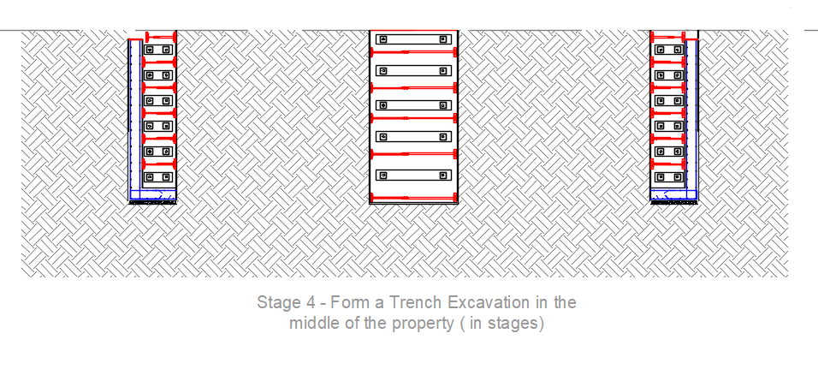
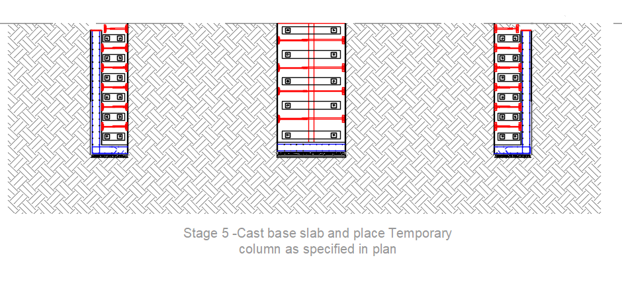
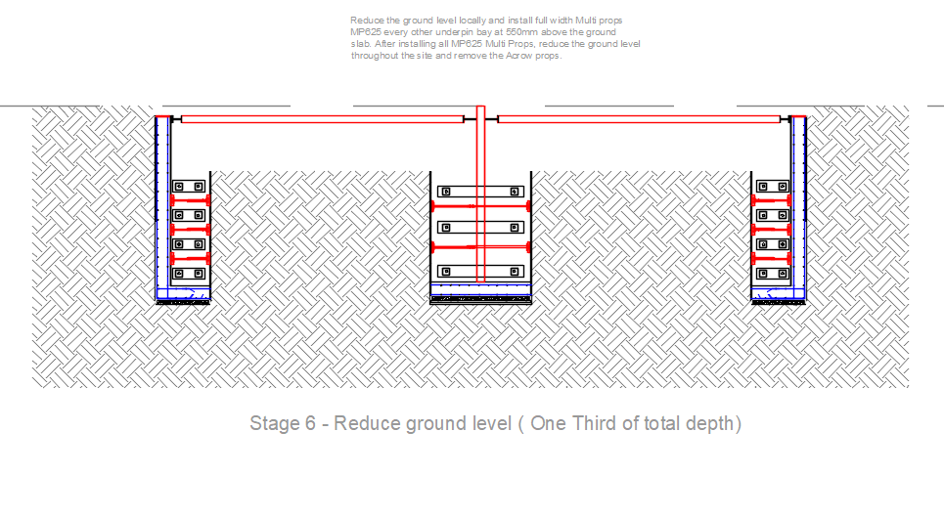
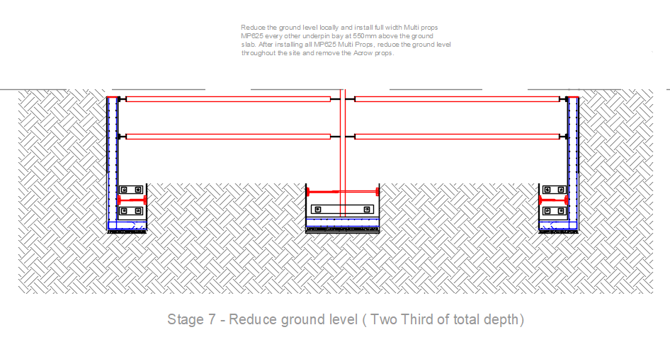
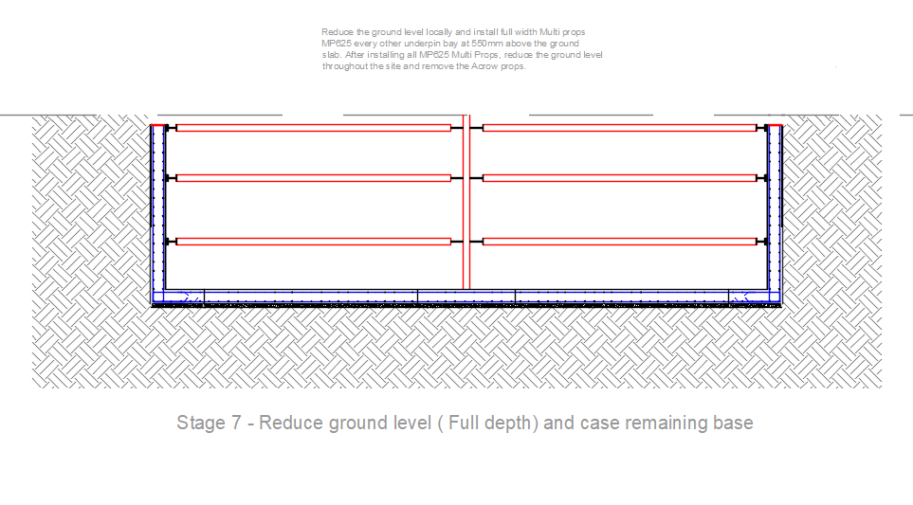
The sequence for the pool exaction and retaining walls is to be the same once the slab for the rest of the basement has been completed.

PROPS
It is proposed to use Acrows and then full width Multiprops to prop the retaining wall during the temporary phase.
As can be seen in our temporary work calculation above, the maximum propping force will be 22.2kN/m.
We propose to use Acrow props for every bay and then replace them with full width Multiprops installed every other bay at 2m c/c’s.
The safe working load for a Acrow Props is 32kN, thus OK. The contractor will conservatively use an additional prop at higher level to better prop the RC wall during the temporary phase.
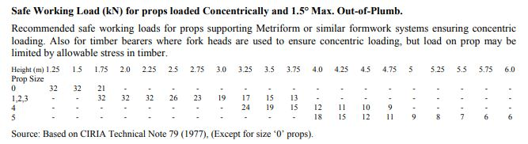

The safe working load for the Multiprops MP 625 at 4.8m is 44.5kN,
2 (m) x 22.2(kN/m) = 44.5kN, thus OK.

The maximum propping force will be 58.6kN/m.

We propose to use SuperSlim Soldier with end jacks that have a safe working load of 100kN at 1m c/c’s.
They will be installed at 45 degrees so the load supported will be: 58.6/cos(45) = 82.9kN, OK
Four M16 threaded rods will be used to fix to the RC wall. Vrd = 4*52.1 = 208.4kN. OK

APPENDIX F
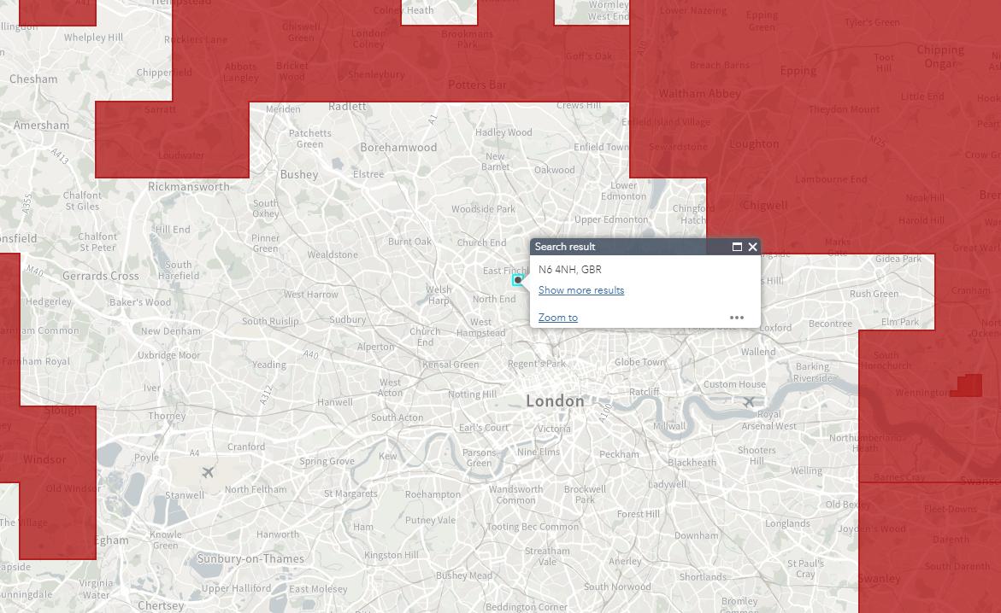
Source: Aerial Archaeology Mapping Explorer (arcgis.com)

General Construction Notes

FOUNDATIONS & EXCAVATIONS
1. Where foundations are in clay soils and within the zone of influence of trees the depths are to be in accordance with N.H.B.C. guidelines ‘Building Near Trees'. Where available, reference must be made to the soil report. All excavations are to be kept dry and the bottom of excavations for foundations must be protected from weathering.
2. Concrete for trench fill foundations is to be grade C28/35.
3. Where new foundations abut existing footings, the Contractor is to allow for local underpinning of the existing foundations.
4. Any drains or service ducts which passing through foundations are to be sleeved, with flexible couplings both sides of footings for drain runs. Tops of foundations may be reduced locally to allow services to pass over subject to Engineers approval with minimum 600mm depth of concrete below services. Precast concrete lintels may be used to support walls over, the Engineer must be consulted for lintel sizes. The Contractor must notify the Engineer if for any reason formation levels vary from those anticipated. Records of all final levels must be kept by the Contractor and issued to the Engineer if requested. The Contractor to agree with the Engineer the method of forming day-joints in foundations.

All foundations are to be agreed with building control, if the foundations cannot be agreed with building control, then we will be required to provide additional calculations and designs, this would be an additional fee. To provide the calculations it would be necessary to conduct a trial hole and inspection site visit and if this is not adequate then it may be necessary to obtain a site investigation from a geotechnical engineer.
GENERAL SPECIFICATION FOR UNDERPINNING: -

RESPONSIBILITIES
1. The Contractor to confirm with the Client that all required party wall awards are in place prior to works commencing.
2. The Contractor shall be completely responsible for the safety of the existing structure during the underpinning operations, and he shall design, supply and erect all the temporary supports that may be required or prove necessary during the course of the work.
3. The details of such supports shall be agreed with the Engineer and other interested parties prior to their erection.

SURVEY AND CONDITION OF BUILDING
1. Before commencing work the Contractor shall request a copy of the Schedule of Conditions prepared as part of the party wall award or carry out an inspection and produce a Schedule of Conditions for the building to be underpinned. This shall be agreed with the Client / Architect / Adjoining owner before commencing work. Where necessary repairs shall be affected to enable the underpinning to be carried out.

PROTECTION
1. The Contractor shall protect the area in which the work is being carried out by the provision of suitable hoarding, fences etc.
2. Unless otherwise instructed by the Architect all work shall be carried out from within the site.

EXCAVATION
1. The underpinning shall be carried out in sections not exceeding 1000mm. The excavation and construction of the sections shall be carried out in a "hit and miss" pattern such that a maximum degree of support is offered to the wall at all times.
2. Unless otherwise stated on the drawings the underpinning shall be carried out for the whole width of the existing foundation.
3. Where excavations exceed 1000mm in depth or wherever it is found necessary or called for on the drawings, all excavations shall be fully planked and strutted. Reference should be made to Specification "Earthworks", in this regard.
4. The material providing the support to the remote earth face below the foundations shall, if necessary, be left in position. It must not therefore be subject to deterioration. Any gaps between this support and the earth face shall be filled with cementitious grout. All timber planking and strutting shall be removed.
5. The underside of the exposed foundations shall be thoroughly cleaned of all soil and other loose material before the section of underpinning is constructed.
6. Excavations which are left open overnight shall be blinded with 50 mm of 1.8 concrete with sulphate resisting cement.
7. If water is struck during excavation, excavation shall cease until a method of dewatering has been devised which will not be detrimental to the adjoining foundations & has been agreed with the Engineer.

RECORDS
1. The contractor shall keep an accurate record of the progress of underpinning operations which shall be available for reference at any time.

Additional Notes

Building Regulations apply to all works of a structural nature. A set of these calculations should be submitted to an Approved Inspector or Local Authority Building Control for approval under the Building Regulations.
We would recommend that an early application is made for Full Plans Building Regulation approval. Should Building Control make any comments on the structural design please pass these back to us for consideration. There is a risk that they may raise queries which will require an amendment to our design, so it is important to seek approval prior to commencing any work.
Should you commence work without Full Plans approval under the Building Act you do so at your own risk - we will not accept liability for alterations, costs or delays resulting from the need to address Building Control’s requirements.
Planning consent may also be required for the works you are proposing. Unless you or your agent have already done so or you have made alternative arrangements, you should contact your Local Authority Planning Department, to check whether planning consent will be required.
These calculations relate only to the proposed works and their effect on the building structure. We have not considered the structural adequacy of other parts of the building except those directly affected by the proposed works or other areas where the calculations specifically identify design checks.
The structural design has been reviewed in accordance with regulation II of the Construction (Design and Management) Regulations 2015. My addition to the usual risks associated with building works and construction material, of which a competent and experienced building contractor should be aware, the following project specific health and safety risks have been identified:
• Demolition / excavation / drilling and cutting into existing structures or the ground should be carried out with extreme caution as there is a risk that unforeseen services will be encountered.
• All walls / beams / slabs / floor structures etc, which are to be demolished or removed should be assessed for any load bearing or stability function and temporary propping provided, as necessary. The design of temporary works support is outside of our brief for the project.
• Any existing structure of fabric to be interfered with by the work should be assessed for the potential presence of asbestos and appropriate action is taken if discovered.
Where new beams are to be installed to support the existing structure, temporary support will be required. When new beams are installed, before removing temporary support, steel or hardwood wedges should be driven into the gap between the top of the new beam and the underside of the retained structure above. The remaining gap should then be packed with a 1:3 dry sand-cement mix or otherwise permanently filled to transfer the load from above. Even with these precautions, some inevitable deflection of the temporary and permanent structure support will occur, and this may result in cracking to the structure above. This is normal and should be repaired and redecorated at the completion of the works. Such works should only be undertaken by an experienced and competent building contractor.
Where new foundations are required, the allowable bearing pressure of the soil at the proposed foundation depth should be assessed against the values assumed in the calculations - Table 10 of the approved document of the building regulations gives guidance in this regard.
References:
BS 648: 1994 Weights of Building Materials
BS 5950: Part I: 2000: Design a Structural Steelwork
BS 5977: Part I: 1981: Lintels Method of Assessment of Load
BS 5628: Part I: 2005: Structural use of Unreinforced Masonry
BS 5628: Part 3: 2005: Masonry - Materials, Components, Design & Workmanship
BS 5268: Part 2: 2002: Structural use of Timber - Permissible Stress Design
BS 6399: Part 1: 1996: Loading for Buildings: Dead and Imposed Loads
BS 6399: Part 2: 1997: Loading For Buildings: Wind Loads
BS 6399: Part 3: 1988: Loading for Buildings: Imposed Roof Loads

Construction Notes:
Concrete Mixes to be designated mixes to BS 8500. The method of placing and the workability of the mix is to be specified by the Contractor to the approval of Local Authority Building Control Admixtures shall not be used without prior approval.
Placing, compacting, finishing and curing to be in accordance with BS8000 Section 2.2
Mass concrete foundation to be mix ref. GEN3 unless stated otherwise in the site investigation report
The following calculations assume that the foundations bear at onto ground capable resisting a bearing pressure of 75kN/m2 without failure of excessive settlement. Where weaker soils are present on-site foundation widths will need to be revised as appropriate.
Minimum block strength to be used in the works shall be 2.8 N/mm2. All blocks used below ground shall be suitable for such use
Mortar Designation: Above ground (iii) 1:1:6 Cement: Lime: Sand
Below ground (iii) 1:0.5:4.5 Cement: Lime: Sand
Where beam lengths and other span dimensions are quoted in the following calculations, they are approximate and shall not be used as a basis for ordering materials. The main contractors shall make his own measured survey of the site to determine precise lengths and details for construction.
All dimensions and levels to be check by the builder before ordering any steelwork,
All steelwork is to be grade S275, shot blasted and painted with 2 coats of zinc phosphate primer or red oxide primer unless noted on drawing as galvanised or concrete encased.
All bolts are to be grade 8.8, all fabrications to be completed in accordance with BS5950.
All new timbers are to be Grade C24 unless noted as C16 on the drawing and must be tantalised. Paint all cut ends with timber preservative on site. Plywood must comply with EN636 Class 3.
All brickwork to be a minimum of 20.5n/mm2 in 1:1:6 Mortar
All concrete (except blinding concrete) is to be a minimum of 30n/mm2 with 20mm diameter aggregate and is to be mechanically vibrated when placed.
All concrete work must comply with BS8110.
Beam supporting cavity walls to have 15mm thick steel plates welded to top of beam and the width of the plate is to suit the width of the supported wall
All external walls to have straps at 2m c/c’s horizontally and vertically for the roof
Timber joists with a span over 2.5m are to ha e one row of noggins at one third the span, noggins can be replaced with herringbone strutting.
All joists in walls are to be cross nailed.
All stud walls parallel to the floor joists must be support by a minimum of a double joist which is to be bolted together using M12 bolts with dog toothed washers @ 500mm c/c
All beams are to be centrally loaded on pad-stone and beams are to extend to the end of any given pad-stone.
The contractor must provide full details on their proposed temporary works, before commencing the structural works.

Appendix G Party Wall Act 1996:

The following extract has been taken from the Party wall act explanatory booklet.

