

ROOFTOP ROOMS Ltd
342 Baker St, Enfield, EN1 3LH.
0208 367 0066 www. rooftoprooms.co.uk

DESIGN & ACCESS STATEMENT

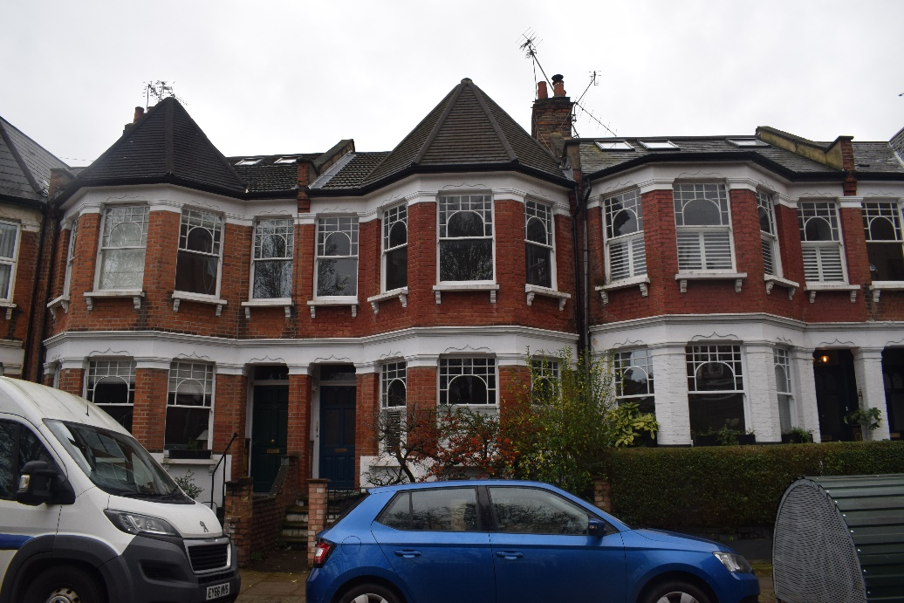
54 Falkland Road, London, N8 0NX

Prepared by Rooftoop Rooms LTD

Contents:

1.0 Introduction

2.0 Site Description

3.0 Proposed Development
4.0 Access
5.0 Summary
6.0 Contractor Commitment & Contact Details

1.0 Introduction
The proposal will take the form of a L-shape rear dormer loft conversion deriving from the direct needs of a growing family. The proposal will be of a scale which meets the guidelines for a L-shape dormer loft conversion as shown on the London Borough of Haringey planning portal.

2.0 Site Description
The proposed site consists of a flat on the first floor. The property is a mid-terrace dwelling, which has been sub divided into flats. The proposed site is a first floor flat of a Victorian terraced Property. A neighbouring flat exists on the ground floor. The proposed site has access to a ground floor garden. Numbers 52 & 56 bound to the east & west. The site is not located in a conservation area. The surrounding area is predominately characterised by planned streets of terraced properties with minor variations in size, form and design. The area is highly populated with other dormer loft conversions in the form of L-Shaped dormers.

3.0 Proposed Development
The proposed development has been designed to meet the guidelines shown on the London Borough of Haringey planning portal. The proposal will extend the roof in a L-Shaped dormer style built within the original roofline. The dormer will be clad with plain tiles that match the colour and material of the existing roof tiles. The design proposes 5No. Velux windows to the front elevation. 2No. uPVC casement windows, 1No. enlargement of an existing window opening on the first floor and 1No. set of French doors with a Juliet-balcony to the rear elevation.

The proposed development is typical of the area and can be found replicated in abundance. The following planning applications are referred to as similarities/equivalents in the compilation of this planning application: Rooftop Rooms LTD had completed a similar project on the same road in 2019 to a first floor flat.

- HGY/2019/1494 – 33a Falkland Road, London N8 0NS
- HGY/2017/2727 – 37 Falkland Road, London N8 0NS

5.0 Access
The proposed loft conversion will not affect the existing parking. Access will not be affected by the proposal.

6.0 Summary
The proposal should be considered acceptable for the following reasons; the proposed roof extension by size scale and design is in keeping with the guidelines provided on the London Borough of Haringey Planning Portal. As such the proposal will not be detrimental to the character and appearance of the surrounding area. It would not represent an incongruous feature in the surrounding pattern of development. Its form, size and overall appearance would be similar to the above examples already approved within the local vicinity. The proposal is designed in such a way that it will have no adverse impact on the neighbouring amenities of the street scene.

7.0 Contractor Commitment & Contact Details
As a conscientious contractor undertaking a significant number of conversions within the local area, we are keen to work with the local authority in order to achieve a sympathetic conversion which meets both the requirements of the local authority but also provides our client with the much needed space to improve the standard of family life. With this in mind, should the nominated planning officer wish to discuss or change any elements of the design, I can be reached on:

Sam Ashen (Structural Engineer)
Sam@rooftoprooms.co.uk
Telephone 0208 367 0066

